Finding an Outdoor Oasis in Santa Monica

Introduction
Meditation is an well-studied practice shown to have significant utility for stress reduction, with regular practice shown to lead to increased feelings of wellbeing and reduced anxiety. Many people are home and under significant stress in due to coronavirus. However, outdoor activities at a safe distance of greater than 6 feet, are considered safe. I would like to set up a free outdoor meditation center for the winter in an area with good weather, such as Santa Monica.

The motivation for this analysis is the selection of a location for an outdoor meditation center in Santa Monica. I would like for the center to be on public grounds (a park, beach, etc.) and near other health and mindfulness-themed venues, such as healthy food/juice, surrounded by other public spaces, and also near trees, in particular, tall palm trees. Nearby venues would ensure that people might stumble upon the class and decide to join, and the palm trees create the proper ambiance. I would like to identify parts of Santa Monica which have these properties.

This analysis would be of interest to community planners and individuals thinking of where they might start a related endeavor, such as meeting for a yoga or running club.

Data
The data used will be pulled from three datasets: the Foursquare API, Google Maps, and the Santa Monica Public Tree database. The Foursquare API provides free basic service to individual users, who can query the server for a list of venues near a given latitude and longitude and properties of the venues. Google Maps provides latitude and longitude for several points of interest, and so Google Maps has been used to identify the approximate centroids of the many Santa Monica Neighborhoods, as formal listings of latitude and longitude of each of the Santa Monica Neighborhoods were not readily available. Finally, the City of Santa Monica maintains on its website a directory of every tree in the city, including its height and location. This database has been used to identify tall palm trees.

Data is available at the following locations:
Foursquare: https://foursquare.com/
Google Maps: https://maps.google.com
Santa Monica Tree Database: https://data.smgov.net/Public-Assets/Trees-Inventory/w8ue-6cnd/data

Methodology
First, I identified the relevant Santa Monica Neighborhoods using Wikipedia and Google Maps, and then I explored them using Foursquare. In particular, I sought out up to 500 nearby venues within a radius of 1000 meters (1.6 miles) from the center of each Santa Monica neighborhood. I then used one-hot encoding and k-means clustering to cluster the neighborhoods into three groups, so that neighborhoods with more similar nearby venues would be in the same cluster, and looked at the top five venues in each neighborhood. From this, I identified clusters with top venues more suitable to the outdoor meditation theme (for example, health food, juice, a park, etc.).

I then performed basic statistical analysis on the tree data set. Statistics on the trees included basic statistics, such as the frequency of the different tree types, and the percent of the total trees which were tall Mexican Fan Palms. I displayed the results in a bar chart.

Finally, I further explored the neighborhood and tree data by plotting it using Folium. From this, I was able to see which clusters were closest to the tall Mexican Fan Palm trees and identify suitable locations for the outdoor meditation center.

Results
SM neighborhoods are geographically clustered, as shown in Figure 1. In addition, this figure shows the location of tall Mexican Fan Palm trees. These trees are along the water, as well as in several places throughout the neighborhood. The Mexican Fan Palm trees represent 12 percent of all the trees in Santa Monica and 60.5 percent of the palm trees in Santa Monica, with palm trees overall representing 19.8 percent of the trees in Santa Monica. Figure 2 illustrates common palm tree types in Santa Monica.

I want a location which is both near the tall palm trees, which are characteristic of the city, as well as near healthy, relevant businesses. Following are descriptions of the top 10 places for each of the three clusters.

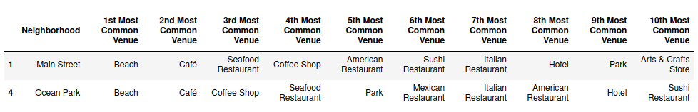

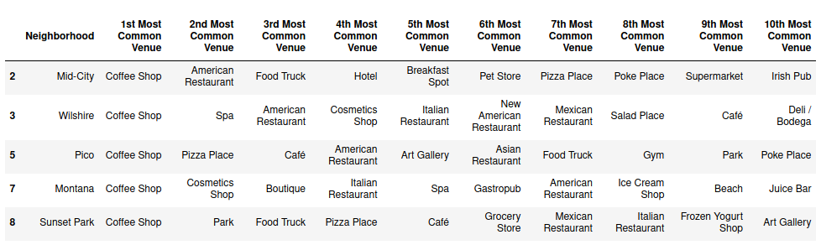

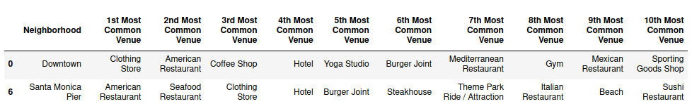

Discussion
Based on the clustering, the first and third cluster appear to be the most relevant. The first cluster has multiple beach venues, with cafes, parks, and coffee shops. The third cluster includes the Santa Monica Pier, which lies right along the beach, with lots of tall Mexican Fan Palm trees. There appears to be a tradeoff between being near desirable venues (the first cluster venues are more suitable), and being near lots of Mexican Palm Trees and foot traffic. The Santa Monica Pier has more people nearby who may see the center in action and join, so the Santa Monica Pier will be my first choice, and the Ocean Park Neighborhood will be my second choice. Within the Ocean Park neighborhood, I would pick Hotchkiss Park. Within the Santa Monica Pier neighborhood, I would pick Tongya Park.

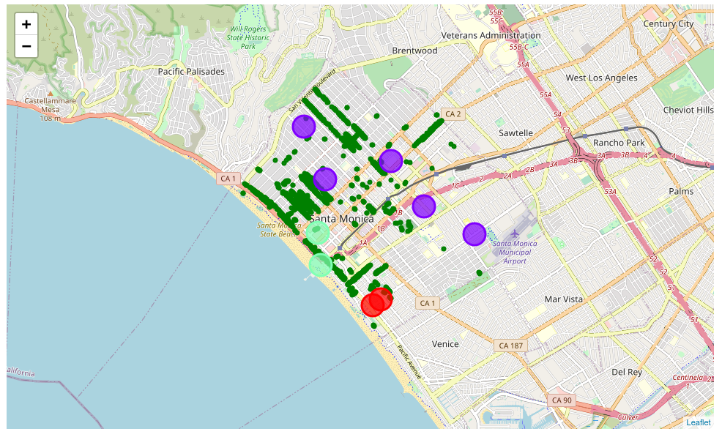Figure 1: Folium map indicates the location of the clusters of Santa Monica neighborhoods-more similar neighborhoods in this case are also geographically closer to each other. The smaller circles in forest green indicate the locations of tall Mexican Fan Palm trees.

Conclusion
Analysis was performed on Santa Monica Neighborhoods, including k-means clustering on data received via the FourSquare API to identify characteristics of the Santa Monica neighborhoods, as well as simple statistics on trees nearby. Tree data was pulled from a database of all of the trees in the City of Santa Monica. Data was also visualized with Folium and Matplotlib, to help identify desireable locations within Santa Monica for an outdoor meditation center near tall Mexican Fan Palm Trees. Two potential locations for the center were identified-Hotchkiss Park in the Ocean Park neighborhood, and Tongya Park in the Santa Monica Pier neighborhood.

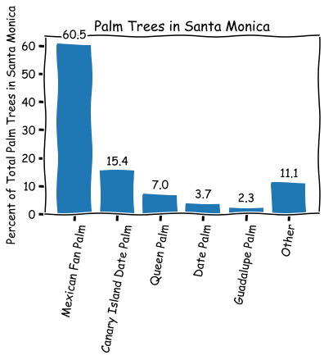Figure 2: Most popular palm trees in Santa Monica.

