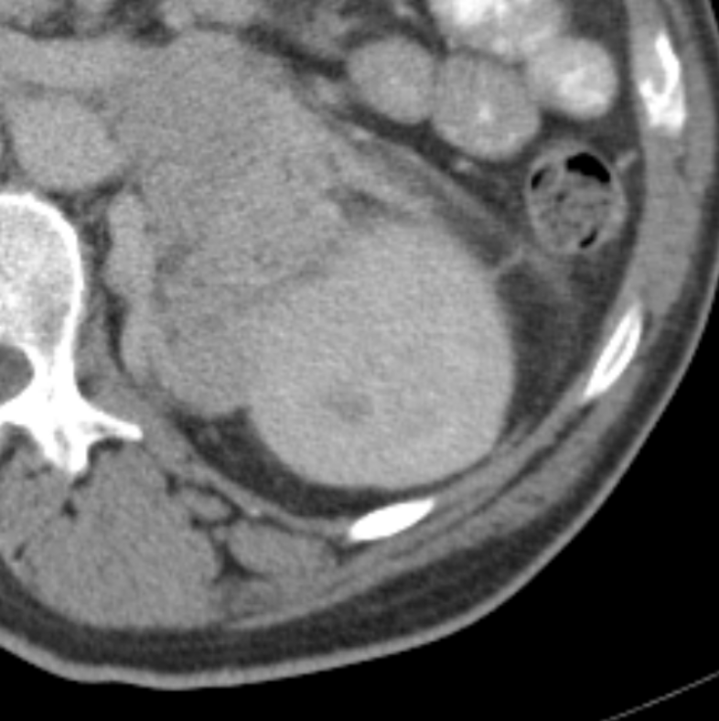
Weak Edge
Left Kidney
Tumour

