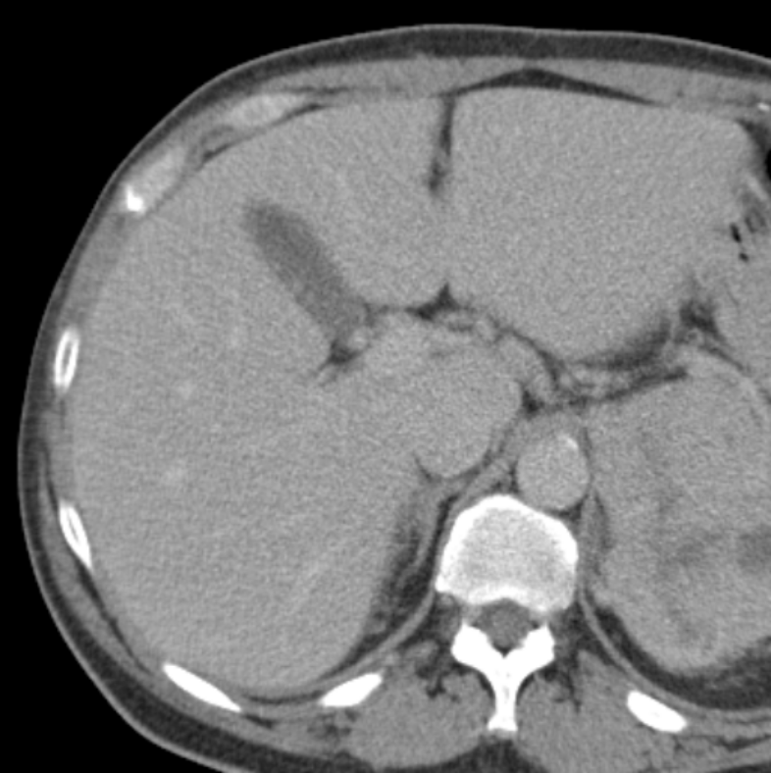
Left Lobe (Medial Segment)
Left Lobe (Lateral Segment)
Right Lobe

