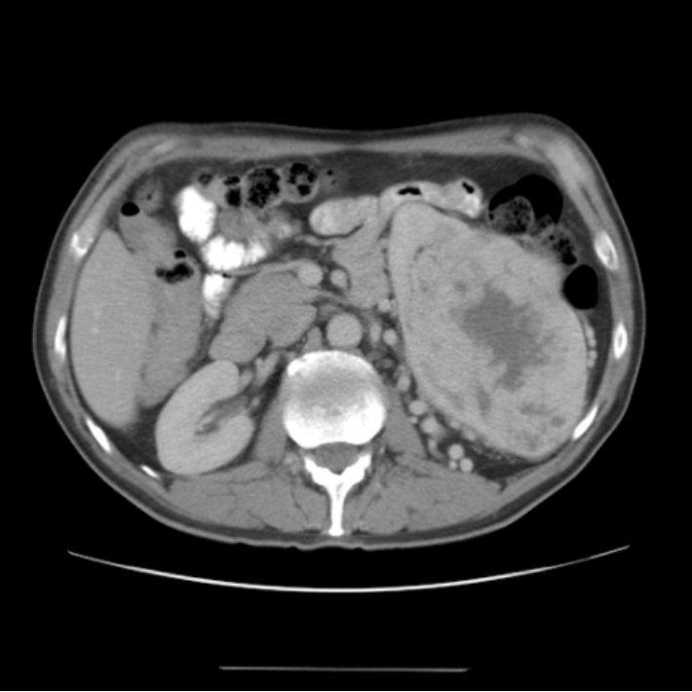
Right Kidney
Vertebra
Aorta
Tumour
Liver
Spinal Cord

