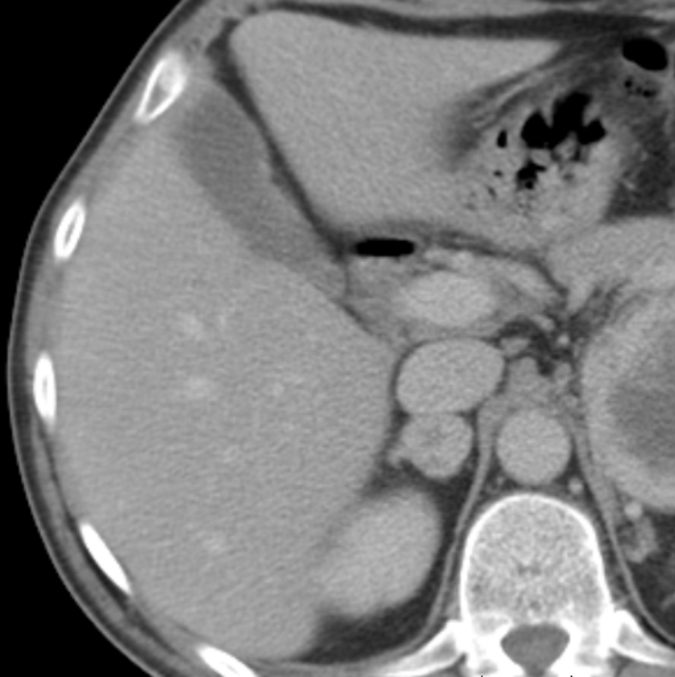
Right Lobe
Left Lobe (Lateral Segment)

