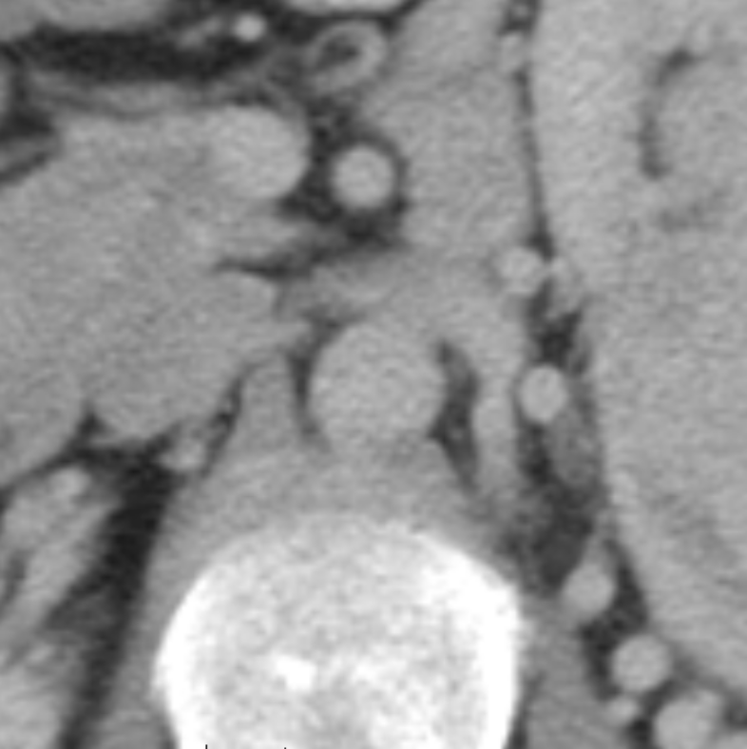
Aorta
Left Renal Vein
Weak Boundary

