Option Explicit

Rem Tushar Patel

Private Sub Clear_Click()

Cls

End Sub

Private Sub End_Click()

End

End Sub

Private Sub Run_Click()

Dim YearBorn As Integer

Dim Age As Integer

Dim Price As Single

Dim Tax As Single

Dim FinalAfterTax As Single

Dim AgeGroup As String

Print Tab(10); "RCI ENTERTAINMENT LTD."

Print Tab(10); "569 Jane St,-Toronto ON"

Print Tab(10); "www.runnymedecollegiate.com"

Print " "

Print " "

YearBorn = InputBox("What year were you born in?", "Year Born")

Age = 2014 - YearBorn

If Age <= 12 Then

Price = 0

Tax = Price * 0.13

FinalAfterTax = Price + Tax

Print Tab(5); "Age:"; Tab(20); Age

Print Tab(5); "Child's Price:"; Tab(20); "$"; Price

Print Tab(5); "Taxes:"; Tab(20); "$"; Tax

Print Tab(5); "Amount Due:"; Tab(20); "$"; FinalAfterTax

ElseIf Age >= 13 And Age <= 17 Then

Price = 5

Tax = Price * 0.13

FinalAfterTax = Price + Tax

Print Tab(5); "Age:"; Tab(20); Age

Print Tab(5); "Youth's Price:"; Tab(20); "$"; Price

Print Tab(5); "Taxes:"; Tab(20); "$"; Tax

Print Tab(5); "Amount Due:"; Tab(20); "$"; FinalAfterTax

ElseIf Age >= 18 And Age <= 59 Then

Price = 15

Tax = Price * 0.13

FinalAfterTax = Price + Tax

Print Tab(5); "Age:"; Tab(20); Age

Print Tab(5); "Adult's Price:"; Tab(20); "$"; Price

Print Tab(5); "Taxes:"; Tab(20); "$"; Tax

Print Tab(5); "Amount Due:"; Tab(20); "$"; FinalAfterTax

Else

Price = 0

Tax = Price * 0.13

FinalAfterTax = Price + Tax

Print Tab(5); "Age:"; Tab(20); Age

Print Tab(5); "Senior's Price:"; Tab(20); "$"; Price

Print Tab(5); "Taxes:"; Tab(20); "$"; Tax

Print Tab(5); "Amount Due:"; Tab(20); "$"; FinalAfterTax

End If

End Sub

Child: Younger less then/equal to 13

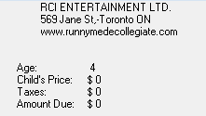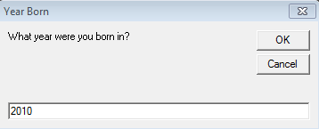

Youth: 14-17

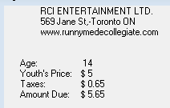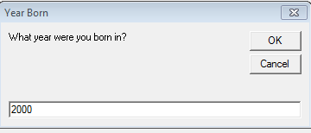

Adult: 18-64

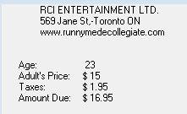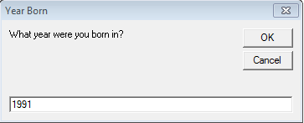

Senior: 65+

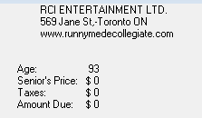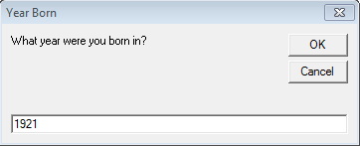

FlowChart

Is it between 18 and 64?

Is it between 14 and 17?

Is it less than 14?

Subtract year born from 2014

Enter the year you were born

Start

Price is $5:00

Price is $15:00

Price is Free

|  |  |  |  |
| --- | --- | --- | --- |
| **Age Group** | **Price** | **Tax** | **Final Price** |
| Child | Free | 0 | 0 |
| Youth | $5 | 0.65 | $5.65 |
| Adult | $15 | 1.95 | $16.95 |
| Senior | Free | 0 | 0 |

End

Add tax by multiplying by 1.13

Price is Free

Is it greater than 64?