Itinerary

Day 1

Depart Toronto 18.30

Arrive Delhi 21.45

Check in at Taj Hotel

**Mornin**g-Breakfast

**Afternoon-** Visit Maqbara-E-Humayun

We will take a cap to Maqbara-E-Humayun after breakfast at 10AM. We will explore the Maqbara till 12 and go for lunch.

**Evening-** Return to hotel and rest

Day 2

**Morning­**- At the conference

**Afternoon**- At the conference

**Evening-** Rest at hotel and dinner at hotel

Day 3

**Morning-** Breakfast and visit Jama Masjid

We will have breakfast at the hotel and take two cabs to Jama Masjid at 10AM. We will tour the masjid until lunch.

**Afternoon-** Lunch and visit Lal Qila

We will eat lunch at Karims, the best or one of the best places to eat in Delhi. Than we will head over to the Lal Qila by 1PM. We will return to the hotel by 3.30 to get ready for the dinner.

**Evening-** Awards dinner and reception

Day 4

**Morning-** Breakfast and get ready to leave.

Afternoon- Flight back to Toronto

Depart Delhi 2.40

Arrive Toronto 12.35

A passport valid for at least 180 days and with at least two blank pages is required as well as a visa. Canadians must be in possession of a visa to visit India. You must obtain a visa prior to arrival or you will be refused entry into the country.

Holders of tourist visas can only stay in India for up to 180 consecutive days, even when the validity of the visa exceeds 180 days.

**Maqbarah-E-Humayun**

Maqbarah-E-Humayun, (Humayun’s Tomb), is the tomb of the emperor Nasir Ud-Din Mohammed Humayun who had once ruled from modern day Hindustan (Hindustan is the Indian name of India, particularly the northern areas) to Afghanistan. He ruled from 1530-1540 and again from 1555-1556. After the death of Humayun, his wife Haji had the tomb contructed in 1570. Inside the walled enclosure of Maqbarah-E-Humayun, there are garden squares, water channels and pathways as well as the monument which holds the emperors tomb. There are also the graves of other emperors of Hindustan.

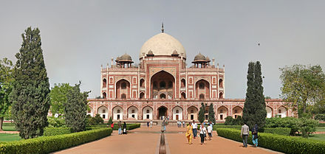

**Jama Masjid**

Jama Masjid (meaning Friday Mosque) is the largest mosque in Hindustan, and the 8th largest in the world, holding upto 25000 people. It was constructed by the emperor Shah Jahan, who had also constructed the Lal Qila and the Taj Mahal. Jama Masjid was built between 1644 and 1648 with red sandstone and marble by over 5000 artisans.

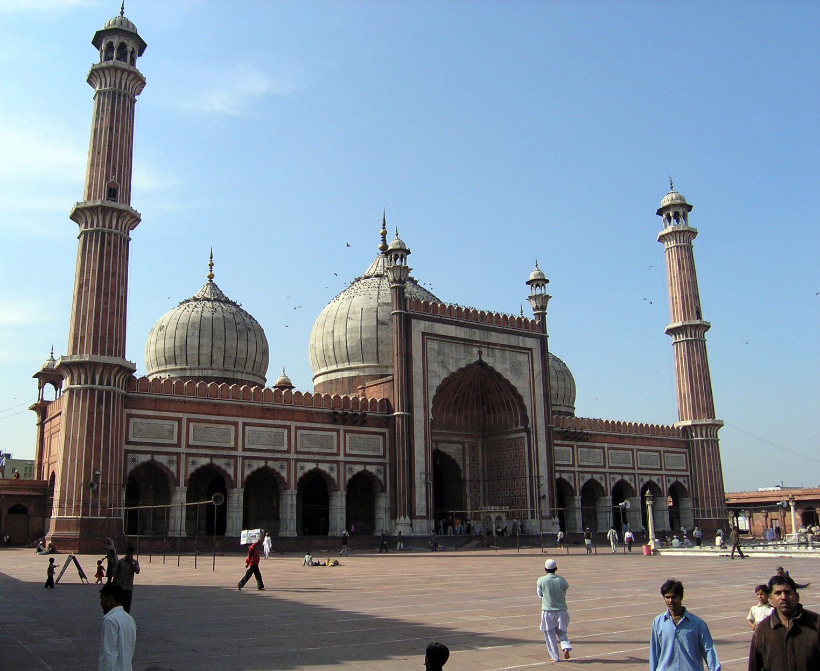

**Lal Qila**

Lal Qila (Red Fort) was the place of residence of several Mughal emperors for nearly 200 years until 1857. The red sandstone walls of the fort rise 33 meters high and were designed to keep out invaders. Contrustion began from1638 and were completed by1648. Within the walls of the fort lie Lahori gate, Delhi Gate, Mumtaz Mahal, Naubat Khana, Diwan-E-Aam, Diwan-E-Khas and many other structures. \\