Tanya Tagaq
Snehan G----n 7F
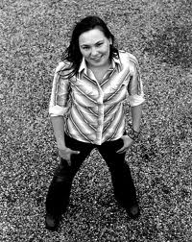
Tanya Tagaq is a Inuk throat singer from Cambridge Bay in the south coast of Victoria Island. After High School at the age of 15, she went to Yellow Knife and started throat singing. She then studies Visual Arts at the Nova Scotia College of Art and Design university. She won the 2006 Juno award and the 2009 Juno award. Her singing delivers images of winter storms and summer sunshine, and is one of the most successful traditional throat singers.

