# Comprehensive DevOps Command Reference Guide

DevOps/Azure Cloud Engineers supporting Pre-Prod and Production environments.  
  
  
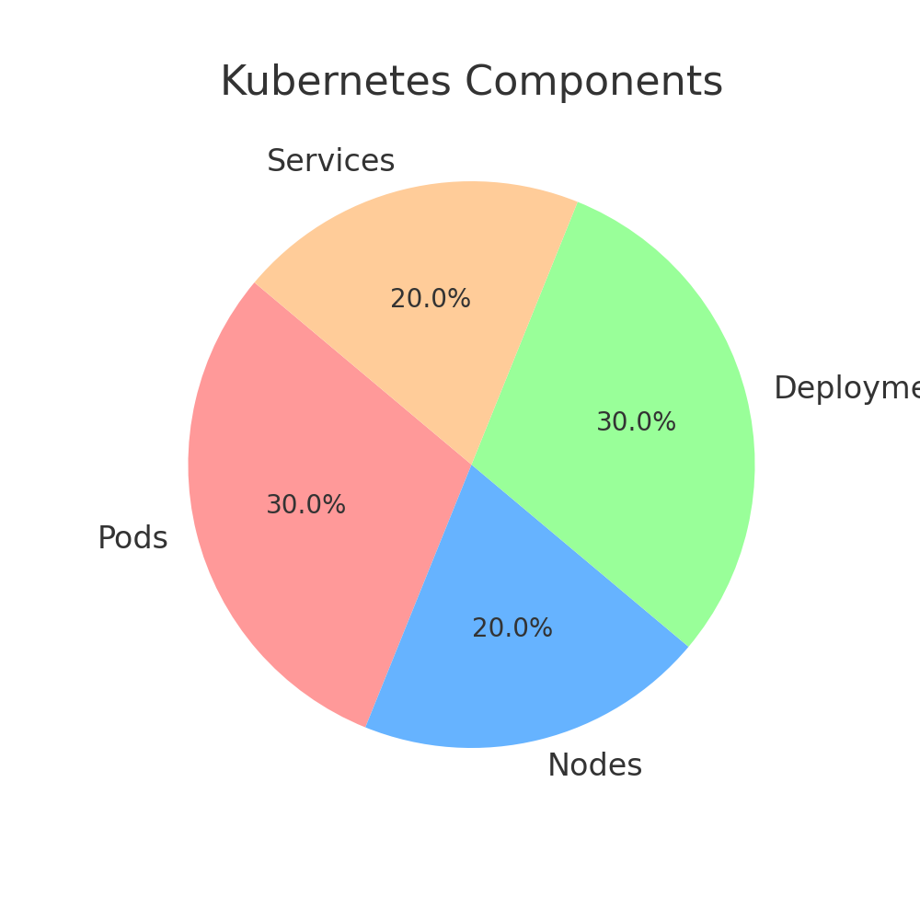

## 1. Git Commands

git init # Initialize a new Git repository  
git clone <repo-url> # Clone a remote repository  
git status # Check status of changes  
git add . # Stage all changes  
git commit -m "Message" # Commit changes  
git push origin main # Push commits to remote repository  
git pull origin main # Pull latest changes from remote  
git branch # List branches  
git checkout -b feature-branch # Create & switch to a new branch  
git merge feature-branch # Merge feature branch into main  
git reset --hard HEAD~1 # Reset last commit (destructive)

## 2. Azure CLI Commands

az login # Login to Azure  
az account set --subscription "MySubscription" # Set active subscription  
az group create --name MyResourceGroup --location eastus # Create a resource group  
az aks create --resource-group MyResourceGroup --name MyAKSCluster --node-count 3 --generate-ssh-keys  
az vm create --resource-group MyResourceGroup --name MyVM --image UbuntuLTS --admin-username azureuser --generate-ssh-keys  
az storage account list # List Azure storage accounts

## 3. Docker Commands

docker ps # List running containers  
docker images # List all images  
docker build -t myimage:v1 . # Build a Docker image  
docker push myrepo.azurecr.io/myimage:v1 # Push image to ACR  
docker run -d -p 8080:80 nginx # Run an Nginx container

## 4. Kubernetes (K8s) Commands

kubectl get nodes # List all nodes in the cluster  
kubectl get pods # List all pods  
kubectl describe pod <pod-name> # Get details of a pod  
kubectl scale deployment myapp --replicas=5 # Scale deployment  
kubectl set image deployment/myapp myapp=myrepo.azurecr.io/myapp:v2  
kubectl rollout undo deployment myapp # Rollback in case of failure  
kubectl get services # List all services  
kubectl get pvc # List persistent volume claims  
kubectl get pv # List persistent volumes  
kubectl logs <pod-name> # View logs of a pod  
kubectl exec -it <pod-name> -- /bin/sh # Open shell in a running pod

## 5. Ansible Commands

ansible-inventory --list # List inventory  
ansible all -m ping # Ping all hosts  
ansible all -m shell -a "uptime" # Run a command on all hosts  
ansible-playbook site.yml --limit webservers # Run playbook for webservers  
ansible all -m user -a "name=john state=present"  
ansible all -m yum -a "name=nginx state=latest"

## 6. Splunk Commands

splunk start # Start Splunk service  
splunk stop # Stop Splunk service  
splunk search "index=_internal | stats count by sourcetype"  
index=myapp_logs earliest=-24h latest=now | stats count by source  
index=web_logs | top 10 uri

## 7. Linux Commands

ls -lh # List files with details  
cd /var/log # Navigate to logs directory  
mkdir mydir # Create a directory  
sudo useradd devops # Create a new user  
df -h # Check disk space  
top # Monitor system usage  
ip a # Check IP addresses  
ping google.com # Test network connectivity  
netstat -tulnp # Check open ports

## 8. Veracode Commands

veracode scan --app MyApp --file myapp.jar # Run static analysis scan  
veracode get-report --app MyApp # Retrieve scan report

## 9. SonarQube Commands

sonar-scanner -Dsonar.projectKey=myproject -Dsonar.host.url=http://sonarqube.mycompany.com  
sonar-quality-gate wait # Wait for quality gate result