Auditor-Controller  Systems Division, eCAPS |  | Programming Request No
 |  | CR -
PROGRAMMING REQUEST FORM
To: ISD Data Management | From: AC Systems Disbursements |  | Date: 09/05/2018
System: Vendor Direct Deposit Website |  |  | Program: Contact Us
Requested Completion Date:
Background

The Vendor Direct Deposit website was created to allow existing vendors to sign up to for direct deposit. The disbursements division would validate the vendor’s information to determine the vendor’s eligibility for direct deposit.

Objective

To redevelop the Vendor Direct Deposit website and improve the ease of use for vendors to sign up and receive payment from the County of Los Angeles via Direct Deposit (EFT). To incorporate the modern look and feel of the recently updated Auditor-Controller website. To ensure accuracy in the vendor information displayed to the vendor, reduce the rejection rate, and improve the attachment upload and validation process.

The purpose of this request is to create a contact us screen to allow vendors to submit questions.

Work Requested:

Create contact us screen:

- Insert Auditor-Controller banner to header
  - Banner taken from http://auditor.lacounty.gov/
  - Underneath banner, display ‘Vendor Direct Deposit Registration Portal’

- Insert text in red font “All fields are required”

- Insert the following form fields on the left section of the page:

Field Name (display) | Field Name (table) | DB Table Name | Notes:
Company:
First Name:
Last Name:
Phone Number:
E-mail Address:
Subject: |  |  | Drop-down with selections: Vendor code issue, Where to change address, When will I receive my payment, I did not receive my payment, Other
Questions:

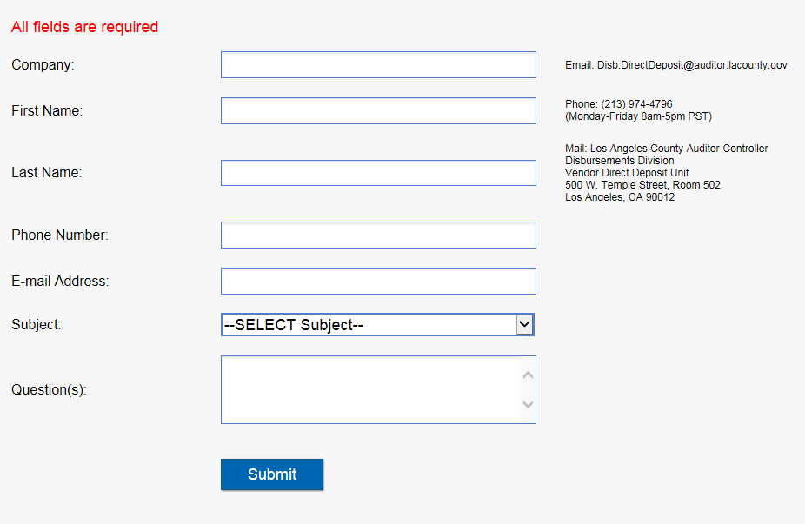

  - Add contact information on right-section of the page including e-mail address, phone number, office hours, and mailing address
      - Email: Disb.DirectDeposit@auditor.lacounty.gov
      - Phone: (213) 974-4796
(Monday-Friday 8am-5pm PST)
      - Mail: Los Angeles County Auditor-Controller
Disbursements Division
Vendor Direct Deposit Unit
500 W. Temple Street, Room 502
Los Angeles, CA 90012

  - Add Submit button to allow user to submit contact us form when clicked.
    - If Submit button clicked and not all fields are filled, display error message showing list of missing fields at the top of the page:

Approved by: |  |  |  | Date:
Programmer's Comments:

Completed by: |  | Completion Date:

