

NutriSPEC

17.12.2019

Prepared By,

Sudarshan Phule

Nikhil Gosavi

Sachin Tiptur Satyanrayana

Kunal Harkare

Akhil Baby

Contents

1 Introduction 4

1.1 Rationale 5

1.2 Software Description 5

2 Specifications 6

2.1 System Architecture 6

2.1.1 Application 6

2.1.2 Core Components 6

2.1.3 Application server 7

2.1.4 Database 7

2.2 Product Use 7

2.3 Customer Requirements 7

Functional Requirements 7

Non-Functional Requirements 8

2.4 Product Features 8

2.5 Product Data 9

2.6 Performance 9

2.7 Cost Calculation 9

3 Use Case Diagrams 11

3.1 Main Use Case Diagram 11

3.2 Users Generalization 11

3.3 Administrative Use Cases 12

Managing Clients and Nutritionists 12

Admin Data Management 12

3.4 Nutritionist Management 14

3.5 User Management 15

4 Project Plan 15

5. Use Case Descriptions 16

6 Class Diagram 21

6.1 Controllers Class Diagram 21

6.2 Services Class Diagram 22

7. Sequence Diagram 23

7.1 User Login 23

7.2 Nutritionist Search 24

7.3 Client Registration 24

7.4 Client Enroll 25

7.5 Nutritionist Search 25

7.6 Client Disenrollment 26

7.7 Add Workout Activity 26

7.8 Add Food Activity 27

7.9 Rate Nutritionist 27

7.10 Add Workout Dictionary 28

7.11 Add Food Dictionary 28

8 State Diagrams 29

8.1 States of Appointment 29

8.2 Appointment Approval 30

8.3 User Enrollment Request 30

9 Activity Diagrams 31

9.1 Nutritionist/Client Sign Up 31

9.2 Search Nutritionist 32

9.3 View Recipe 32

9.4 Add Food Dictionary 33

9.5 View Food Dictionary 33

9.6 Client Enrollment 34

9.7 Client Disenrollment 35

9.8 Generate Client Report 36

9.9 Rate Nutritionist 37

9.10 Create Diet Plan 37

10 Entity – Relationship Diagram 38

11 Data Flow Diagrams 39

Appointment data Flow 39

Admin data flow 40

12 Component Diagrams 40

12.1 Admin Component Diagram 40

12.2 Nutritionist Component Diagram 41

12.3 Client Component Diagram 41

13 Package Diagram 42

14 User Interface 42

15 Testing 42

15.1 Test cases 43

# 1 Introduction

This document describes the Requirements, System Architecture, Use cases and design details of ‘NutriSpec’ student project for the Software Engineering course. The document explains the rationale and objective of the ‘NutriSpec’ and provides detailed view of software models used to implement ‘NutriSpec’.

## 1.1 Rationale

Proper nutrition is essential to lead a healthy life. Adequate nutrition can help become more productive and can create opportunities to gradually break the cycle of intermittent illnesses which can prove to be fatal in the long term. Nutrition is about eating a healthy and balanced diet.

Nutritionists and dietitians are experts who suggest and promote food as a remedy for many illnesses and disorders. They prescribe diet plans and set goals which are made as per users need. But the services provided by these experts are not cheap. A nutritionist’s education, experience and location are factors in determining how they charge for the service.

In today’s digital world, it’s not relevant to consult/visit a Nutritionist on a regular basis. It is time consuming, costly and a hassle process. So, an application providing an interface and information database to clients and Nutritionists helps in overcoming these drawbacks. ‘NutriSpec’ is an application which provides user friendly interface connecting clients and Nutritionists with various features.

This project is not only to make these services available at lower costs but also to provide them with live guidance from an expert for accurate diagnosis.

## 1.2 Software Description

Our application ‘NutriSpec’ aimed at every individual to search, consult nutritionist and maintain their Nutrition plan. This also connects client with Nutritionists based on the location of the client, Nutritionists to manage their clients’ data and consult online. It enables nutritionists to provide their service online by interacting with clients over this application.

Nutritionists can enroll with the ‘NutriSpec’ company administrator and make their profile visible/reachable to millions of clients. They can also get a personalized Nutritionist page with details of their clients and related data. Nutritionist can update the client information with the consultation reports and diet prescriptions. Also, he can monitor the progress of the client. A nutritionist can also write blogs and success stories in the application.

Client can search for a Nutritionist without requiring a registration. A location-based search is possible with ‘NutriSpec.’ Client can get contact details of the Nutritionist and view the Nutritionist profile, ratings, qualifications, blogs and success stories. Client can also contact Nutritionist via ‘NutriSpec’ online contact form.

Registration of each user to help monitor the individual separately and accurately. The record of user's history would be analyzed to ensure better diagnosis which would be concentrated to the concerned user. User Personalization would also make users more engaged in the activities which would increase the probability of completing the tasks and thus resulting in maintaining good health. Relevant and tailored experiences also boost user retention.

# 2 Specifications

## 2.1 System Architecture

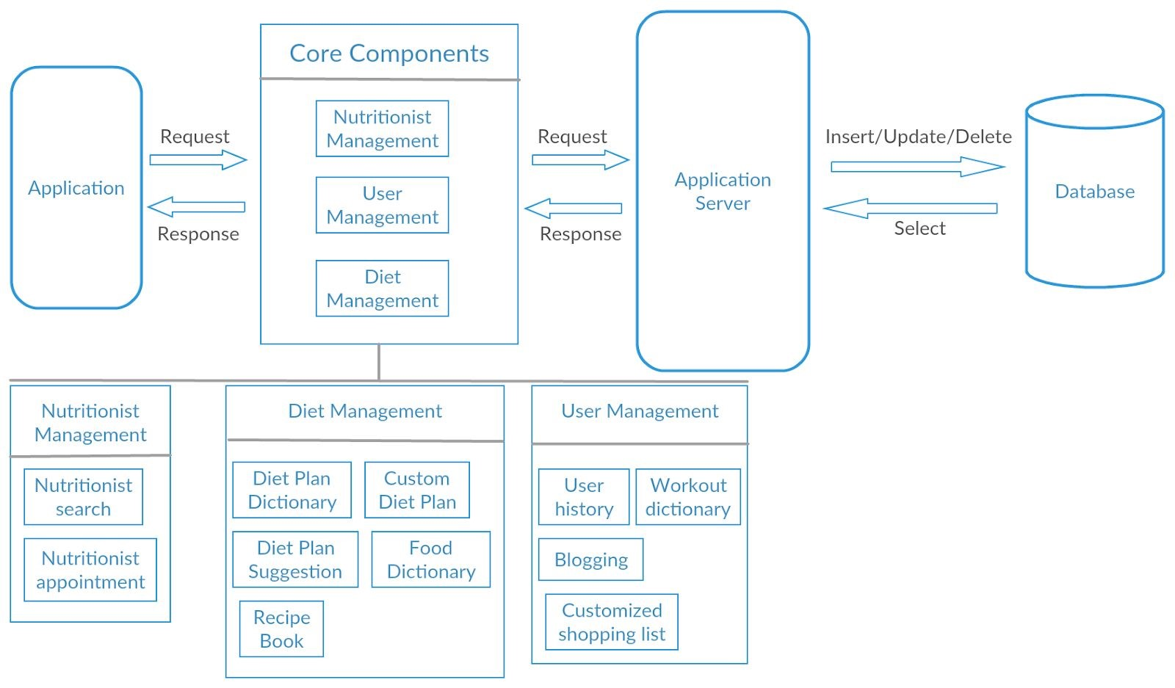

### 2.1.1 Application

This component houses the user interface of the application. These consists mainly of pages for each of the use cases and modules inside the system.

### 2.1.2 Core Components

#### Nutritionist Management

This component deals mainly with searching and making and appointment with the nutritionist. This module contains all the details associated with nutritionist. The ratings associated with every nutritionist is also maintained in this component. The user search​ queries shall be handled by the details based on this component eg location of the nutritionist, ratings(numeric and textual) of the nutritionist.

#### Diet Management

This component specifies all the dietary planning associated to users. These dietary plans are assigned to the user by nutritionists. This component contains two major containers:

Recipe Book: Book containing all the instructions needed to prepare a dish. These instructions are recommended by nutritionists and are therefore precise on the amount of calories and fat a dish must contain.

Food dictionary: These dictionaries contain ready-made dishes made from above recipe book. It is not necessary for a nutritionist to associate a dish from the existing food dictionaries and can create a custom food(dish) from the recipe book which is specifically targeted as per user deficiencies. The nutritionist can also get dietary suggestions based on the user profile while associating a dietary plan.

#### User Management

This component contains information of all the users in the system. The user and the nutritionist have access to the user’s history and can generate monthly or weekly reports to gain insight into the activities. The user is also suggested with workout activities from a dictionary which is based on user’s goal. User can also post blogs which has a view scope limited only to other users. This component contains a suggestion view for shopping list which is system computed based on user’s deficiencies.

### 2.1.3 Application server

The application server provides access to the data for the user. It serves as an interface between the user and the database server and hosts the application. The requests sent by the user are validated and processed to generate a response which is then sent back to the user.

### 2.1.4 Database

The database server provides the data requested by the application server on behalf of the user. The database server processes queries and generates data which is sent back to the application server. The database houses all the information about users and nutritionist and their associations.

## 2.2 Product Use

This application can be used by Nutritionists, Diet Specialists, Fitness Bloggers and Clients(General Public).

## 2.3 Customer Requirements

### Functional Requirements

1. Users with different roles (Admin, Nutritionist, Client) should be able to sign up and login to the system
2. User should be able to recover, reset or change password if required
3. Admin user should be able to add and delete food dictionary, workout dictionary and Food unit
4. Client user should be able update own profile, add his workout and food consumption activity
5. Client user should be able to perform below:

* Search nutritionist
* View nutritionist profile
* View blogs by nutritionists
* Enroll and get appointment of nutritionist
* Rate the nutritionist
* Disenroll from a nutritionist.

1. Nutritionist user should be able to perform below:

* Update own profile
* Create own blogs
* View appointments of his clients
* View client profile
* Write prescriptions to clients
* Generate client report
* Disenroll client

1. Application will calculate BMI based on client’s weight and height

### Non-Functional Requirements

1. The application should load in 3 seconds even though the number of simultaneous users count is greater than 10000
2. Application should be implemented across iOS and Android Platforms
3. Application should support Android Versions from Android 4.4 (KitKat) to Android 9.0 (Pie)

## 2.4 Product Features

|  |  |
| --- | --- |
| F101 | Client Sign Up |
| F102 | Nutritionist Sign up |
| F103 | Nutritionist Search |
| F104 | Book appointment with nutritionist |
| F105 | View Recipe book |
| F106 | View Food dictionary |
| F107 | Give Rating to Nutritionist |
| F108 | View Client Health History |
| F109 | Create Food dictionary |
| F110 | Create Recipe Book |
| F111 | Create Diet Plan |
| F112 | Create Custom Diet Plan |
| F113 | Adding user activity |
| F114 | Adding food consumption |
| F115 | Generating activity report for specified period |
| F116 | Rate Nutritionist |
| F117 | Delete client |

## 2.5 Product Data

|  |  |
| --- | --- |
| D10 | Client Data |
| D11 | Nutritionist Data |
| D12 | Admin Data |
| D13 | Enrollment Data |
| D14 | Report Data |

## 2.6 Performance

|  |  |
| --- | --- |
| Functionality | High |
| Reliability | High |
| Flexibility | High |
| Usability | Simple |

## 2.7 Cost Calculation

|  |  |  |  |  |  |  |
| --- | --- | --- | --- | --- | --- | --- |
| **Function Point – method** |  | | |  | |  |
|  |  | | |  | |  |
| **Category** | **Number** | **Classification** | **Weighting** | | **Row sum** | **Comments** |
| Input | 12 | Just | 3 | | 36 | Login Input |
|  | 6 | Medium | 4 | | 24 | Patient Input |
|  | 1 | Complex | 6 | | 6 | Patient Registration |
| Query | 4 | Just | 3 | | 3 | Patient Registration |
|  | 2 | Medium | 4 | | 32 | Checking Schedule Conflict, Inserting appointment |
|  | 1 | Complex | 6 | | 0 |  |
| External output | 0 | Simple | 4 | | 0 | Appointment Information |
|  | 0 | Medium | 5 | | 0 | Schedule Display for Doctor |
|  | 1 | Complex | 7 | | 7 | Check conflict of schedule |
|  | 4 | Simple | 7 | | 28 | Login Screen |
| Internal Logical | 2 | Medium | 10 | | 20 | Class Models |
| Files | 1 | Complex | 15 | | 15 | Class view Models & UI screens |
| Sum |  |  | E1 | | 90 |  |
| Factors | 1 Integration with other application systems (0-5) | | | | 0 |  |
| (The function point value change by + / - 30%) | 2 Decentralized data, distributed processing (0-5) | | | | 0 |  |
|  | 3 Transaction Rate (0-5) | | | | 1 |  |
|  | 4 processing logic | | | |  |  |
|  | A computational operations (0-10) | | | | 1 |  |
|  | B control procedures (0-5) | | | | 3 |  |
|  | C exceptions (0-10) | | | | 5 |  |
|  | D logic (0-5) | | | | 2 |  |
|  | 5 reusability (0-5) | | | | 4 |  |
|  | 6 database conversions (0-5) | | | | 4 |  |
|  | 7 Adaptability (0-5) | | | | 3 |  |
| Sum of the 7 factors | E2 | | | | 23 |  |
| Impact factor rating = (E2/100) + 0.7 | E3 | | | | 0.93 |  |
| Weighted Function Points: E1 * E3 |  | | | | 83.7 |  |
| Effort by IBM table (interpolated) | E4 | | | | 48 |  |
| Optimal duration of development (2.5 MM * ^ s, where s = 0.35 (online systems)) | E5 | | | | 9.691130499 |  |
| Average size of the team (E4/E5) | 4.95 | | | | 4.952982524 |  |

# 3 Use Case Diagrams

## 3.1 Main Use Case Diagram

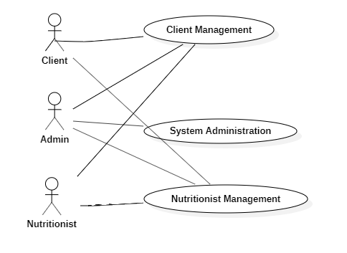

## 3.2 Users Generalization

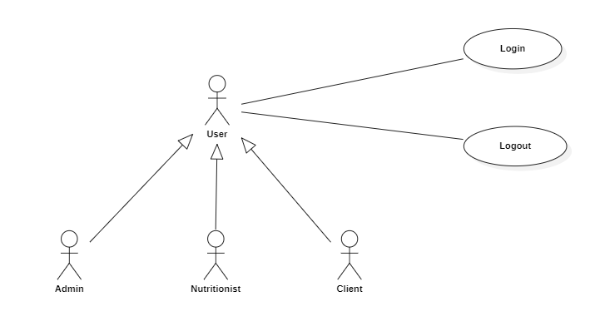

## 3.3 Administrative Use Cases

### Managing Clients and Nutritionists

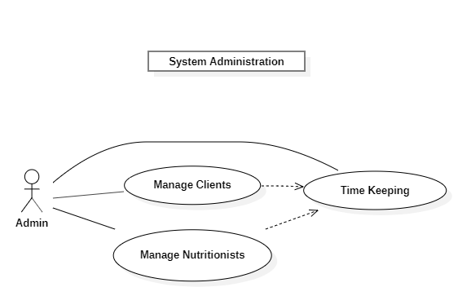

### Admin Data Management

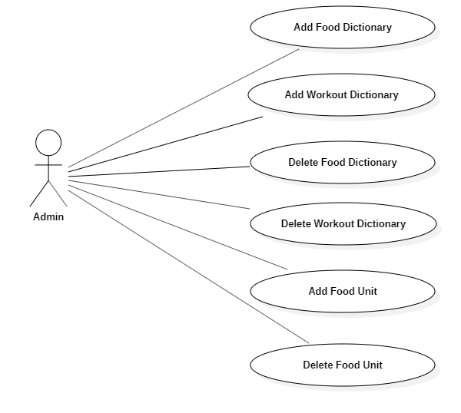

## 3.4 Nutritionist Management

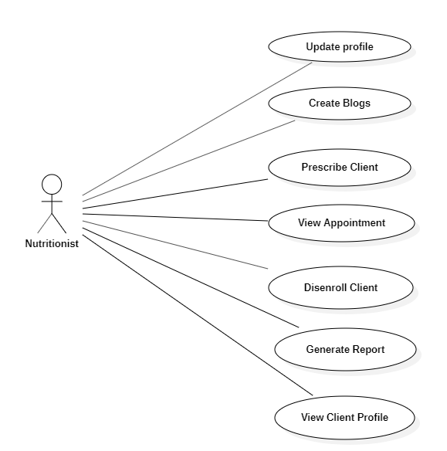

## 3.5 User Management

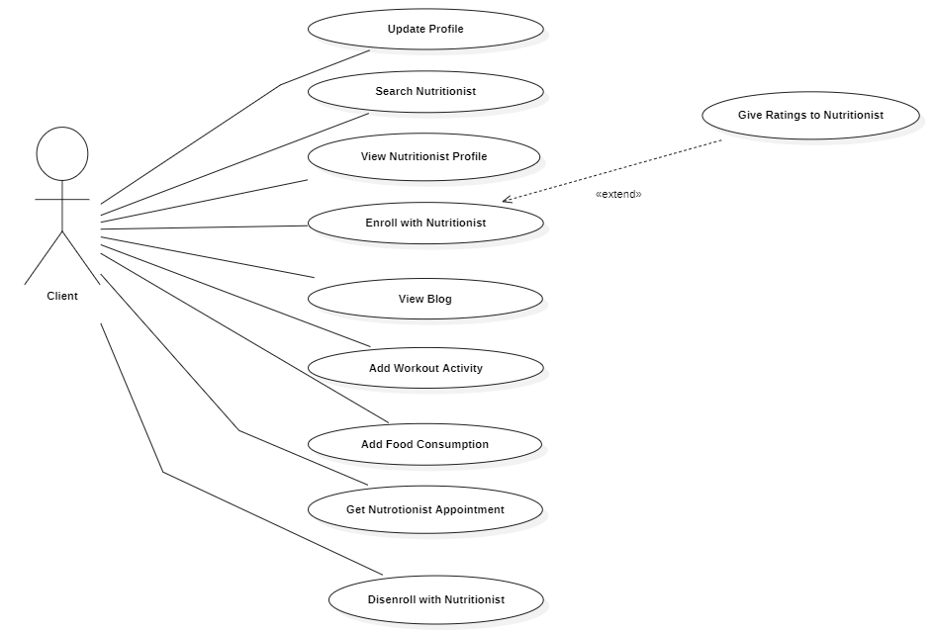

# 4 Project Plan

|  |  |  |  |
| --- | --- | --- | --- |
| **Phase** | **Duration** | **Start Date** | **End Date** |
| **Planning** |  |  |  |
| **Customer Requirement** | **5** | **11.11.2019** | **15.11.2019** |
| **Lastenheft or Specifications** | **2** | **17.11.019** | **18.11.2019** |
| **Cost Calculation** | **1** | **19.11.2019** | **19.11.2019** |
| **Use case diagrams** | **3** | **20.11.2019** | **22.11.2019** |
| **Analysis** |  |  |  |
| **Project Plan** | **1** | **25.11.2019** | **25.11.2019** |
| **Use case descriptions** | **2** | **26.11.2019** | **27.11.2019** |
| **Design** |  |  |  |
| **Class Diagrams** | **1** | **28.11.2019** | **28.11.2019** |
| **Activity Diagram** | **2** | **29.11.2019** | **02.12.2019** |
| **Sequence Diagram** | **2** | **03.12.2019** | **04.12.2019** |
| **State Diagram** | **1** | **05.12.2019** | **05.12.2019** |
| **Package Diagram** | **1** | **06.12.2019** | **06.12.2019** |
| **Component Diagram** | **1** | **09.12.2019** | **09.12.2019** |
| **Deployment Diagram** | **1** | **10.12.2019** | **10.12.2019** |
| **Implementation** |  |  |  |
| **Code & Unit Testing** | **15** | **11.12.2019** | **31.12.2019** |
| **Testing** |  |  |  |
| **Test cases** | **2** | **01.01.2020** | **02.01.2020** |
| **Test Execution** | **2** | **03.01.2020** | **04.01.2020** |

# 5. Use Case Descriptions

|  |  |
| --- | --- |
| **F101** | **Client Sign Up** |
| Short Description | Registering a Client to NutriSpec portal |
| Actors | Client, Admin |
| Trigger | Entering Client user details in registration form and submit |
| Preconditions | Name, Age, Date of birth, Sex, Place, Date, Mobile number, Weight, Height, Blood Group, Food Habits |
| Postconditions | New user data will be created, and data stored in database |
| Normal Flow | 1. Client/User fills in all relevant fields on Registration form  2. Validation of entered data  3. Save the data  4. Send user credentials to Client(Display/Email) |
|  |  |
| F102 | Nutritionist Sign Up |
| Short Description | Registering a Nutritionist to NutriSpec portal |
| Actors | Nutritionist, Admin |
| Trigger | Entering Nutritionist details in registration form and submit |
| Preconditions | Name, Age, Date of birth, Sex, Place, Date, Mobile number, Education, Specialization |
| Postconditions | New Nutritionist data will be created, and data stored in database |
| Normal Flow | 1. Nutritionist fills in all relevant fields on Registration form  2. Validation of entered data  3. Save the data  4. Send user credentials to Nutritionist(Display/Email) |

|  |  |
| --- | --- |
| **F103** | **Nutritionist Search** |
| Short Description | Searching for a Nutritionist in the nearby location |
| Actors | Client |
| Trigger | Entering search criteria in the search tab |
| Preconditions | User is on the search page |
| Postconditions | List of Nutritionists available and registered on the application are shown |
| Normal Flow | 1. Client/User fills search criteria in search tab  2. Search string is queried with the database  3. Results are displayed on the screen |

|  |  |
| --- | --- |
| **F104** | Book appointment with nutritionist |
| Short Description | Booking an appointment with the Nutritionist for the consultation |
| Actors | Client |
| Trigger | Clicking on Enroll button against a particular Nutritionist |
| Preconditions | User searched for Nutritionist, Client data |
| Postconditions | User enrolled and tied to a Nutritionist |
| Normal Flow | 1. Search for a Nutritionist and select a Nutritionist 2. Click on the enroll button against Nutritionist 3. Fill in the details required by Enroll form 4. Submit the form |

|  |  |
| --- | --- |
| **F105** | View Recipe book |
| Short Description | View a Recipe of a specific dish, suggested by Nutritionist or for the dish found in Food dictionary |
| Actors | Client/Nutritionist |
| Trigger | Click on a recipe book button |
| Preconditions | User logged in to NutriSpec Application |
| Postconditions | Food recipe for selected dish is displayed |
| Normal Flow | 1. Search for a dish in Food dictionary 2. Click on the Recipe link of the particular dish 3. Recipe details are printed on the screen |

|  |  |
| --- | --- |
| **F106** | View Food Dictionary |
| Short Description | View a dictionary of a dishes added by difference Nutritionists |
| Actors | Client |
| Trigger | Click on a Food dictionary button |
| Preconditions | User logged in to NutriSpec Application |
| Postconditions | Food dictionary is listed |
| Normal Flow | 1. Sign in as Client 2. Click on Food dictionary 3. Food list printed on the screen |

|  |  |
| --- | --- |
| **F107** | **Give ratings to nutritionist** |
| Short Description | After enrolment with nutritionist rating can be given to nutritionist. |
| Actors | Client |
| Trigger | Click on Give Ratings to nutritionist button |
| Preconditions | Client should be logged in and enrolled with nutritionist |
| Postconditions | Ratings will be added to the nutritionist profile |
| Normal Flow | 1. Client clicks on nutritionist profile  2. Enters form  3. Clicks on add rating button |

|  |  |
| --- | --- |
| **F108** | **View Client report** |
| Short Description | Client report will be seen |
| Actors | Nutritionist |
| Trigger | Entering Client details in the form and click on report button |
| Preconditions | Must be associated with client |
| Postconditions | Client report is generated |
| Normal Flow | 1. Nutritionist selects client  2. clicks on view report button |

|  |  |
| --- | --- |
| **F109** | **Create Food Dictionary** |
| Short Description | Creating and adding Food dictionary |
| Actors | Admin |
| Trigger | Entering food dictionary details in the form and click on Submit/add button |
| Preconditions | Admin should be logged in. Food name, description, unit already known. |
| Postconditions | New food dictionary will be added to the table. |
| Normal Flow | 1. Admin clicks on add food dictionary button  2. Fills form data.  3. Clicks on submit button |

|  |  |
| --- | --- |
| **F109** | **Create Food Dictionary** |
| Short Description | Creating and adding Food dictionary |
| Actors | Admin |
| Trigger | Entering food dictionary details in the form and click on Submit/add button |
| Preconditions | Admin should be logged in. Food name, description, unit already known. |
| Postconditions | New food dictionary will be added to the table. |
| Normal Flow | 1. Admin clicks on add food dictionary button  2. Fills form data.  3. Clicks on submit button |

|  |  |
| --- | --- |
| **F110** | **Create Recipe Book** |
| Short Description | Creating and adding Recipe Book |
| Actors | Admin |
| Trigger | Entering recipe book details in the form and click on Submit/add button |
| Preconditions | None |
| Postconditions | Recipe book created |
| Normal Flow | 1. Admin clicks on add food dictionary button  2. Fills form data.  3. Clicks on submit button |

|  |  |
| --- | --- |
| **/F111** | **Create Diet Plan** |
| Short Description | Nutritionist creates a diet plan for the client |
| Actors | Nutritionist |
| Trigger | click on Prescribe button |
| Preconditions | Must be logged in and should be associated with client |
| Postconditions | Nutritionist prescription gets reflected to client |
| Normal Flow | 1. Clicks on prescribe client menu  2. Enters the diet plan  3. Clicks on submit button |

|  |  |
| --- | --- |
| **F112** | **Add User Workout Activity** |
| Short Description | Adding Workout Activity |
| Actors | Client |
| Trigger | Entering workout activity details in the form and click on Submit/add button |
| Preconditions | Client should know workout name, number of attempts, duration, and date |
| Postconditions | New Workout activity will be added to the table. |
| Normal Flow | 1. Client clicks on add workout activity menu  2. Enters workout activity form details  3. Clicks on add workout activity button. |

|  |  |
| --- | --- |
| **F113** | **Add Food consumption** |
| Short Description | Adding own food consumption |
| Actors | Client |
| Trigger | Entering food consumption details in the form and click on Submit/add button |
| Preconditions | Client should know food name, consumption quantity, duration, date and unit |
| Postconditions | New food consumption will be added to the table. |
| Normal Flow | 1. Client clicks on food consumption activity menu  2. Enters food consumption activity form details  3. Clicks on add food consumption button. |

|  |  |
| --- | --- |
| **F115** | **Rate Nutritionists** |
| Short Description | After enrolment with nutritionist rating can be given to nutritionist. |
| Actors | Client |
| Trigger | Click on Give Ratings to nutritionist button |
| Preconditions | Client should be logged in and enrolled with nutritionist |
| Postconditions | Ratings will be added to the nutritionist profile |
| Normal Flow | 1. Client clicks on nutritionist profile  2. Enters form  3. Clicks on add rating button |

|  |  |
| --- | --- |
| **F116** | **Delete Client** |
| Short Description | Nutritionist ends consultation with specific client |
| Actors | Nutritionist |
| Trigger | click on Disenroll button |
| Preconditions | Must be associated with client. |
| Postconditions | Client Nutritionist association will be removed |
| Normal Flow | 1. Nutritionist selects client  2. clicks on disenroll button |

# 6 Class Diagram

## 6.1 Controllers Class Diagram

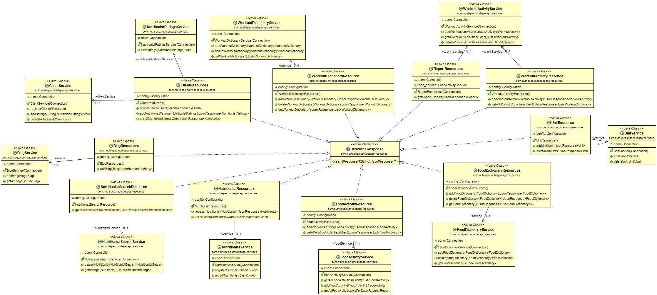

## 6.2 Services Class Diagram

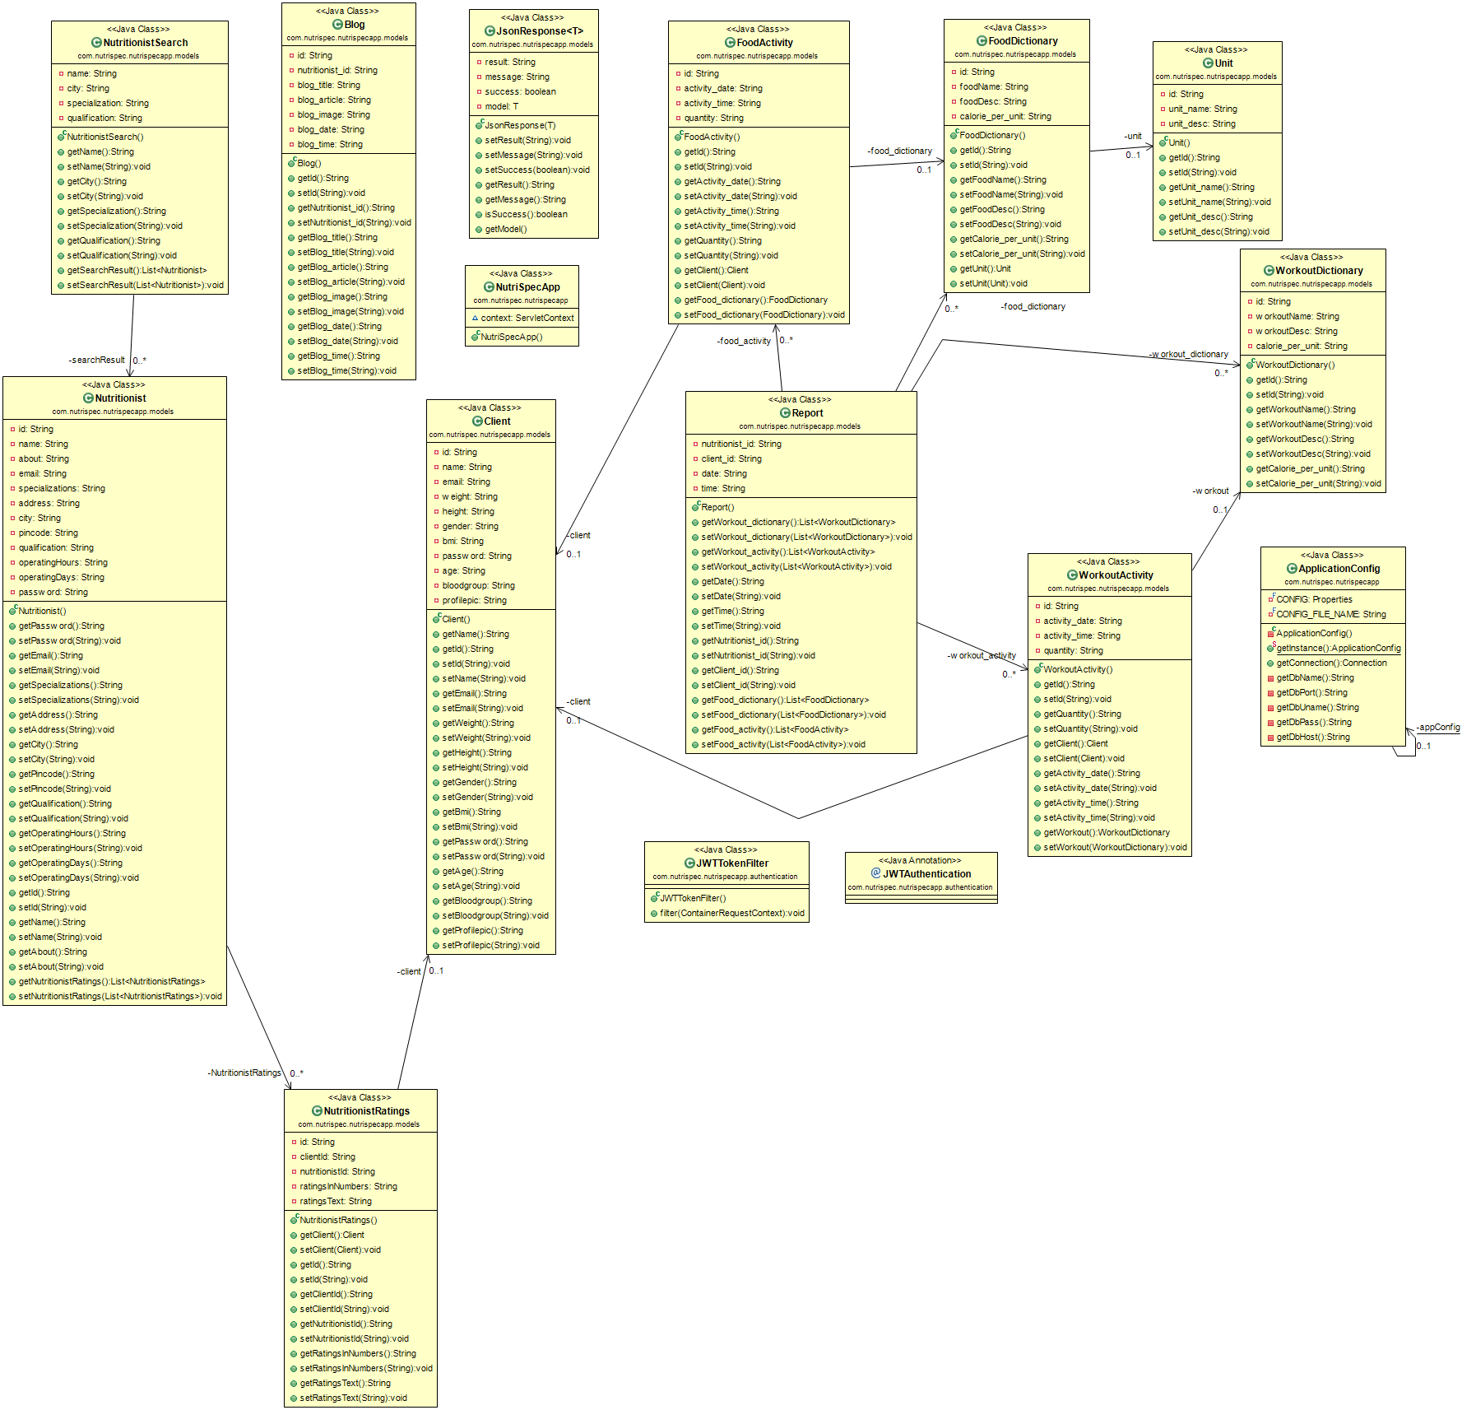

# 7. Sequence Diagram

## 7.1 User Login

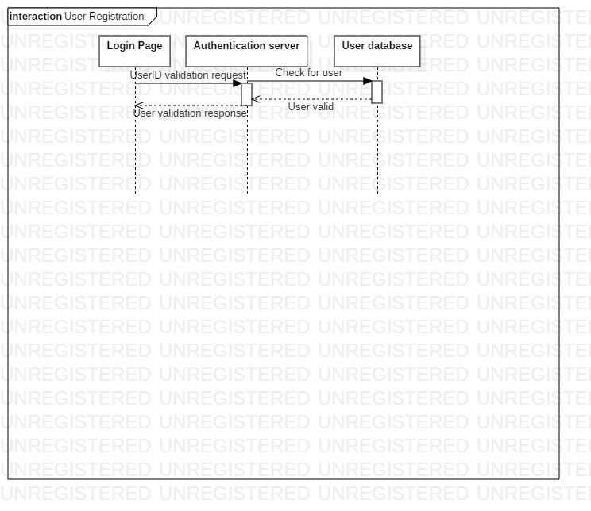

## 7.2 Nutritionist Search

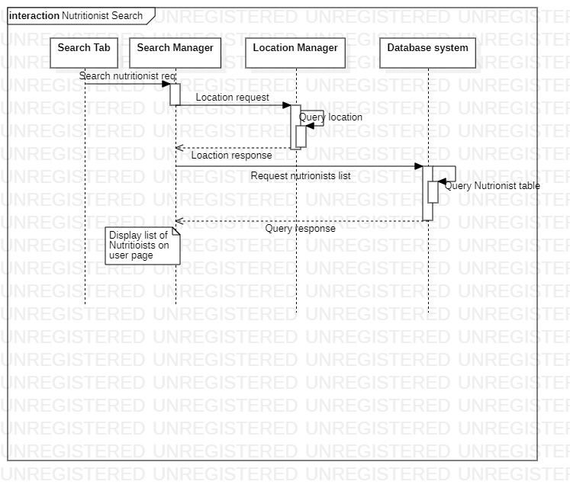

## 7.3 Client Registration

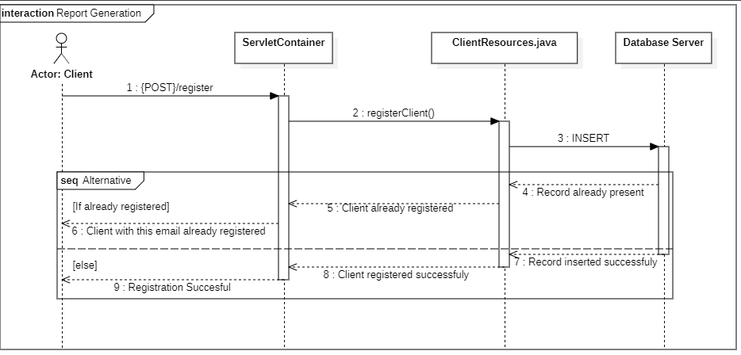

## 7.4 Client Enroll

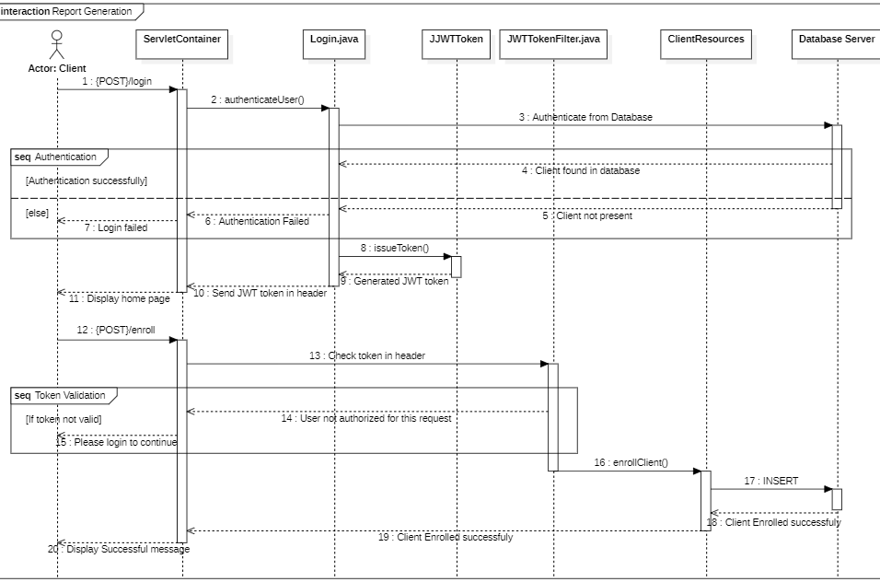

## 7.5 Nutritionist Search

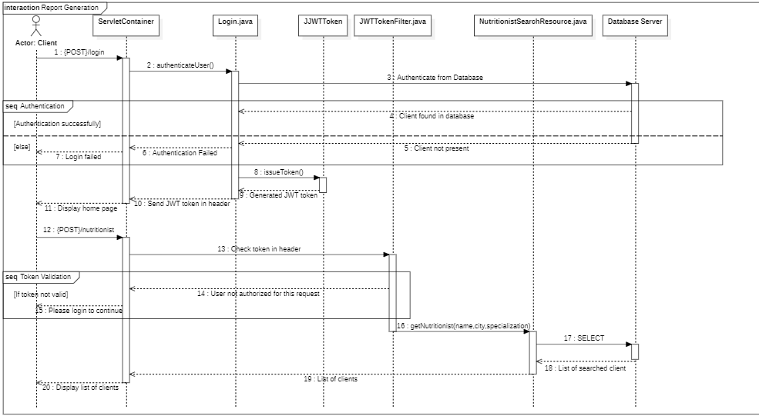

## 7.6 Client Disenrollment

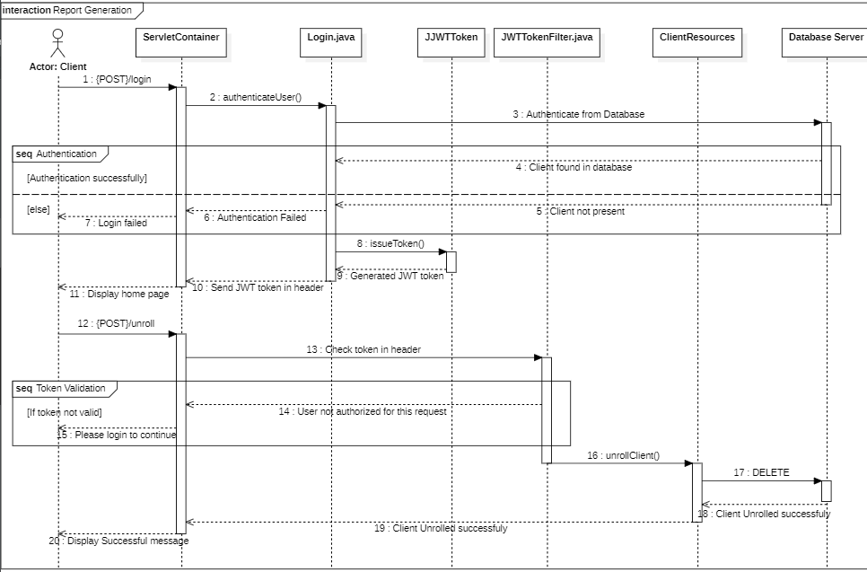

## 7.7 Add Workout Activity

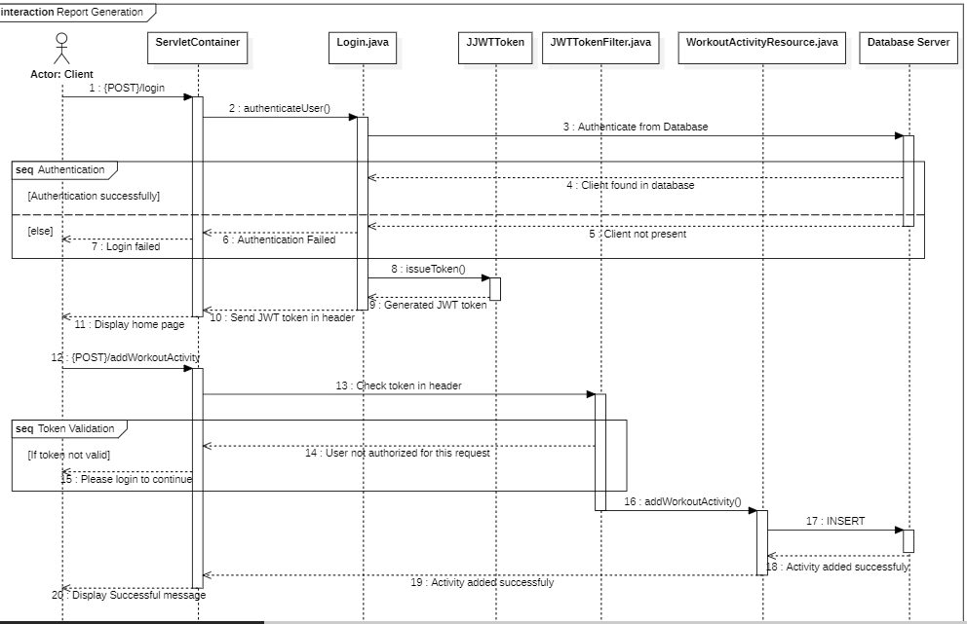

## 7.8 Add Food Activity

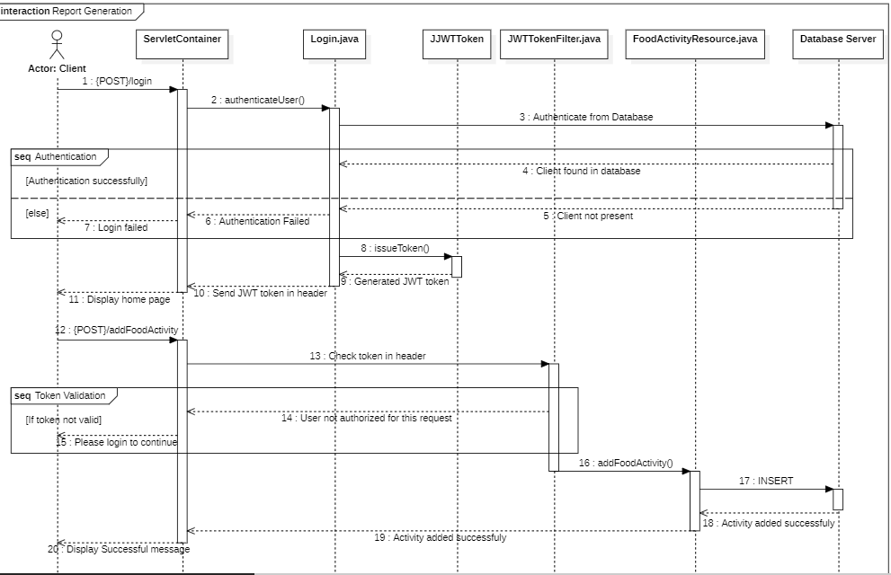

## 7.9 Rate Nutritionist

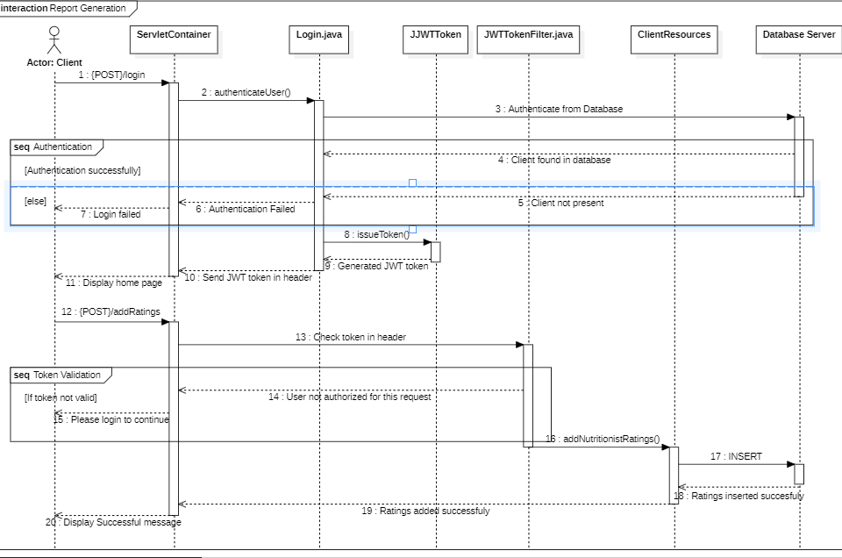

## 7.10 Add Workout Dictionary

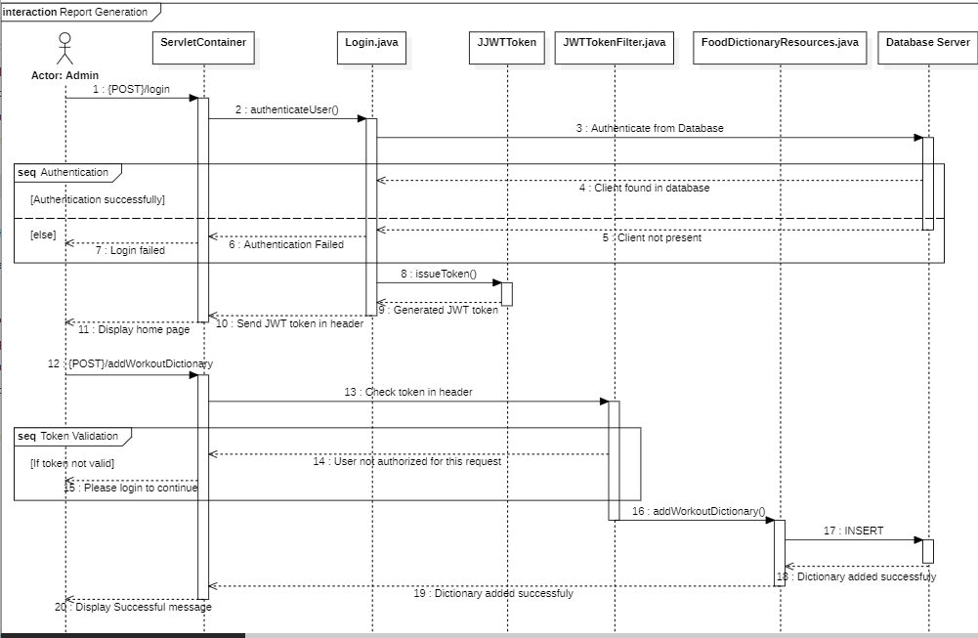

## 7.11 Add Food Dictionary

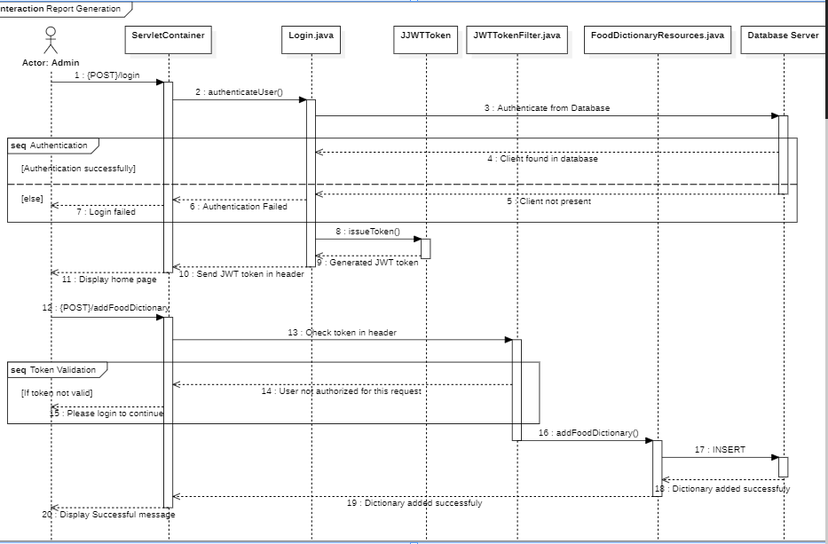

# 8 State Diagrams

## 8.1 States of Appointment

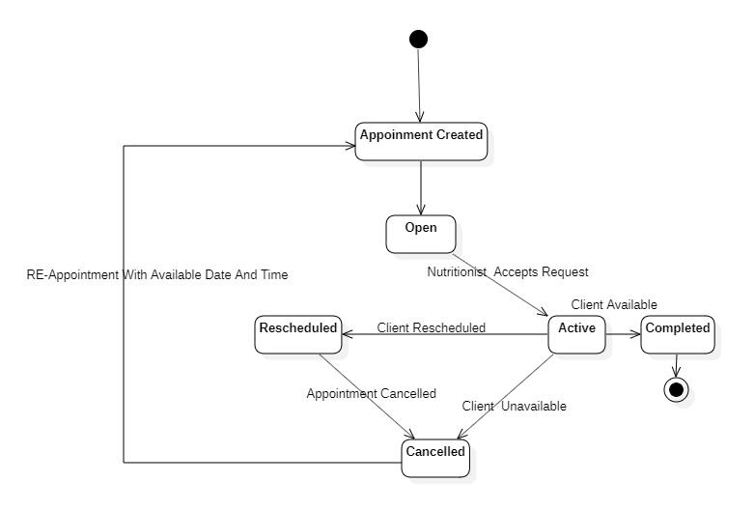

## 8.2 Appointment Approval

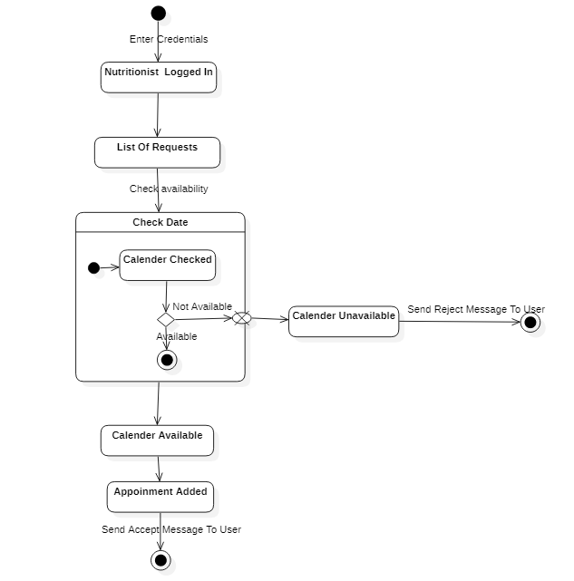

## 8.3 User Enrollment Request

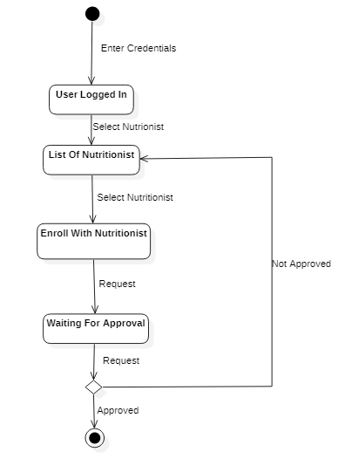

# 9 Activity Diagrams

## 9.1 Nutritionist/Client Sign Up

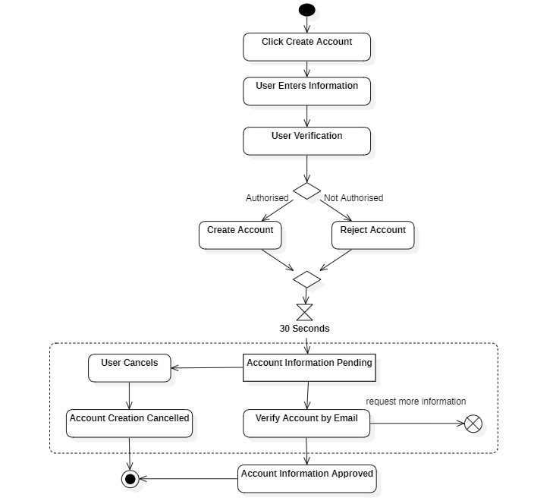

## 9.2 Search Nutritionist

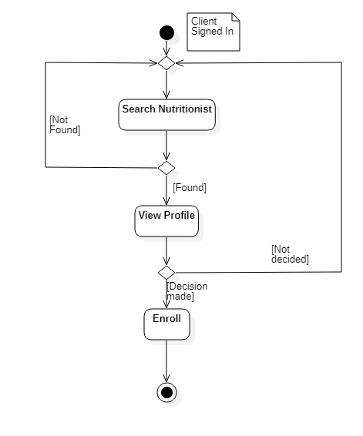

## 9.3 View Recipe

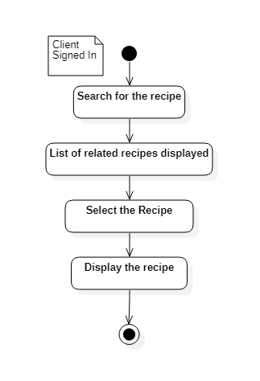

## 9.4 Add Food Dictionary

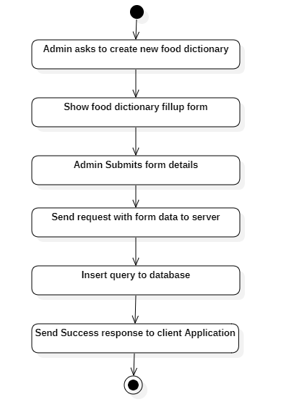

## 9.5 View Food Dictionary

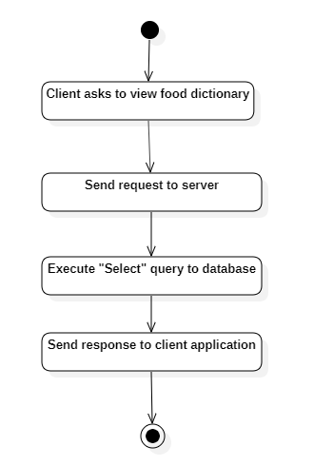

## 9.6 Client Enrollment

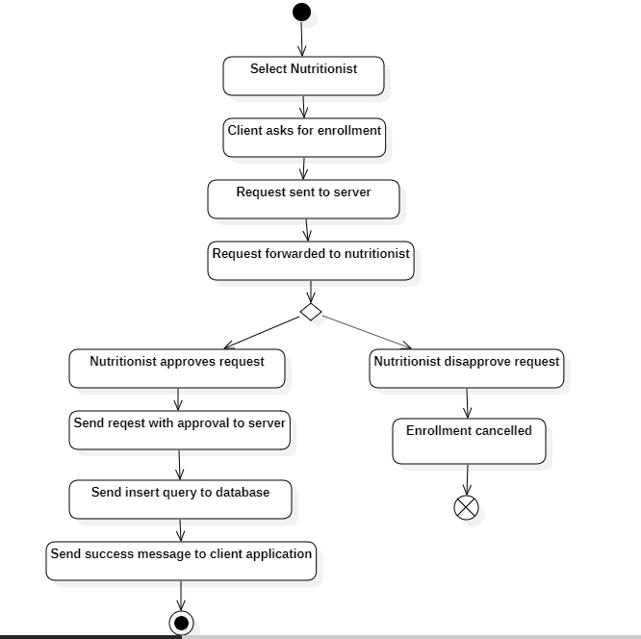

## 9.7 Client Disenrollment

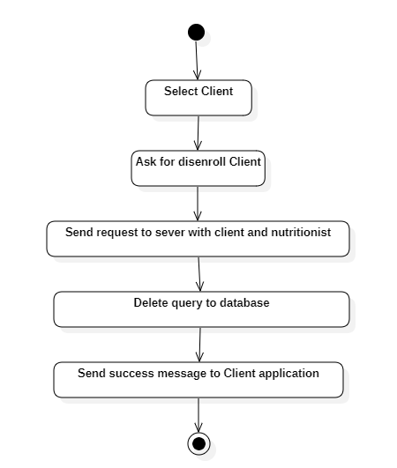

## 9.8 Generate Client Report

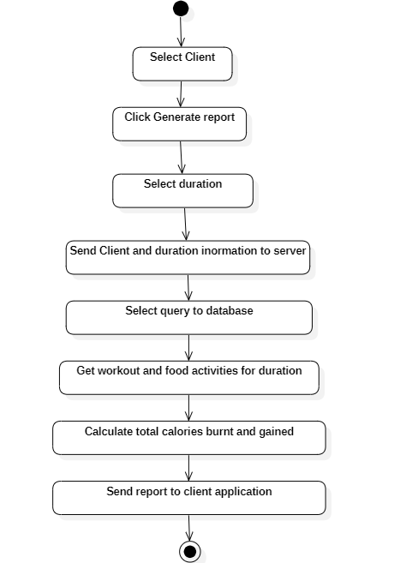

## 9.9 Rate Nutritionist

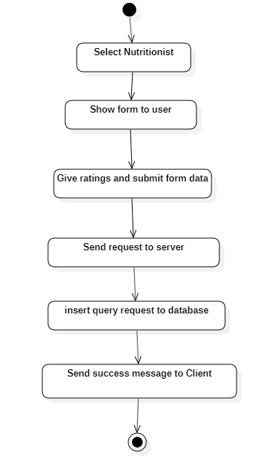

## 9.10 Create Diet Plan

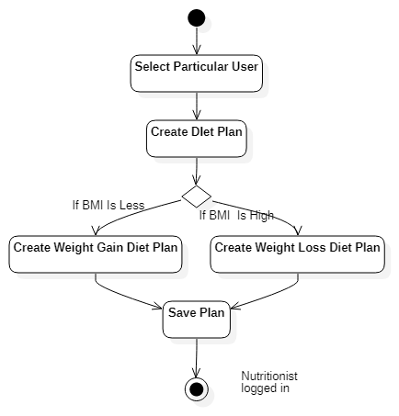

# 10 Entity – Relationship Diagram

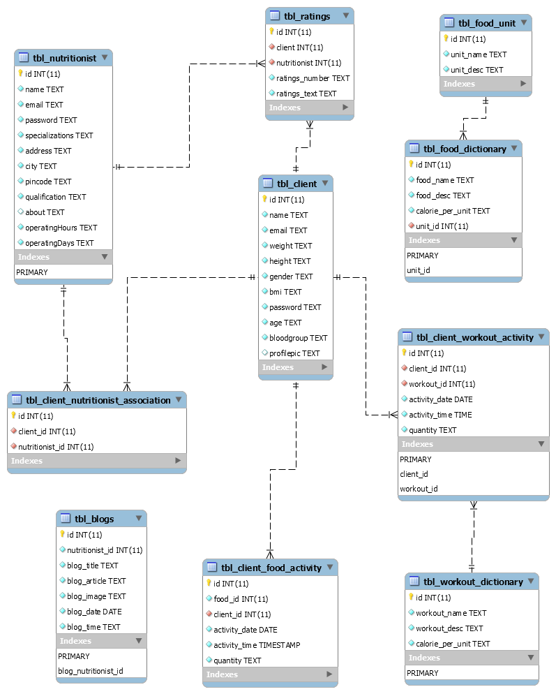

# 11 Data Flow Diagrams

## Appointment data Flow

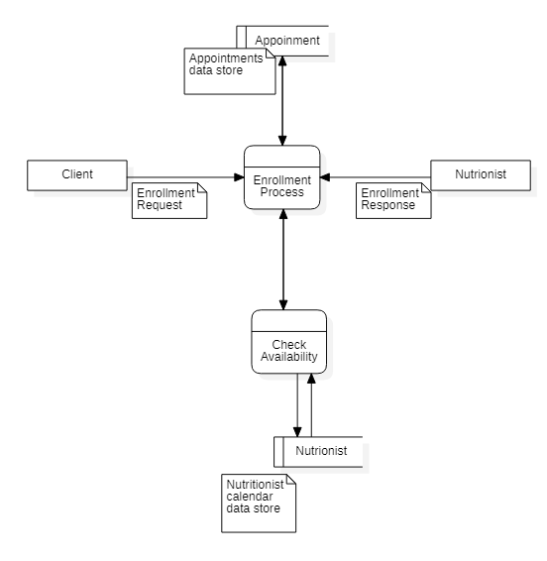

## Admin data flow

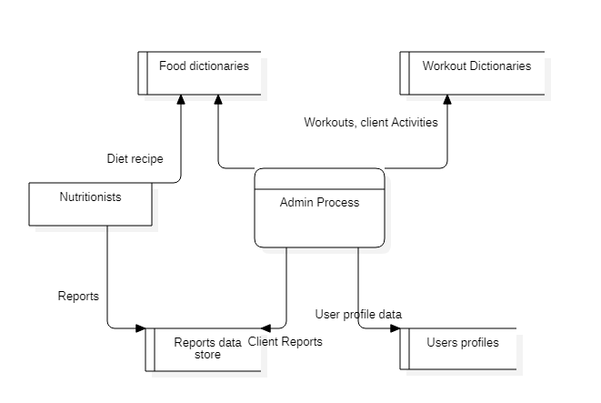

# 12 Component Diagrams

## 12.1 Admin Component Diagram

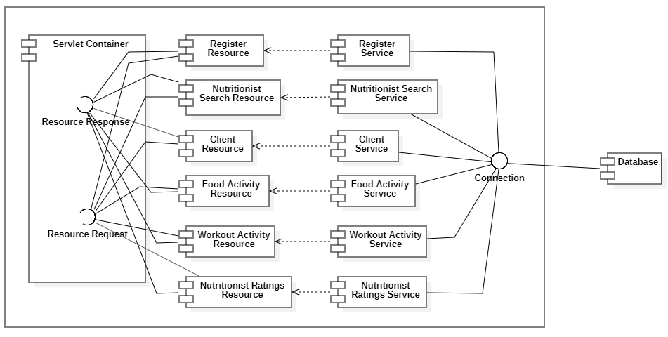

## 12.2 Nutritionist Component Diagram

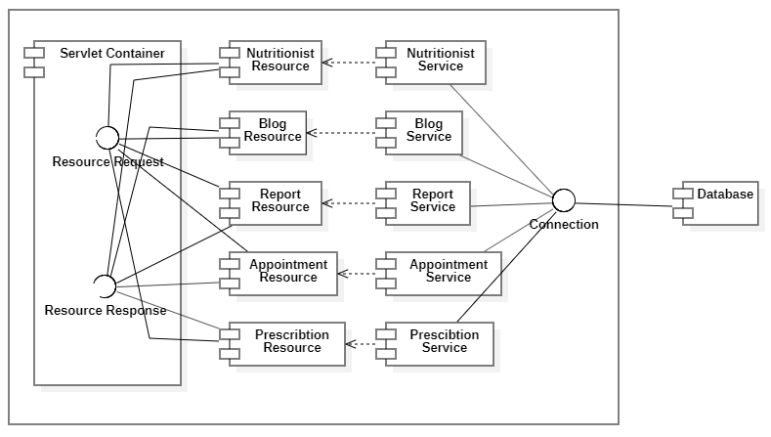

## 12.3 Client Component Diagram

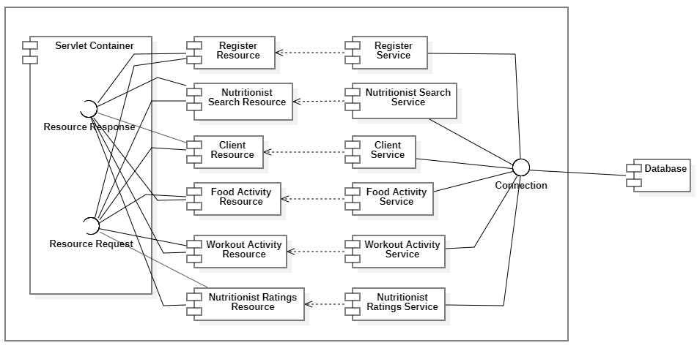

# 13 Package Diagram

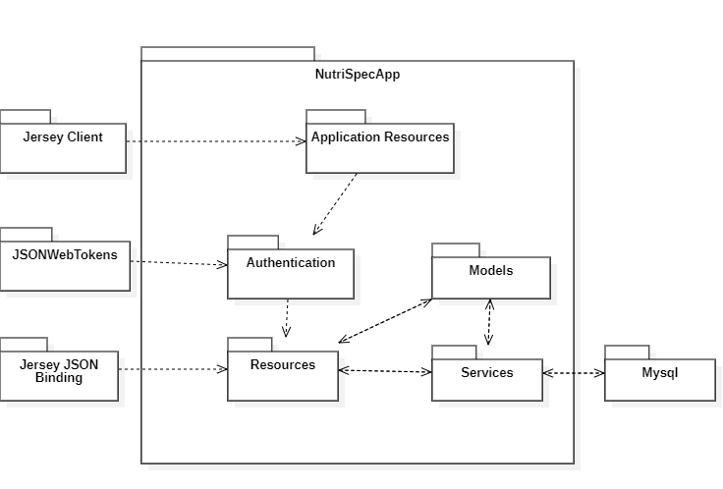

# 14 User Interface

# 15 Testing

A set of manual tests were performed using the application.

Test Environment: Android Phone with NutriSpec app installed with local data store

## 15.1 Test cases

|  |  |  |  |  |
| --- | --- | --- | --- | --- |
| Test case ID | Name | Steps | Output | Result |
| TC_NS_01 | User Login | 1. Open the application 2. Enter the login name and password | User logged in with his roles enables | Pass |
| TC_NS_02 | Client Registration | 1. Open the application and click on Register tab 2. Fill in the registration form with Name, Age, Sex, DOB, Blood Group, Weight, Height, Email, Phone number 3. Click on Submit button | A registration success message will be shown on the screen | Pass |
| TC_NS_03 | Requesting Appointment | 1. Open the app and login as a Client 2. Search for nutritionists using search tab 3. Select the desired Nutritionist 4. On Nutritionist page, click on enroll button | Enrollment request will be sent to Nutritionist and Client receives an enrollment Id | Pass |
| TC_NS_04 | View Recipe Book | 1. Open the application and login as Client 2. Click on the recipe tab 3. Search and click on the required dish name | Recipe displayed on the screen | Pass |
| TC_NS_05 | Add workout Activity | 1. Client clicks on add workout activity menu 2. 2. Enters workout activity form details 3. 3. Clicks on add workout activity button. | Clients work out details added | Pass |
| TC_NS_06 | Add food Activity | 1. Client clicks on food consumption activity menu 2. Enters food Consumption activity form details 3. Clicks on add food consumption button | Clients food consumption details are added | Pass |
| TC_NS_07 | Add Workout Dictionary | 1. Sign In as Admin 2. Click on add workout dictionary button 3. Fill the form data 4. Click on submit button | A new workout dictionary added to database | Pass |
| TC_NS_08 | Add Food Dictionary | 1. Sign in as Admin 2. Click on add food dictionary button 3. Fill form data 4. Click on submit button | A new food dictionary added to database | Pass |
| TC_NS_09 | Generate Report | 1. Sign in as a Nutritionist 2. Click on a particular client 3. Click on Generate report tab | Client report is generated | Pass |
| TC_NS_10 | Prescribe Client | 1. Sign in as Nutritionist 2. Click on a particular client profile 3. Click on prescribe button 4. Fill in with details 5. Submit the prescription | A prescription is created and stored in database | Pass |