Name : Gargi Mahesh Malvi
Roll No : 20
EXPERIMENT NO -8
Code:
CREATE TABLE DEPARTMENT (
DEPTNO NUMBER(2) PRIMARY KEY,
DNAME VARCHAR2(20),
LOCATION VARCHAR2(20)
);
CREATE TABLE EMPLOYEE (
EMPNO NUMBER(4) PRIMARY KEY,
ENAME VARCHAR2(20),
JOB VARCHAR2(20),
SALARY NUMBER(8,2),
DEPTNO NUMBER(2),
FOREIGN KEY (DEPTNO) REFERENCES DEPARTMENT(DEPTNO)
);
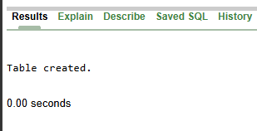
INSERT INTO DEPARTMENT VALUES (10, 'HR', 'MUMBAI');
INSERT INTO DEPARTMENT VALUES (20, 'IT', 'PUNE');
INSERT INTO DEPARTMENT VALUES (30, 'SALES', 'DELHI');
INSERT INTO DEPARTMENT VALUES (40, 'FINANCE', 'NAGPUR');
SELECT * FROM DEPARTMENT;
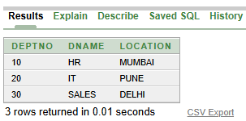
INSERT INTO EMPLOYEE VALUES (101, 'AMIT', 'MANAGER', 50000, 10);
INSERT INTO EMPLOYEE VALUES (102, 'RAHUL', 'DEVELOPER', 40000, 20);
INSERT INTO EMPLOYEE VALUES (103, 'PRIYA', 'ANALYST', 35000, 20);
INSERT INTO EMPLOYEE VALUES (104, 'NEHA', 'SALESMAN', 30000, 30);
SELECT * FROM EMPLOYEE;
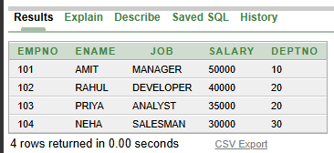

SELECT ENAME, SALARY
FROM EMPLOYEE
WHERE SALARY > (SELECT AVG(SALARY) FROM EMPLOYEE);
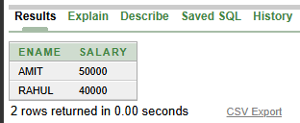
SELECT ENAME, JOB
FROM EMPLOYEE
WHERE DEPTNO IN
(SELECT DEPTNO FROM DEPARTMENT WHERE DNAME = 'IT');
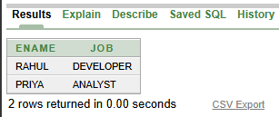
SELECT ENAME, SALARY
FROM EMPLOYEE
WHERE SALARY >
(SELECT AVG(SALARY)
FROM EMPLOYEE
WHERE DEPTNO =
(SELECT DEPTNO
FROM DEPARTMENT
WHERE DNAME = 'IT'));
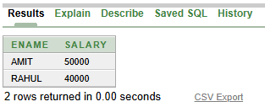
CREATE TABLE HIGH_SALARY (
EMPNO NUMBER(4),
ENAME VARCHAR2(20),
SALARY NUMBER(8,2)
);
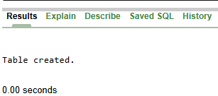
INSERT INTO HIGH_SALARY
SELECT EMPNO, ENAME, SALARY
FROM EMPLOYEE
WHERE SALARY > (SELECT AVG(SALARY) FROM EMPLOYEE);
SELECT * FROM HIGH_SALARY;
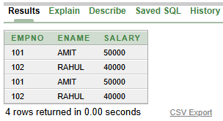
UPDATE EMPLOYEE
SET SALARY = SALARY * 1.10
WHERE DEPTNO IN
(SELECT DEPTNO
FROM DEPARTMENT
WHERE DNAME = 'IT');
SELECT * FROM EMPLOYEE;
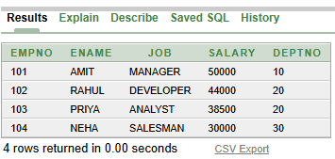
SELECT * FROM EMPLOYEE;


