Name : Gargi Mahesh Malvi
Roll no : 18 Div/Batch : B/B1
EXPERIMENT NO :02

CREATE TABLE STUDENT27(
NAME VARCHAR2(20),
EMAIL VARCHAR2(30),
ADDRESS VARCHAR2(20),
DOB VARCHAR2(20),
PHONE_NO VARCHAR2(20)
);
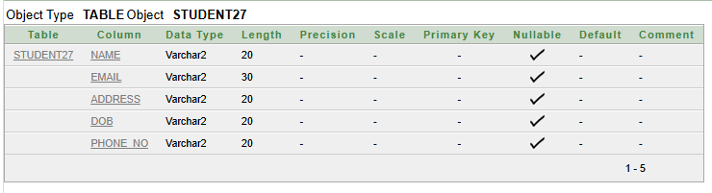

ALTER TABLE STUDENT27
ADD(ROLL_NO VARCHAR2(20));
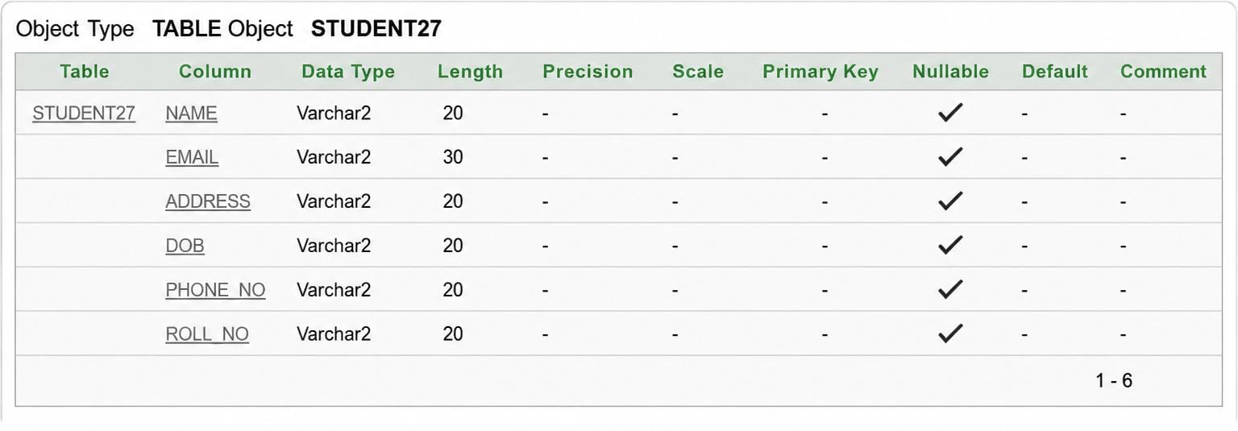

ALTER TABLE STUDENT27
DROP COLUMN ROLL_NO;
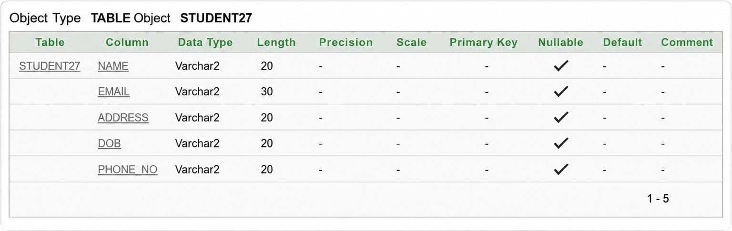

ALTER TABLE STUDENT26
MODIFY(DOB NCHAR(30));
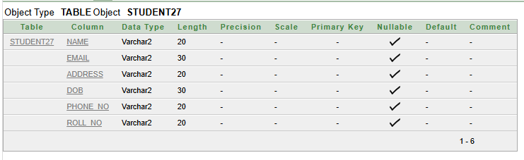

CREATE TABLE REGISTRATION26(
NAME VARCHAR2(20),
REG_ID VARCHAR2(30),
REG_DATE VARCHAR2(20),
REG_FEE VARCHAR2(20)
);
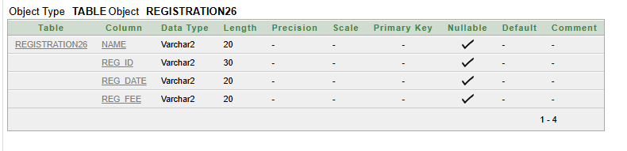
CREATE TABLE FACULTY26(
NAME VARCHAR2(20),
ID VARCHAR2(30),
PHONE_NO VARCHAR2(20),
SALARY VARCHAR2(20),
SUBJECT VARCHAR2(20)
);
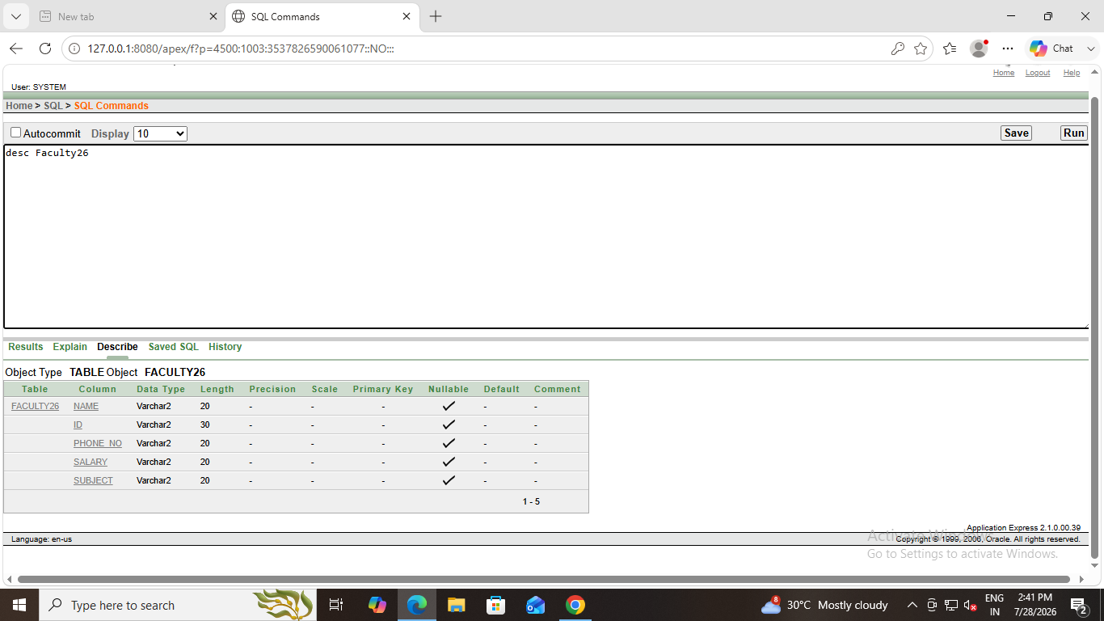

CREATE TABLE COLLEGE2(
NAME VARCHAR2(20),
EMAIL VARCHAR2(30),
LOCATION VARCHAR2(20)
);


