Name : Pranali Rajesh Karande
Roll no : 06 Div/Batch : B/B1
EXPERIMENT NO :03

INSERT INTO student2(name, email,
phone_no, dob)
VALUES ('gargi', 12, 12345, 17);

INSERT INTO student2(name, email,
phone_no, dob)
VALUES ('pranali', 'pranali.com', 15678, 15/05);

INSERT INTO student2(name, email,
phone_no, dob)
VALUES ('riya', 'riya.com', 16583, 12/03);

INSERT INTO student2(name, email,
phone_no, dob)
VALUES ('mansi', 'mansi.com', 46789, 10/04);

INSERT INTO student2(name, email,
phone_no, dob)
VALUES ('nishita', 'nishita.com', 14237, 11/04);

INSERT INTO student2(name, email,
phone_no, dob)
VALUES ('aarya', 'aarya.com', 345, 10/08);

INSERT INTO student2(name, email,
phone_no, dob)
VALUES ('hary', ' hary.com', 9865, 34/05);

INSERT INTO student2(name, email,
phone_no, dob)
VALUES ('monu', ' monu.com', 7895, 04/1);

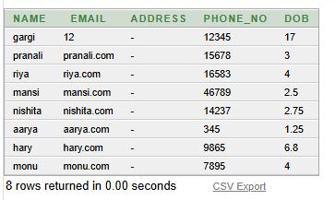
DELETE FROM student2
WHERE student_name =’riya’;

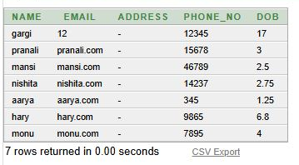

UPDATE student2
SET EMAIL = ‘gargi.com’
WHERE NAME = ‘gargi’;


