Name : Gargi Mahesh Malvi
Roll no : 18 Div/Batch : B/B1
EXPERIMENT NO :04
- Create user JOY identified by a1234
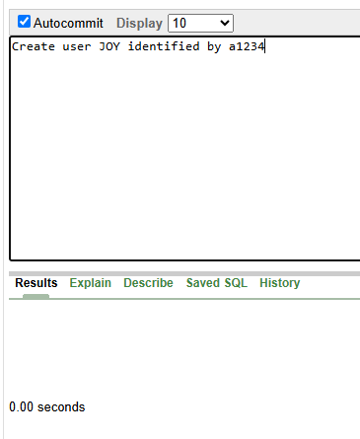

- Grant SELECT on STUDENT27 to JOY; 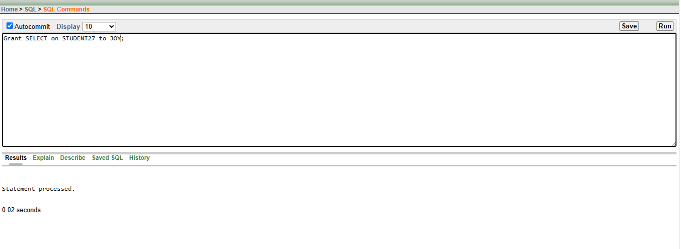
- Grant SELECT,INSERT on STUDENT27 to JOY;
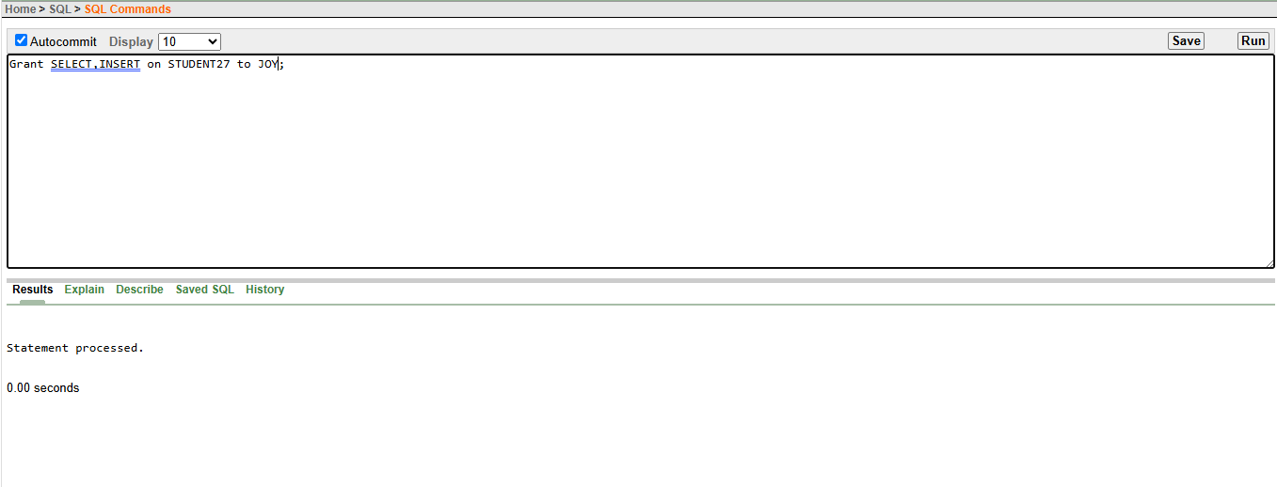

- Grant ALL on STUDENT27 to JOY;
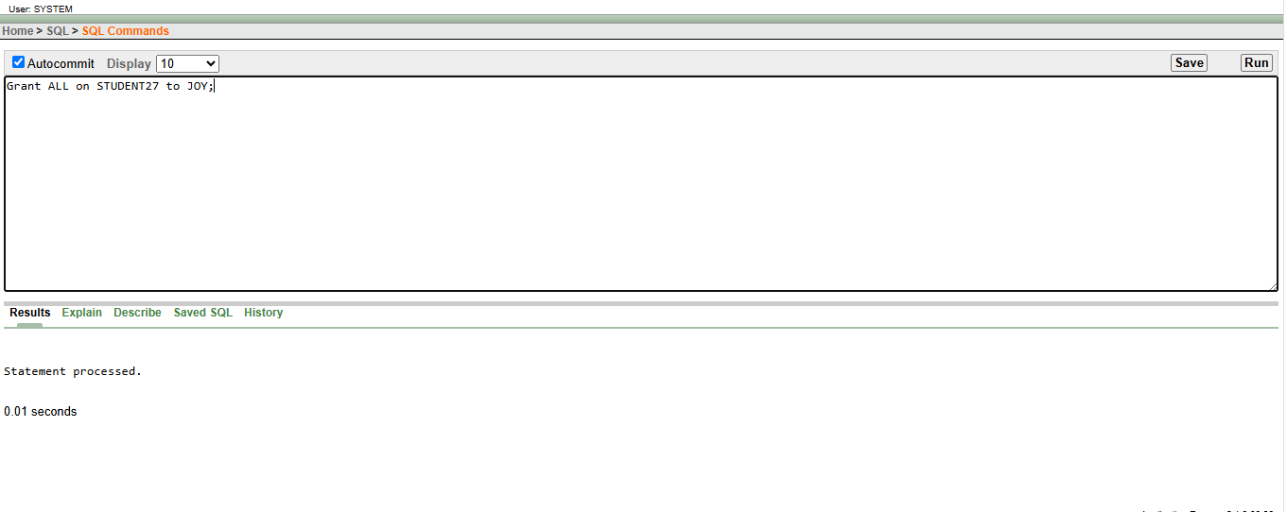
- Revoke SELECT on STUDENT27 from JOY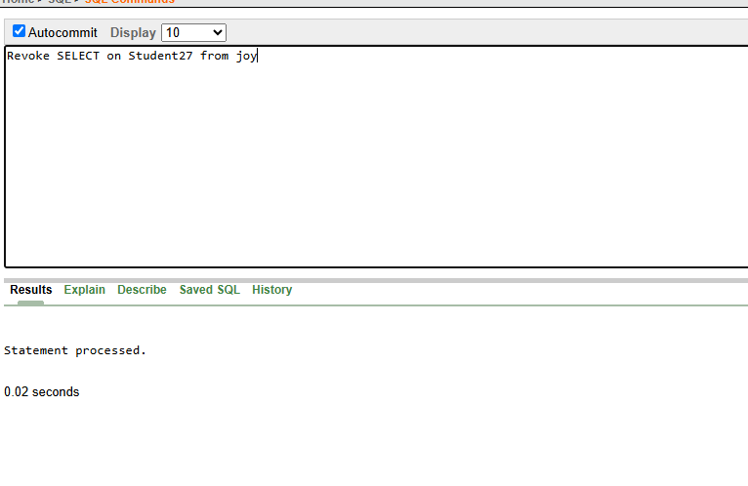
- Commit;
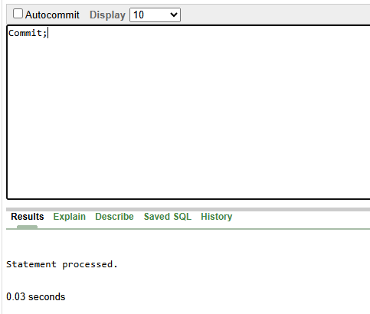

- Rollback;


