|| Jai Sri Gurudev||
Sri Adichunchanagiri ShikshanaTrust(R)

SJBINSTITUTEOF TECHNOLOGY

BGS Health & Education City, Dr. Vishnuvardhan Road, Kengeri, Bengaluru–560060
An Autonomous Institute under Visvesvaraya Technological University, Belagavi
Affiliated to Visvesvaraya Technological University, Belagavi& Approved by AICTE, New Delhi, Certified by ISO9001-2015
Accreditedby NBA &NAAC,NewDelhi with‘A+’Grade,RecognizedbyUGC,NewDelhiwith2(f)and12(B)



Question Bank

Course Name: Operating System

Course Code: 23ISI404

Module –1 , 2, 3,4 and 5

By

Faculty Name: Dr. Siddanna S R

Semester: 4th‘A


Department of Information Science & Engineering



||Jai Sri Gurudev||
Sri Adichunchanagiri Shikshana Trust(R)

SJBINSTITUTE OFTECHNOLOGY


(Affiliated to Visvesvaraya Technological University, Belagavi & Approved by AICTE, New Delhi)No.67,BGS Health & Education City, Dr. Vishnuvardhan Road, Kengeri, Bengaluru-560060.

DEPARTMENTOFINFORMATION SCIENCE & ENGINEERING

Question Bank (4thSem)

Question Bank: Module 1 ,2,3,4 And 5 | Academic Year: EVEN - 2025-26
Course: Operating System | Course-Code: 23ISI404 | Sem: IV ‘A
Staff-In charge: Dr. Siddanna S R
Module 1

Q.No. | Questions | CO  Mapped | BT  Level | Marks
1 | What is Operating System and explain its various views and roles from different perspectives. | CO1 | L2 | 10
2 | List and explain the various services provided by an Operating System for users and efficient functioning. | CO1 | L2 | 10
3 | What are system calls? Explain with examples and describe different types of system calls. | CO1 | L2 | 10
4 | Explain the sequence of system calls for copying a file and provide an example with an application invoking the open() system call. | CO1 | L2 | 10
5 | Describe the storage structure of the computer system, dual-mode operation, and the various operating system structures. Include appropriate diagrams.. | CO1 | L2 | 10
Module 2

Q.No. | Questions | CO  Mapped | BT  Level | Marks
1 | Explain process states, transitions, and the Process Control Block (PCB), along with the various operations performed on processes. | CO2 | L2 | 10
2 | Describe the role of schedulers in process execution and explain different types of scheduling algorithms. Also, discuss CPU scheduling criteria and the need for scheduling. | CO2 | L2 | 10
3 | What is multithreading, and explain the different multithreading models with their diagrams, benefits, and issues associated with multithreaded programming? | CO2 | L2 | 10
4 | What is interprocess communication (IPC)? Explain the types of IPC (message passing and shared memory) with their strengths and weaknesses, and discuss the methods for implementing message-passing IPC. | CO2 | L2 | 10
5 | Explain preemptive and non-preemptive scheduling, and define the following scheduling terms: CPU utilization, throughput, turnaround time, waiting time, and response time. | CO2 | L2 | 10

Module 2- Problems

Q.No. | Questions | CO  Mapped | BT  Level | Marks
1 | Consider the following processes with the burst time and arrival time. Calculate the Average Waiting and Average Turnaround time using FCFS. | CO2 | L3 | 10
2 | Consider the following processes with the burst time and arrival time. Calculate the Average Waiting and Average Turnaround time using FCFS.  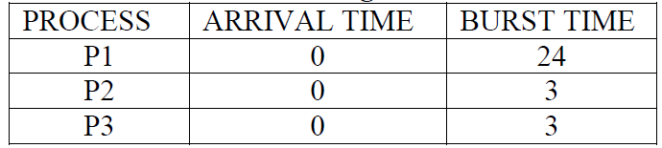 | CO2 | L3 | 10
3 | Consider the following processes with the burst time and arrival time. Calculate the Average Waiting and Average Turnaround time using FCFS.  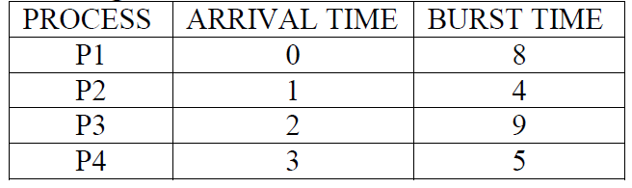 | CO2 | L3 | 10
4 | Consider the following processes with the burst time and arrival time. Calculate the Average Waiting and Average Turnaround time using SJF  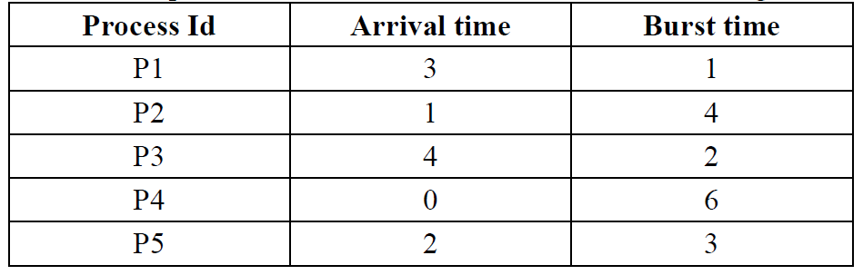 | CO2 | L3 | 10
5 | Consider the following processes with the burst time and arrival time. Calculate the Average Waiting and Average Turnaround time using SJF  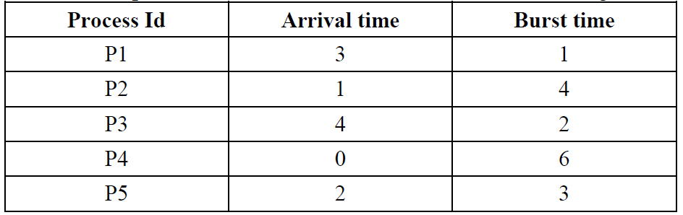 | CO2 | L3 | 10
6 | Consider the following processes with the burst time and arrival time. Calculate the Average Waiting and Average Turnaround time using SJF  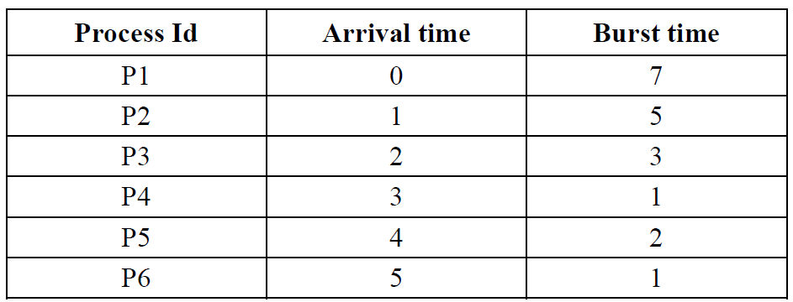 | CO2 | L3 | 10

Q.No. | Questions | CO  Mapped | BT  Level | Marks
7 | Consider the following processes with the burst time and arrival time. Calculate the Average Waiting and Average Turnaround time using SRTF  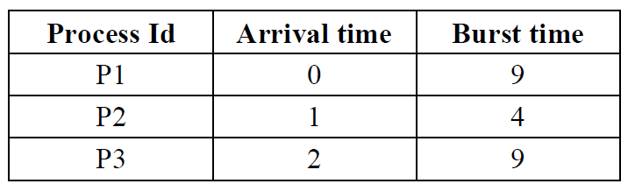 | CO2 | L3 | 10
8 | Consider the following processes with the burst time and arrival time. Calculate the Average Waiting and Average Turnaround time using SRTF  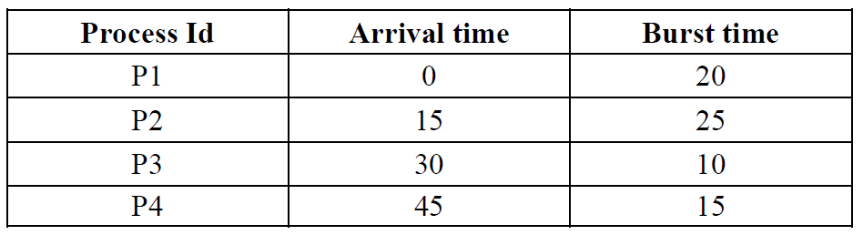 | CO2 | L3 | 10
9 | Consider the following processes with the burst time and arrival time. Calculate the Average Waiting and Average Turnaround time using Round Robin scheduling algorithm with the time Quantum=2 units  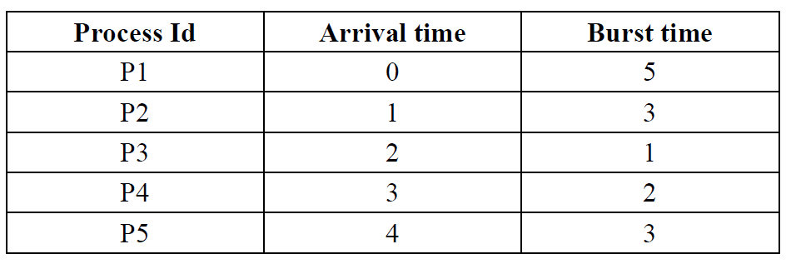 | CO2 | L3 | 10
10 | Consider the following processes with the burst time and arrival time. Calculate the Average Waiting and Average Turnaround time using Round Robin scheduling algorithm with the time Quantum=2 units  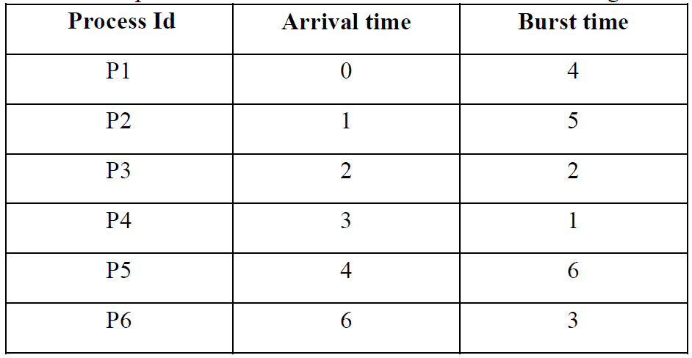 | CO2 | L3 | 10

Q.No. | Questions | CO  Mapped | BT  Level | Marks
11 | Consider the following processes with the burst time and arrival time. Calculate the Average Waiting and Average Turnaround time using Round Robin scheduling algorithm with the time Quantum=3 units  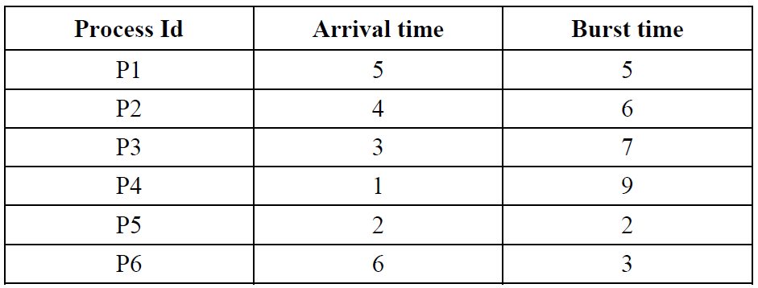 | CO2 | L3 | 10
12 | Consider the following processes with the burst time and arrival time. Calculate the Average Waiting and Average Turnaround time using non-preemptive Priority Scheduling Algorithm.  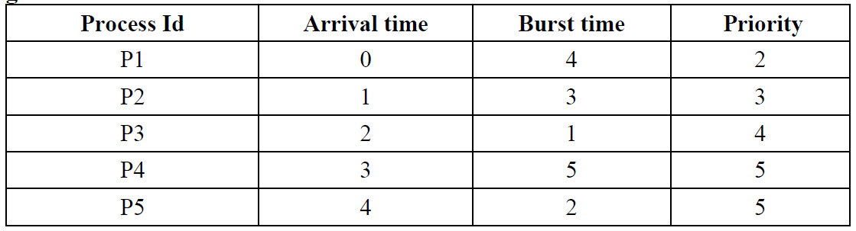 | CO2 | L3 | 10
13 | Consider the following processes with the burst time and arrival time. Calculate the Average Waiting and Average Turnaround time using preemptive Priority Scheduling Algorithm.   | CO2 | L3 | 10

Module 3

Q.No. | Questions | CO  Mapped | BT  Level | Marks
1 | Define Mutual Exclusion. | CO3 | L1 | 5
2 | Define process synchronization | CO3 | L1 | 5
3 | What is critical section problem? | CO3 | L1 | 5
4 | Explain Peterson’s solution for critical section problem | CO3 | L2 | 5
5 | Explain Hardware solutions for critical section problem | CO3 | L2 | 10
6 | What is Semaphore? Give the implementation of Bounded Buffer Producer Consumer Problem using Semaphore | CO3 | L3 | 10
7 | Explain the Dining philosopher problem | CO3 | L3 | 10

8 | Give the solution for readers/writers problem using semaphore | CO3 | L2 | 10
9 | Explain Petersons algorithm | CO3 | L2 | 5
10 | The operating system contains 3 resources .the number of instances of each resource type are  7,7,10 .The current resource allocation state is as shown below  Process Current allocation R1 R2 R3 Maximum need R1 R2 R3  P1 2 2 3 3 6 8  P2 2 0 3 4 3 3  P3 1 2 4 3 4 4  1)Is the current allocation in safe state.  2)can the request made by process P1(1,1,0) be granted. | CO3 | L3 | 10
11 | Explain deadlock prevention methods in detail | CO3 | L2 | 10
12 | consider the following snapshot  Process Current allocation R1 R2 Maximum need R1 R2 Available R1 R2  P1 1 2 4 2 1 1  P2 0 1 1 2  P3 1 0 1 3  P4 2 0 3 2  1)What is the need matrix.  2)Check whether system is safe or unsafe. | CO3 | L3 | 10
13 | consider the following snapshot  Process Current allocation A B C D Maximum need A B C D Available A B C D  P0 0 0 1 2 0 0 1 2 1 5 2 0  P1 1 0 0 0 1 7 5 0  P2 1 3 5 4 2 3 5 6  P3 0 6 3 2 0 6 5 2  P4 0 0 1 4 0 6 5 6  What is the content of need matrix,  2)determine If system is in safe state.  3)If a request from process P1 arrives for (0,4,2,0)can the request be granted immediately | CO3 | L3 | 10
14 | For resource types A,B, C maximum instances present in the system are A=10,B=5,C=7  1)calculate need matrix.  2)check whether system is safe or not  Process Current allocation A B C Maximum need A B C Available A B C  P0 0 1 0 7 5 3 3 3 2  P1 2 0 0 3 2 2  P2 3 0 2 9 0 2  P3 2 1 1 2 2 2  P4 0 0 2 4 3 3 | CO3 | L3 | 10
15 | Explain deadlock detection and deadlock recovery in detail | CO3 | L2 | 10

16 | Describe the Bankers algorithm for deadlock avoidance | CO3 | L2 | 10
17 | what are the necessary conditions for deadlock to occur | CO3 | L2 | 10
18 | Explain the resource allocation graph | CO3 | L2 | 10

Module 4

Q. No. | Questions | CO  Mapped | BT  Level | Marks
1 | Explain shared pages? | CO4 | L2 | 5
2 | Explain hashed page table | CO4 | L2 | 5
3 | Explain segmentation . Compare paging and segmentation | CO4 | L2 | 6
4 | Explain the concept of swapping. Why is it required? | CO4 | L2 | 6
5 | Explain best fit and first fit algorithm for dynamic partitioned memory management | CO4 | L2 | 6
6 | Explain internal and external fragmentation with a neat diagram. | CO4 | L2 | 5
7 | What is paging? Explain with a neat diagram | CO4 | L2 | 10
8 | Explain Translation lookaside buffer(TLB) with a neat diagram | CO4 | L2 | 10
9 | Explain inverted page table with a diagram | CO4 | L2 | 5
10 | Explain segmentation with neat diagram | CO4 | L2 | 5
11 | Describe the following allocation algorithms  1)first fit 2)best fit 3)worst fit | CO4 | L2 | 8
12 | With a diagram discuss the steps involved in handling a page fault | CO4 | L2 | 10
13 | Explain thrashing. | CO4 | L2 | 5
14 | Consider the following page reference string  2,3,2,1,5,2,4,5,3,2,5,2  How many page faults would occur in case of  a)LRU b)FIFO c)optimal page replacement algorithms assuming 3 frames. Note that initially all frames are empty | CO4 | L3 | 10
15 | Explain the different page replacement algorithms | CO4 | L2 | 10
16 | Explain demand paging. Give advantage and disadvantage of demand paging | CO4 | L2 | 5
17 | write a note on virtual memory | CO4 | L2 | 5

Module 5

Q. No. | Questions | CO  Mapped | BT  Level | Marks
1 | Explain different file access methods | CO5 | L2 | 10
2 | Describe the working of following allocation methods  1)contigious 2)linked | CO5 | L2 | 10
3 | With a neat diagram describe 1)tree structured directory 2)Acyclic graph directory | CO5 | L2 | 10
4 | What do you mean by free space list? With suitable examples explain any 2 methods of implementation of free space list | CO5 | L2 | 10
5 | With suitable examples explain different methods of implementation of free space list | CO5 | L2 | 10
6 | List the common file types along with its extentions and functions | CO5 | L2 | 5
7 | Explain in detail file attributes | CO5 | L2 | 5
8 | Describe the working of following allocation methods  1)contigious 2)indexed | CO5 | L2 | 10
9 | Explain the various directory structures | CO5 | L2 | 10
10 | what are the operations possible on file | CO5 | L2 | 5
11 | Explain access matrix method of system protection with domain as objects and its implementation | CO5 | L2 | 10
12 | consider a disc queue with requests for I/O to blocks on cylinder  98,183,37,122,14, 124,65,67  If the disc head is start at 53,then find out the total head movement with respect to FCFS,SSTF,SCAN,C-SCAN, and LOOK scheduling | CO5 | L3 | 10
13 | Suppose that a disc drive has 5000 cylinders , numbered 0 through 4999.The drive is serving a request at cylinder 143.The queue of pending requests in FIFO order is86,1470,913,1774,948,1509,1022,1750,130 starting from the head position. What is the total distance (in cylinders) that the disc arm moves to satisfy all the pending requests for each of the  following disc scheduling algorithms ? FCFS,SSTF,SCAN,LOOK,C-SCAN,C-LOOK | CO5 | L3 | 10
14 | Explain in detail about overview of mass storage structure | CO5 | L2 | 10
15 | Explain SCAN,CSCAN and LOOK scheduling techniques | CO5 | L2 | 10
16 | Explain the various disc scheduling algorithm with example | CO5 | L2 | 10

