**HIVE DOCUMENTATION**

**MOVIE DETAILS DATASET**

1. The number of movies between 1950 and 1960

HQL

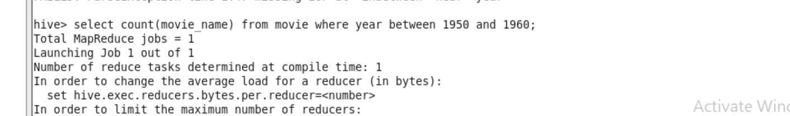

RESULT

1. Number of movies having rating more than 4.

HQL

RESULT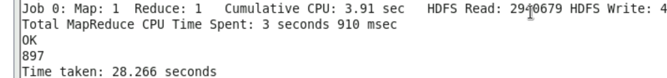

1. Movies rating between 3 and 4

HQL

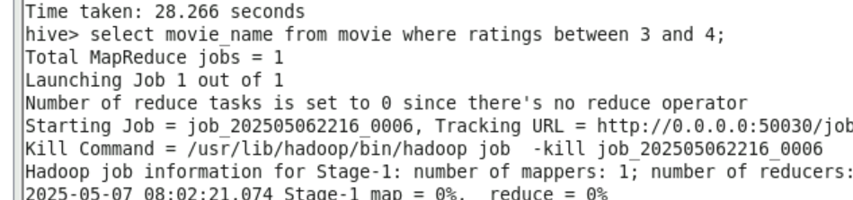

RESULT

1. Movie with duration more than 2 hours

HQL

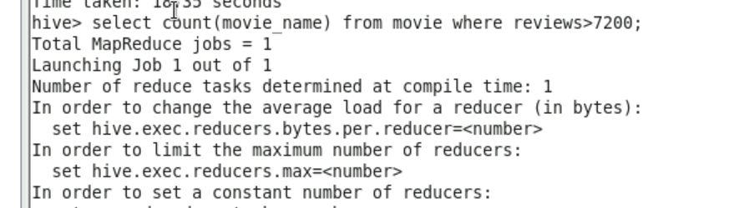

RESULT

1. List of years and numbers of movies released each year

HQL

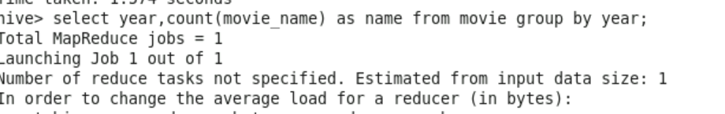

RESULT

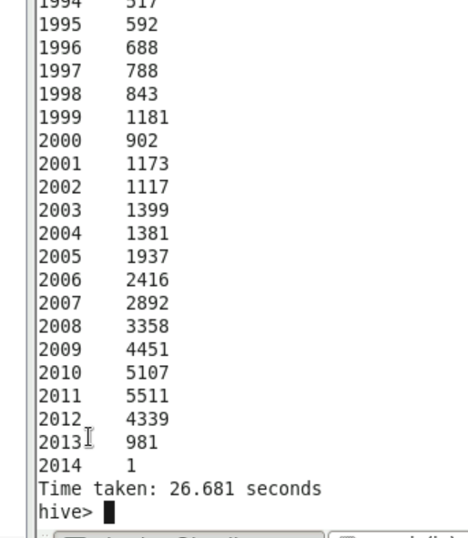

1. Total number of movies in Dataset

HQL

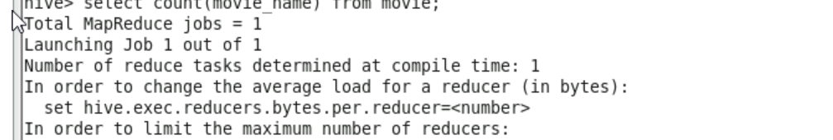

RESULT

