CS3105: SE Term Project
Product Design
Team | 1, Sagar Singh

Architectural Model
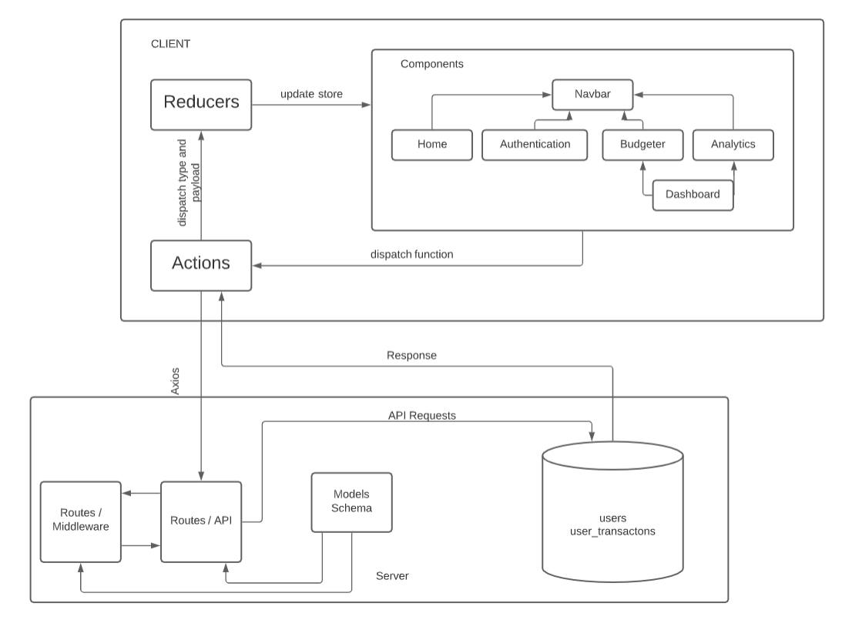

Navbar | State:  - Renders Navigation bar for all web pages.  - Contains Home navigation text and Sign in button for non-authenticated users.  - Replaces Sign in button with Dashboard button, Username and Logout button.  Behavior:  - Home navigation text links to home page.  - Sign in button links to Authentication page.  - Dashboard button links to the Budgeter page.  Logout button logs out the user and redirects to Authentication page.
Home | State:  - Renders Home page.  - Contains 3 sections: Title, Getting Started, How to use?  Behavior:  - Title shows a title and a small description.
Authentication | State:  - Authentication consists of two forms but only one is shown at a time.  - Sign In contains two fields: email and password and two buttons: Sign In and “Go to Sign Up” button.  - Sign Up contains 6 fields: first name, last name, username, email, password and confirm password and two buttons: Sign up and “Go to Sign In” button.  Behavior:  - For both, sign in and sign up, the user has to fill all the fields.  - After filling up the fields the user will be registered and authenticated when sign up button is clicked. If the sign In button is clicked, the user will only be authenticated.  - In both cases, the user will be redirected to the home page.
Dashboard | State:  - Renders two buttons: Budgeter and Analytics  Behavior:  - Budgeter button links to Budgeter page.  - Analytics button links to Analytic page.
Budgeter | State:  - Renders a button at the top that opens a modal to add an entry.  - Renders rows of data consisting date, transaction group : title, amount, edit button and delete button.  Behavior:  - Create button opens a modal that consist of 4 fields where Group is prefilled with “EXPENDITURE” which can be changed. Title, Description and Amount is empty. Group, Title and Amount are mandatory to fill. Submitting this adds a entry to below row data.  - Edit button opens the same modal prefilled with that particular entry’s date and follows its rules. Submitting this would update that entry.  - Delete button would delete that particular entry.
Analytics | Empty

Class Diagram(s)
This is for UML class diagram capturing the relationships between classes. It is only necessary to show methods that are publically accessible by other classes. Only show an instance variable of a class if it is publically accessible

Sequence Diagram(s)
UML sequence diagram for the agreed significant use case.
While you may reference an external file here, most instructors strongly prefer embedded images, or, failing that, external files in generic formats such as JPEG, PNG or PDF.

Design Rationale
This is a running list of issues that arise as your design process proceeds. This is an important section of the design document as it captures the thought process of the product's designers. It includes why or why not (rejected solutions) a design decision was made and supports future changes to the product. It should be updated whenever a design change occurs.

It is RARELY the case that the first design you consider is the best one that you can come up with that meets the requirements and that can be implemented, tested, and delivered on schedule. Your instructor will be looking for signs that you considered at least a few approaches, and that you had a coherent rationale for preferring the design your team eventually adopts.
This is the place to record such thoughts – what alternatives did you consider? What are the strengths (and deficiencies) of the final design compared to the other alternatives considered? Why did you select the approach you finally chose? This last question should be answered with an eye to the tradeoffs inevitably involved in creating an appropriate design.

