Software Requirements Specification Document
Home Budget Economy
Team1, Sagar Singh

Brief problem statement
Savings has always been an important factor of anyone’s financial life. It comes handy in situations such as emergencies, investments or starting a business. Having financial stability is one of the most prime factors for a stable life, both for themselves and their families. To attain this stability, it is important to have a good balance between income and expenditure. This could be achieved by either increasing the income or decreasing the expenditure. The problem with former is that as income increases, consumption of goods also increases. Hence having a control over one’s expenditure is more important. Thus, developing means to promote the latter is a must.

System requirements
Stack Used
MERN
- Node.js
- Database: mongoDB, MongoDB Atlas
- API: express.js, mongoose
- Central Data Store for state: Redux
- Frontend: React.js

Dependencies (Frontend)
- react
- react-dom
- axios
- redux
- react-redux
- redux-thunk
- jwt-decode
- react-router-dom
- @mui/icons-material
- @mui/material
- chart.js
- react-chartjs-2
- web-vitals
Dependencies (Backend)
- express
- mongoose
- bcryptjs
- jsonwebtoken
- cors
- concurrently
- config
- dotenv
- mocha
- nodemon
Languages
- HTML
- CSS
- JavaScript
Deployment
- Frontend: Netlify
- Backend: Heroku

Users profile
Requirements from user:
- Should have basic fluency in English.
- Should have a basic understanding about webpages and websites.
Demography for users:
- The application is open to all who want to have financial stability in terms of expenditures.
- Although, the application is open to all, the application is most useful for people who are starting their careers. Thus, the target audience is around the age 22-30 years.
- The website in its current stage is useful for office workers who live in urban/suburban area since some of the expenditure groups are targeted specially for them.

Feature requirements (described using use cases)

No. | User Case Name | Description | Release
 | Visit Home Page | Any user can visit the home page and read about the website. | R1
 | Sign Up | User can create a new account. | R1
 | Sign In | User can sign in with his/her own account. | R1
 | Add an Entry | Authorized user can add an entry. | R1
 | Edit an Entry | Authorized user can edit his own entry. | R1
 | Delete an Entry | Authorized user can delete his own entry. | R1
 | View Entries from previous months | Authorized user can select a month from the side bar and view all the entries that pertain to that month. | R2
 | View Analytics for each month | Authorized user can view entered data in the Analytics section in the form of line chart. | R2
 | Create User Account | Server will create an account for the use with the details provided by the user. Password will be encrypted. | R1
 | Authorize User | Upon signing up or signing in, server would generate a jwt token, which will expire after one hour, to authorize the user. | R1

Use case diagram

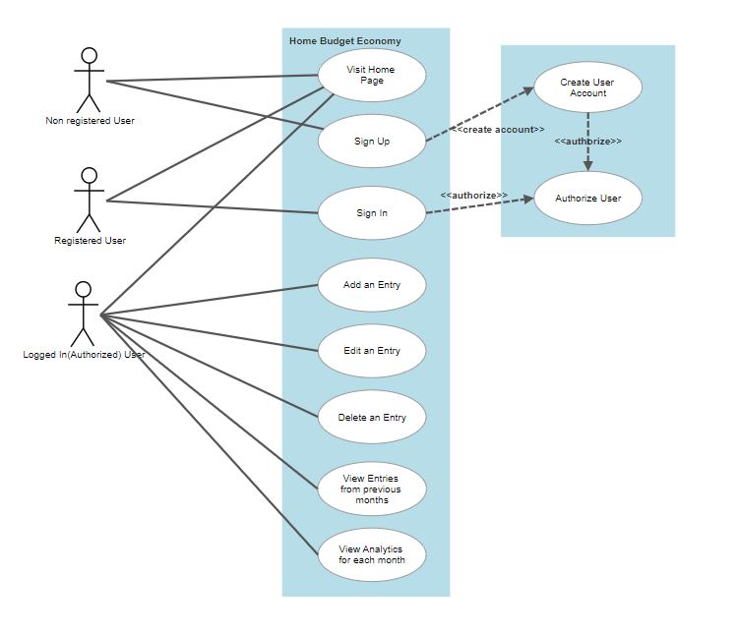

Use case description

Use Case Number: | 1
Use Case Name: | Visit Home Page
Overview: | Anyone can visit the homepage by visiting the site through the URL and view the contents provided on the home page.
Actors: | Any user.
Pre condition: | URL must be visited.
Flow: | Step1: Click or enter the URL.
 | None
Post Condition: | None

Use Case Number: | 2
Use Case Name: | Sign Up
Overview: | Unregistered users can sign up for the page by entering first name, last name, username, email id and password.
Actors: | Unregistered User.
Pre condition: | Authentication Page must be visited through the buttons provided on the navigation bar or home page and then the sign up form must be opened.
Flow: | Step1: Visiting the sign up form within Authentication page.  Step2: User must enter all the details asked by the form and then click “Sign Up” button.  Step3: The user is now registered and authorized for an hour.  Step4: The user is redirected to home page.
Alternate:
Step1: If entered details are missing or conflicting, the nothing happens. The website should show the necessary warning message.
Post Condition: | None

Use Case Number: | 3
Use Case Name: | Sign In
Overview: | Registered users can sign in for the page by entering email id and password.
Actors: | Registered User.
Pre condition: | Authentication Page must be visited through the buttons provided on the navigation bar or home page.
Flow: | Step1: Visiting the sign in form within Authentication page.  Step2: Registered User must enter email id and password and then click “Sign In” button.  Step3: The user is now authorized for viewing their dashboard.  Step4: The user is redirected to home page.
Alternate:
Step1: If entered details are missing or conflicting, the nothing happens. The website should show the necessary warning message.
Post Condition: | None

Use Case Number: | 4
Use Case Name: | Add an Entry
Overview: | In Budgeter page the authorized user can add an entry to their dataset.
Actors: | Authorized User.
Pre condition: | Budgeter page must be visited through the dashboard button provided on the navigation bar.
Flow: | Step1: Visiting the Budgeter Page.  Step2: Click on the “Make an Entry” button.  Step3: Add data in the required fields.  Step4: Click “Submit”.
Alternate:
Step1: If entered details are missing or conflicting, the nothing happens. The website should show the necessary warning message.
Post Condition: | None

Use Case Number: | 5
Use Case Name: | Edit an Entry
Overview: | In Budgeter page the authorized user can edit an entry present in their dataset.
Actors: | Authorized User.
Pre condition: | User must be authorized and present on Budgeter page.
Flow: | Step1: Present on the Budgeter Page.  Step2: Click on the Edit icon button present beside each entry.  Step3: Edit data on the modal opened.  Step4: Click “Submit”.
Alternate:
Step1: If entered details are missing or conflicting, the nothing happens. The website should show the necessary warning message.
Post Condition: | None

Use Case Number: | 6
Use Case Name: | Delete an Entry
Overview: | In Budgeter page the authorized user can delete an entry present in their dataset.
Actors: | Authorized User
Pre condition: | User must be authorized and present on Budgeter page.
Flow: | Step1: Present on the Budgeter Page.  Step2: Click on the Delete icon button present beside each entry.
 | None
Post Condition: | None

Use Case Number: | 7
Use Case Name: | View Entries from previous months
Overview: | Authorized user can select a month from the side bar and view all the entries that pertain to that month.
Actors: | Authorized User
Pre condition: | User must be authorized and present either on the Budgeter page or Analytics page.
Flow: | Step1: Present on either the Budgeter Page or Analytics Page.  Step2: Click on the Date button and select a date from a list of dates on sidebar.
 | None
Post Condition: | None

Use Case Number: | 8
Use Case Name: | View Analytics for each month
Overview: | Authorized user can view their data in the Analytics section in the form of line chart. There will be 1 Income line, 4 expenditure lines and 1 savings line.
Actors: | Authorized User
Pre condition: | User must be authorized and present either on the Analytics page.
Flow: | Step1: Click on the Analytics button present on the Budgeter page.  Step2: View the data for the selected month.
 | None
Post Condition: | None

Use Case Number: | 9
Use Case Name: | Create User Account
Overview: | Server will create an account for the use with the details provided by the user. Password will be encrypted.
Actors: | Server
Pre condition: | None
Flow: | Step1: The server receives an API request for user creation.  Step2: The server will use mongoose and models provided to create a user entry and user_transactions entry in tables in the database.
Alternate:
Step1: If request has any conflicts, then warning response with corresponding response status will send accordingly.
Post Condition: | None

Use Case Number: | 10
Use Case Name: | Authorize User
Overview: | Upon signing up or signing in, server would generate a jwt token, which will expire after one hour, to authorize the user.
Actors: | Server
Pre condition: | The user must be registered.
Flow: | Step1: The server receives an API request for user authorization upon sign in.  Step2: The server will check the details provided and authorize the user accordingly.  Step3: The server will create a jwt token and return the user details along with jwt token accordingly.
Alternate:
Step1: If request has any conflicts, then warning response with corresponding response status will send accordingly.
Post Condition: | None

