Problem statement:

Create an API endpoint using AWS

1) Open AWS

2) Create the EC2 Instance and connect to that

3) Install

Java

Maven

Git

4) Clone the Repo https://github.com/onlyfullstack/rest-assured-tutorial.git

5) cd rest-assured-tutorial

6) mvn spring-boot:run

======================================

API Chaining using Rest assured and Maven project

1) Get All Employee

2) Create Employee

3) Update the Employee

4) Delete that Employee

5) Get Deleted Employee

Creating API end point on AWS:

1. Opening AWS in lab

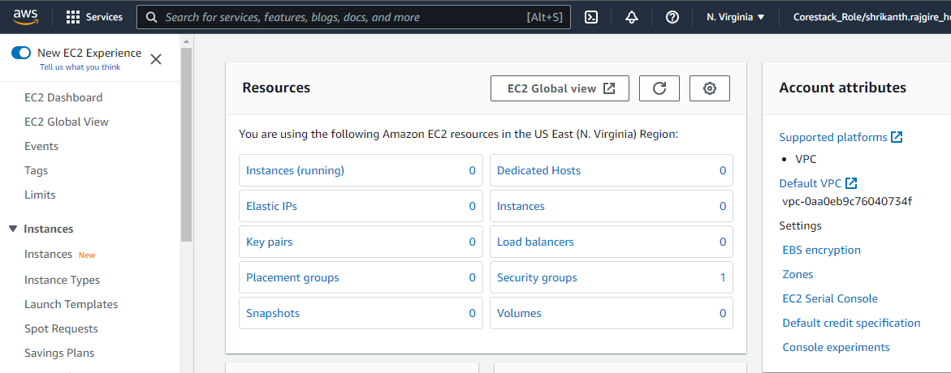

1. Create the EC2 Instance and connect to that

Start the EC2 instance

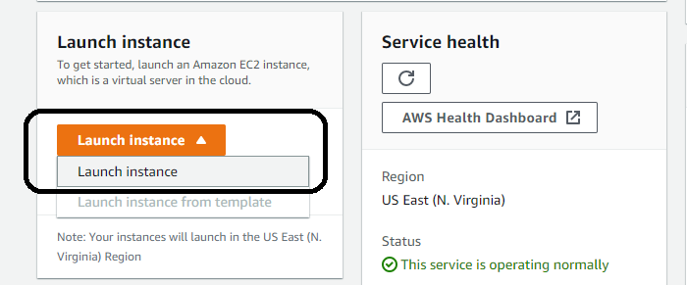

Configure EC2 instance

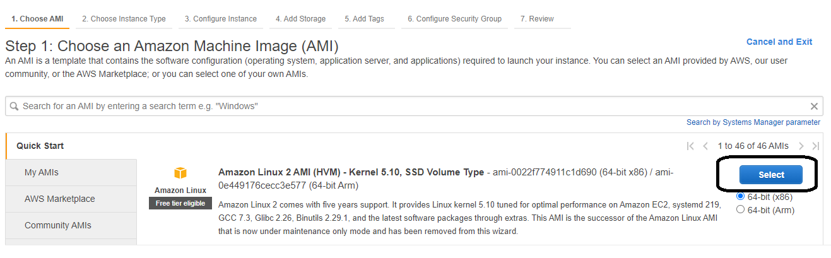

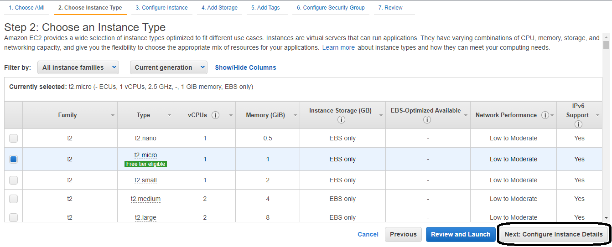

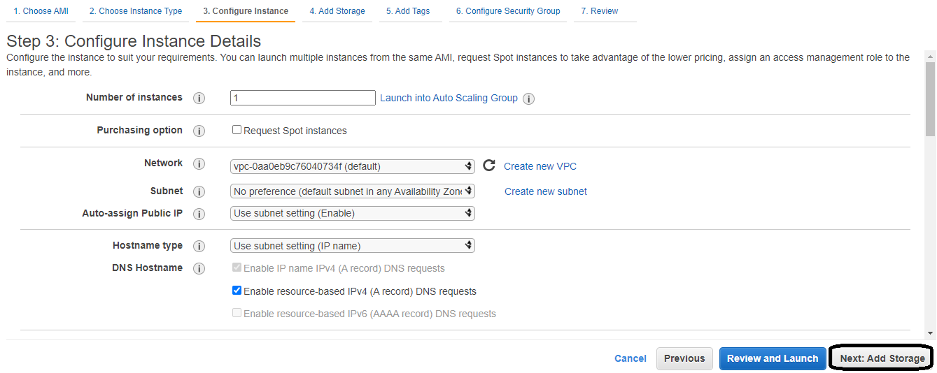

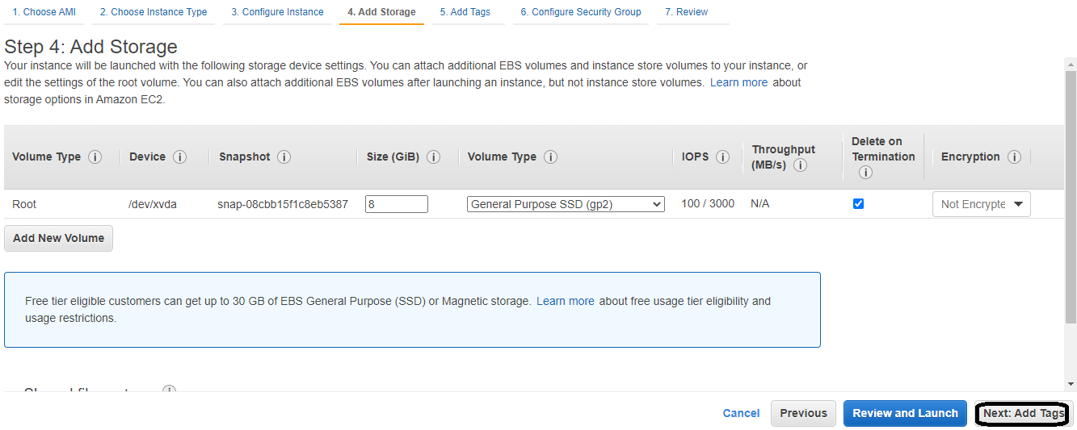

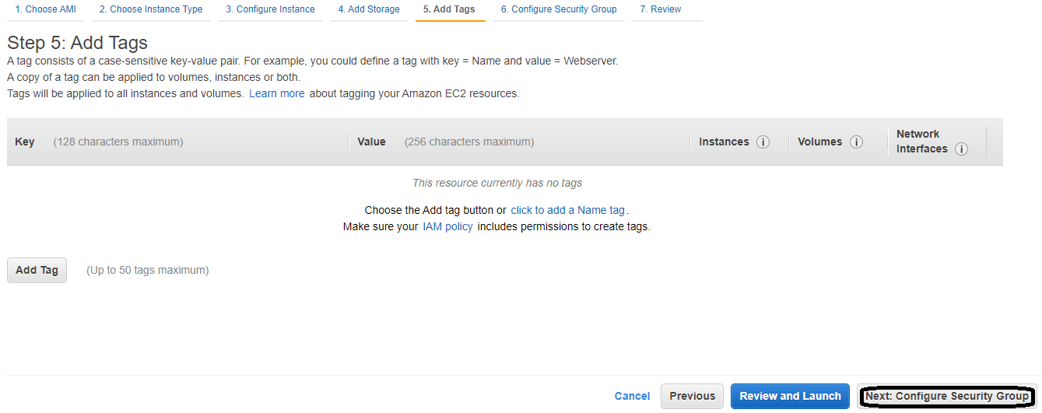

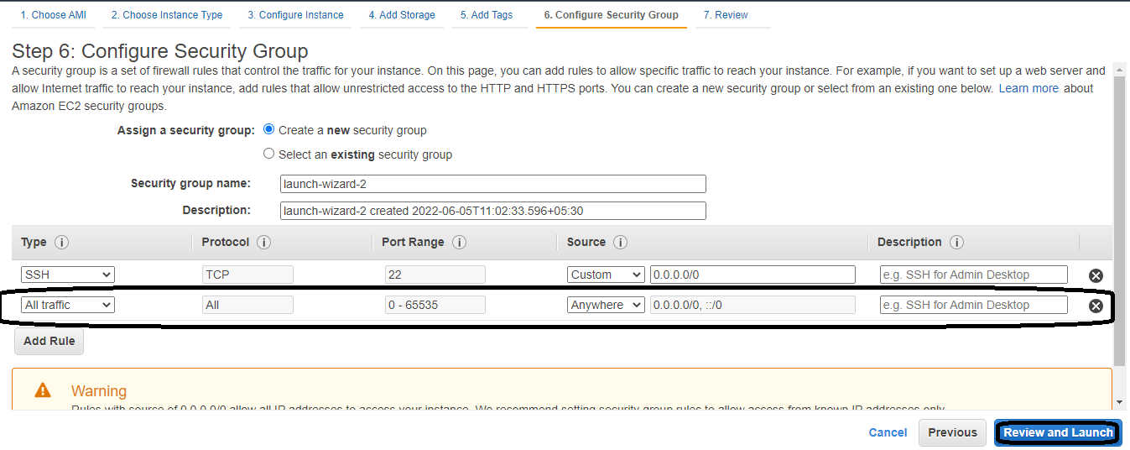

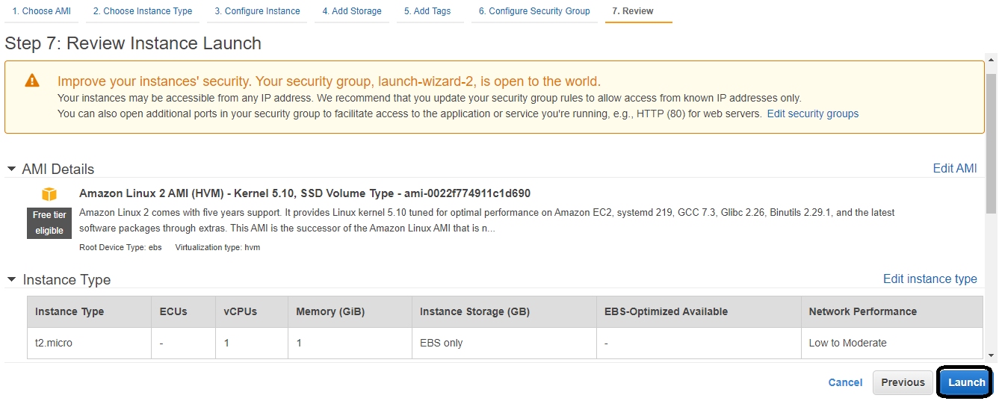

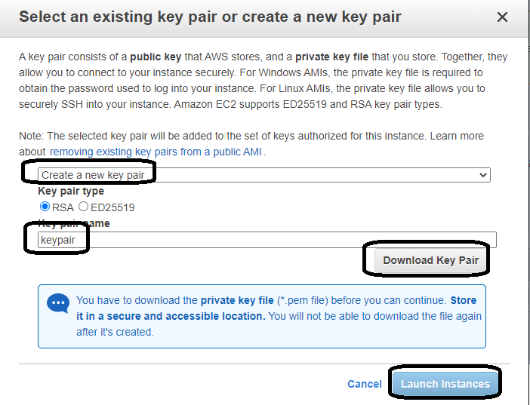

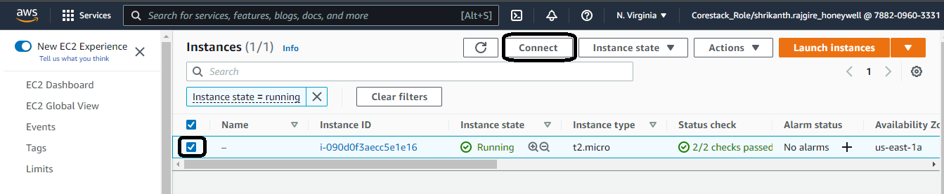

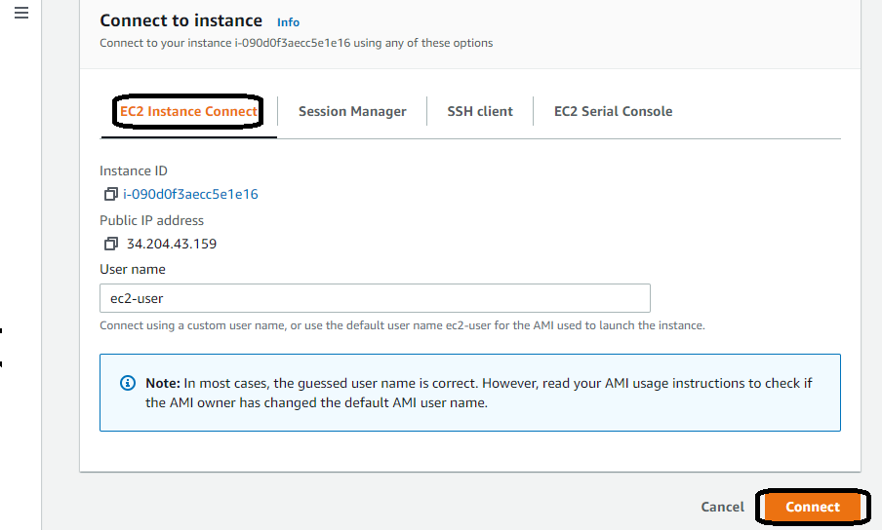

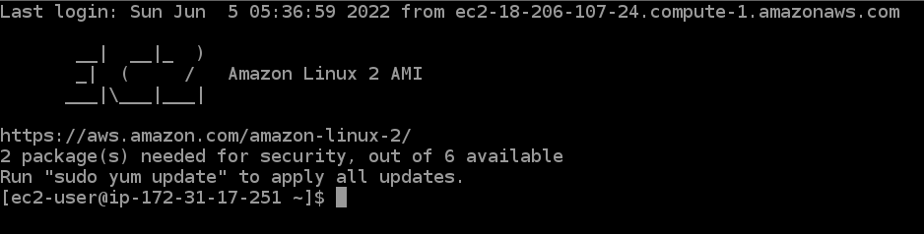

3) Install below software using the mentioned commands

Java

sudo yum install java-1.8.0

Maven

sudo yum install maven

Git

sudo yum install git

1. Clone the Repo <https://github.com/onlyfullstack/rest-assured-tutorial.git>

Git clone <https://github.com/onlyfullstack/rest-assured-tutorial.git>

1. Change the current directory to rest assured tutorial

cd rest-assured-tutorial

1. Run the java spring server

mvn spring-boot:run

API Chaining using Rest assured and Maven project

Create new Maven project “Phase3Project”

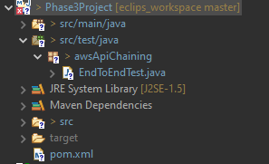

Add below dependencies in pom.xml file

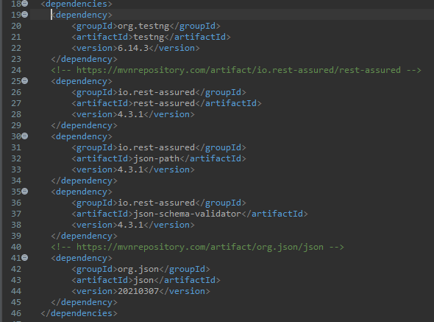

Access the API running on the AWS using the end point & validate

<http://34.204.43.159:8088/employees>

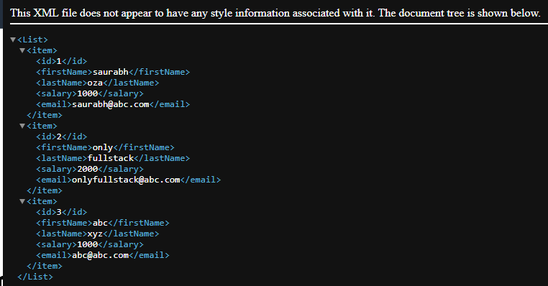

Created the EndToEndTest java class

Create test function with Test as annotation contains end to end API testing as mentioned below steps

1) Get All Employee

2) Create Employee

3) Update the Employee

4) Delete that Employee

5) Get Deleted Employee

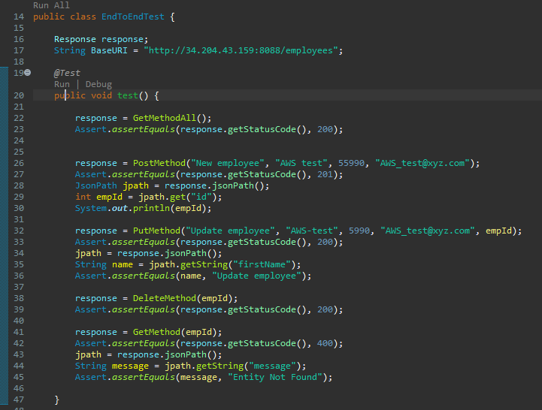

Get and Post method function definitions

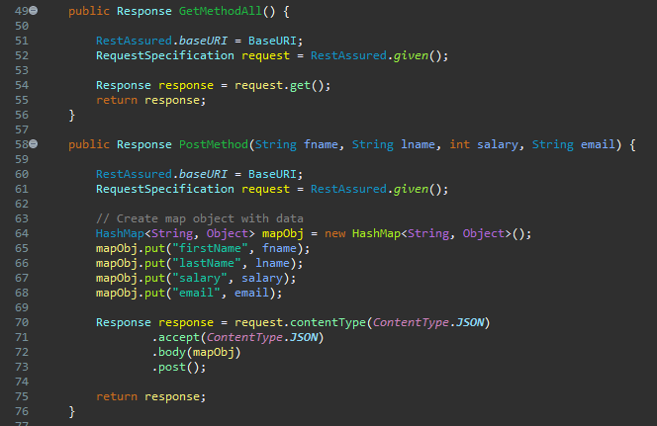

Put and Delete method function definitions

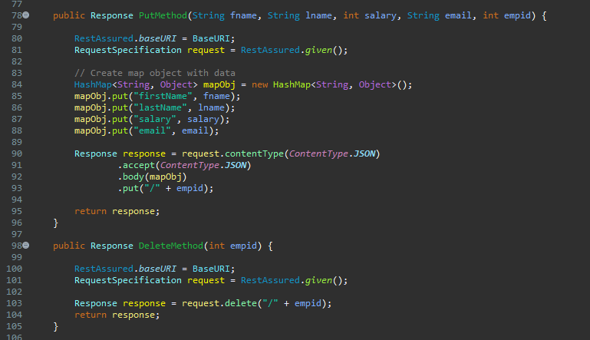

Get single employed method definition

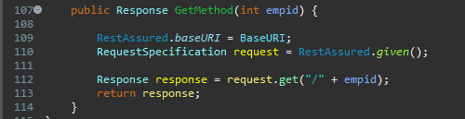

After running the test tests for pass result is attached below.

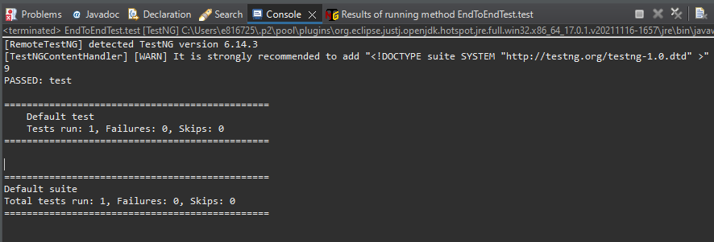

Below is the GitHub link for the full source code of Phase 3 project

<https://github.com/sgrajgire/SimpliLearn_Phase3Project.git>

Path to the source code:

[SimpliLearn_Phase3Project](https://github.com/sgrajgire/SimpliLearn_Phase3Project)/[src](https://github.com/sgrajgire/SimpliLearn_Phase3Project/tree/main/src)/[test](https://github.com/sgrajgire/SimpliLearn_Phase3Project/tree/main/src/test)/[java](https://github.com/sgrajgire/SimpliLearn_Phase3Project/tree/main/src/test/java)/**awsApiChaining**/