Phase 4 Project

Mobile Automation and Cloud Testing

**Project objective:**

Amazon Web Services (abbreviated AWS) is a collection of remote computing services (also called web services) that together make a cloud computing platform, offered over the Internet by Amazon for an infrastructure. Let's consider the Swiggy application which uses Devops tools like (Jenkins/Appium/Docker) for improved automated testing infrastructure, continuous integration, continuous deployment, and continuous delivery.

Steps followed

* Create Maven project for the Swiggy application.
* Write an Appium script.
* Create EC2 instance, S3 bucket, creating EBS volume, and mounting in AWS console.
* Set up Jenkins server by installing Jenkins in ec2 and by installing required plugins like Docker/Selenium in Jenkins.
* Set up Docker for containerizing your application on Docker.
* Create a CI/CD pipeline in Jenkins with Appium test cases and containerizing the application using Docker.

# Creating a Maven Project

Created Phase4project Maven project

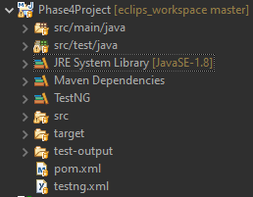

Added all the dependencies in pom.xml file

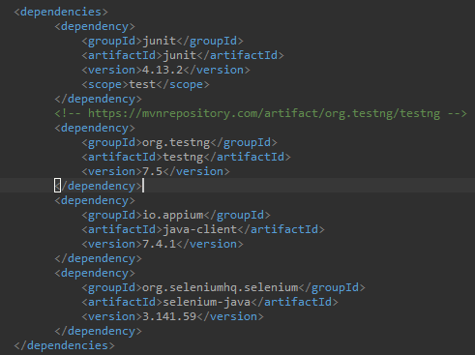

# Writing Appium script

## Create test class “SwiggyAppTest.java” file

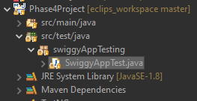

## Importing all required libraries

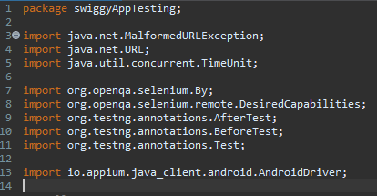

## Created initial setup

Setting up physical android phone with below configuration

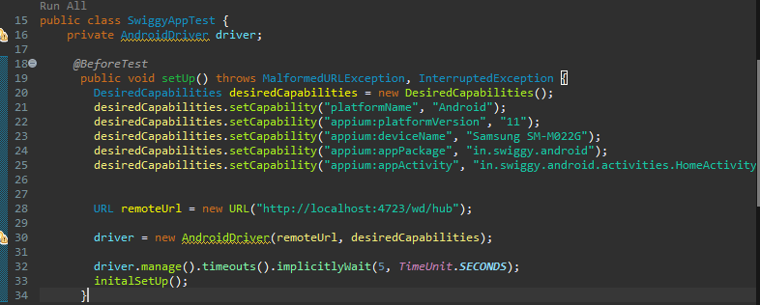

Initial setup for Swiggy application

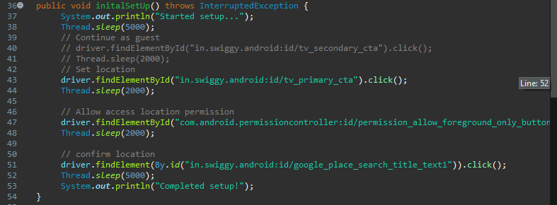

## Test cases to search for an item or restaurant

Common search function

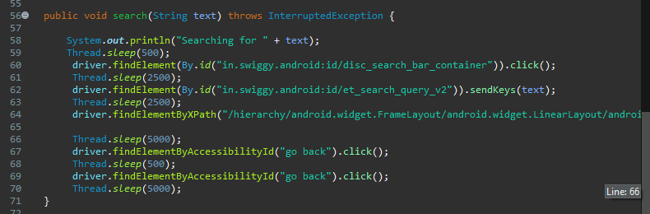

Test cases to search a food item and a restaurant

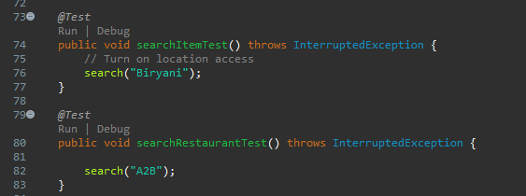

## Test case to change location of Swiggy application

Changing current location to Bangalore

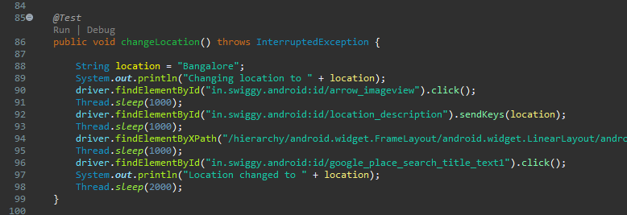

## Quit the application

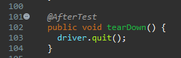

## Convert the project to TestNG: creating the testing.xml file

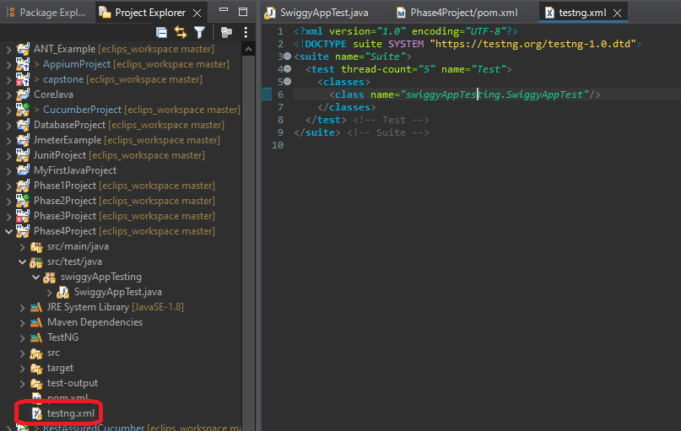

## Running the testing.xml using TestNG locally

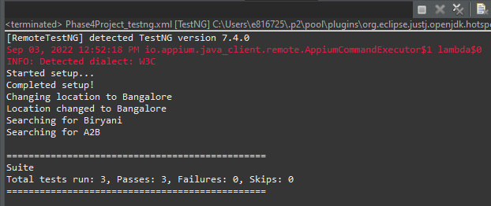

## Moving the code to GitHub

Pushed the code to GitHub : <https://github.com/sgrajgire/SimpliLearn_Phase4Project.git>

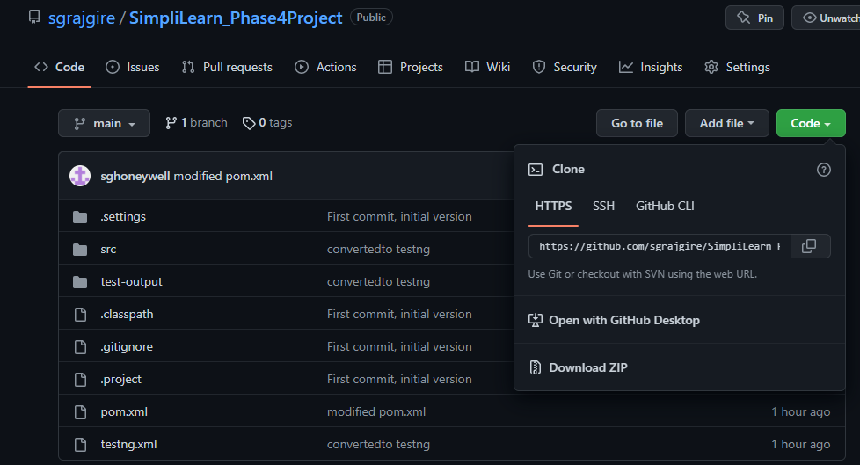

## Creating EC2 Instance in AWS

Opening AWS in lab

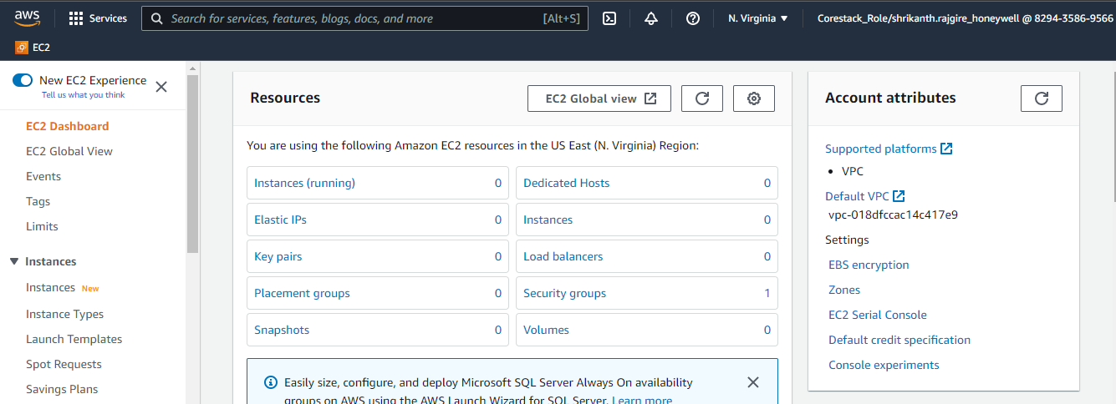

Create the EC2 Instance and connect to that

Start the EC2 instance

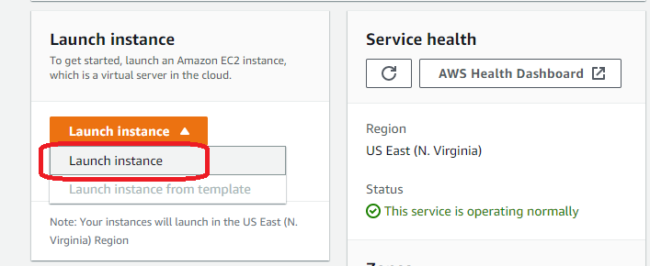

Configure EC2 instance

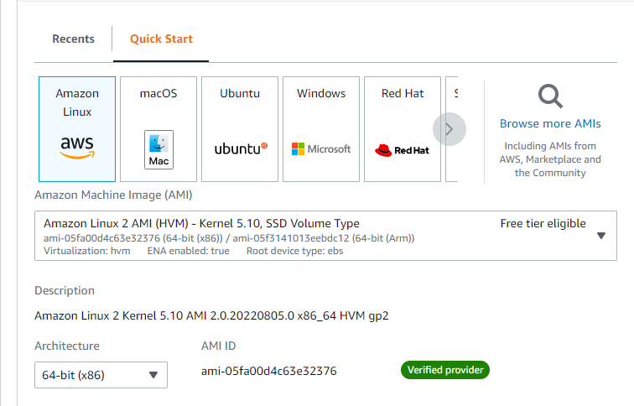

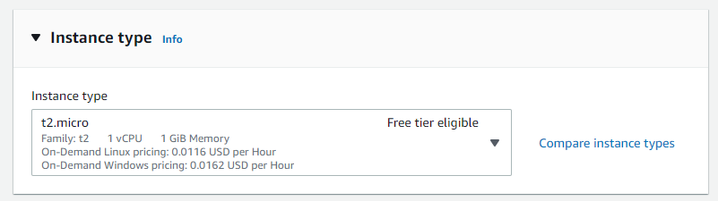

Create a new key pair

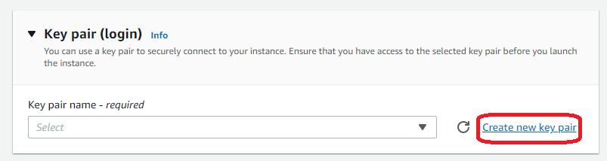

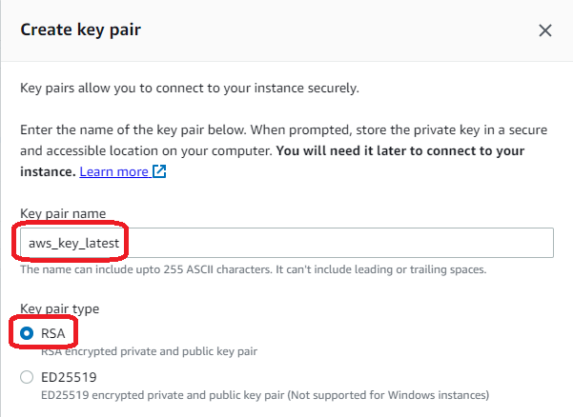

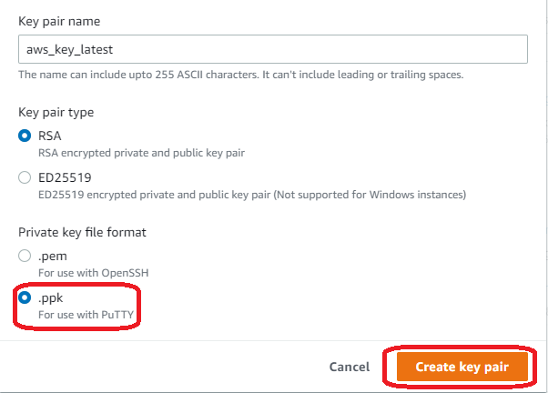

Network settings

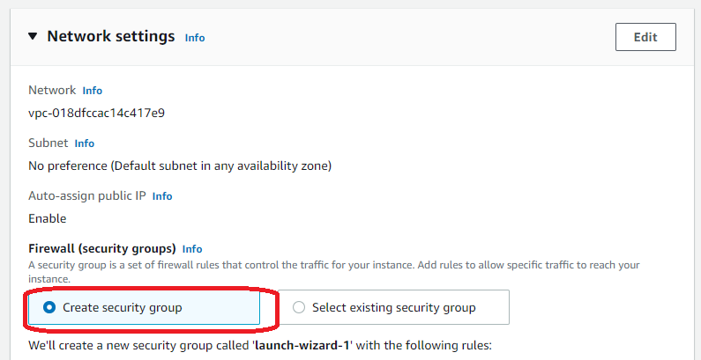

Add new security rule

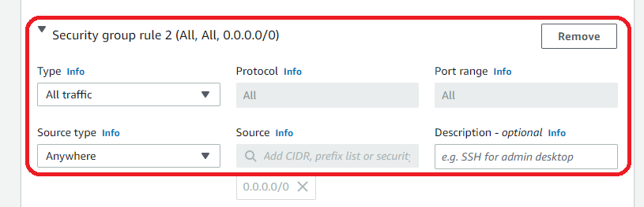

Add storage

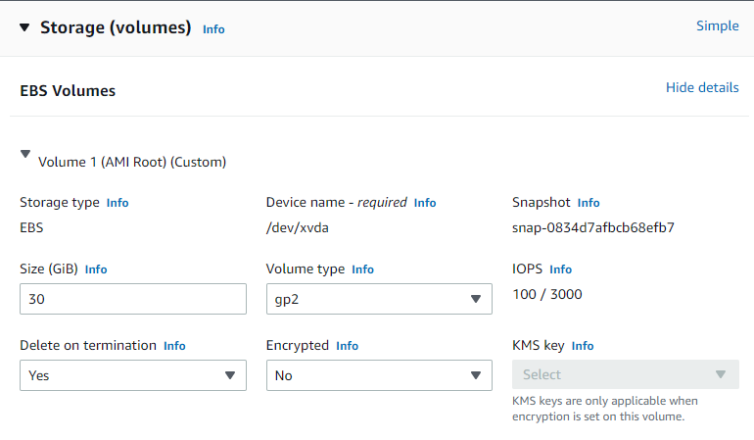

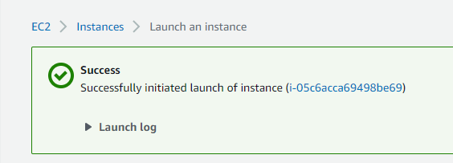

EC2 status and connect to that machine

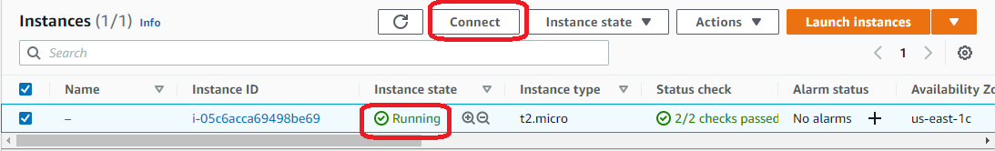

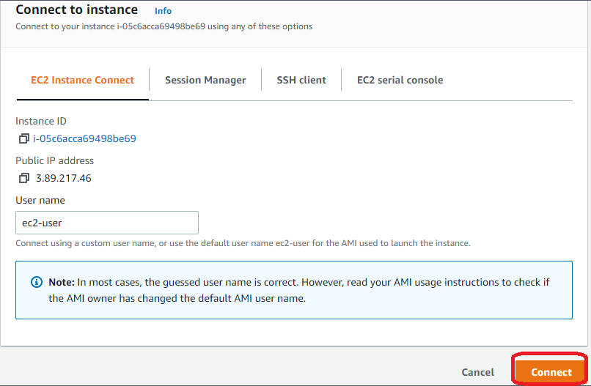

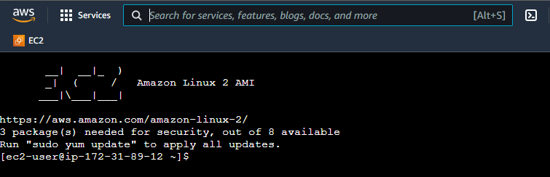

Update : sudo yum update -y

Install docker on EC2 with below command:

sudo amazon-linux-extras install docker -y

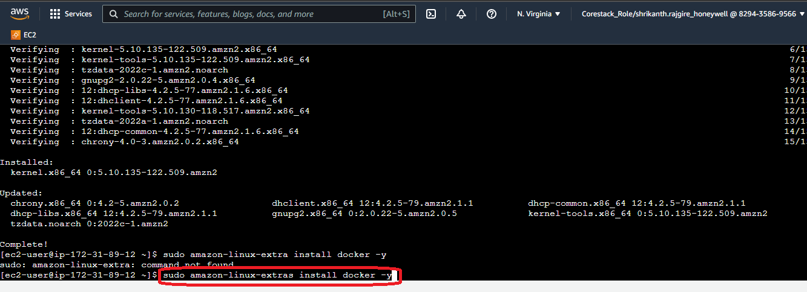

Start the docker on EC2

sudo service docker start

Check the docker version

docker –version

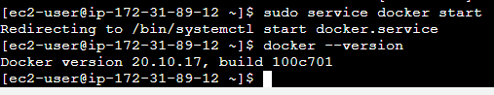

Install & run Jenkins on docker in EC2 machine

docker run -p 8080:8080 -p 50000:50000 jenkins:2.60.3

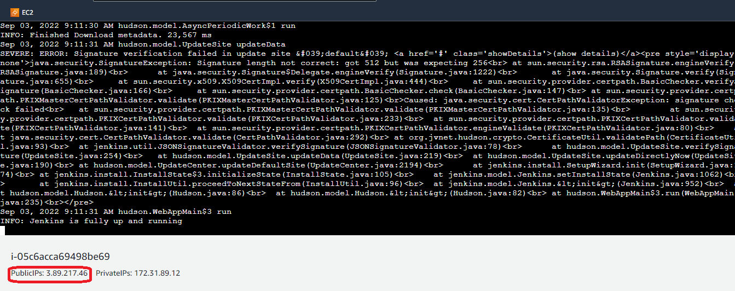

Connect to Jenkins using public 3.89.217.46 and port 8080

<http://3.89.217.46:8080/>

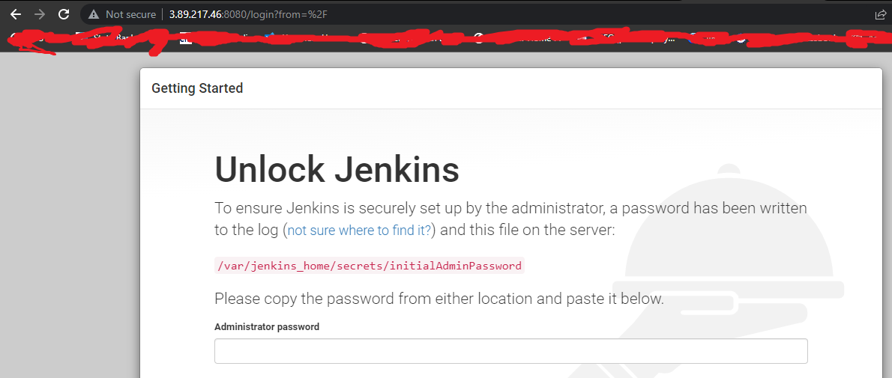

Copy the initial password from below

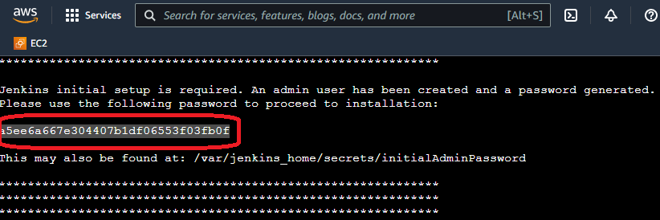

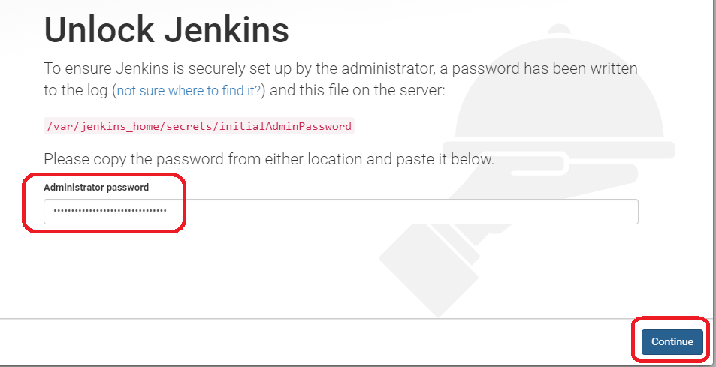

Select plugins to install

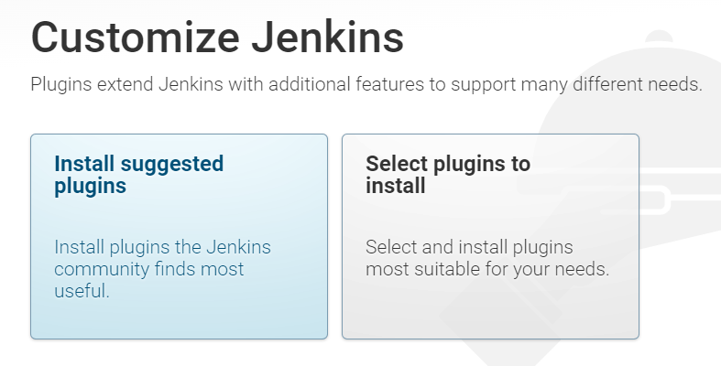

Select plugins and install

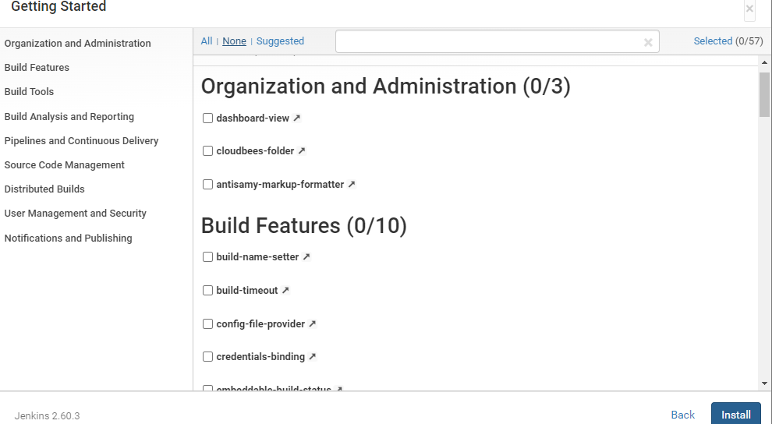

Create first user on Jenkins, Save and finish.

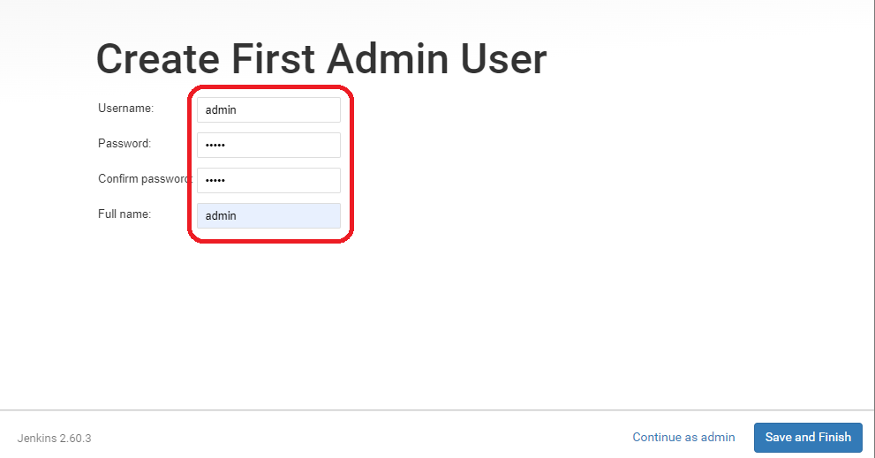

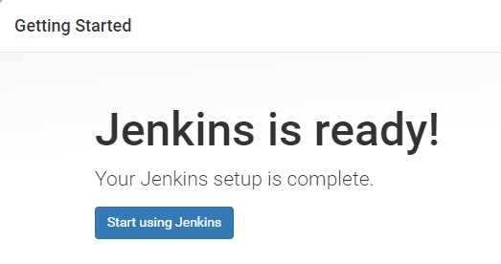

Landing page

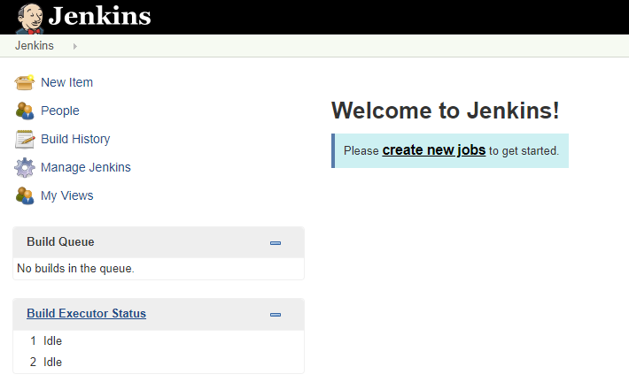

Create new job

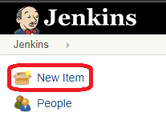

Enter project name and choose free style project

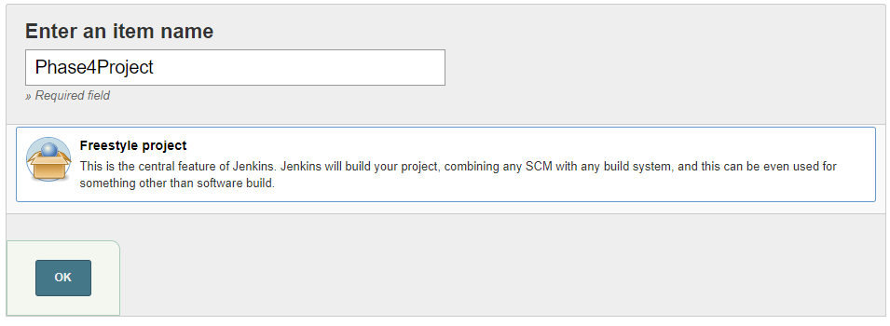

Fill necessary details as below

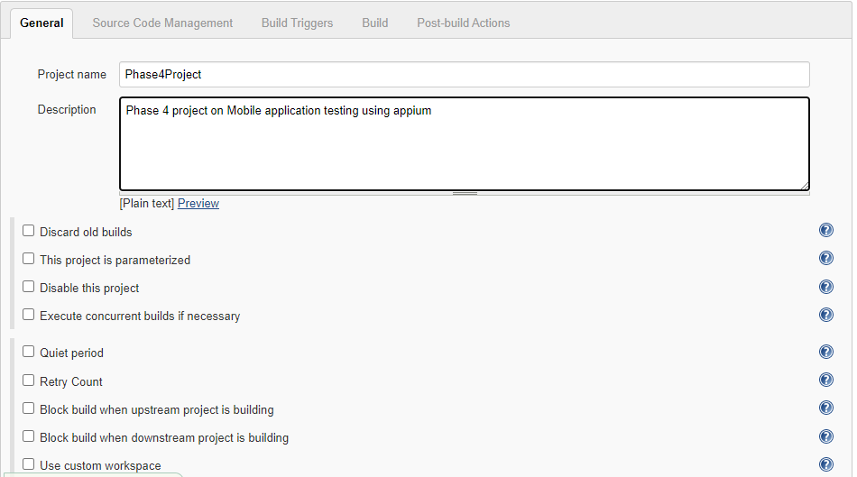

Add Git repository

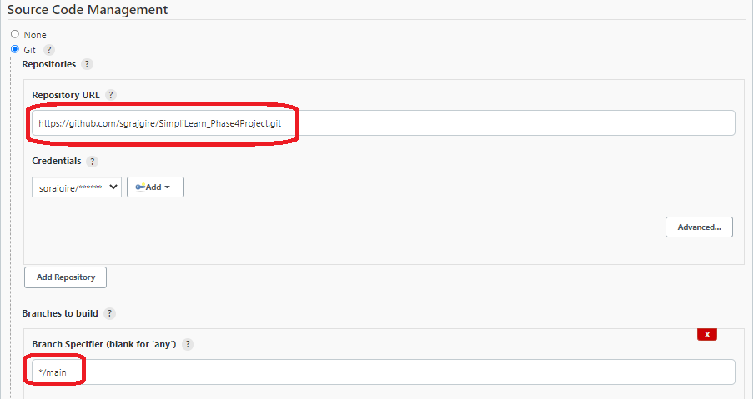

Add build

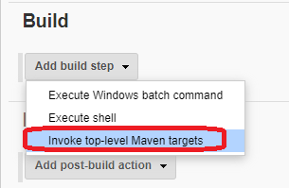

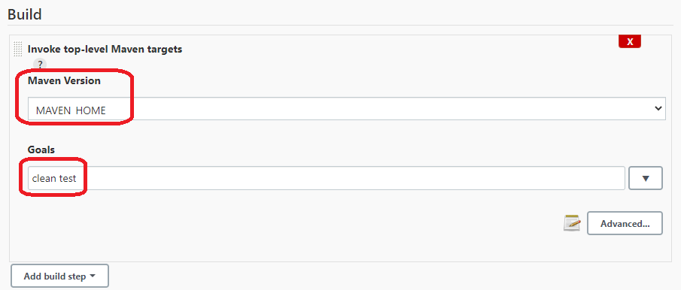

Setup post build with report

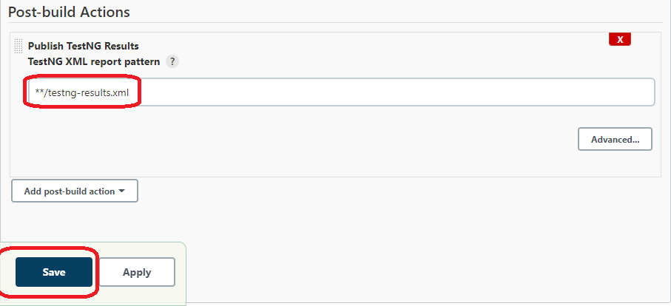

Executed tests on Jenkins under docker and results are below

Online simulator wasn’t available so executed on local system using docker and jenkins

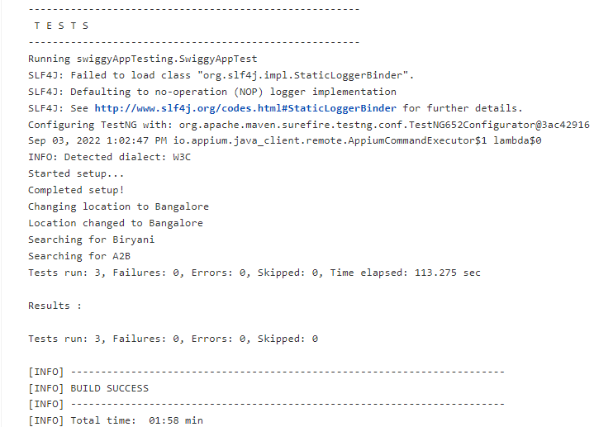

TestNG results

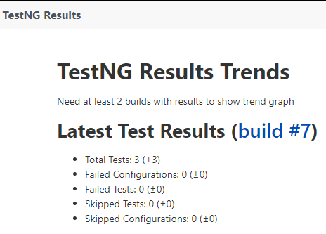

## Github Link to source code

<https://github.com/sgrajgire/SimpliLearn_Phase4Project.git>