Solverah — Causal Fit Model
First draft causal graph + implementation plan · July 2026

Why a causal graph, not a similarity score
Most "fit" tools compare a person profile and a company profile as two independent vectors and measure distance between them. That treats fit as similarity. Solverah's own thesis — understanding the interaction between person and environment, not either alone — is a different, stronger claim: it says a specific person trait combined with a specific environment trait produces a specific outcome. That is a causal claim, not a correlational one, and it requires a different kind of model: a causal Bayesian network, where edges represent hypothesized cause-and-effect mechanisms and each edge's strength is a probability that sharpens as real evidence comes in, rather than a fixed weight.
The graph below is a first-draft hypothesis, not a finished model. It is meant to be argued with tonight, not accepted as-is.

First-draft causal graph
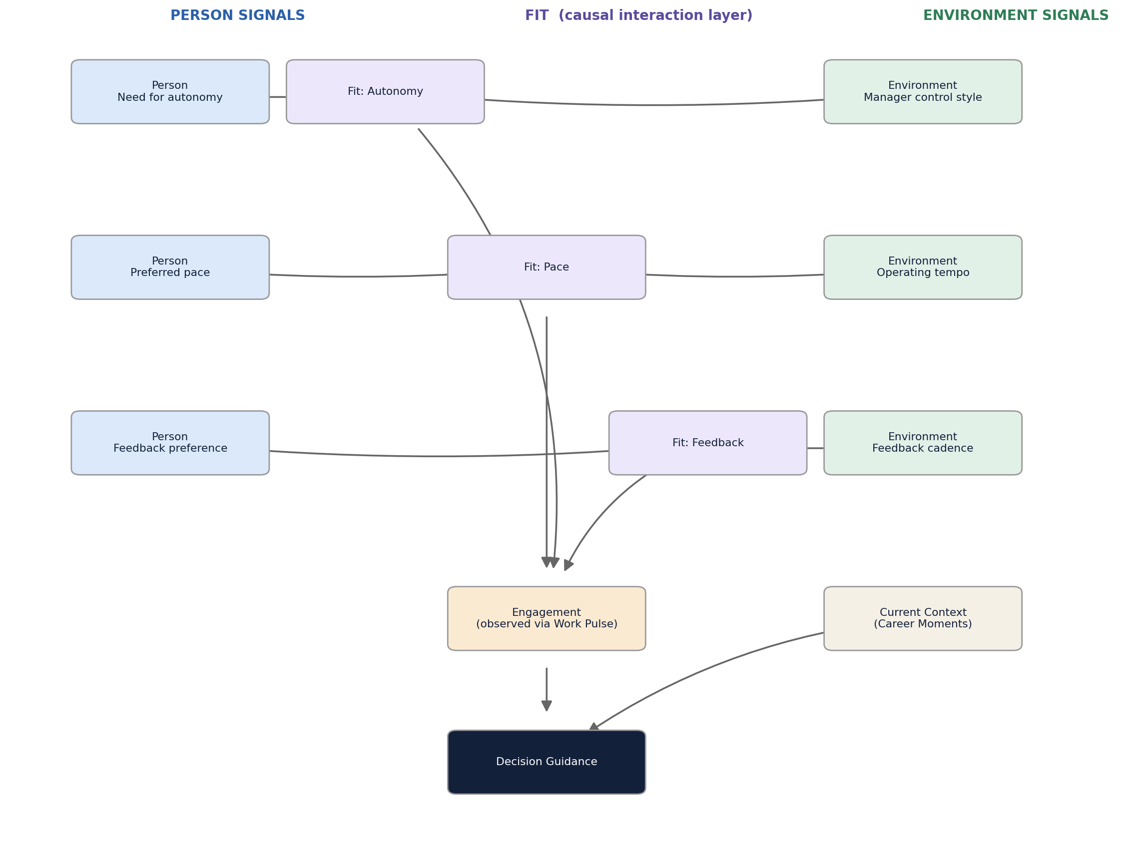
Read the graph as: person-side traits and environment-side traits each causally feed a Fit node for that dimension (autonomy, pace, feedback style). The Fit nodes jointly drive Engagement, which Work Pulse observes over time. Engagement plus Current Context (from Career Moments) drives the Guidance output. Only three dimensions are sketched here — enough to prove the shape works. Every additional Solverah signal (values alignment, growth trajectory, workload tolerance, etc.) becomes another Person/Environment pair feeding its own Fit node into the same Engagement node.

Node definitions
Node | Layer | Feeds from | What it represents
P_Autonomy | Person | Reflection | Person's need for autonomy
P_Pace | Person | Reflection | Person's preferred work pace / tempo
P_Feedback | Person | Reflection | Person's preferred feedback style
E_ManagerStyle | Environment | ManagerMatch | Manager's control vs. empowering style
E_CulturePace | Environment | CompanyLens | Company's operating tempo
E_FeedbackCadence | Environment | ManagerMatch | Manager's feedback cadence / style
Fit_Autonomy / Pace / Feedback | Fit (causal) | Derived | The interaction node — not a distance metric, a hypothesized causal outcome of the person/environment pair
Engagement | Outcome | Work Pulse | Observed over time; driven jointly by all Fit nodes
Current Context | Context | Career Moments | Timing, urgency, career stage — modifies guidance, not fit itself
Guidance | Output | Decision Intelligence | The recommendation, driven by Engagement + Current Context

Why this specific piece is the IP
Everything left of the Fit layer (signal capture) and everything right of Guidance (narrating the output in natural language via an LLM) is replicable by any competent team in weeks — it's commodity NLP and commodity LLM plumbing. The Fit layer is the part that isn't: the specific causal structure you assert, and the outcome data used to test and refine it over time, are what a competitor cannot get by reading your marketing materials. Protect and iterate on that layer deliberately; don't let engineering effort default to the two commodity ends because they're easier to build first.

Recommended tooling stack
Layer | Tool | Why
Graph structure | networkx | Lightweight, well-documented DAG representation; plays well with the other two libraries below
Bayesian network + inference | pgmpy | Pure Python. Defines CPDs by hand today, and later learns them from logged outcome data (MLE / BayesianEstimator) without a rewrite
Causal estimation + counterfactuals | DoWhy | Purpose-built for "what if" queries (interventions, counterfactuals) and includes refutation tests to check whether an assumed causal edge is actually supported by data, rather than spurious
Narrative layer (later) | LLM, RAG-style | Only narrates the structured output of the layers above — should not be doing the fit reasoning itself

Implementation phasing
Phase 0 (tomorrow): a single vertical slice — the autonomy dimension only, hand-specified CPDs, run end to end to prove the pipeline shape. Attached: autonomy_fit_model.py.
Phase 1: expand to the pace and feedback dimensions; combine three Fit nodes into one Engagement node, matching the full graph above.
Phase 2: start logging real signals from Reflection, Work Pulse, CompanyLens, and ManagerMatch even before the model uses them for live scoring — you need this dataset before Phase 3 is possible.
Phase 3: replace hand-specified CPDs with pgmpy's parameter learning, fit on logged outcomes.
Phase 4: layer DoWhy on top for intervention/counterfactual queries ("would guidance have differed under a different manager") and run its refutation tests against the causal structure itself.
Phase 5: Narrative Intelligence — an LLM grounded on the structured Fit/Engagement output, producing the human-readable explanation.

Tomorrow's starter code
autonomy_fit_model.py implements Phase 0 with pgmpy: a 5-node network (P_Autonomy, E_ManagerStyle, Fit_Autonomy, Engagement, Guidance) with hand-elicited CPDs, verified to run. Sample output — the same person trait (high need for autonomy) produces different guidance depending on the environment, which is the entire point:
P(Guidance | High autonomy need, Controlling manager):
Reconsider : 0.589 Proceed : 0.411
P(Guidance | High autonomy need, Empowering manager):
Reconsider : 0.345 Proceed : 0.655
Same person, different environment, different guidance — produced by an explicit causal mechanism (Fit_Autonomy) you can inspect, not a black-box similarity score. That inspectability is what makes the output "explainable" in the sense your architecture doc already promises.

Open questions for tonight's call
Does Reflection actually capture these traits as clean discrete states (Low/High), or is the real data messier / more continuous than a first-draft binary model assumes?
Are you comfortable hand-eliciting the initial causal structure and CPDs yourselves, or does this need a domain expert (an I/O psychologist) to sanity-check the edges before they ship in any form to users?
How will Solverah capture ground-truth outcome data — did this person actually thrive — since the entire model stays speculative until Phase 3 has real data to learn from?
Is binary (Low/High) per trait an acceptable v1 simplification, or does it undercut the "continuously evolving profile, no premature scoring" claim enough that you need ordinal or continuous states from day one?

