Slide 2 –

* Different user experiences for Students / Staff
* Administrative efforts for retention policies, phishing, maintenance, and troubleshooting are all doubled
* Collaborative learning is difficult. Document sharing/Teams/SharePoint are all separated
* Federated login (SSO) is only available at a single tenant without separate IDPs
* Managing and maintaining “Alumni” accounts for life creates an ever expanding user base. We aren’t Google/Microsoft.

Slide 4 –

* Vendor migration is possible, but at a high cost in large tenant situation
* Communication is a key component to success. Ensure that all departments are aware and gather information on how they use email addresses
* Decide what you want to move this goes for accounts (Alumni, Current students only) and content (OneDrive/Email/) and length of time.
* This process is not a short one, build your timelines accordingly. Set expectations with your school about the length. Once the timeline is set make sure to keep with your dates.
* Decide when you want to begin creating accounts only using the new process.
* Covid provided an opportunity to strike while our enrollment was stagnant
* The basic outline of our process was 6 steps
* Stop creating new student email addresses in @eagles. Transition all new student accounts to @ewu.edu
* Open migration for volunteers, March 2021.
* Shutdown alumni email, June 2021. (they were all notified last year and given a year to make the transition)
* Begin mass migrations after commencement, June 2021.
* Complete migration, September 1, 2021.
* Shutdown @eagles addresses completely after commencement, June 2022.

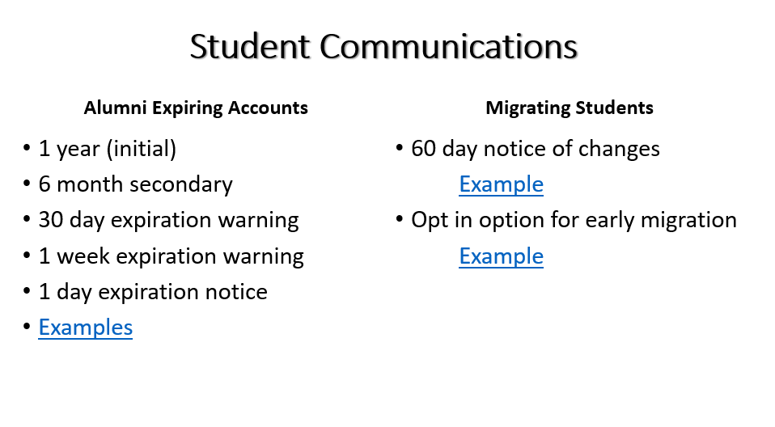

Slide 5

DESTINATION (FIRST IN ORDER BECAUSE MICROSOFT)

* **In Azure AD select App Registrations (New Registration)**
  + Name the application and select – Accounts in Any organizational directory (Azure AD Multitenant)
  + In the Redirect URI use [https://office.com](https://office.com/)
  + After the application is created note the App (client) ID
  + Review the permissions Select Request API Permissions and select Exchange Online/Mailbox/Mailbox Migration. Click Add
  + Under Client Secrets for the application select New Client Secret – Set your desired expirations **SAVE THIS PASSWORD**
* **Create the Organizational Relationship using** [**des_orgrel.ps1**](https://github.com/sgreen25/BuildingBridges/blob/main/des_orgrel.ps1)
  + You will need the Application ID / Password for this step
* **Once the application is created you’ll need to find it in the Azure AD Applications list. Select the app and click permissions/Grant. You’ll have to authenticate and click accept as an admin for the tenant**
  + The application will be located at the following URL:

[https://login.microsoftonline.com/sourcetenant.onmicrosoft.com/adminconsent?client_id=[application_id_of_the_app_you_just_created]&redirect_uri=https://office.com](https://login.microsoftonline.com/sourcetenant.onmicrosoft.com/adminconsent?client_id=%5bapplication_id_of_the_app_you_just_created%5d&redirect_uri=https://office.com)

SOURCE 2nd Steps

* **Login to your Source Tenant (you may need to use a separate browser, or private browsing session.** 
  + Go to the URL provided from the application authorization in the destination tenant and accept the authorization
* **Create the Organizational Relationship using** [**source_orgrel.ps1**](https://github.com/sgreen25/BuildingBridges/blob/main/source_orgrel.ps1)
  + You will need the Tenant ID of the Destination, the App ID of the application in the Target
  + You will also need to create a Mail Enabled Security Group for all of the users who are being migrated to be placed into

SLIDE 6

* Create Batches (Microsoft will throttle your connections)
* The users will need to be put into the security group in the source tenant before they will be authorized to migrate
* You will need to match the ExchangeGuid, and add the LegacyExchangeDN from the source tenant to the destination
* *Use the Exchange Online GUI, do not auto complete the batches. You can save yourself a bunch of effort and control the process.
* The Steps and Scripts are detailed [here](https://github.com/sgreen25/BuildingBridges/blob/main/Steps_Scripts.txt)
* If you are moving OneDrive files be sure to use the step to create the OneDrive in the destination tenant

SLIDE 8

* No matter how much you communicate people will get errors from caching and bookmarked pages.
* All users now have a seamless experience regardless of Staff/Student/Faculty
* Faculty can now share Teams/OneDrive with the users via the Address Book in Exchange
* Security is in a single location
* User account flow is simplified to a single line with very few exceptions.

SLIDE 9

* Have a plan.
* Map out how your existing processes work (Onboarding Students/Staff)
* Communicate the coming change to internal support users, and students as early as possible
* It’s a slow process
* Find all of the applications you’ll need to update email addresses in manually and work with the stakeholders and vendors to create import files. It’s much easier to do mass changes this way.
* Accept the fact that no matter how well, or how often you communicate people will not pay attention. Work with your support staff front line to create a unified response to those users.