Inventory Screen, Sean Griffen

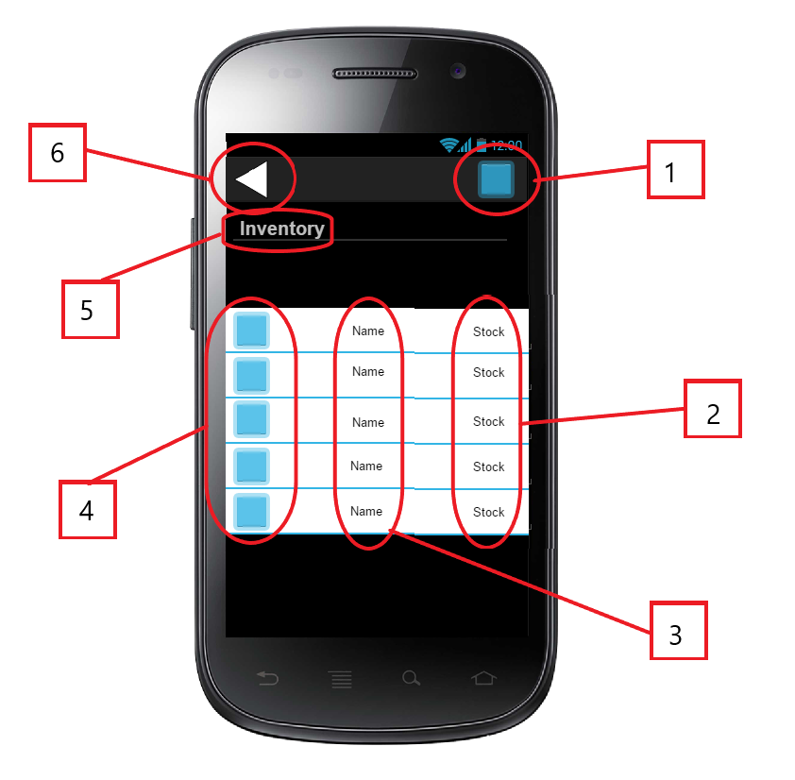

The inventory component of this app is part of the user’s information. It is accessed from either the user’s profile, or the main screen, the map. This screen is denoted by the title (5), and can be exited by either the phone’s built in back button, or the in-app back button (6). The user can also click (1) to see their profile to tweak user settings like name, password, matches in, etc. The Main part of this screen is the list of items that the user currently has. Each item comes with a picture (4), a name (3), and a number denoting how much of that item the user has in possession (2). The item block positions scale according to how many items the user has (e.g. the icons, name, and stock become larger when there are less items to display, and smaller to a point, then “scrollable” when there are a lot of items to display). What items are displayed on this screen is completely unique to a specific user and cannot be edited by a different account.

Store Screen, Sean Griffen

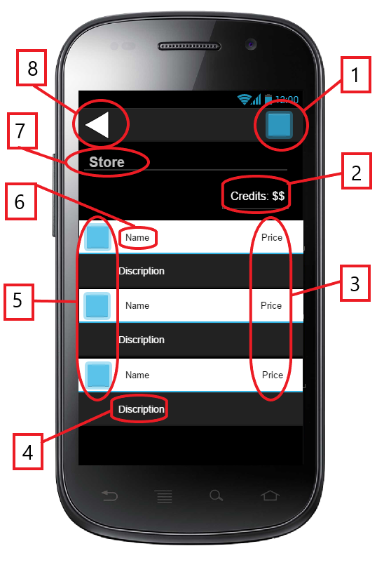

The store component of this app works similar to the inventory screen in the sense that it displays items. This has a different functionality however, as on this screen, the user adds to their inventory by tapping an item (providing that the user has an equal or greater amount of game credits (2) to the price (3) of the item). The screen has a title (7), so the user knows which screen they are on, and this screen can be exited in the same way as the inventory screen, by hitting the device’s back button, or the in-app back button (8). Each item comes with a picture (5), a name (6), and a short description (4) of how to use it like its radius of effect on other users and/or effects on the user carrying said item. The user can also click their icon (1) so see their settings in the same way as the inventory screen. This screen is not unique to an individual player but is unique to a match. A Moderator can change which items are available to use in a given match, and this screen will reflect that.