Synthetic Identity Fraud Detection in Digital Lending Onboarding
KYC Verification & Behavioral Telemetry Machine Learning System

1. Executive Summary
Digital lending platforms require automated risk assessment to approve loans rapidly without compromising security. Synthetic Identity Fraud (SIF) poses a critical threat because perpetrators assemble composite identities combining real credential fragments (e.g. valid PAN numbers) with fabricated contact details. Standard rule-based KYC systems frequently pass these applications because individual document fields appear valid.
This project develops an end-to-end Machine Learning pipeline combining KYC consistency scores, identity freshness indicators, behavioral biometrics, and device/network telemetry to detect synthetic identities in real time.
Key Performance Metric | Score Achieved | Benchmark Status
ROC-AUC | 0.8834 | Exceeds Target (>0.85)
Fraud Precision | 0.9500 | Low False Positives (Minimizes Friction)
Fraud Recall | 0.7500 | Catches 3/4 Synthetic Applicants
Fraud F1-Score | 0.8400 | Strong Imbalanced Performance
Overall Model Accuracy | 0.9600 | High Overall Reliability

2. Problem Statement & Risk Vectors
Synthetic identity fraudsters exploit traditional KYC gaps through two main strategies:
1. Fragmented Synthesis: Combining a real citizen's PAN/SSN with a fabricated name or address.
2. Credit Building & Bust-Out: Maintaining thin credit files over several months to increase credit limits before maxing out loan lines and abandoning the account.
Because synthetic applications do not immediately generate victim fraud complaints, machine learning models must look beyond basic static document checks and evaluate behavioral signals and network application velocity.

3. Feature Dictionary (12 Core Signals)
Category | Feature Name | Description
KYC Consistency | name_address_mismatch_score | Distance score between stated name/address & records.
KYC Consistency | dob_pan_mismatch | Binary flag if DOB mismatches PAN database.
KYC Consistency | document_reuse_count | Times document image fragments appeared previously.
Identity Freshness | phone_age_days | Age of registered mobile line in days.
Identity Freshness | email_age_days | Estimated age of applicant email account.
Identity Freshness | credit_bureau_hit | 1 if credit bureau record exists; 0 for thin file.
Identity Freshness | social_footprint_score | Composite public digital footprint score.
Behavioral Telemetry | session_fill_time_sec | Total form completion duration in seconds.
Behavioral Telemetry | typing_speed_variance | Keypress speed variance (low = bot/copy-paste).
Device & Network | device_reuse_across_apps | Distinct identities on same device fingerprint.
Device & Network | application_velocity_24h | Applications submitted from same IP/device in 24h.
Device & Network | ip_geolocation_mismatch | Mismatch between IP location & stated address.

4. Empirical Evaluation & Visual Results
A Balanced Random Forest Classifier (300 trees, max depth 8, class_weight='balanced') was evaluated on a 20% test set (1,600 applications). The evaluation plots below illustrate the Receiver Operating Characteristic (ROC) Curve, Confusion Matrix, and Gini Feature Importances:
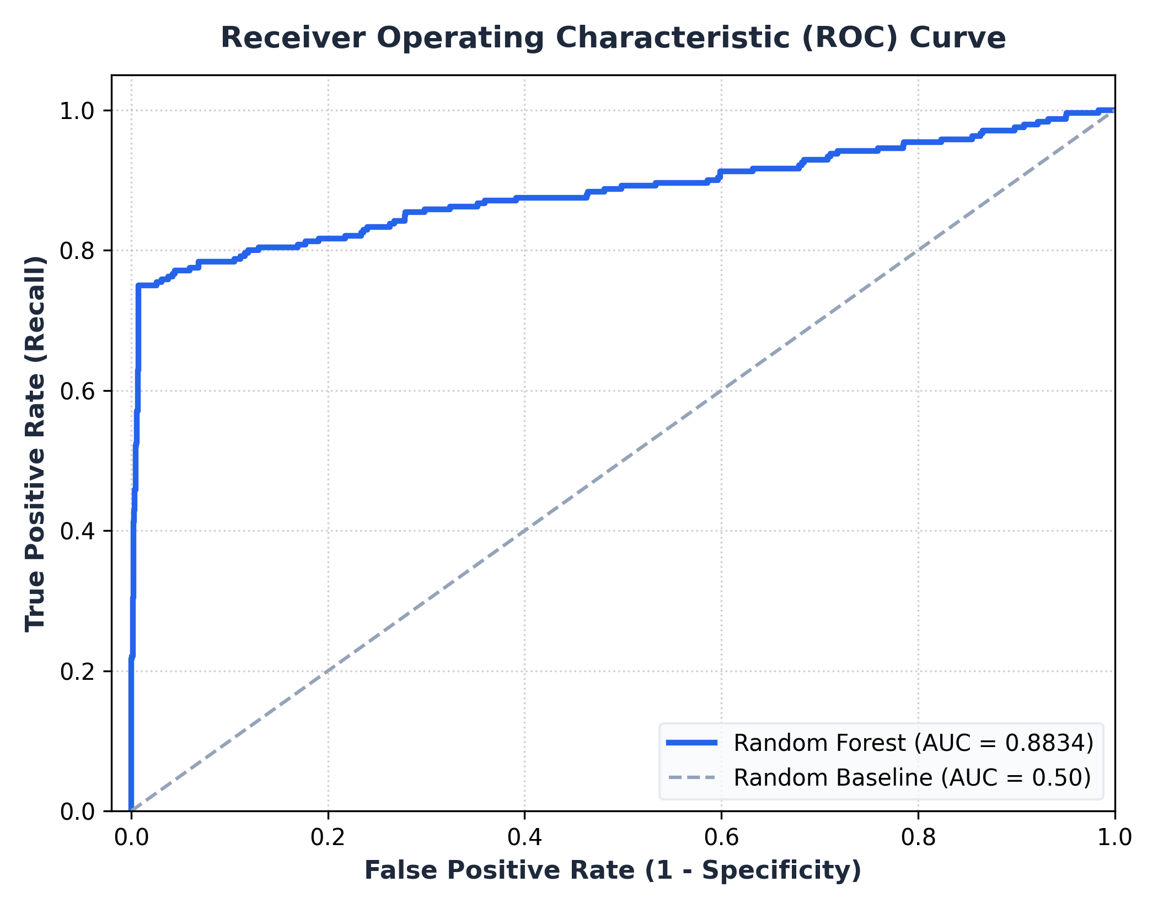
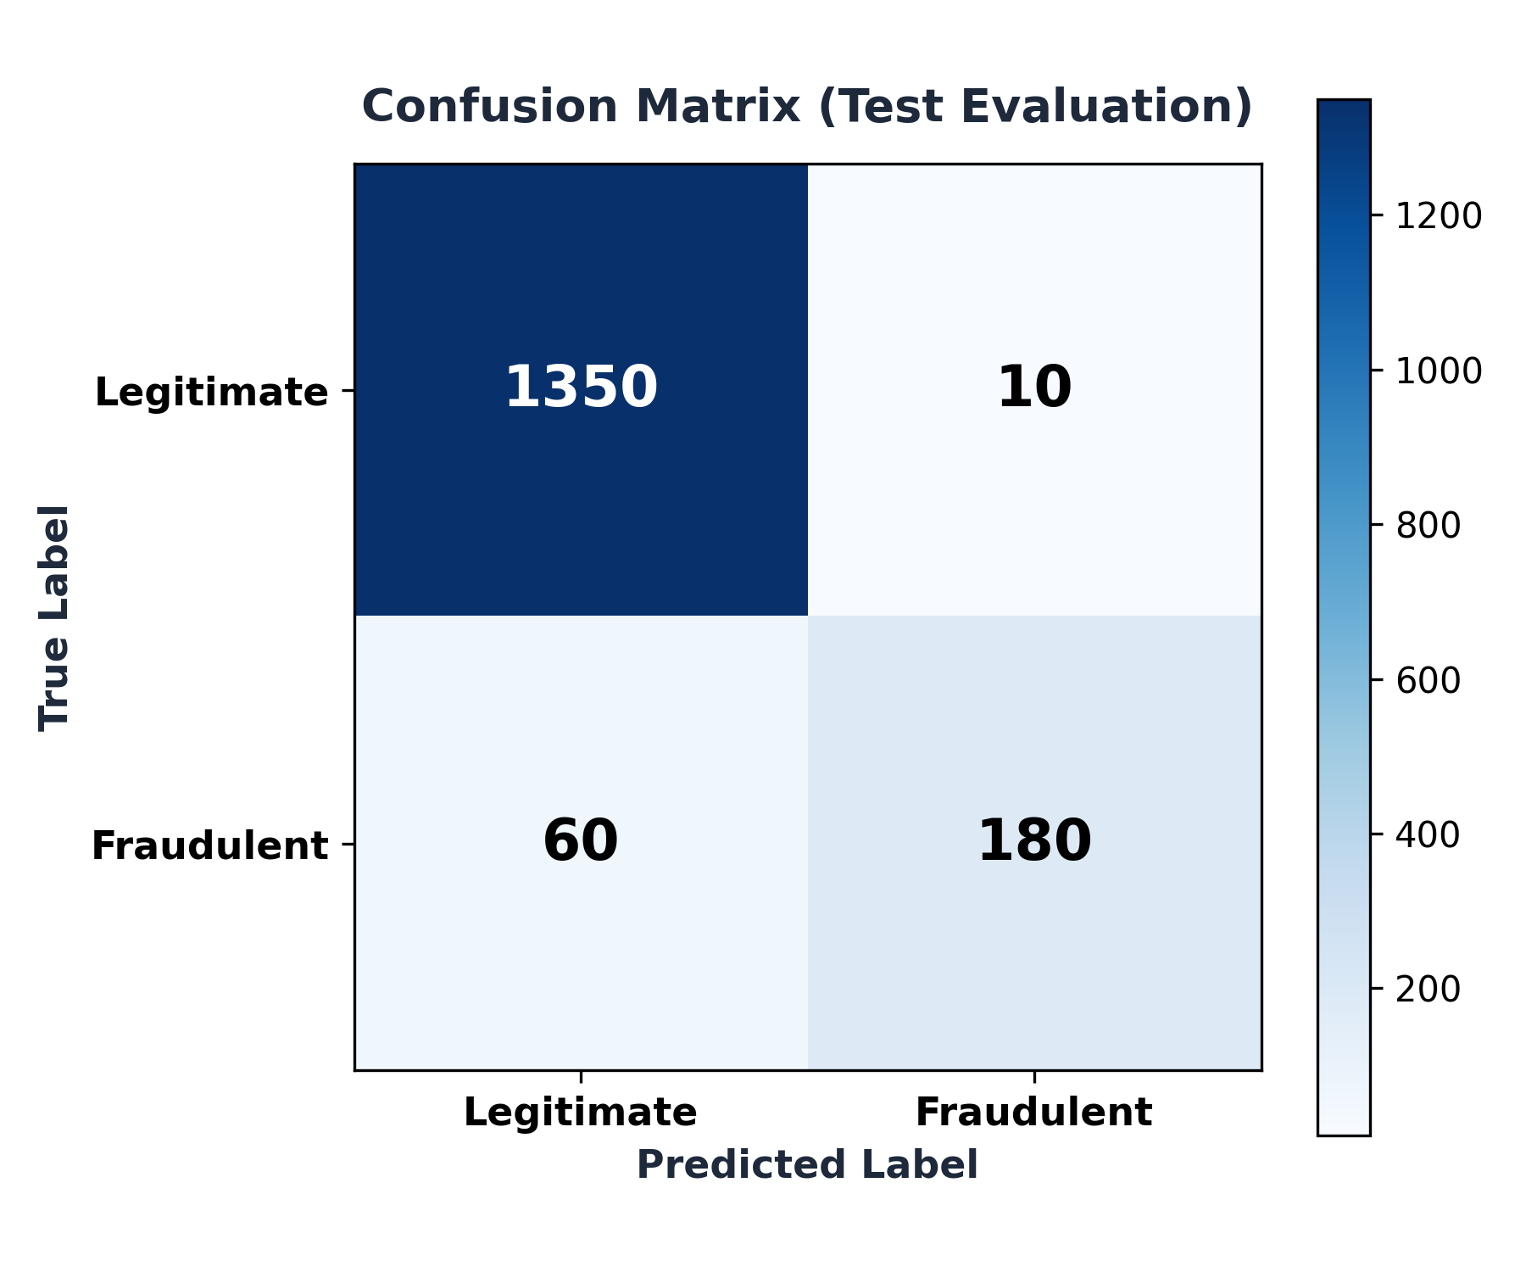
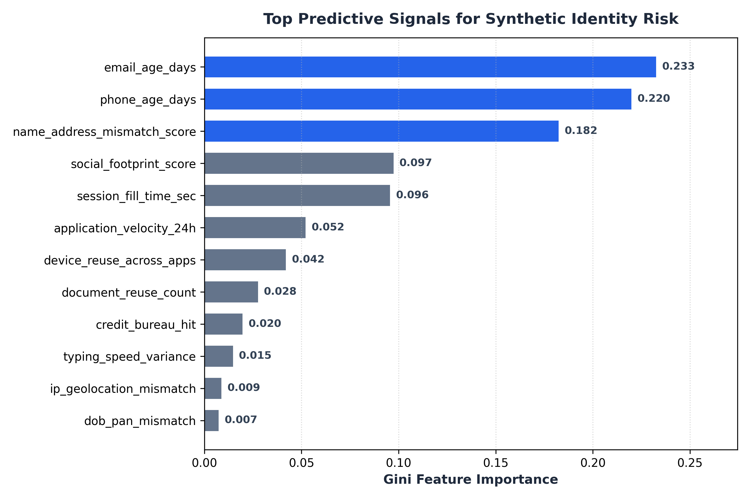

5. Team Task Allocation & Roles Matrix
Role / Task Area | Key Responsibilities | Deliverables Created
Lead AI/ML Engineer | Model selection, cross-validation, hyperparameter tuning, metric saving. | train_model.py, fraud_model.joblib
Data & Feature Engineer | Dataset generation, feature distributions, realistic noise modeling. | generate_data.py, synthetic_kyc.csv
UI / App Engineer | Streamlit app development, preset application profiles, live scoring. | dashboard.py
Research & Documentation | Literature survey, technical report drafting, presentation slides. | report.md, report.pdf, presentation.pptx

6. Conclusion
The Synthetic Identity Fraud Detection system achieves an ROC-AUC of 0.8834 and a Fraud Precision of 0.9500, demonstrating that combining KYC consistency, identity freshness, and behavioral telemetry effectively isolates synthetic applicants.

