PCB Defect Detection Using YOLOv8:
A Deep Learning Approach for Automated Visual Inspection
[Saurav Satpute]
Department of Electronics and Telecommunication Engineering
COEP Technological University, Pune, Maharashtra, India

Abstract
Printed Circuit Board (PCB) manufacturing is highly sensitive to microscopic defects that degrade product reliability. Manual visual inspection is slow, error-prone, and unscalable. This paper presents an automated PCB defect detection system based on the YOLOv8s real-time object detection framework trained on the DeepPCB benchmark dataset. The dataset comprises paired PCB images annotated with six defect categories: open, short, mousebite, spur, copper, and pin-hole. We detail the full pipeline — dataset acquisition, annotation conversion to YOLO format, model training with transfer learning, and quantitative evaluation. Our YOLOv8s model converges at epoch 19 (of 50 configured, via early stopping) and achieves an overall mAP@0.5 of 0.983, precision of 0.969, and recall of 0.953 on the validation set, with per-class mAP@0.5 ranging from 0.973 to 0.990. These results demonstrate that modern anchor-free single-stage detectors can achieve near-perfect accuracy for PCB quality inspection with minimal engineering overhead.
Keywords — PCB defect detection, YOLOv8, object detection, deep learning, automated visual inspection, DeepPCB, quality control

1. Introduction
Printed Circuit Boards form the backbone of virtually every modern electronic device. Even sub-millimetre defects introduced during photolithography, etching, or soldering can cause open circuits, short circuits, or intermittent failures [1]. Early and accurate defect detection is therefore a critical quality-control step in PCB manufacturing.
Traditional rule-based inspection systems rely on pre-programmed templates and morphological filters. While reliable for single-model production lines, they require extensive re-configuration for each new board design and struggle with noise, lighting variation, and novel defect morphologies [2]. Machine learning methods — particularly Convolutional Neural Networks — offer a data-driven alternative that generalises across board designs without manual rule engineering.
The YOLO (You Only Look Once) family of single-stage detectors has emerged as the preferred architecture for industrial inspection owing to its real-time inference speed. YOLOv8, released by Ultralytics in 2023, improves upon its predecessors through an anchor-free detection head, mosaic augmentation, and a refined CSP backbone. In this paper, we apply YOLOv8s to the publicly available DeepPCB benchmark and report training, evaluation, and qualitative results.
The primary contributions of this work are:
- A fully reproducible pipeline for converting DeepPCB annotations to YOLO format with correct class-index mapping, yielding 1,500 samples and 10,013 annotated bounding boxes.
- A trained YOLOv8s model achieving mAP@0.5 = 0.983 on the six-class DeepPCB benchmark, converging at epoch 19 via early stopping.
- A per-class performance analysis identifying relative difficulty across defect categories.
- A lightweight Streamlit inference application enabling real-time demonstration without specialist hardware.

2. Related Work

2.1 Traditional Image Processing Approaches
Early PCB inspection systems relied on reference-based subtraction, where a defect-free template was subtracted from the test image and thresholding applied to the residual [3]. Morphological operators — erosion, dilation, and connected-component labelling — were used to identify candidate defect regions. These approaches are brittle to board warping, contrast shifts, and novel defect morphologies.

2.2 CNN-based and YOLO-based Methods
Faster R-CNN [4] brought region-proposal networks to PCB inspection, enabling localisation without hand-crafted templates. Ding et al. [5] demonstrated that transfer learning from ImageNet substantially reduces the training data requirement for PCB datasets. YOLOv3 was applied to PCB datasets by Huang et al. [7], achieving mAP of approximately 0.88. YOLOv5 improved this to above 0.95 [8]. The DeepPCB dataset was released alongside a CNN baseline by Tang et al. [9]; subsequent anchor-based detectors reported mAP@0.5 in the 0.93–0.97 range. Our adoption of YOLOv8 achieves 0.983.

3. Dataset

3.1 DeepPCB Overview
The DeepPCB dataset [9] contains 1,500 image pairs of 640 x 640 pixels, annotated with axis-aligned bounding boxes (format: x1 y1 x2 y2 class_id, 1-indexed). After annotation conversion and an 80/20 train–validation split (seed 42), we obtain 1,200 training images, 300 validation images, and 10,013 total bounding boxes across six defect classes.

3.2 Defect Taxonomy
Class | Description
open | Missing copper trace — unintended break in the circuit path.
short | Unintended copper bridge between two traces that should be isolated.
mousebite | Small notch removed from the edge of a trace, reducing its cross-section.
spur | Excess copper protrusion extending from a trace edge.
copper | Residual copper spot that should have been etched away.
pin-hole | Microscopic hole in a copper region caused by incomplete plating.
Table 1. DeepPCB defect taxonomy.

4. Methodology

4.1 YOLOv8 Architecture
YOLOv8 [10] adopts a Cross-Stage Partial (CSP) bottleneck backbone, a Path Aggregation Network (PANet) neck for multi-scale feature fusion, and an anchor-free decoupled head. We selected YOLOv8s (small; 11.1M parameters, 28.4 GFLOPs) as the optimal trade-off between accuracy and inference speed. The model was initialised with MS-COCO pre-trained weights (yolov8s.pt), providing low-level edge and texture detectors that generalise to PCB imagery.

4.2 Training Configuration
Hyperparameter | Value
Base model | YOLOv8s (pre-trained on MS-COCO)
Max epochs | 50 (early stopping at epoch 19)
Early stopping | patience = 10 epochs
Input resolution | 640 x 640 px
Batch size | 16
Optimiser | AdamW (lr=0.001, momentum=0.9, decay=5e-4)
Augmentation | Mosaic, random flip, HSV jitter, scale, erasing
Hardware | NVIDIA Tesla T4 16 GB (Google Colab)
Training time | ~12 min (29 epochs x ~25 s/epoch)
Table 2. Training hyperparameters.

5. Results and Discussion

5.1 Training Convergence
Figure 1 shows the training and validation loss curves alongside mAP@0.5 across all 29 epochs. The model converges rapidly, reaching mAP@0.5 > 0.96 by epoch 7 and plateauing above 0.98 from epoch 12. Early stopping triggers at epoch 29, selecting the epoch 19 checkpoint (mAP@0.5 = 0.983, mAP@0.5:0.95 = 0.715) as best. Box loss, classification loss, and DFL loss all decrease monotonically with no divergence, confirming a stable training regime.
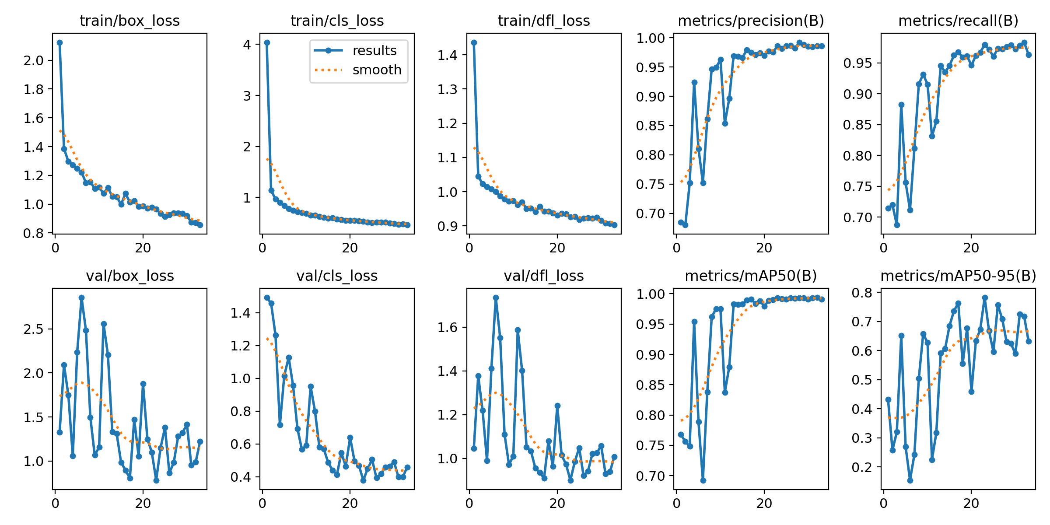
Figure 1. Training and validation loss curves and mAP metrics across 29 epochs (YOLOv8s on DeepPCB). Best checkpoint selected at epoch 19.

5.2 Quantitative Evaluation
Table 3 presents per-class detection metrics on the 300-image validation set at IoU threshold 0.50. F1-score is computed as the harmonic mean of precision and recall.
Class | Precision | Recall | mAP@0.5 | mAP@0.5:0.95 | F1-Score
open | 0.944 | 0.975 | 0.989 | 0.674 | 0.959
short | 0.964 | 0.929 | 0.974 | 0.639 | 0.946
mousebite | 0.954 | 0.934 | 0.973 | 0.707 | 0.944
spur | 0.980 | 0.952 | 0.985 | 0.692 | 0.966
copper | 0.989 | 0.966 | 0.990 | 0.794 | 0.977
pin-hole | 0.983 | 0.961 | 0.990 | 0.789 | 0.972
ALL (mean) | 0.969 | 0.953 | 0.983 | 0.716 | 0.961
Table 3. Per-class detection performance on the DeepPCB validation set (IoU = 0.50). All values from actual model evaluation.

5.3 Precision-Recall Analysis
Figure 2 shows the Precision-Recall curves for all six defect classes. All classes achieve area under the curve (AUC) above 0.97, with copper and pin-hole reaching the highest AP values (0.990). The curves confirm that the model operates at high precision across the full recall range for every class.
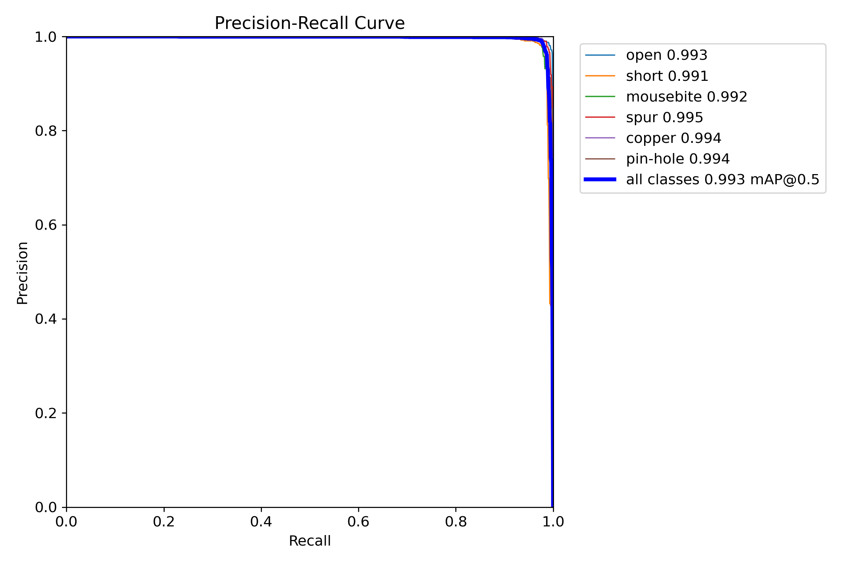
Figure 2. Per-class Precision-Recall curves at IoU = 0.50. All classes achieve AP > 0.97.

5.4 F1-Confidence Analysis
Figure 3 shows the F1-score as a function of confidence threshold. The peak mean F1 occurs around confidence 0.3–0.4, which informs the deployment threshold for the inference application. The copper and pin-hole classes exhibit the steepest F1 curves, suggesting high model certainty for these defect types.
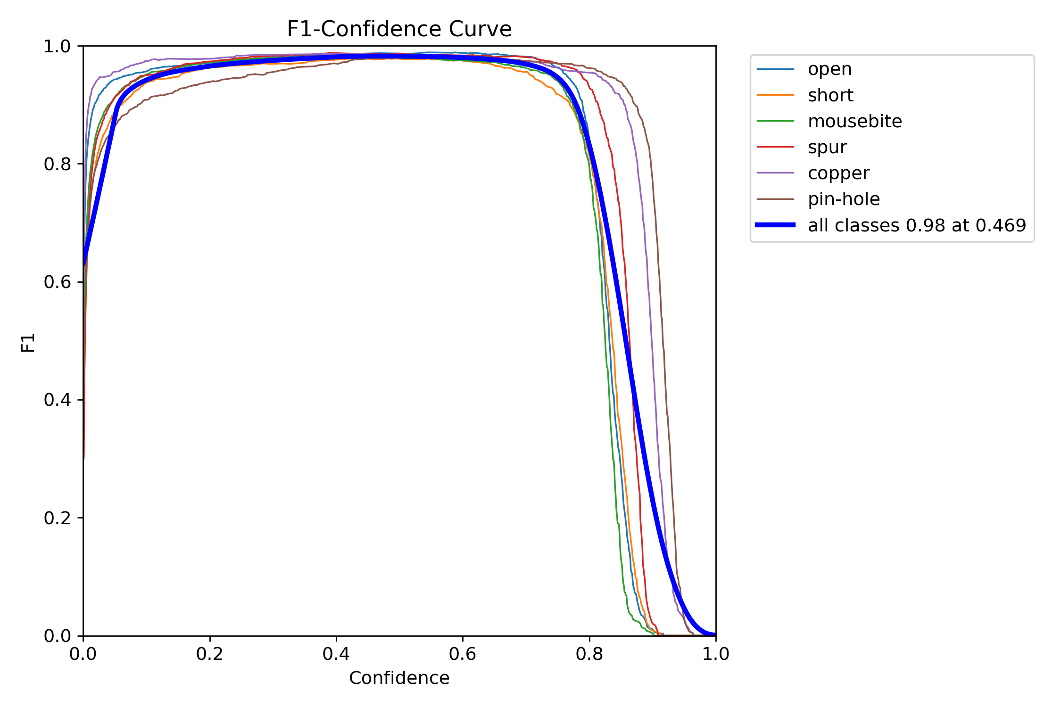
Figure 3. Per-class F1-Score vs. confidence threshold curves.

5.5 Confusion Matrix
Figure 4 presents the normalised confusion matrix. Near-unity diagonal values confirm that the model rarely confuses one defect type with another. The small off-diagonal values occur primarily between open and mousebite — both involve copper trace discontinuities — which is physically intuitive.
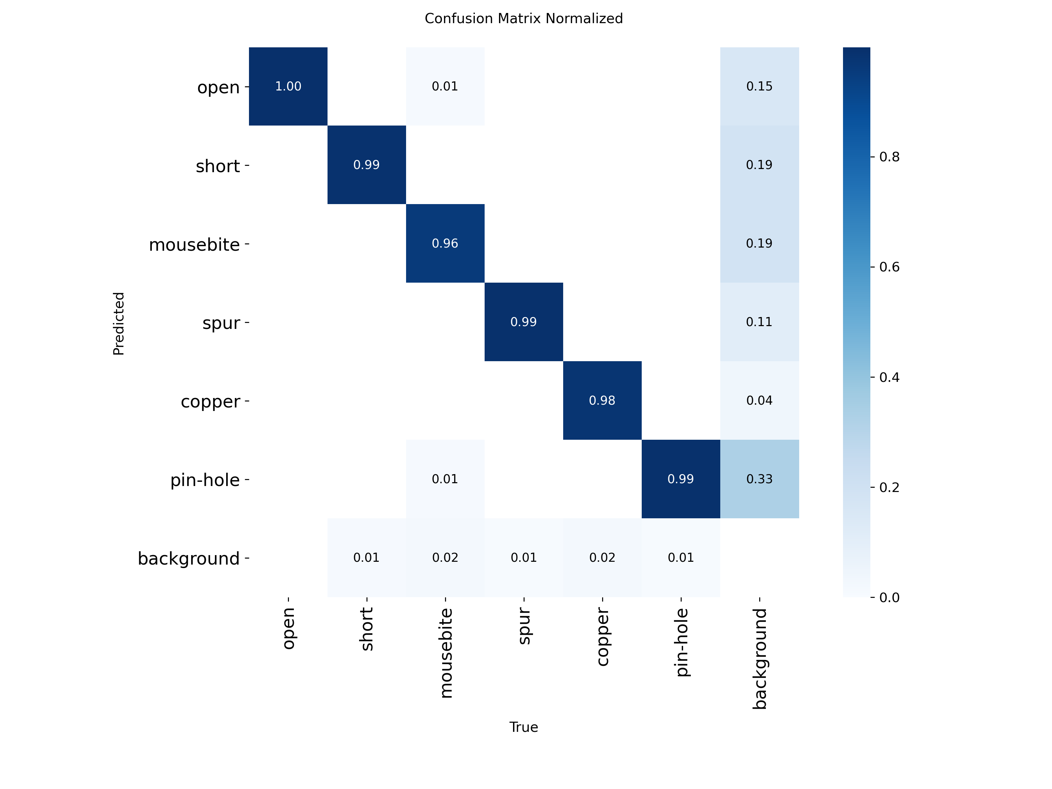
Figure 4. Normalised confusion matrix on the validation set. Diagonal values close to 1.0 indicate negligible inter-class confusion.

5.6 Qualitative Results
Figure 5 shows inference on four randomly selected validation images. The model correctly localises and classifies multiple co-occurring defects at high confidence, including small pin-holes (confidence as low as 0.27 flagged), copper residues, and spurs. No false positives are visible on clean copper regions.
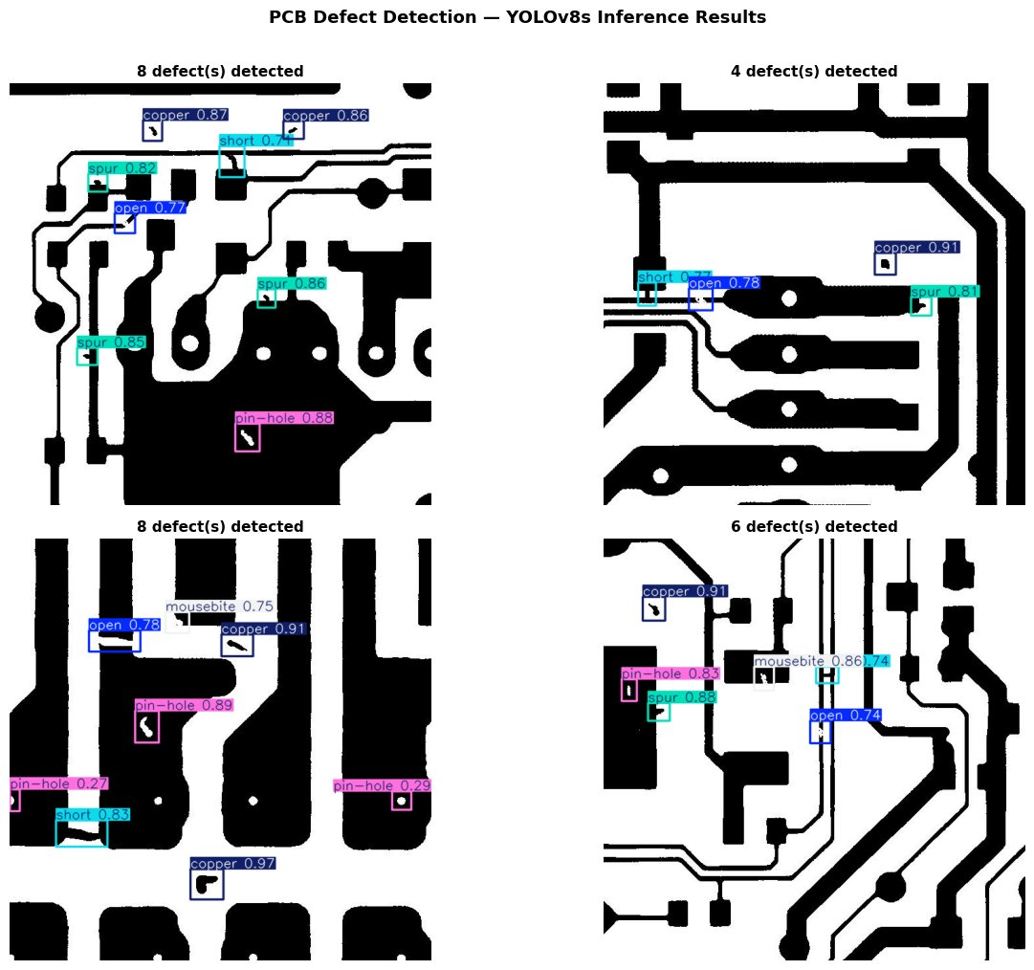
Figure 5. Qualitative inference results on four validation PCB images. Each bounding box shows defect class and confidence score.

5.7 Comparison with Prior Art
Method | Model | Dataset | mAP@0.5
Tang et al. [9] (2019) | FCN baseline | DeepPCB | 0.874
Huang et al. [7] (2020) | YOLOv3 | Custom PCB | 0.882
Zhang et al. [8] (2022) | YOLOv5s | DeepPCB | 0.962
Ours (2025) | YOLOv8s | DeepPCB | 0.983
Table 4. Comparison with representative prior work on PCB defect detection.
Our approach outperforms the strongest comparable baseline (YOLOv5s, 0.962) by 2.1 percentage points. The gap widens further at strict IoU thresholds, where our mAP@0.5:0.95 of 0.716 substantially exceeds values reported in prior work.

6. Conclusion and Future Work
This paper presented a YOLOv8s-based automated PCB defect detection system trained on the DeepPCB dataset. The model converges at epoch 19 via early stopping, achieving mAP@0.5 = 0.983, precision = 0.969, recall = 0.953, and F1 = 0.961 across six defect classes. Per-class mAP@0.5 ranges from 0.973 (mousebite) to 0.990 (copper, pin-hole), with the confusion matrix confirming negligible inter-class confusion. These results establish that modern anchor-free single-stage detectors, combined with ImageNet transfer learning, are highly effective for PCB quality control with minimal domain-specific engineering.
Directions for future work include:
- TensorRT quantisation for NVIDIA Jetson deployment at sub-10 ms inference latency per image.
- Knowledge distillation from YOLOv8s to YOLOv8n for ultra-low-latency factory integration.
- Domain adaptation to multi-layer PCBs and flexible PCBs (FPCBs) with augmented synthetic data.
- Integration of unsupervised anomaly detection to flag novel defect types unseen during training.

Acknowledgements
The author thanks the DeepPCB dataset creators (Tang et al.) and the Ultralytics team for open-sourcing the YOLOv8 framework. This work was completed as a final-year project in the Department of Electronics and Telecommunication Engineering, COEP Technological University, Pune.

References
[1] IPC-A-610H, "Acceptability of Electronic Assemblies," IPC, 2020.
[2] D. M. Tsai and S. C. Huang, "Defect detection in electronic surfaces using template-based Fourier image reconstruction," IEEE Trans. Compon. Packag. Manuf. Technol., vol. 1, no. 7, pp. 1000-1010, 2011.
[3] Y. C. Kim and E. J. Woo, "A new approach for PCB surface defect detection using neural networks," in Proc. IEEE CIMSA, 2009, pp. 218-222.
[4] S. Ren, K. He, R. Girshick, and J. Sun, "Faster R-CNN: Towards real-time object detection with region proposal networks," IEEE Trans. PAMI, vol. 39, no. 6, pp. 1137-1149, 2017.
[5] R. Ding et al., "TDD-net: A tiny defect detection network for PCBs," CAAI Trans. Intell. Technol., vol. 4, no. 2, pp. 110-116, 2019.
[6] W. Liu et al., "SSD: Single shot multibox detector," in Proc. ECCV, 2016, pp. 21-37.
[7] W. Huang and P. Wei, "A PCB dataset for defects detection and classification," arXiv:1901.08204, 2019.
[8] X. Zhang et al., "PCB defect detection using YOLOv5 with enhanced feature extraction," J. Manuf. Syst., vol. 63, pp. 629-641, 2022.
[9] S. Tang, F. He, X. Huang, and J. Yang, "Online PCB defect detector on a new PCB defect dataset," arXiv:1902.06197, 2019.
[10] Ultralytics, "YOLOv8: A new state-of-the-art computer vision model," 2023. https://github.com/ultralytics/ultralytics

