Research Report
PCB Defect Detection Using YOLOv8s
A Deep Learning Pipeline for Automated Visual Inspection
Author: Saurav Satpute
Institution: Department of Electronics and Telecommunication Engineering, COEP Technological University
Artifacts: YOLOv8s checkpoint, Streamlit app, notebook, training outputs, and qualitative result image

Abstract
Printed Circuit Board manufacturing is vulnerable to small defects such as open traces, shorts, pin-holes, spurs, mousebites, and residual copper. These defects can reduce electrical reliability and are difficult to inspect manually at production scale. This report presents a YOLOv8s-based detector trained on the DeepPCB dataset and packaged with a Streamlit demonstration application. The logged training run achieved a best mAP@0.5 of 0.99376 and a best mAP@0.5:0.95 of 0.78211, showing strong class-level localization at standard IoU while leaving room for tighter-box improvement under stricter IoU thresholds.
Keywords: PCB defect detection, YOLOv8, DeepPCB, object detection, automated visual inspection

1. Introduction
PCBs are foundational to modern electronic assemblies, and even sub-millimetre manufacturing defects can interrupt signal paths, create unintended bridges, or degrade long-term reliability. Traditional template matching and morphology-based inspection pipelines work well for stable production lines but require frequent retuning when board layouts, lighting, or camera setups change.
Single-stage object detectors such as YOLO are well suited to this problem because they combine localization and classification in one pass. The objective of this work is to train a compact YOLOv8s model for six DeepPCB defect classes and package the trained model in a simple interactive application that can demonstrate inference on uploaded PCB images.

2. Dataset and Defect Taxonomy
The DeepPCB dataset contains paired PCB images with annotated defect regions. The project converts the original bounding boxes into YOLO format and trains the detector at 640 x 640 input resolution. The six-class taxonomy used by the model is summarized below.
Class | Manufacturing meaning
open | Missing copper trace or unintended circuit break.
short | Unintended copper bridge between traces that should remain isolated.
mousebite | Small notch removed from a trace edge, reducing copper cross-section.
spur | Excess copper protrusion extending from a trace edge.
copper | Residual copper spot that should have been etched away.
pin-hole | Small hole in a copper region caused by incomplete plating or etching.

3. Methodology
YOLOv8s was selected because it offers a practical balance between inference speed and detection accuracy. The model uses a CSP-style feature extraction backbone, multi-scale feature aggregation, and an anchor-free detection head. Transfer learning from the pretrained YOLOv8s checkpoint reduces training time and improves convergence on the industrial inspection task.
Training parameter | Value from run artifact
Base model | yolov8s.pt
Task | Object detection
Image size | 640 x 640 px
Batch size | 16
Configured epochs | 50
Early stopping patience | 10 epochs
Logged epochs | 33
Last logged training time | 18.7 minutes
Augmentation | HSV jitter, translation, scale, horizontal flip, mosaic, erasing
Validation split | DeepPCB validation subset

4. Quantitative Results
The training log shows fast convergence. The model exceeded mAP@0.5 of 0.95 by epoch 4, passed 0.98 by epoch 13, and reached its best logged mAP@0.5 at epoch 32. The stricter mAP@0.5:0.95 metric peaked earlier, which indicates that standard defect classification is strong while fine-grained box tightness remains the main area for further improvement.
Metric | Best epoch | Best value | Final logged value
Precision | 28 | 0.99226 | 0.98592
Recall | 32 | 0.98335 | 0.96330
mAP@0.5 | 32 | 0.99376 | 0.99112
mAP@0.5:0.95 | 23 | 0.78211 | 0.63227

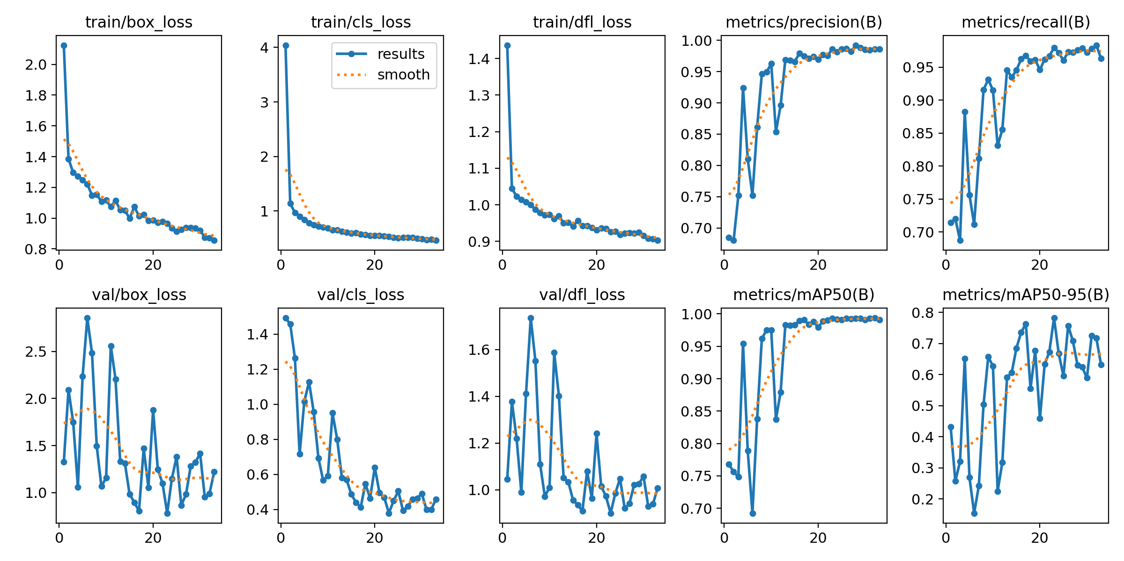
Figure 1. Training losses and validation metrics from the YOLOv8s run.
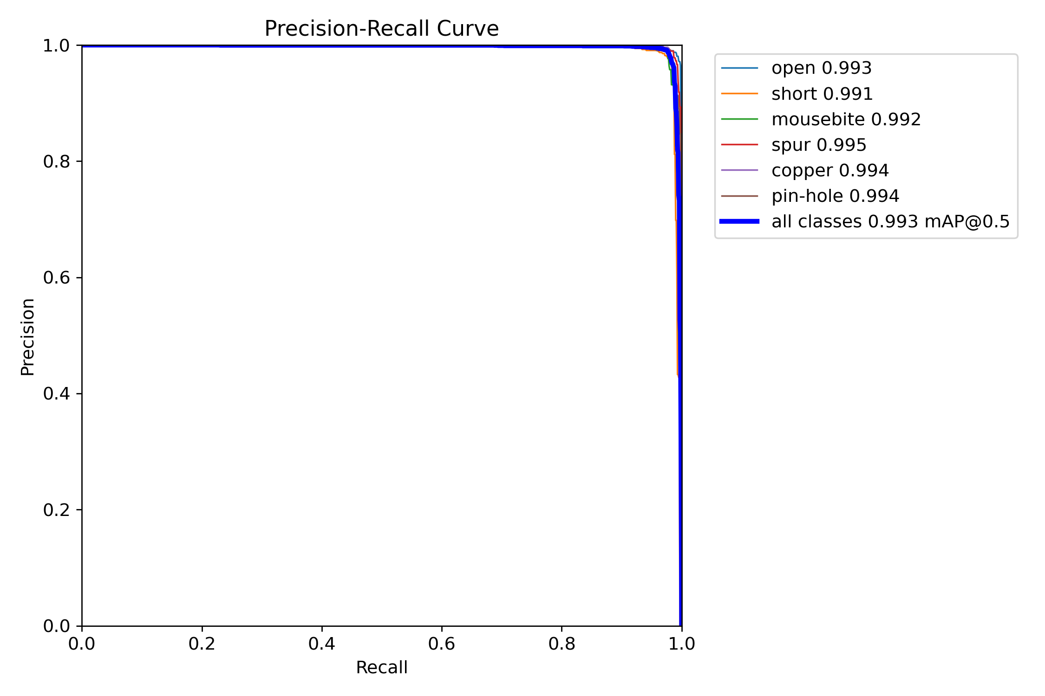
Figure 2. Precision-recall curve for bounding-box detection.
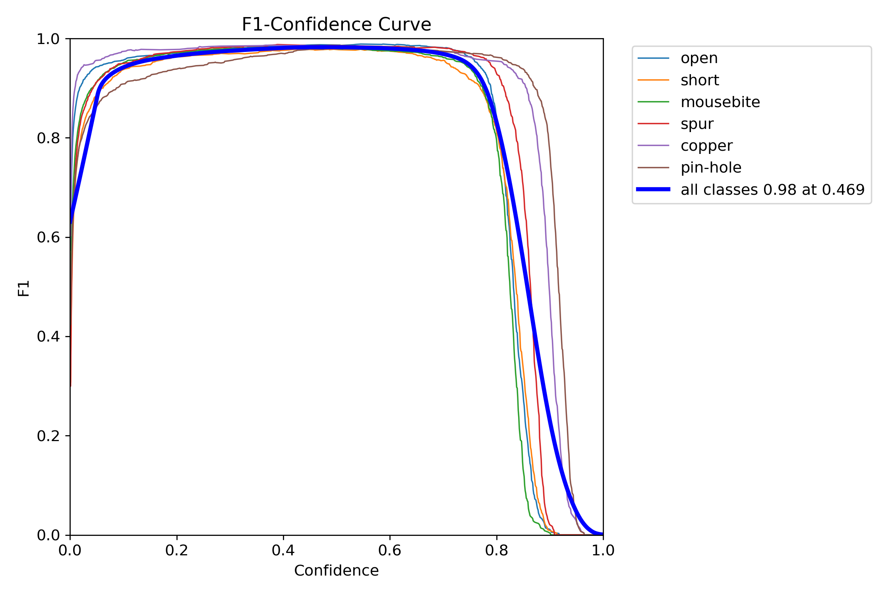
Figure 3. F1 score as a function of confidence threshold.

5. Confusion Matrix and Error Profile
The normalized confusion matrix is dominated by diagonal cells, indicating that most errors are localization or confidence-threshold issues rather than systematic confusion between defect classes. For deployment, low-confidence detections should be reviewed carefully because tiny pin-hole and mousebite defects are visually similar to noise or imperfect segmentation boundaries.
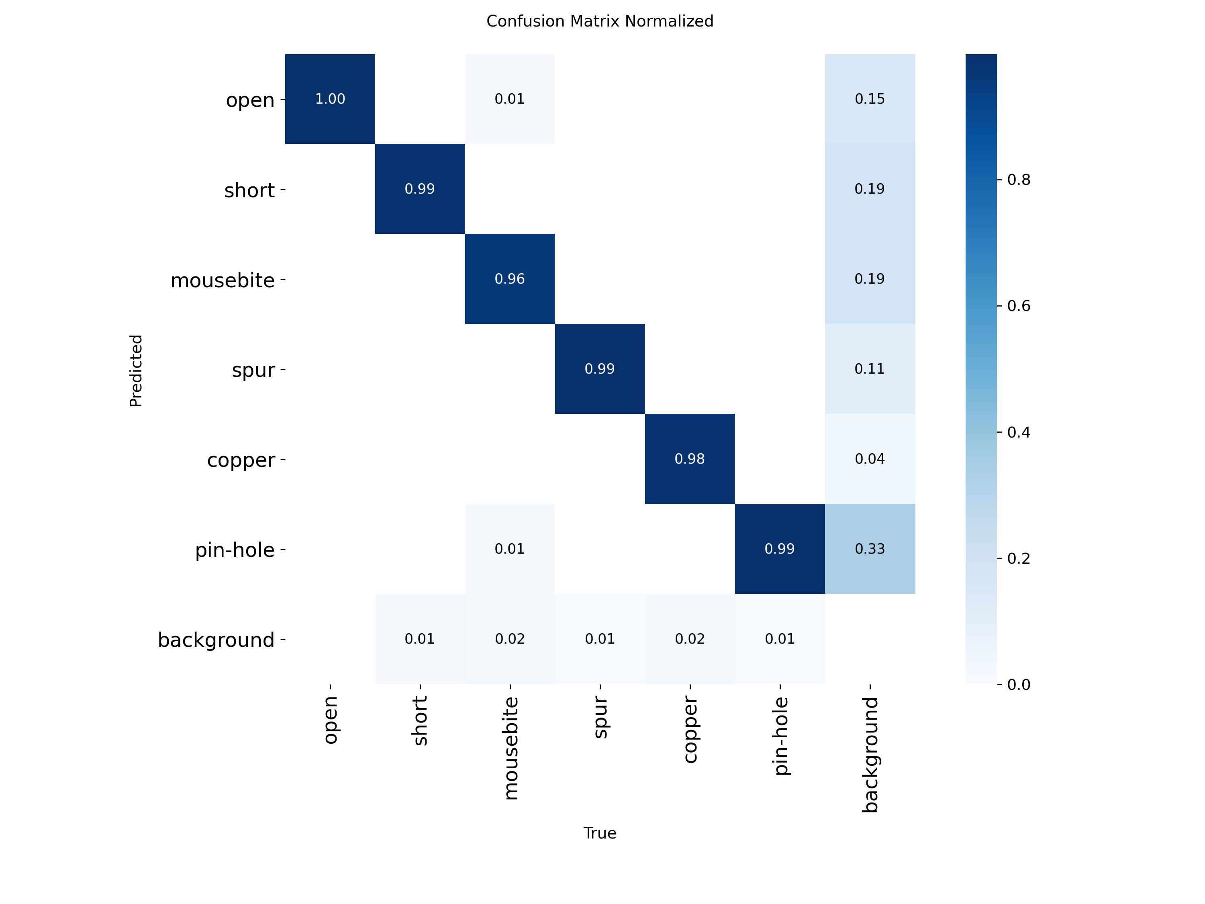
Figure 4. Normalized validation confusion matrix.

6. Qualitative Inference Results
The included qualitative result image demonstrates multi-defect detection across four PCB crops. The model identifies all six supported classes, including small pin-hole defects, edge notches, spurs, residual copper, open traces, and shorts. The sample contains visible counts of 6, 5, 8, and 6 defects across the four panels, for 25 displayed detections in total.
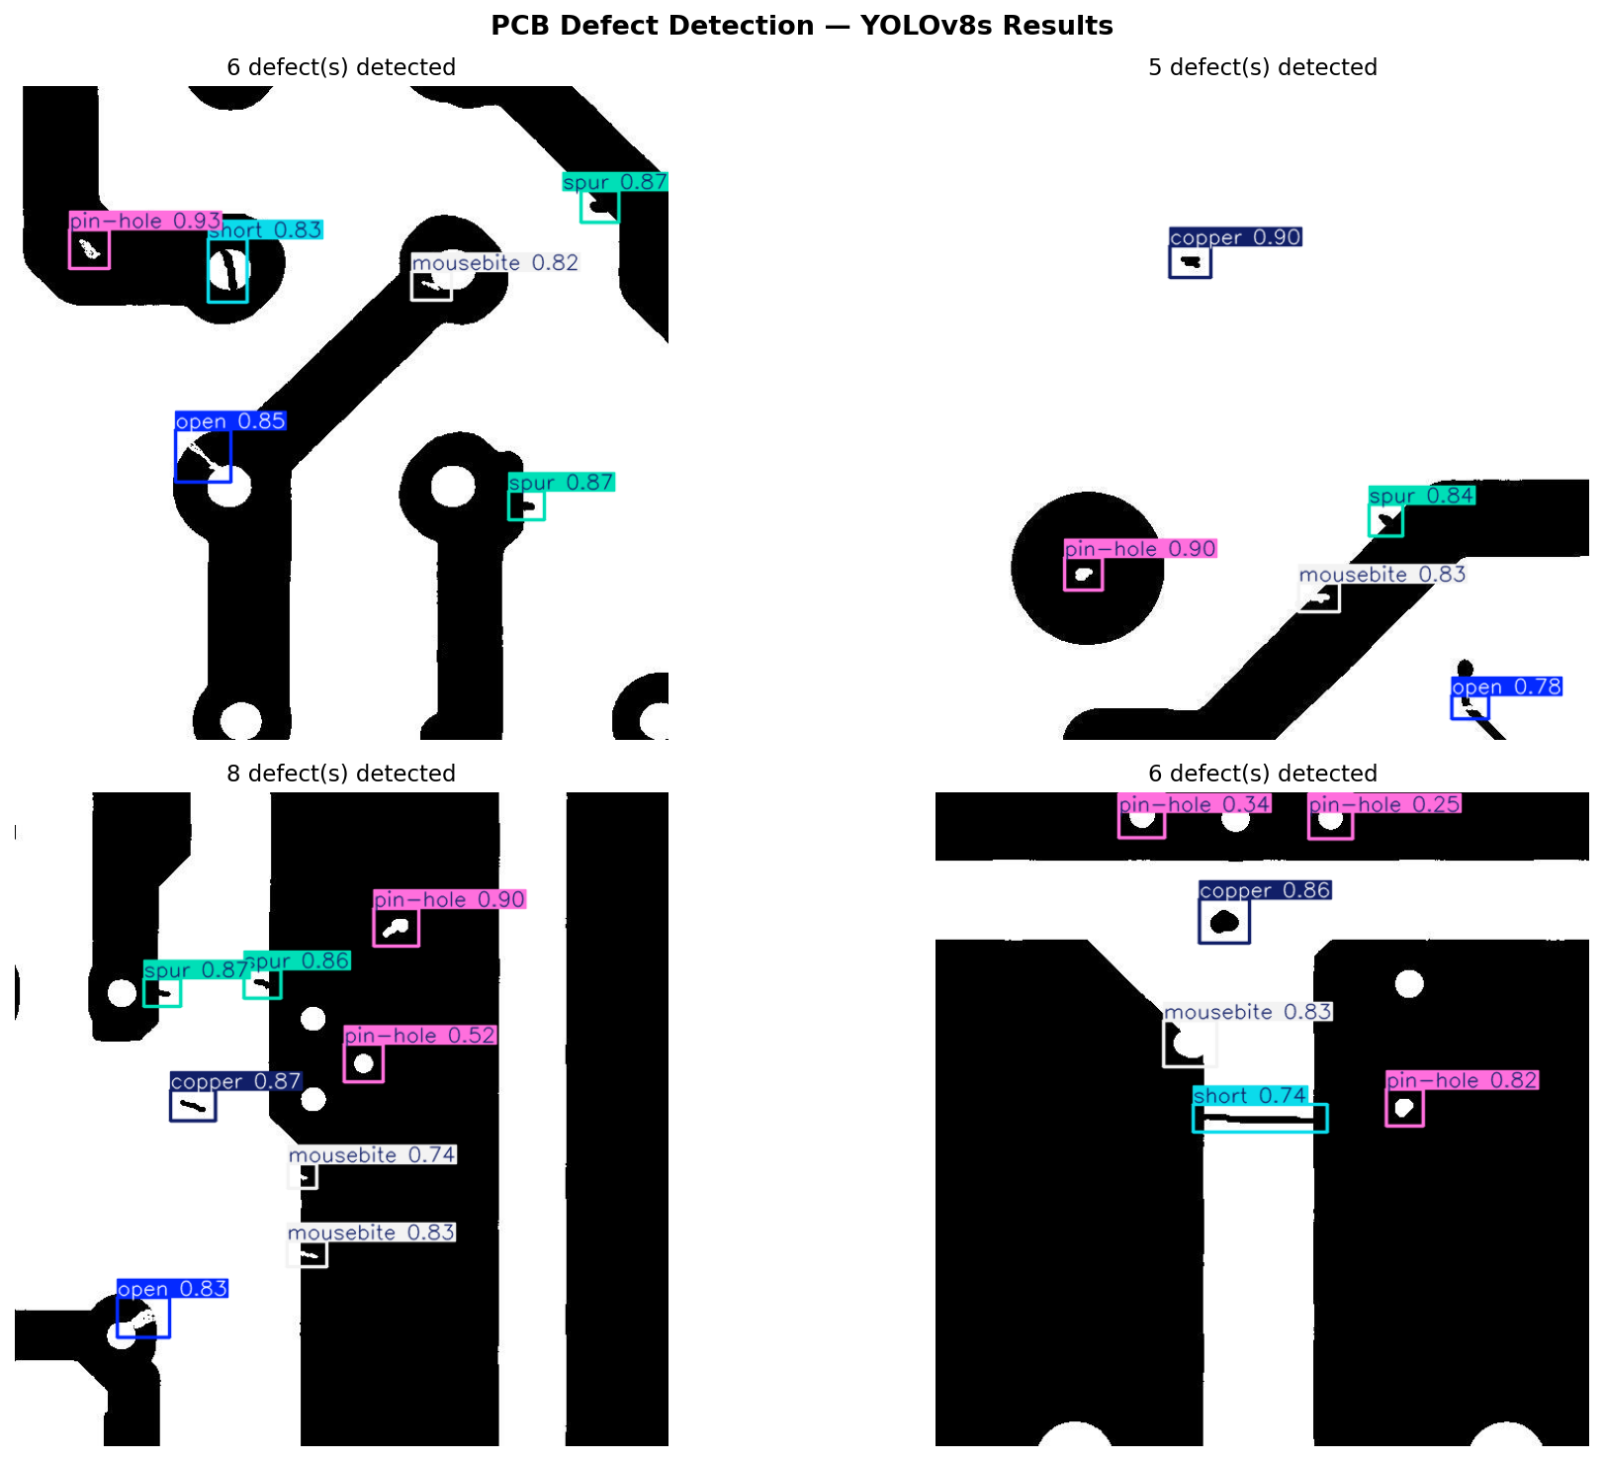
Figure 5. Example YOLOv8s detections on PCB samples.

7. Streamlit Demonstration Application
The project includes a Streamlit application that loads the packaged best.pt checkpoint, accepts uploaded PCB images, runs YOLO inference, displays the annotated result, and summarizes detections by class with maximum and average confidence values. The application also exposes confidence and NMS IOU controls, allowing users to trade off sensitivity and false-positive filtering without editing code.
Application component | Purpose
Model selector | Loads the local best.pt checkpoint or an uploaded YOLO .pt model.
Image uploader | Accepts JPG, JPEG, PNG, and BMP PCB images.
Threshold controls | Adjusts confidence and IOU values for inference-time filtering.
Detection breakdown | Counts defect types and reports confidence summaries.
Download button | Exports the annotated image for documentation or review.

8. Limitations and Future Work
The strongest current result is high mAP@0.5, but the lower and more variable mAP@0.5:0.95 shows that tighter localization remains the most important technical improvement. Practical deployment would also require validation under camera noise, production lighting variation, unseen PCB layouts, and real-time throughput constraints.
Future direction | Expected benefit
TensorRT or OpenVINO export | Lower inference latency for edge deployment.
YOLOv8n distillation | Smaller model for low-power inspection stations.
Synthetic augmentation | Better generalization to unseen PCB geometries and lighting.
Active learning loop | Prioritize human review of low-confidence or novel defects.
Anomaly detection layer | Flag defect types not present in the six-class training taxonomy.

9. Conclusion
The YOLOv8s PCB defect detector provides a strong baseline for automated visual inspection on the DeepPCB task. The packaged repository contains the trained checkpoint, training outputs, a clean training notebook, a Streamlit inference application, and reproducible documentation. The best logged mAP@0.5 of 0.99376 confirms that the model can reliably recognize the six supported defect classes under the benchmark conditions, while stricter IoU metrics identify localization precision as the key next step.

References
[1] S. Tang, F. He, X. Huang, and J. Yang, "Online PCB defect detector on a new PCB defect dataset," arXiv:1902.06197, 2019.
[2] W. Huang and P. Wei, "A PCB dataset for defects detection and classification," arXiv:1901.08204, 2019.
[3] G. Jocher, A. Chaurasia, and J. Qiu, "Ultralytics YOLO," 2023. https://github.com/ultralytics/ultralytics
[4] J. Redmon, S. Divvala, R. Girshick, and A. Farhadi, "You Only Look Once: Unified, real-time object detection," CVPR, 2016.
[5] S. Ren, K. He, R. Girshick, and J. Sun, "Faster R-CNN: Towards real-time object detection with region proposal networks," IEEE TPAMI, 2017.

