**CLASSIFIER- ARTIFICIAL NEURAL NETWORK**

Artiﬁcial neural network, as a rule called neural network (NNs), are frameworks made out of numerous basic preparing components (neurons) working in equal whose capacity is controlled by network structure, association qualities, and the handling performed at processing components or hubs (different deﬁnitions can likewise be found). NNs exist in numerous assortments, however they can be sorted into two principle gatherings, where the qualification lies in the learning strategy:

•Supervised learning-The organization is prepared with instances of information and wanted yield.

•Unsupervised learning-The organization attempts to arrange the information in a valuable manner without utilizing outer input.

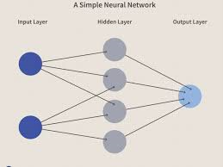

**ALGORITHM-SEQUENTIAL NEURAL NETWORK**

Neural Networks build high-level features through their successive layers one after the other. We put forward a neural network model in which each layer is related to a set of candidate mappings. When an input is given, at each layer, one mapping among the candidate mappings is selected according to the sequential algorithm. The resultant model is such that a path from the root node to the leaf node denotes a proper sequence of transformations. Instead of interpreting global transformations, as in the case of classical multilayer networks, this particular model allows us to learn a group of local transformations. It is therefore able to process data with different features through specific sequences of such local transformations, leading to a significant increase in the expression power of the model with respect to a classical multilayered network. Experiments carried out on different datasets show the relevance of this particular approach. Sequential algorithm is the most easiest way to construct a model in Keras. It allows us to build a model layer by layer. Each layer has its particular weights that correspond to the layer the follows it. We can make use of the ‘add()’ function to add more layers to our model.