**CHAPTER 11- IMPLEMENTATION**

**import** tensorflow **as** tf

mnist**=**tf**.**keras**.**datasets**.**mnist

(x_train, y_train),(x_test, y_test) **=**mnist**.**load_data()

x_train**=**tf**.**keras**.**utils**.**normalize(x_train,axis**=**1)

x_test**=**tf**.**keras**.**utils**.**normalize(x_test,axis**=**1)

model**=**tf**.**keras**.**models**.**Sequential([

tf**.**keras**.**layers**.**Flatten(input_shape**=**(28,28)),

tf**.**keras**.**layers**.**Dense(128, activation**=**tf**.**nn**.**relu),

tf**.**keras**.**layers**.**Dense(128, activation**=**tf**.**nn**.**relu),

tf**.**keras**.**layers**.**Dense(10, activation**=**tf**.**nn**.**softmax)])

model**.**compile(optimizer**=**'adam', loss**=**'sparse_categorical_crossentropy', metrics**=**['accuracy'])

model**.**fit(x_train,y_train, epochs**=**3)

Epoch 1/3

1875/1875 [==============================] - 3s 1ms/step - loss: 0.2602 - accuracy: 0.9245

Epoch 2/3

1875/1875 [==============================] - 3s 1ms/step - loss: 0.1045 - accuracy: 0.9675

Epoch 3/3

1875/1875 [==============================] - 3s 1ms/step - loss: 0.0713 - accuracy: 0.9775

Out[1]:

<tensorflow.python.keras.callbacks.History at 0x1f22baa8d60>

In [2]:

val_loss, val_acc**=**model**.**evaluate(x_test, y_test)

print(val_loss, val_acc)

313/313 [==============================] - 0s 1ms/step - loss: 0.0835 - accuracy: 0.9733

0.083494171500206 0.9732999801635742

In [3]:

**import**matplotlib.pyplot**as**plt

plt**.**imshow(x_train[0], cmap**=**plt**.**cm**.**binary)

plt**.**show()

print(x_train[0])

17

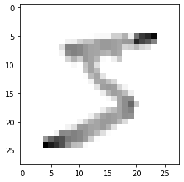

[[0. 0. 0. 0. 0. 0.

0. 0. 0. 0. 0. 0.

0. 0. 0. 0. 0. 0.

0. 0. 0. 0. 0. 0.

0. 0. 0. 0. ]

[0. 0. 0. 0. 0. 0.

0. 0. 0. 0. 0. 0.

0. 0. 0. 0. 0. 0.

0. 0. 0. 0. 0. 0.

0. 0. 0. 0. ]

[0. 0. 0. 0. 0. 0.

0. 0. 0. 0. 0. 0.

0. 0. 0. 0. 0. 0.

0. 0. 0. 0. 0. 0.

0. 0. 0. 0. ]

[0. 0. 0. 0. 0. 0.

0. 0. 0. 0. 0. 0.

0. 0. 0. 0. 0. 0.

0. 0. 0. 0. 0. 0.

0. 0. 0. 0. ]

[0. 0. 0. 0. 0. 0.

0. 0. 0. 0. 0. 0.

0. 0. 0. 0. 0. 0.

0. 0. 0. 0. 0. 0.

0. 0. 0. 0. ]

[0. 0. 0. 0. 0. 0.

0. 0. 0. 0. 0. 0.

0.00393124 0.02332955 0.02620568 0.02625207 0.17420356 0.17566281

0.28629534 0.05664824 0.51877786 0.71632322 0.77892406 0.89301644

0. 0. 0. 0. ]

[0. 0. 0. 0. 0. 0.

0. 0. 0.05780486 0.06524513 0.16128198 0.22713296

0.22277047 0.32790981 0.36833534 0.3689874 0.34978968 0.32678448

0.368094 0.3747499 0.79066747 0.67980478 0.61494005 0.45002403

0. 0. 0. 0. ]

[0. 0. 0. 0. 0. 0.

0. 0.12250613 0.45858525 0.45852825 0.43408872 0.37314701

18

0.33153488 0.32790981 0.36833534 0.3689874 0.34978968 0.32420121

0.15214552 0.17865984 0.25626376 0.1573102 0.12298801

0. 0. 0. 0. ]

[0. 0. 0. 0. 0. 0.

0. 0.04500225 0.4219755 0.45852825 0.43408872 0.37314701

0.33153488 0.32790981 0.28826244 0.26543758 0.34149427 0.31128482

0. 0. 0. 0. 0. 0.

0. 0. 0. 0. ]

[0. 0. 0. 0. 0. 0.

0. 0. 0.1541463 0.28272888 0.18358693 0.37314701

0.33153488 0.26569767 0.01601458 0. 0.05945042 0.19891229

0. 0. 0. 0. 0. 0.

0. 0. 0. 0. ]

[0. 0. 0. 0. 0. 0.

0. 0. 0. 0.0253731 0.00171577 0.22713296

0.33153488 0.11664776 0. 0. 0. 0.

0. 0. 0. 0. 0. 0.

0. 0. 0. 0. ]

[0. 0. 0. 0. 0. 0.

0. 0. 0. 0. 0. 0.20500962

0.33153488 0.24625638 0.00291174 0. 0. 0.

0. 0. 0. 0. 0. 0.

0. 0. 0. 0. ]

[0. 0. 0. 0. 0. 0.

0. 0. 0. 0. 0. 0.01622378

0.24897876 0.32790981 0.10191096 0. 0. 0.

0. 0. 0. 0. 0. 0.

0. 0. 0. 0. ]

[0. 0. 0. 0. 0. 0.

0. 0. 0. 0. 0. 0.

0.04586451 0.31235677 0.32757096 0.23335172 0.14931733 0.00129164

0. 0. 0. 0. 0. 0.

0. 0. 0. 0. ]

[0. 0. 0. 0. 0. 0.

0. 0. 0. 0. 0. 0.

0. 0.10498298 0.34940902 0.3689874 0.34978968 0.15370495

0.04089933 0. 0. 0. 0. 0.

0. 0. 0. 0. ]

[0. 0. 0. 0. 0. 0.

0. 0. 0. 0. 0. 0.

0. 0. 0.06551419 0.27127137 0.34978968 0.32678448

0.245396 0.05882702 0. 0. 0. 0.

0. 0. 0. 0. ]

[0. 0. 0. 0. 0. 0.

0. 0. 0. 0. 0. 0.

0. 0. 0. 0.02333517 0.12857881 0.32549285

0.41390126 0.40743158 0. 0. 0. 0.

0. 0. 0. 0. ]

[0. 0. 0. 0. 0. 0.

0. 0. 0. 0. 0. 0.

0. 0. 0. 0. 0. 0.32161793

0.41390126 0.54251585 0.20001074 0. 0. 0.

0. 0. 0. 0. ]

[0. 0. 0. 0. 0. 0.

0. 0. 0. 0. 0. 0.

0. 0. 0.06697006 0.18959827 0.25300993 0.32678448

0.41390126 0.45100715 0.00625034 0. 0. 0.

0. 0. 0. 0. ]

[0. 0. 0. 0. 0. 0.

19

0. 0. 0. 0. 0. 0.

0.05110617 0.19182076 0.33339444 0.3689874 0.34978968 0.32678448

0.40899334 0.39653769 0. 0. 0. 0.

0. 0. 0. 0. ]

[0. 0. 0. 0. 0. 0.

0. 0. 0. 0. 0.04117838 0.16813739

0.28960162 0.32790981 0.36833534 0.3689874 0.34978968 0.25961929

0.12760592 0. 0. 0. 0. 0.

0. 0. 0. 0. ]

[0. 0. 0. 0. 0. 0.

0. 0. 0.04431706 0.11961607 0.36545809 0.37314701

0.33153488 0.32790981 0.36833534 0.28877275 0.111988 0.00258328

0. 0. 0. 0. 0. 0.

0. 0. 0. 0. ]

[0. 0. 0. 0. 0. 0.

0.05298497 0.42752138 0.4219755 0.45852825 0.43408872 0.37314701

0.33153488 0.25273681 0.11646967 0.01312603 0. 0.

0. 0. 0. 0. 0. 0.

0. 0. 0. 0. ]

[0. 0. 0. 0. 0.37491383 0.56222061

0.66525569 0.63253163 0.48748768 0.45852825 0.43408872 0.359873

0.17428513 0.01425695 0. 0. 0. 0.

0. 0. 0. 0. 0. 0.

0. 0. 0. 0. ]

[0. 0. 0. 0. 0.92705966 0.82698729

0.74473314 0.63253163 0.4084877 0.24466922 0.22648107 0.02359823

0. 0. 0. 0. 0. 0.

0. 0. 0. 0. 0. 0.

0. 0. 0. 0. ]

[0. 0. 0. 0. 0. 0.

0. 0. 0. 0. 0. 0.

0. 0. 0. 0. 0. 0.

0. 0. 0. 0. 0. 0.

0. 0. 0. 0. ]

[0. 0. 0. 0. 0. 0.

0. 0. 0. 0. 0. 0.

0. 0. 0. 0. 0. 0.

0. 0. 0. 0. 0. 0.

0. 0. 0. 0. ]

[0. 0. 0. 0. 0. 0.

0. 0. 0. 0. 0. 0.

0. 0. 0. 0. 0. 0.

0. 0. 0. 0. 0. 0.

0. 0. 0. 0. ]]

In [4]:

model**.**save('epic_num_reader.model')

WARNING:tensorflow:From C:\Users\prncc\anaconda3\lib\site-packages\tensorflow\python\training\tracking\tracking.py:111: Model.state_updates (from tensorflow.python.keras.engine.training) is deprecated and will be removed in a future version.

Instructions for updating:

This property should not be used in TensorFlow 2.0, as updates are applied automatically.

WARNING:tensorflow:From C:\Users\prncc\anaconda3\lib\site-packages\tensorflow\python\training\tracking\tracking.py:111: Layer.updates (from tensorflow.python.keras.engine.base_layer) is deprecated and will be removed in a future version.

Instructions for updating:

20

This property should not be used in TensorFlow 2.0, as updates are applied automatically.

INFO:tensorflow:Assets written to: epic_num_reader.model\assets

new_model**=**tf**.**keras**.**models**.**load_model('epic_num_reader.model') In [5]

In [6]:

predictions**=**new_model**.**predict([x_test])

In [7]:

print(predictions)

[[2.2446521e-08 1.6073621e-07 2.8700836e-06 ... 9.9999142e-01

1.5195930e-08 1.7568410e-06]

[1.1745748e-06 4.7907233e-03 9.9495029e-01 ... 4.4733167e-08

1.2370440e-07 1.7251296e-09]

[3.8843245e-07 9.9988365e-01 4.0777624e-05 ... 2.3151975e-05

1.0285361e-05 1.1934999e-06]

...

[7.7898370e-08 6.1385371e-08 1.5636862e-08 ... 9.1768434e-06

3.7060865e-06 6.4659375e-04]

[8.4857013e-05 6.2228230e-07 2.7413894e-06 ... 6.4985511e-06

1.8824053e-04 5.6882758e-08]

[7.2184214e-08 1.9933077e-07 1.2579572e-07 ... 2.7098190e-10

1.5022833e-07 1.2045092e-09]]

In [8]:

**import**numpy**as** np

print(np**.**argmax(predictions[3]))

0

In [9]:

plt**.**imshow(x_test[3])

plt**.**show()

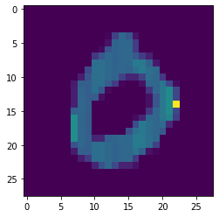

In [10]:

**import**numpy**as** np

print(np**.**argmax(predictions[4]))

4

21

In [11]:

plt**.**imshow(x_test[4])

plt**.**show()

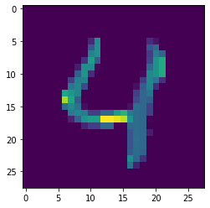

In [12]:

**import**numpy**as** np

print(np**.**argmax(predictions[5]))

1

In [13]:

plt**.**imshow(x_test[5])

plt**.**show()

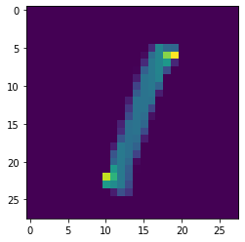

In [14]:

**import**numpy**as** np

print(np**.**argmax(predictions[6]))

4

22

In [15]:

plt**.**imshow(x_test[6])

plt**.**show()

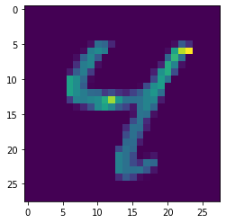

In [16]:

**import**numpy**as** np

print(np**.**argmax(predictions[8]))

5

In [17]:

plt**.**imshow(x_test[8])

plt**.**show()

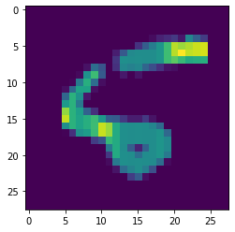

In [18]:

**import**numpy**as** np

print(np**.**argmax(predictions[7]))

9

23

In [19]:

plt**.**imshow(x_test[7])

plt**.**show()

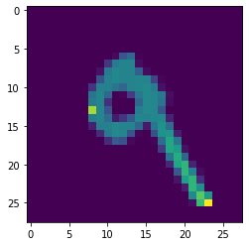

In [ ]: