Supplementary material
China-US schizophrenia burden study, 1990-2023
Blinded manuscript
PROVISIONAL ANALYTICAL DRAFT - NOT FOR SUBMISSION
Official GBD 2023 population and official NCI Joinpoint outputs remain external submission gates.

Supplementary methods and audit trail
This supplement contains the full audit, sensitivity analyses, secondary APC outputs, and external submission gates. Native GBD uncertainty intervals are never relabeled as confidence intervals for derived quantities.

Table S1. Data provenance
Source Role | Gbd Release | File | Retrieval Date | Dimensions | Status
burden estimates | GBD 2023 | cause_all.csv | not recorded in source archive | China; United States; 1990-2023; Female; Male; incidence; prevalence; YLD; DALY; counts and rates | included
population denominators | UNVERIFIED - PROVISIONAL ONLY | rate pairs | 2026-07-07 | China; United States; 1990-2023; Female; Male; ages 15-19 through 70+ | PROVISIONAL proxy
GBD percent metric | GBD 2023 | cause_all.csv | not applicable | mixed measure-specific denominators | excluded
probability of death | GBD 2023 | GBD_1990_2023_ProbabilityOfDeath_ChinaUS_Schizophrenia.csv | not applicable | not a schizophrenia-specific causal outcome | excluded
risk factor extract | GBD 2023 | IHME-GBD_2023_DATA-5ef7a575-1.zip | not applicable | single sexual-violence risk branch | excluded

Table S2. Completeness and validity audit
Location Name | Sex Name | Measure Name | All Age Count Years | Asr Years | Adult Age Groups | Adult Age Year Cells | Missing Values | Invalid Ui Rows | Nonpositive Rows
China | Female | Incidence | 34 | 34 | 12 | 408 | 0 | 0 | 0
China | Male | Incidence | 34 | 34 | 12 | 408 | 0 | 0 | 0
United States of America | Female | Incidence | 34 | 34 | 12 | 408 | 0 | 0 | 0
United States of America | Male | Incidence | 34 | 34 | 12 | 408 | 0 | 0 | 0
China | Female | Prevalence | 34 | 34 | 12 | 408 | 0 | 0 | 0
China | Male | Prevalence | 34 | 34 | 12 | 408 | 0 | 0 | 0
United States of America | Female | Prevalence | 34 | 34 | 12 | 408 | 0 | 0 | 0
United States of America | Male | Prevalence | 34 | 34 | 12 | 408 | 0 | 0 | 0
China | Female | DALYs | 34 | 34 | 12 | 408 | 0 | 0 | 0
China | Male | DALYs | 34 | 34 | 12 | 408 | 0 | 0 | 0
United States of America | Female | DALYs | 34 | 34 | 12 | 408 | 0 | 0 | 0
United States of America | Male | DALYs | 34 | 34 | 12 | 408 | 0 | 0 | 0

Table S3. YLD-DALY identity audit
Matched Cells | Max Abs Difference Val | Max Relative Difference Val | Max Abs Difference Lower | Max Relative Difference Lower | Max Abs Difference Upper | Max Relative Difference Upper | Numerically Identical
3944 | 7.342e-06 | 2.600e-08 | 5.305e-06 | 2.600e-08 | 9.112e-06 | 2.600e-08 | True

Table S4. Weighted trend sensitivity
Location Name | Sex Name | Measure Name | Primary Aapc | Ui Weighted Fixed Knot Aapc | Difference | Interpretation
China | Female | DALYs | 0.0478 | 0.0479 | 0.0000 | Sensitivity only; GBD UIs are not independent sampling SEs.
China | Female | Incidence | 0.0125 | 0.0125 | 0.0000 | Sensitivity only; GBD UIs are not independent sampling SEs.
China | Female | Prevalence | 0.0235 | 0.0235 | -0.0000 | Sensitivity only; GBD UIs are not independent sampling SEs.
China | Male | DALYs | 0.0363 | 0.0364 | 0.0000 | Sensitivity only; GBD UIs are not independent sampling SEs.
China | Male | Incidence | -0.0014 | -0.0015 | -0.0001 | Sensitivity only; GBD UIs are not independent sampling SEs.
China | Male | Prevalence | 0.0151 | 0.0151 | -0.0000 | Sensitivity only; GBD UIs are not independent sampling SEs.
United States of America | Female | DALYs | -0.2491 | -0.2490 | 0.0001 | Sensitivity only; GBD UIs are not independent sampling SEs.
United States of America | Female | Incidence | -0.2097 | -0.2097 | -0.0000 | Sensitivity only; GBD UIs are not independent sampling SEs.
United States of America | Female | Prevalence | -0.2301 | -0.2301 | -0.0000 | Sensitivity only; GBD UIs are not independent sampling SEs.
United States of America | Male | DALYs | -0.1091 | -0.1093 | -0.0003 | Sensitivity only; GBD UIs are not independent sampling SEs.
United States of America | Male | Incidence | -0.0756 | -0.0756 | 0.0000 | Sensitivity only; GBD UIs are not independent sampling SEs.
United States of America | Male | Prevalence | -0.0792 | -0.0795 | -0.0003 | Sensitivity only; GBD UIs are not independent sampling SEs.

Table S5. Alternative-window decomposition
Location Name | Sex Name | Measure Name | Start Year | End Year | Population Growth | Population Aging | Rate Change | Total Change | Closure Error
China | Female | Incidence | 2000 | 2023 | 25,800.6 | -16,753.1 | -44.0 | 9,003.5 | <1e-8
China | Female | Incidence | 2010 | 2023 | 6,631.4 | -15,075.7 | -98.8 | -8,543.1 | <1e-8
China | Female | Prevalence | 2000 | 2023 | 441,892.3 | 141,474.3 | 4,316.4 | 587,682.9 | <1e-8
China | Female | Prevalence | 2010 | 2023 | 115,992.3 | 105,591.2 | 3,603.3 | 225,186.9 | <1e-8
China | Female | DALYs | 2000 | 2023 | 279,994.0 | 65,055.7 | 3,837.7 | 348,887.4 | <1e-8
China | Female | DALYs | 2010 | 2023 | 73,357.4 | 47,212.8 | 2,075.5 | 122,645.6 | <1e-8
China | Male | Incidence | 2000 | 2023 | 31,984.6 | -17,917.7 | -736.2 | 13,330.6 | <1e-8
China | Male | Incidence | 2010 | 2023 | 9,912.6 | -14,824.1 | -1,216.8 | -6,128.3 | <1e-8
China | Male | Prevalence | 2000 | 2023 | 503,527.9 | 112,420.3 | 720.8 | 616,668.9 | <1e-8
China | Male | Prevalence | 2010 | 2023 | 158,953.8 | 88,892.7 | -8,321.7 | 239,524.8 | <1e-8
China | Male | DALYs | 2000 | 2023 | 323,737.4 | 45,956.9 | 1,373.9 | 371,068.3 | <1e-8
China | Male | DALYs | 2010 | 2023 | 101,869.9 | 38,213.5 | -1,998.2 | 138,085.2 | <1e-8
United States | Female | Incidence | 2000 | 2023 | 7,109.1 | -2,354.0 | -1,359.7 | 3,395.3 | <1e-8
United States | Female | Incidence | 2010 | 2023 | 3,533.2 | -2,230.8 | -1,490.6 | -188.2 | <1e-8
United States | Female | Prevalence | 2000 | 2023 | 152,502.5 | -24,138.8 | -41,253.5 | 87,110.1 | <1e-8
United States | Female | Prevalence | 2010 | 2023 | 75,457.3 | -18,182.9 | -39,211.3 | 18,063.0 | <1e-8
United States | Female | DALYs | 2000 | 2023 | 93,339.5 | -17,769.8 | -30,272.9 | 45,296.8 | <1e-8
United States | Female | DALYs | 2010 | 2023 | 46,181.9 | -13,070.9 | -30,525.3 | 2,585.7 | <1e-8
United States | Male | Incidence | 2000 | 2023 | 9,319.4 | -3,568.1 | -926.9 | 4,824.4 | <1e-8
United States | Male | Incidence | 2010 | 2023 | 4,782.6 | -2,766.3 | -1,074.7 | 941.6 | <1e-8
United States | Male | Prevalence | 2000 | 2023 | 175,570.3 | -33,834.5 | -19,992.6 | 121,743.2 | <1e-8
United States | Male | Prevalence | 2010 | 2023 | 90,194.4 | -20,565.8 | -19,674.8 | 49,953.7 | <1e-8
United States | Male | DALYs | 2000 | 2023 | 110,458.3 | -25,255.7 | -16,940.9 | 68,261.8 | <1e-8
United States | Male | DALYs | 2010 | 2023 | 56,601.3 | -15,027.6 | -16,615.4 | 24,958.3 | <1e-8

Secondary APC analysis
The APC analysis is intentionally restricted to incidence and estimable summaries. Curvature relative risks describe nonlinear departures after removing intercept and linear trend. They are not separately identified causal effects.
Location Name | Sex Name | Measure Name | Start Year | End Year | Net Drift | Net Drift Lower Model Ci | Net Drift Upper Model Ci | Interpretation
China | Female | Incidence | 1994 | 2023 | 0.0075 | -0.0040 | 0.0189 | Estimable net drift; model CI does not propagate GBD posterior uncertainty.
China | Male | Incidence | 1994 | 2023 | 0.0024 | -0.0085 | 0.0134 | Estimable net drift; model CI does not propagate GBD posterior uncertainty.
United States | Female | Incidence | 1994 | 2023 | -0.0812 | -0.1169 | -0.0454 | Estimable net drift; model CI does not propagate GBD posterior uncertainty.
United States | Male | Incidence | 1994 | 2023 | 0.0235 | -0.0079 | 0.0549 | Estimable net drift; model CI does not propagate GBD posterior uncertainty.

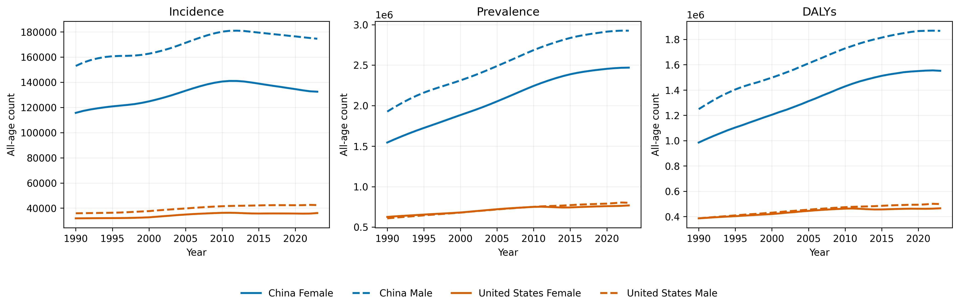
Figure S1. All-age schizophrenia outcome counts by country and sex, 1990-2023.
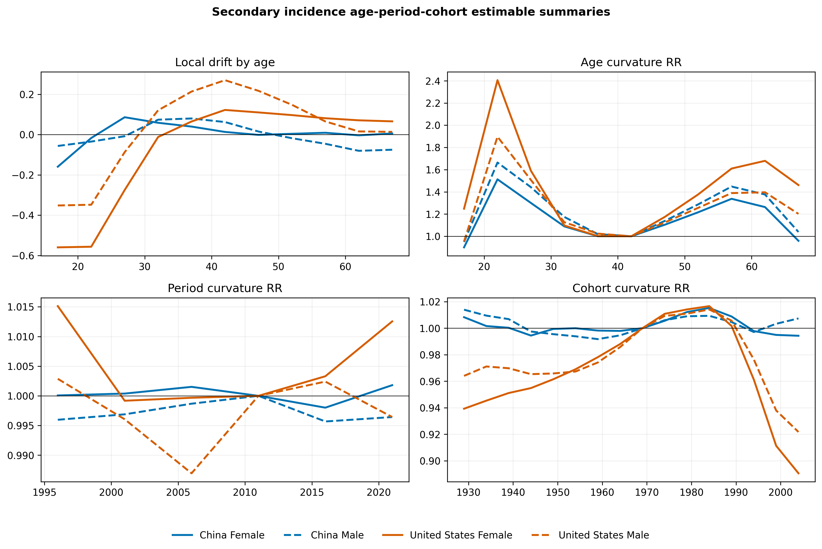
Figure S2. Secondary incidence APC estimable summaries. Relative-risk curves are nonlinear curvature contrasts, not independent causal age, period, or cohort effects.

External submission gates
- Population status: derived_proxy_NOT_OFFICIAL
- Trend status: independent permutation implementation; official NCI results not yet imported
- Official GBD 2023 population must replace the proxy before submission.
- Official NCI Joinpoint output must be generated by a registered end user and imported before the method is described as NCI Joinpoint.
- Posterior draws remain unavailable; derived uncertainty must remain explicitly limited.

