Contrasting sex-specific trends and demographic contributions to schizophrenia burden in China and the United States, 1990–2023
A comparative analysis of Global Burden of Disease 2023 estimates
Blinded manuscript

Abstract
Background: Schizophrenia is associated with substantial lifelong disability, yet national trends are difficult to interpret from case counts alone because they also reflect population growth and ageing. We compared sex-specific schizophrenia burden in China and the United States, two populous countries with markedly different demographic trajectories.
Methods: We analyzed GBD 2023 estimates of incidence, prevalence, and disability-adjusted life-years (DALYs) from 1990 to 2023. We examined all-age quantities and age-standardized rates (ASRs), characterized nonlinear ASR trends with segmented log-linear regression selected by the Bayesian information criterion, and used Shapley replacement to separate changes in all-age burden into population-size, age-structure, and age-specific-rate components. A descriptive age-period-cohort (APC) analysis used incidence as the principal secondary outcome, with prevalence and DALY rate surfaces examined exploratorily. Because posterior draws were unavailable, derived quantities are reported as point estimates.
Results: Absolute burden increased in every country-sex stratum between 1990 and 2023. DALY ASRs in China changed from 175.3 to 177.6 per 100,000 among females and from 207.2 to 209.1 among males; corresponding U.S. rates changed from 269.5 to 247.9 and from 281.2 to 270.2. Under the prespecified ±0.05%/year descriptive stability band, segmented AAPCs were practically stable in China and negative in the United States. These classifications were unchanged in the AR(1) sensitivity analysis. Collapsing age groups materially altered at least one decomposition component in 3 of 12 panels.
Conclusions: Rising numbers of incident cases, prevalent cases, and DALYs were not accompanied by worsening age-standardized burden in either country. The contrast between absolute and standardized measures highlights the importance of demographic context for service planning. Derived changes and decomposition components are reported as point estimates because posterior draws were unavailable.
Keywords: schizophrenia; Global Burden of Disease; China; United States; segmented regression; decomposition; demographic change; sex differences

Background
Schizophrenia is a severe mental disorder associated with persistent functional impairment, premature mortality, family burden, and substantial health and social care needs [1-3]. In the GBD framework, schizophrenia DALYs are represented by years lived with disability (YLDs) because no direct fatal component is assigned to the disorder; this convention does not imply that people with schizophrenia have no excess mortality [1,3]. YLD rows were not included in the downloaded data, so we could not independently verify numerical identity between YLDs and DALYs in the study extract.
Earlier global GBD analyses found that incident and prevalent case counts and DALYs increased substantially while age-standardized schizophrenia rates changed much less [2,3]. Counts and standardized rates therefore answer different questions: absolute quantities reflect population size and age structure as well as age-specific rates, whereas ASRs remove differences in population age composition.
Recent GBD studies provide important context for this comparison. A 2026 analysis of GBD 2023 data from China reported the same 1990-2023 endpoints, sex strata, and decomposition into population growth, ageing, and age-specific-rate change [4]. Its Chinese endpoint estimates are identical to those used here because both studies draw from the same GBD release. Other studies based on GBD 2021 have examined schizophrenia trends alongside sex and age patterns, country comparisons, decomposition, joinpoint models, inequalities, and projections [5-7]. Against this background, our contribution is a release-matched, sex-specific comparison of China and the United States through 2023, using a common analytic framework for paired trend, decomposition, and age-specific summaries.
China and the United States were selected a priori because both are populous countries but have contrasting age structures and demographic trajectories. We expected all-age quantities to rise more consistently than ASRs, demographic contributions to differ between countries, and aggregate trends to mask some age-specific variation. We therefore quantified endpoints and nonlinear trends, compared country and sex trajectories, decomposed changes in all-age burden, and examined how aggregate patterns related to secondary APC summaries.

Methods

Study design and data source
We conducted a comparative secondary analysis of GBD 2023 modeled health estimates [8]. The analytic population comprised females and males in China and the United States from 1990 through 2023. The data contained annual posterior means and 95% uncertainty intervals (UIs) for incidence, prevalence, and DALYs by age, sex, country, year, and metric. GBD schizophrenia estimates synthesize epidemiological inputs under reference case definitions, commonly ICD-10 F20 and corresponding DSM definitions, and use Bayesian disease modeling to generate internally consistent incidence and prevalence estimates by age, sex, location, and year [3,8]. Severity-specific prevalence is combined with population-derived disability weights to estimate YLDs [2,8]. We did not have access to country-specific microdata, source-level sample sizes, or posterior draws. Because the files contained only aggregated, non-identifiable estimates, institutional review board review and informed consent were not applicable.

Outcomes and analytical exclusions
Primary outcomes were incidence, prevalence, and DALYs. Trend analyses used all-age numbers and ASRs per 100,000 from the GBD Results Tool; the GBD ASRs standardize age-specific rates to a common reference population [8]. For decomposition, we combined matching Number and Rate estimates with official population estimates across 20 mutually exclusive age groups from 0-4 through 95+ years. We excluded the GBD Percent metric because its denominator and age basis differed across outcomes. Probability of death was outside the scope of this nonfatal-burden analysis. The available risk-factor file covered only a limited branch of schizophrenia-attributable DALYs and was insufficient for a complete comparative risk analysis, so risk attribution was not pursued. YLDs were not a prespecified outcome and were not present in the downloaded data.

Data quality and population denominators
We checked dimensional uniqueness, completeness across all 34 years, missingness, nonnegativity, uncertainty-bound ordering, and consistency of age groups. The IHME files contained 2,720 exact zero point estimates: incidence Number and Rate at ages 0-9 and 80+, and prevalence and DALY Number and Rate at ages 0-9, in both countries, both sexes, and every year. We retained these values as supplied. The files do not indicate whether the zeros represent biological structural zeros or limits of GBD model support. Log-rate APC analyses were therefore restricted to positive-valued ages 10-69. The all-age decomposition retained the full age partition, with an additional incidence sensitivity analysis restricted to ages 10-79. Age-specific quantities were reconstructed from official GBD 2023 population estimates as population × rate / 100,000.

Trend and comparison analyses
We modeled log ASRs using an open Python implementation of piecewise linear regression based on the general joinpoint parameterization [9]. Candidate models allowed zero to two change points, with at least four annual observations in each segment, and the Bayesian information criterion determined the number and location of breakpoints. Segment annual percentage changes and overall average annual percentage changes (AAPCs) summarize fitted changes in the annual GBD posterior means. For interpretation, absolute annual changes below 0.05% were classified as practically stable; thresholds of 0.02% and 0.10% were examined in sensitivity analyses. This classification is descriptive and is not an equivalence test. Additional sensitivities varied the allowed number of breakpoints, minimum segment length, calendar window, scale, and log-UI-width weighting. We also refitted the candidate models using iterative Prais-Winsten feasible generalized least squares with an AR(1) error structure. NCI Joinpoint is cited as methodological context [10], but the NCI software was not used.
We calculated China-U.S. contrasts within each outcome and sex, and female-male contrasts within each outcome and country, as differences in AAPCs. Lag-1 residual autocorrelation was examined because annual GBD estimates may be serially correlated. We did not perform parallelism F tests or multiplicity-adjusted significance testing. GBD UIs are reported for the original estimates only; ratios, differences, changes, AAPCs, and decomposition components are point estimates because posterior draws and cross-estimate correlations were unavailable.

Demographic decomposition
For each outcome, country, and sex, we decomposed the change in reconstructed all-age quantities into contributions from population size, age structure, and age-specific rates [11]. Marginal contributions were averaged over all six possible factor-replacement orders, yielding a Shapley decomposition. We verified that the three components summed to the reconstructed total change within numerical tolerance and that reconstructed endpoints matched the reported all-age numbers. The primary comparison covered 1990-2023; analyses beginning in 2000 and 2010 and annual- and five-year-chain decompositions assessed sensitivity to the endpoints and replacement path. We also compared the original 20 age groups with four broader groups (0-19, 20-39, 40-59, and 60+ years). Because incidence was exactly zero at ages 0-9 and 80+ in the source data, an additional sensitivity decomposition was restricted to ages 10-79 and was reported separately from all-age burden.

Secondary age-period-cohort analysis
The APC analysis used equal five-year age groups from 10-14 through 65-69 years and six five-year periods from 1994-1998 through 2019-2023. Incidence was the principal secondary outcome; prevalence and DALY rate surfaces were included as exploratory extensions. To address the APC identification problem, we used constrained nonlinear functions consistent with the estimable-function literature [12-15]. Reported summaries include a global period slope, separately fitted age-specific log-rate slopes, an age rate-ratio curve, and period- and cohort-curvature rate ratios. The population-weighted least-squares model included an intercept, centered linear age and period terms, and nonlinear age, period, and cohort bases orthogonal to the intercept and linear trend. These summaries were not designed to reproduce conventional NCI APC estimable functions. We assessed the influence of population weighting with an equal-weight analysis and repeated the analysis over an earlier window spanning 1990-1994 through 2015-2019. Rate-ratio curves were normalized to one at the reference categories.

Reporting and reproducibility
The analysis was performed in Python with deterministic settings. Tables and figures were generated directly from the study's machine-readable inputs and result files, and reporting followed the Guidelines for Accurate and Transparent Health Estimates Reporting (GATHER) [16]. The accompanying materials include analysis scripts, input data, machine-readable results, and figures. OpenAI Codex was used to assist with software development and manuscript drafting. The authors reviewed the resulting code, analyses, text, claims, and references and take responsibility for the final work; the tool is not an author.

Results

Data completeness and outcome selection
All 12 country-sex-outcome panels contained 34 annual all-age quantities and 34 annual ASRs. Each decomposition dataset included 20 age groups spanning 0-4 through 95+ years. We found no negative values or invalid UI ordering. The files did contain 2,720 exact zero Number/Rate cells: incidence at ages 0-9 and 80+, and prevalence and DALYs at ages 0-9, in every country-sex-year stratum. YLDs were absent from the extract, so numerical identity between YLDs and DALYs could not be checked directly; this did not affect the three prespecified outcomes. Population-rate reconstruction error was negligible (99th percentile absolute discrepancy, 9.06e-11%), and reconstructed decomposition endpoints matched reported all-age numbers within floating-point tolerance.

Burden levels and temporal changes
All-age incidence, prevalence, and DALY quantities were higher in 2023 than in 1990 for both sexes in both countries. In China, AAPCs for the three outcomes remained within the ±0.05%/year practical-stability band; in the United States, all three AAPCs were negative. Male point-estimate rates were generally higher than female rates.
Table 1. Endpoint burden and descriptive trends
Location | Sex | Outcome | 1990 quantity (95% UI) | 2023 quantity (95% UI) | Quantity change, % | ASR 1990 (95% UI) | ASR 2023 (95% UI) | Descriptive AAPC, %/year
China | Female | Incidence | 115,697 (97,975-138,931) | 132,520 (111,395-155,089) | 14.5 | 18.35 (15.45-21.78) | 18.42 (15.40-21.88) | 0.012
China | Female | Prevalence | 1,544,462 (1,278,400-1,844,258) | 2,469,230 (2,074,473-2,895,939) | 59.9 | 276.90 (233.25-329.61) | 278.86 (234.44-331.62) | 0.024
China | Female | DALYs | 985,172 (724,062-1,242,487) | 1,551,859 (1,120,102-1,948,123) | 57.5 | 175.27 (131.54-219.91) | 177.61 (129.65-223.14) | 0.048
China | Male | Incidence | 152,989 (129,743-182,808) | 174,592 (147,864-202,989) | 14.1 | 22.78 (19.22-26.98) | 22.77 (19.21-26.93) | -0.001
China | Male | Prevalence | 1,926,496 (1,592,841-2,282,654) | 2,925,661 (2,451,025-3,441,426) | 51.9 | 322.43 (269.45-380.65) | 324.40 (272.30-383.47) | 0.015
China | Male | DALYs | 1,249,021 (905,406-1,575,895) | 1,867,497 (1,364,871-2,322,508) | 49.5 | 207.25 (151.97-258.34) | 209.14 (154.27-260.57) | 0.036
United States | Female | Incidence | 31,876 (26,748-38,496) | 36,071 (30,645-42,094) | 13.2 | 24.55 (20.89-29.32) | 23.04 (19.65-27.07) | -0.210
United States | Female | Prevalence | 625,836 (518,779-742,574) | 767,642 (646,811-896,627) | 22.7 | 435.19 (361.33-517.16) | 403.27 (336.96-477.10) | -0.230
United States | Female | DALYs | 386,308 (272,674-478,016) | 465,494 (334,682-564,154) | 20.5 | 269.48 (190.04-335.42) | 247.86 (176.81-305.03) | -0.249
United States | Male | Incidence | 35,897 (30,748-42,985) | 42,426 (36,456-49,242) | 18.2 | 27.28 (23.47-32.00) | 26.42 (22.57-30.86) | -0.076
United States | Male | Prevalence | 608,106 (507,602-721,030) | 800,475 (674,409-934,021) | 31.6 | 443.11 (370.70-523.98) | 428.80 (358.33-502.32) | -0.079
United States | Male | DALYs | 386,160 (278,483-478,712) | 499,087 (362,580-610,406) | 29.2 | 281.20 (202.44-346.56) | 270.16 (194.75-334.97) | -0.109

Quantity denotes incident cases, prevalent cases, or DALYs; DALYs represent healthy life-years lost rather than numbers of people. The 95% UIs are those reported by GBD for the endpoint estimates. Percentage changes and AAPCs are point estimates without propagated posterior uncertainty.
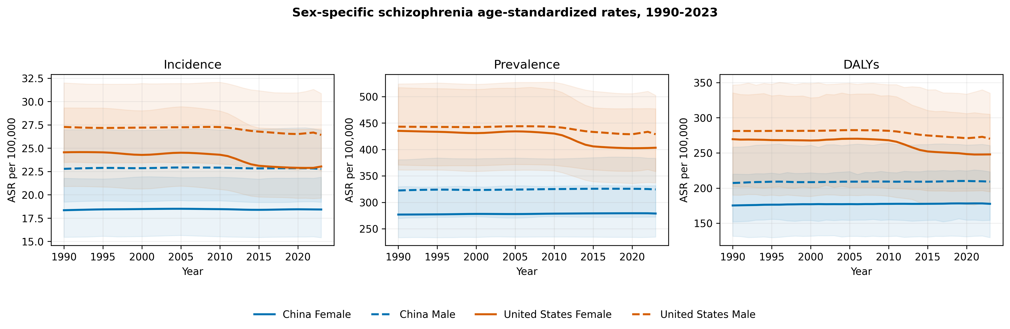
Figure 1. Sex-specific schizophrenia age-standardized rates in China and the United States, 1990-2023. Shading shows native 95% GBD uncertainty intervals.

Segmented trends and descriptive comparisons
The BIC-selected segmented curves captured modest nonlinear features in the annual posterior means. Absolute lag-1 residual correlation was at least 0.5 in 8 of the 12 primary fits, indicating that an independent-error model was not adequate for every panel. Refitting with AR(1) feasible GLS left the practical trajectory classification unchanged in all 12 panels, retained the same number of breakpoints in 11, and changed AAPC by no more than 0.009 percentage points/year. Breakpoint years shifted in several Chinese panels, so breakpoint locations and slopes are reported descriptively.
Table 2. China-United States annualized endpoint contrasts
Sex | Outcome | China, %/year | United States, %/year | US-China, percentage points
Female | Incidence | 0.013 | -0.193 | -0.206
Female | Prevalence | 0.021 | -0.231 | -0.252
Female | DALYs | 0.040 | -0.253 | -0.293
Male | Incidence | -0.001 | -0.097 | -0.095
Male | Prevalence | 0.018 | -0.099 | -0.118
Male | DALYs | 0.028 | -0.121 | -0.149

Annualized endpoint changes were calculated from the 1990 and 2023 ASRs and are reported as point estimates. The contrast is United States minus China. Confidence intervals and parallelism tests were not calculated; additional country and sex contrasts are provided in the supplement.
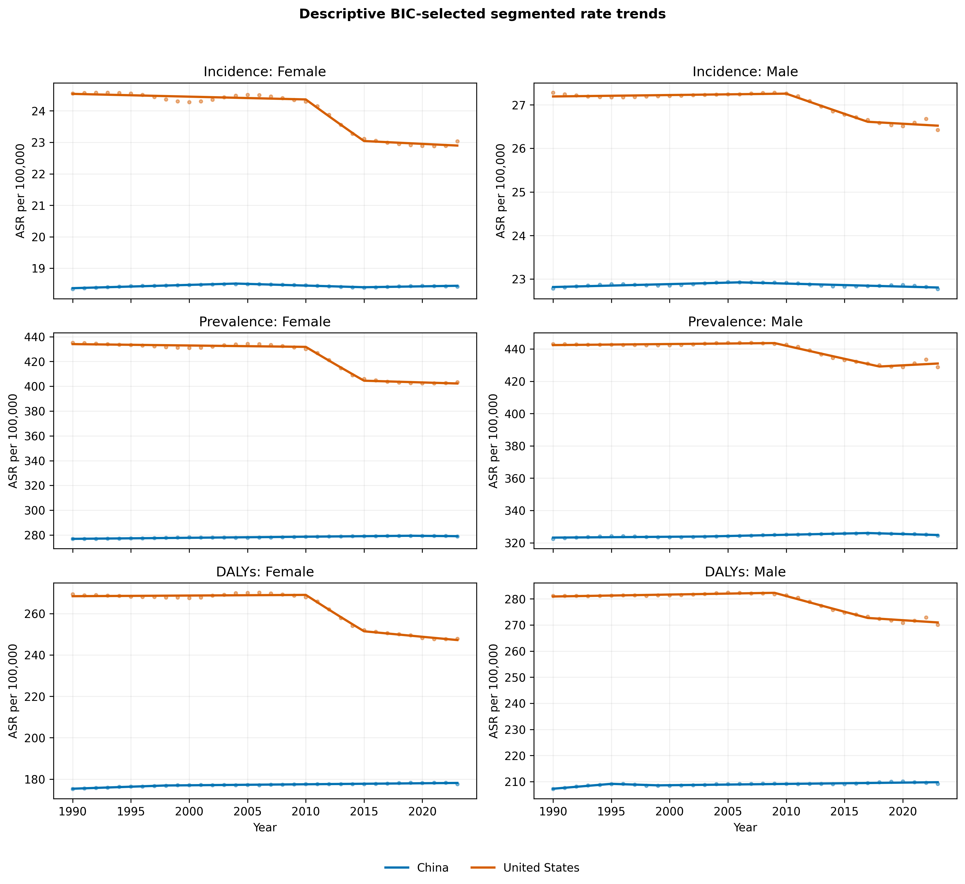
Figure 2. Observed and fitted segmented age-standardized rate trajectories. The fitted curves were selected by BIC using the study's Python implementation; they are not output from the NCI Joinpoint program.

Age-specific patterns
Age profiles varied by outcome and sex, with male point estimates generally higher than female estimates. Incidence peaked in early adulthood, while prevalence and DALY rates remained substantial through middle adulthood. Incidence values at ages 80+ were exact zeros in the source data; these plotted cells reflect the supplied GBD estimates rather than evidence of absent incidence at older ages.
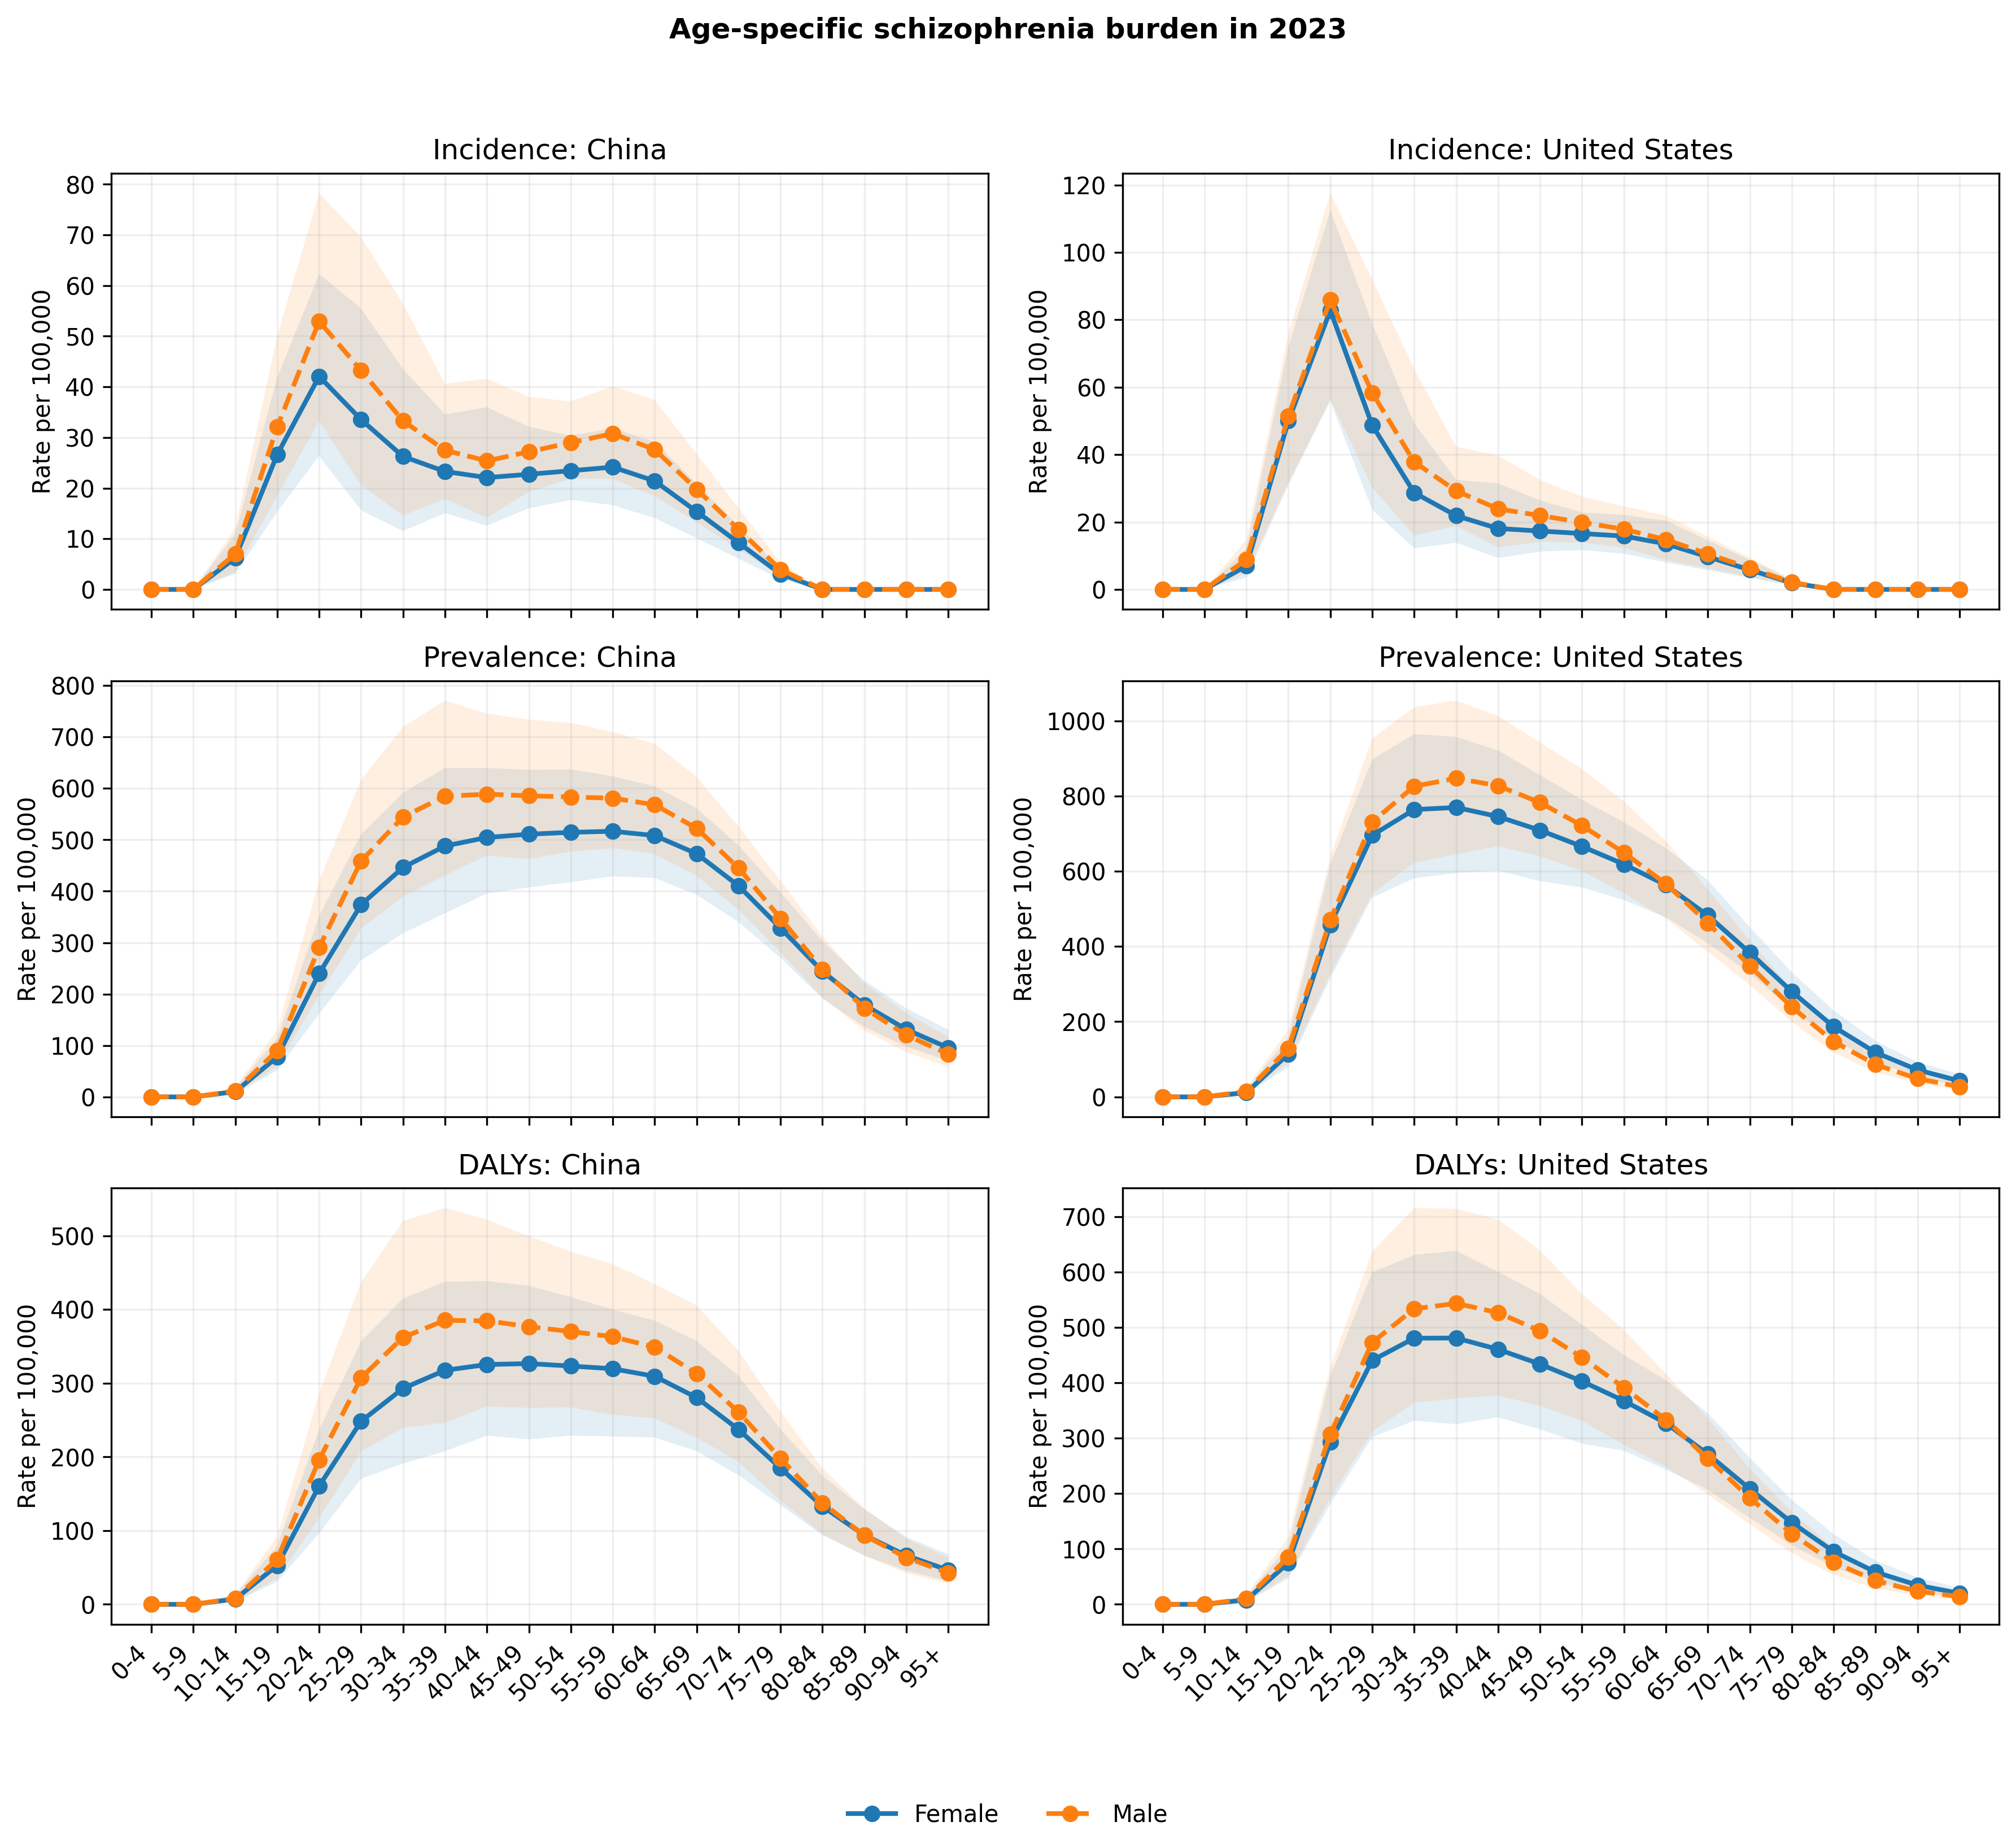
Figure 3. Age-specific incidence, prevalence, and DALY rates in 2023 by country and sex. Shading shows native 95% GBD uncertainty intervals.

Drivers of changing all-age quantities
Table 3. Shapley decomposition of all-age changes, 1990-2023
Location | Sex | Outcome | Population size | Age structure | Age-specific rate | Total change
China | Female | Incidence | 24,854 | -8,744 | 712 | 16,823
China | Female | Prevalence | 394,946 | 511,754 | 18,068 | 924,768
China | Female | DALYs | 249,766 | 297,673 | 19,248 | 566,687
China | Male | Incidence | 30,554 | -8,856 | -95 | 21,603
China | Male | Prevalence | 446,098 | 537,692 | 15,376 | 999,165
China | Male | DALYs | 286,716 | 317,336 | 14,425 | 618,476
United States | Female | Incidence | 8,969 | -2,903 | -1,870 | 4,195
United States | Female | Prevalence | 183,048 | 8,052 | -49,294 | 141,806
United States | Female | DALYs | 112,027 | 1,113 | -33,954 | 79,186
United States | Male | Incidence | 11,463 | -3,817 | -1,117 | 6,529
United States | Male | Prevalence | 204,543 | 9,379 | -21,553 | 192,369
United States | Male | DALYs | 128,713 | 1,060 | -16,847 | 112,927

Population-size change contributed positively in all 12 panels, whereas the age-structure and age-specific-rate components differed by country, sex, and outcome (Table 3). Negative values indicate components that offset part of the total increase; because the components are additive rather than compositional, their percentages can exceed 100%. Annual- and five-year-chain allocations differed from endpoint allocations by at most 7.9% of total change. Restricting incidence to positive-valued ages 10-79 preserved the sign of every component, although magnitudes changed. Collapsing the age groups produced material variation in at least one component in 3 of 12 panels. Results based on the original 20 age groups are therefore presented as primary, with the collapsed groups used as an aggregation sensitivity analysis.
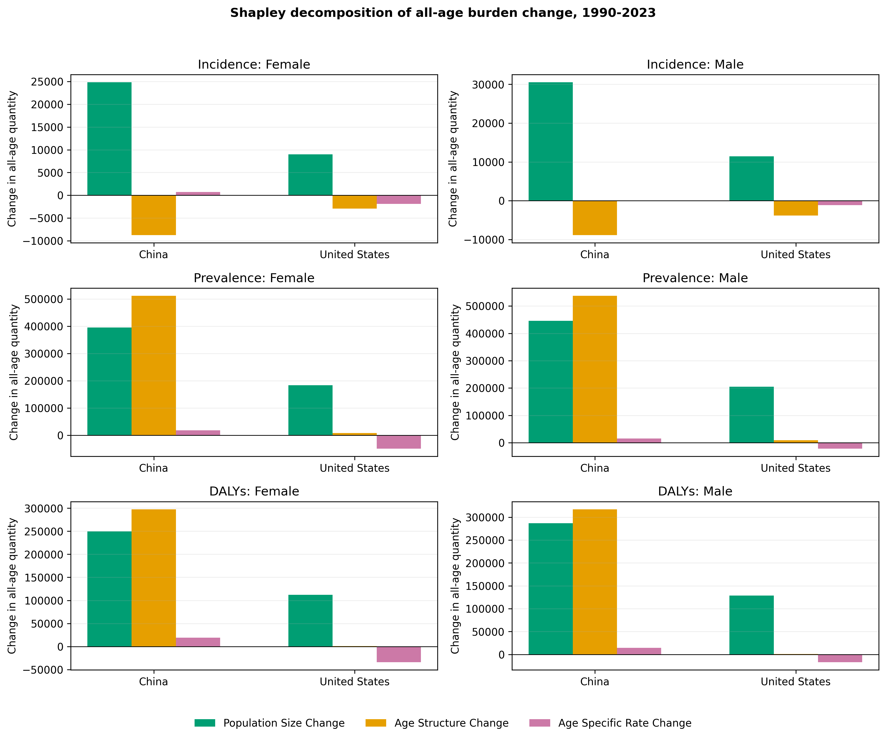
Figure 4. Shapley decomposition of changes in reconstructed all-age schizophrenia quantities, 1990-2023. Components were calculated from posterior mean rates.

Secondary age-period-cohort summaries
Across the 12 APC panels, the global period slope in the primary window ranged from -0.291%/year for female DALYs in the United States to 0.038%/year for male incidence in the United States. Practical-stability classifications were identical in the primary and 1990-2019 windows for all 12 panels. Ten panels contained age-specific slopes in opposing directions, illustrating how an aggregate trend can mask variation across age groups.
Period-curvature rate ratios ranged from 0.968 to 1.008, and cohort-curvature rate ratios from 0.925 to 1.018. Replacing population weights with equal weights changed the global period slope by no more than 0.002 percentage points/year. These normalized curves summarize period and cohort curvature without assigning causal effects.
For incidence, the practical-stability classification from the global APC period slope agreed with the segmented AAPC in 3 of the 4 country-sex strata. Exact agreement is not expected because the two summaries use different age ranges, weighting and standardization schemes, calendar aggregation, and model forms. Prevalence and DALY APC panels were retained as exploratory rate-surface analyses.

Discussion
The main finding was a divergence between absolute and age-standardized measures. From 1990 to 2023, estimated numbers of incident cases, people living with schizophrenia, and DALYs increased in both countries, while Chinese ASRs were essentially stable under the prespecified descriptive band and U.S. ASRs declined, most clearly among females. Population growth, shifts in age structure, and changes in age-specific rates contributed differently to these patterns.
The APC analysis provides a complementary view of age-specific change. Opposing age-specific slopes in several panels indicate that a single aggregate trajectory can obscure groups moving in different directions. For China-male incidence, both the segmented AAPC and the global APC period slope fell within the practical-stability band. For U.S.-male incidence, the segmented AAPC was negative while the selected-age global period slope remained within that band. The two measures differ in calendar window, age coverage, population weighting, standardization, and model form, so they need not agree exactly.
The divergence between counts and standardized rates is consistent with findings from earlier GBD releases. Using GBD 2019, Solmi and colleagues reported global increases from 14.2 to 23.6 million prevalent cases, 0.941 to 1.3 million incident cases, and 9.1 to 15.1 million DALYs between 1990 and 2019, while age-standardized estimates changed comparatively little [3]. Song and colleagues, using GBD 2023, reported the same Chinese sex-specific endpoint changes observed here: incidence increased by 14.1% among males and 14.5% among females, prevalence by 51.9% and 59.9%, and DALYs by 49.5% and 57.5%, respectively [4]. The numerical agreement is expected because both analyses use the same release. A GBD 2021 analysis of China instead reported a both-sex ASPR increase from 374.60 to 388.99 per 100,000 through 2021 [5]. That estimate comes from an earlier release, combines sexes, and covers a different calendar period, so it is not directly interchangeable with the present sex-specific GBD 2023 series.
Applying the same decomposition to both countries and sexes helps clarify why similar increases in absolute burden can arise from different combinations of population growth, ageing, and age-specific rates. In China, age structure made a sizeable positive contribution to prevalence and DALYs, whereas U.S. age-specific-rate components were negative for several outcomes. The decomposition allocates the observed endpoint difference among these components but does not identify the mechanisms that produced them.
The distinction between these measures matters for planning. Incident and prevalent case counts provide one indication of potential service volume, whereas DALYs quantify healthy life lost rather than numbers of people. Actual service use also depends on detection, access, coverage, severity, and treatment pathways. ASRs are useful for comparing rates over time and across countries after adjusting for age composition, but they can obscure growth in the absolute number of people who may need care. Conversely, rising counts alone should not be interpreted as evidence that individual risk has increased.
Male rates were higher for several outcomes, and incidence was concentrated in younger age groups, broadly consistent with earlier GBD analyses of schizophrenia [2,3]. The modeled data cannot distinguish how much of the observed country or sex variation reflects underlying incidence, diagnostic recognition, data availability, access to care, remission, excess mortality, or GBD modeling assumptions.

Strengths and limitations
This study has several strengths. Both countries were analyzed with the same GBD 2023 definitions and the same sex-specific workflow, allowing direct comparison within a single release. We kept GBD-reported UIs separate from derived point estimates, verified reconstruction and Shapley closure numerically, checked the source-data zero cells, and examined serial correlation, alternative decomposition paths, age-group aggregation, APC weighting, and window choice. These checks make the computational steps reproducible and show where the main findings are sensitive to analytic choices.
The analysis also has important limitations. GBD values are modeled estimates rather than direct observations, and source availability and modeling assumptions may differ across years, sexes, outcomes, and countries. Posterior draws and cross-estimate covariance were unavailable, so uncertainty could not be propagated to derived changes, slopes, decomposition components, or APC summaries. Broader age grouping altered some decomposition components, and the interpretation of exact zero-valued age cells was unavailable from the source files. The APC analysis was limited to ages 10-69 and used constrained functions rather than conventional NCI estimable functions. Finally, the country comparison is ecological and cannot establish causal effects of policies or health systems.

Conclusions
Between 1990 and 2023, estimated numbers of incident cases, prevalent cases, and DALYs increased in both China and the United States, but the age-standardized trajectories differed: Chinese slopes were practically stable under the prespecified descriptive rule, whereas U.S. slopes were negative. Decomposition showed that population growth, age structure, and age-specific rates contributed differently across outcomes and settings. Interpreting schizophrenia burden therefore requires attention to absolute service volume, health loss, standardized rates, age structure, and sex together.

Supplementary information
- Supplementary file 1: supplementary_material.docx, containing Tables S1-S15 and Figures S1-S2.
- Supplementary file 2: statistical_methods_appendix.docx, containing complete estimating equations, constraints, sensitivities, and the uncertainty taxonomy.
- Supplementary file 3: companion CSV files containing the machine-readable analysis results.

List of abbreviations
AAPC: average annual percentage change; APC: age-period-cohort; ASR: age-standardized rate; BIC: Bayesian information criterion; DALY: disability-adjusted life-year; GATHER: Guidelines for Accurate and Transparent Health Estimates Reporting; GBD: Global Burden of Disease; IHME: Institute for Health Metrics and Evaluation; NCI: National Cancer Institute; UI: uncertainty interval; YLD: year lived with disability.

Declarations

Ethics approval and consent to participate
Not applicable. This study used aggregated, non-identifiable modeled estimates available through the Institute for Health Metrics and Evaluation.

Consent for publication
Not applicable.

Availability of data and materials
GBD estimates are available through the IHME GBD Results Tool subject to IHME terms [8]. The study repository contains the analysis scripts, input CSV files, derived result tables, and figures used for this manuscript. Redistribution of source data must comply with IHME terms. No persistent public repository or archive DOI has yet been assigned.

Competing interests
Competing-interest information has been omitted from the blinded manuscript and will be provided by the submitting author through the journal submission system.

Funding
Funding and funder-role information has been omitted from the blinded manuscript and will be provided by the submitting author through the journal submission system.

Authors' contributions
Author names and CRediT contribution statements have been omitted for blinded review and will be provided through the journal submission system.

Acknowledgements
We acknowledge the Institute for Health Metrics and Evaluation and the Global Burden of Disease collaborators for producing and making the GBD 2023 estimates available. This acknowledgment does not imply endorsement of the present analysis.

References
1. GBD 2019 Mental Disorders Collaborators. Global, regional, and national burden of 12 mental disorders in 204 countries and territories, 1990-2019: a systematic analysis for the Global Burden of Disease Study 2019. Lancet Psychiatry. 2022;9(2):137-150. doi:10.1016/S2215-0366(21)00395-3.
2. Charlson FJ, Ferrari AJ, Santomauro DF, et al. Global epidemiology and burden of schizophrenia: findings from the Global Burden of Disease Study 2016. Schizophr Bull. 2018;44(6):1195-1203. doi:10.1093/schbul/sby058.
3. Solmi M, Seitidis G, Mavridis D, et al. Incidence, prevalence, and global burden of schizophrenia - data, with critical appraisal, from the Global Burden of Disease (GBD) 2019. Mol Psychiatry. 2023;28(12):5319-5327. doi:10.1038/s41380-023-02138-4.
4. Song H, Fang L, Li H. Long-term trends in the burden of schizophrenia in China, 1990-2052: an analysis of the Global Burden of Disease Study 2023. Psychol Res Behav Manag. 2026;19:574531. doi:10.2147/PRBM.S574531.
5. Huo J, Li R, Ren X, et al. Trends in incidence, prevalence, and disability-adjusted life years of schizophrenia in China from 1990 to 2021, with projections for 2022-2050. Front Psychiatry. 2025;16:1651350. doi:10.3389/fpsyt.2025.1651350.
6. Luo W, Gao J, Guo Z, et al. Trends and cross-country inequalities in schizophrenia from 1990 to 2021, with prediction to 2035: a systematic analysis of the Global Burden of Disease Study 2021. BMC Psychiatry. 2025;25:928. doi:10.1186/s12888-025-07273-6.
7. Zhou W, He J, Wu L, et al. Global, regional, and national burden of schizophrenia: epidemiological trends, decomposition, joinpoint analysis, and projections to 2036 based on GBD 2021. Front Psychiatry. 2026;17:1702808. doi:10.3389/fpsyt.2026.1702808.
8. Global Burden of Disease Collaborative Network. Global Burden of Disease Study 2023 (GBD 2023) Results. Seattle, United States: Institute for Health Metrics and Evaluation; 2024. https://vizhub.healthdata.org/gbd-results/. Accessed 1 September 2026.
9. Kim HJ, Fay MP, Feuer EJ, Midthune DN. Permutation tests for joinpoint regression with applications to cancer rates. Stat Med. 2000;19(3):335-351; correction 2001;20(4):655. doi:10.1002/(SICI)1097-0258(20000215)19:3<335::AID-SIM336>3.0.CO;2-Z.
10. National Cancer Institute. Joinpoint Regression Program, version 6.1.0. Surveillance Research Program. https://surveillance.cancer.gov/joinpoint/. Accessed 1 September 2026.
11. Das Gupta P. Standardization and decomposition of rates: a user's manual. Current Population Reports, Series P23-186. Washington, DC: US Bureau of the Census; 1993. https://www.census.gov/library/publications/1993/demo/p23-186.html. Accessed 4 September 2026.
12. Holford TR. The estimation of age, period and cohort effects for vital rates. Biometrics. 1983;39(2):311-324. doi:10.2307/2531004.
13. Clayton D, Schifflers E. Models for temporal variation in cancer rates. II: age-period-cohort models. Stat Med. 1987;6(4):469-481. doi:10.1002/sim.4780060406.
14. Luo L. Assessing validity and application scope of the intrinsic estimator approach to the age-period-cohort problem. Demography. 2013;50(6):1945-1967. doi:10.1007/s13524-013-0243-z.
15. Rutherford MJ, Lambert PC, Thompson JR. Age-period-cohort modeling. Stata J. 2010;10(4):606-627. doi:10.1177/1536867X1101000405.
16. Stevens GA, Alkema L, Black RE, et al. Guidelines for Accurate and Transparent Health Estimates Reporting: the GATHER statement. Lancet. 2016;388(10062):e19-e23. doi:10.1016/S0140-6736(16)30388-9.

