Schizophrenia burden in China and the United States, 1990-2023
Analysis report based on Global Burden of Disease 2023 estimates
Updated 4 September 2026

Abstract
Background: Schizophrenia produces substantial lifelong disability, but comparisons of national trends can be obscured by population growth, population ageing, and changes in age-specific rates. We compared sex-specific schizophrenia burden in China and the United States, two populous settings with contrasting demographic trajectories.
Methods: We analyzed GBD 2023 incidence, prevalence, and disability-adjusted life-year (DALY) estimates for 1990-2023. We summarized all-age quantities and age-standardized rates (ASRs), described nonlinear trends with Bayesian-information-criterion-selected segmented log-linear regression, and decomposed changes into population-size, age-structure, and age-specific-rate components using Shapley replacement. Custom descriptive age-period-cohort (APC) summaries used incidence as the principal secondary outcome; prevalence and DALY rate surfaces were exploratory. All derived results are point estimates because posterior draws were unavailable.
Results: From 1990 to 2023, point estimates of incident cases, prevalent cases, and DALYs increased in every country-sex stratum. DALY ASRs in China changed from 175.3 to 177.6 per 100,000 among females and 207.2 to 209.1 among males. Corresponding U.S. rates changed from 269.5 to 247.9 among females and 281.2 to 270.2 among males. Using a descriptive ±0.05%/year stability band, Chinese segmented AAPCs were practically stable and U.S. AAPCs were negative. AR(1) sensitivity retained these labels in all 12 panels. Collapsing age bins materially changed at least one decomposition component in 3 of 12 panels.
Conclusions: Larger point estimates of incident and prevalent case counts and DALYs did not imply worsening age-standardized burden. The modeled estimates describe demographic and rate patterns that may inform capacity planning, but posterior uncertainty was not propagated to changes or component rankings and the analyses do not establish effects of health systems or policies.
Keywords: schizophrenia; Global Burden of Disease; China; United States; segmented regression; decomposition; demographic change; sex differences

Background
Schizophrenia is a severe mental disorder associated with persistent functional impairment, premature mortality, family burden, and substantial health and social care needs [1-3]. In the GBD schizophrenia framework, DALYs are represented by years lived with disability (YLDs) because schizophrenia is not assigned a direct fatal component; this framework property does not imply an absence of excess mortality among people with schizophrenia [1,3]. The retained production export did not contain YLD rows and therefore did not itself verify numerical identity.
Earlier global GBD analyses found that incident and prevalent case counts and DALYs increased substantially while age-standardized schizophrenia rates changed much less [2,3]. Counts and standardized rates therefore answer different questions: absolute quantities reflect population size and age structure as well as age-specific rates, whereas ASRs remove differences in population age composition.
A 2026 GBD 2023 study of China already reported the same 1990-2023 endpoints, sex strata, and decomposition into population growth, ageing, and age-specific-rate change [4]. The Chinese 1990 and 2023 endpoint point estimates used here overlap exactly with that study because both analyses use the same GBD release. GBD 2021 studies have also combined schizophrenia trends with sex and age patterns, country comparisons, decomposition, joinpoint models, inequalities, and projections [5-7]. Country-level trend and decomposition analysis is therefore a crowded literature, and neither method is claimed as novel here. The incremental contribution is a release-matched, sex-specific China-U.S. comparison through 2023 in one reproducible framework, with descriptive paired contrasts and no causal interpretation of ecological differences.
We selected China and the United States a priori as two populous settings with contrasting age structures and demographic trajectories, while avoiding causal attribution of differences to national policies or health systems. We hypothesized that all-age quantities would increase more consistently than ASRs, that demographic component allocations would differ between countries, and that aggregate trends could conceal age-specific heterogeneity. Our objectives were to quantify endpoints and nonlinear trends, compare country and sex trajectories descriptively, decompose all-age changes, and characterize convergence or divergence between aggregate trends and custom secondary age-period-cohort summaries.

Methods

Study design and data source
We conducted a comparative secondary analysis of GBD 2023 modeled health estimates [8]. The analytic population comprised females and males in China and the United States from 1990 through 2023. The burden extract contained annual posterior means and 95% uncertainty intervals (UIs) for incidence, prevalence, and DALYs by age, sex, country, year, and metric. GBD schizophrenia estimates synthesize epidemiological inputs under reference case definitions, commonly ICD-10 F20 and corresponding DSM definitions, using Bayesian disease modeling to generate internally consistent incidence and prevalence by age, sex, location, and year [3,8]. Severity-specific prevalence is combined with population-derived disability weights to estimate YLDs [2,8]. We did not have access to the underlying country-specific microdata, source-level sample sizes, or posterior draws. The exported files contained aggregated, non-identifiable estimates; institutional review board review and informed consent were therefore not applicable.

Outcomes and analytical exclusions
Primary outcomes were incidence, prevalence, and DALYs. Trend analyses used all-age numbers and ASRs per 100,000 supplied by the GBD Results Tool; GBD ASRs apply a common GBD reference population to age-specific rates [8]. The production decomposition used matching Number and Rate estimates plus official population for 20 mutually exclusive age groups from 0-4 through 95+ years. We excluded the GBD Percent metric because its denominator and age basis differed by outcome. Probability-of-death was outside the nonfatal-burden question. The available risk-factor extract was explicitly schizophrenia-attributable DALYs but covered only one limited risk branch; comparative risk attribution was outside the analysis question and the extract was insufficient for a complete risk analysis. YLDs were not included in the production export and were not required because they were not a study outcome.

Data quality and population denominators
We audited dimensional uniqueness, completeness across 34 years, missingness, nonnegativity, uncertainty-bound ordering, and age-bin consistency. The preserved IHME exports contained 2,720 exact zero point estimates: incidence Number and Rate at ages 0-9 and 80+, and prevalence and DALY Number and Rate at ages 0-9, in both countries, both sexes, and all years. These values were retained unchanged. The exports do not establish whether they are biological structural zeros or a GBD model-support convention. Log-rate APC analyses therefore used positive ages 10-69; the all-age decomposition retained the complete partition and an incidence sensitivity used ages 10-79. Decomposition used official GBD 2023 population estimates. The matching fine-age burden and population exports were accompanied by verified retrieval records, export identifiers, query dimensions, preserved raw-file records, and SHA-256 hashes. We checked age-specific reconstruction by multiplying population by rate and dividing by 100,000.

Trend and comparison analyses
We modeled log ASRs with an open Python implementation of piecewise linear regression, using the general joinpoint parameterization [9]. Candidate models allowed zero to two change points and required at least four annual observations per segment. The number and locations of change points were selected by the Bayesian information criterion. Segment annual percentage changes and overall average annual percentage changes (AAPCs) summarize fitted changes in annual GBD posterior means; change points are descriptive, not inferential. Continuous estimates are primary. For compact wording, absolute annual changes below 0.05% were labeled practically stable, with 0.02% and 0.10% thresholds as sensitivity checks; these are not statistical equivalence tests. Sensitivities varied breakpoint count, minimum segment length, calendar window, scale, and log-UI-width weights. We also fitted the same candidates by iterative Prais-Winsten feasible generalized least squares with an AR(1) error structure. All sensitivity results remained model-conditional descriptions rather than GBD posterior uncertainty. A registered NCI Joinpoint analysis may be used as optional software comparison but is not required for the primary open workflow [10].
We summarized China-U.S. contrasts within outcome and sex and female-male contrasts within outcome and country as differences in descriptive AAPCs. Lag-1 residual autocorrelation was used as a diagnostic because annual GBD estimates may be serially correlated. We did not conduct parallelism F tests or multiplicity-adjusted significance tests. Native GBD UIs were reported only for original GBD estimates. Derived ratios, differences, changes, AAPCs, and decomposition components remained point estimates because posterior draws and cross-estimate correlations were unavailable.

Demographic decomposition
For each outcome, country, and sex, we decomposed the change in reconstructed all-age quantities into population-size change, age-structure change, and age-specific-rate change [11]. We averaged marginal contributions over all six possible factor-replacement orders, which is equivalent to a Shapley decomposition. Components were required to sum to total reconstructed change within numerical tolerance, and reconstructed endpoint quantities were checked against reported all-age numbers. Primary estimates used 1990-2023; 2000-2023, 2010-2023, annual-chain, and five-year-chain analyses assessed endpoint and path sensitivity. We compared the 20-group partition with a four-group collapse of 0-19, 20-39, 40-59, and 60+ years. Because incidence was exactly zero at ages 0-9 and 80+ in the source export, we also decomposed the restricted ages 10-79 as a sensitivity quantity that was not labeled all-age burden.

Secondary age-period-cohort analysis
Custom descriptive APC summaries used equal five-year age groups covering 10-14 to 65-69 years and six equal periods from 1994-1998 through 2019-2023. Incidence was the principal secondary outcome; prevalence and DALY rate surfaces were exploratory extensions, not incident-event risks. We report a global period slope, separately fitted age-specific log-rate slopes, a descriptive age rate-ratio curve, and period- and cohort-curvature rate ratios. The population-weighted least-squares design included an intercept, centered linear age and period terms, and nonlinear age, period, and cohort bases orthogonal to intercept and linear trend. We do not claim equivalence to conventional NCI APC estimable functions, and all outputs are labeled custom descriptive summaries. An equal-weight sensitivity assessed the influence of population weights. Reference rate ratios were one, and period/cohort patterns were not interpreted causally. A window sensitivity used six periods from 1990-1994 through 2015-2019.

Reporting and reproducibility
The analysis was conducted in Python with deterministic settings. Every table and figure was generated from saved machine-readable inputs. The repository retains the analysis code, data provenance, data dictionary, model settings, and validation records needed to inspect the results.

Results

Data completeness and outcome selection
All 12 primary country-sex-outcome panels contained 34 annual all-age quantities and 34 annual ASRs. The production-data decomposition panels contained 20 age groups spanning 0-4 through 95+ years. No negative values or invalid UI ordering were identified, but 2,720 fine-age Number/Rate cells had exact zero point estimates. The zero keys matched the preserved source exports: incidence at ages 0-9 and 80+, and prevalence and DALYs at ages 0-9, in every country-sex-year stratum. The export did not include YLDs; the YLD-DALY duplication audit was therefore recorded as not available and did not affect the three specified study outcomes. The 99th percentile absolute population-rate reconstruction discrepancy was 9.06e-11%, and decomposition endpoint reconstructions agreed with reported all-age numbers within floating-point tolerance.

Burden levels and temporal changes
Point estimates of all-age incidence, prevalence, and DALY quantities increased between 1990 and 2023 in both countries and both sexes. Chinese AAPCs fell within the descriptive ±0.05%/year practical-stability band, whereas U.S. AAPCs were negative across the three outcomes. Males generally had higher point-estimate rates than females. These statements describe magnitudes and do not imply posterior-draw evidence for change or between-group differences.
Table 1. Endpoint burden and descriptive trends
Location | Sex | Outcome | 1990 quantity (95% UI) | 2023 quantity (95% UI) | Quantity change, % | ASR 1990 (95% UI) | ASR 2023 (95% UI) | Descriptive AAPC, %/year
China | Female | Incidence | 115,697 (97,975-138,931) | 132,520 (111,395-155,089) | 14.5 | 18.35 (15.45-21.78) | 18.42 (15.40-21.88) | 0.012
China | Female | Prevalence | 1,544,462 (1,278,400-1,844,258) | 2,469,230 (2,074,473-2,895,939) | 59.9 | 276.90 (233.25-329.61) | 278.86 (234.44-331.62) | 0.024
China | Female | DALYs | 985,172 (724,062-1,242,487) | 1,551,859 (1,120,102-1,948,123) | 57.5 | 175.27 (131.54-219.91) | 177.61 (129.65-223.14) | 0.048
China | Male | Incidence | 152,989 (129,743-182,808) | 174,592 (147,864-202,989) | 14.1 | 22.78 (19.22-26.98) | 22.77 (19.21-26.93) | -0.001
China | Male | Prevalence | 1,926,496 (1,592,841-2,282,654) | 2,925,661 (2,451,025-3,441,426) | 51.9 | 322.43 (269.45-380.65) | 324.40 (272.30-383.47) | 0.015
China | Male | DALYs | 1,249,021 (905,406-1,575,895) | 1,867,497 (1,364,871-2,322,508) | 49.5 | 207.25 (151.97-258.34) | 209.14 (154.27-260.57) | 0.036
United States | Female | Incidence | 31,876 (26,748-38,496) | 36,071 (30,645-42,094) | 13.2 | 24.55 (20.89-29.32) | 23.04 (19.65-27.07) | -0.210
United States | Female | Prevalence | 625,836 (518,779-742,574) | 767,642 (646,811-896,627) | 22.7 | 435.19 (361.33-517.16) | 403.27 (336.96-477.10) | -0.230
United States | Female | DALYs | 386,308 (272,674-478,016) | 465,494 (334,682-564,154) | 20.5 | 269.48 (190.04-335.42) | 247.86 (176.81-305.03) | -0.249
United States | Male | Incidence | 35,897 (30,748-42,985) | 42,426 (36,456-49,242) | 18.2 | 27.28 (23.47-32.00) | 26.42 (22.57-30.86) | -0.076
United States | Male | Prevalence | 608,106 (507,602-721,030) | 800,475 (674,409-934,021) | 31.6 | 443.11 (370.70-523.98) | 428.80 (358.33-502.32) | -0.079
United States | Male | DALYs | 386,160 (278,483-478,712) | 499,087 (362,580-610,406) | 29.2 | 281.20 (202.44-346.56) | 270.16 (194.75-334.97) | -0.109

Quantity denotes incident cases, prevalent cases, or DALYs; DALYs are healthy life-years lost, not people. The 95% UIs apply to native GBD endpoint estimates. Percentage changes and AAPCs are point summaries without propagated posterior uncertainty.
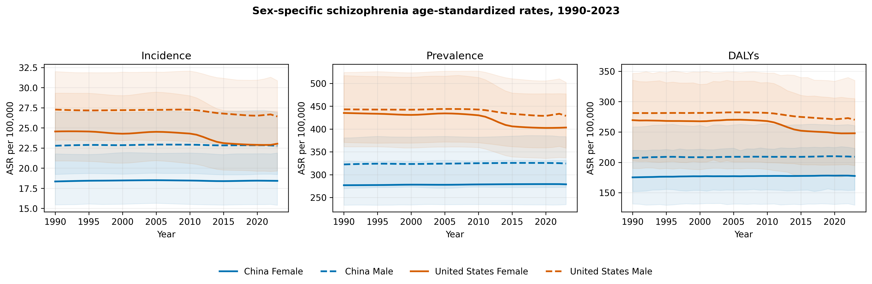
Figure 1. Sex-specific schizophrenia age-standardized rates in China and the United States, 1990-2023. Shading shows native 95% GBD uncertainty intervals.

Segmented trends and descriptive comparisons
BIC-selected segmented curves summarized nonlinear features of the annual posterior means. Eight of 12 primary fits had absolute lag-1 residual correlation of at least 0.5, so the independent-error approximation was not uniformly plausible. AR(1) feasible-GLS sensitivity retained the practical trajectory label in 12 of 12 panels, retained the breakpoint count in 11 of 12, and changed AAPC by at most 0.009 percentage points/year. Selected breakpoint years differed for some Chinese panels and remain descriptive. No change point, slope, or between-group contrast was interpreted as a significance test.
Table 2. China-United States annualized endpoint contrasts
Sex | Outcome | China, %/year | United States, %/year | US-China, percentage points
Female | Incidence | 0.013 | -0.193 | -0.206
Female | Prevalence | 0.021 | -0.231 | -0.252
Female | DALYs | 0.040 | -0.253 | -0.293
Male | Incidence | -0.001 | -0.097 | -0.095
Male | Prevalence | 0.018 | -0.099 | -0.118
Male | DALYs | 0.028 | -0.121 | -0.149

Annualized endpoint changes are descriptive point estimates calculated from the 1990 and 2023 ASRs. The difference is United States minus China; no parallelism test or interval is implied. Full country and sex contrasts are reported in the supplement.
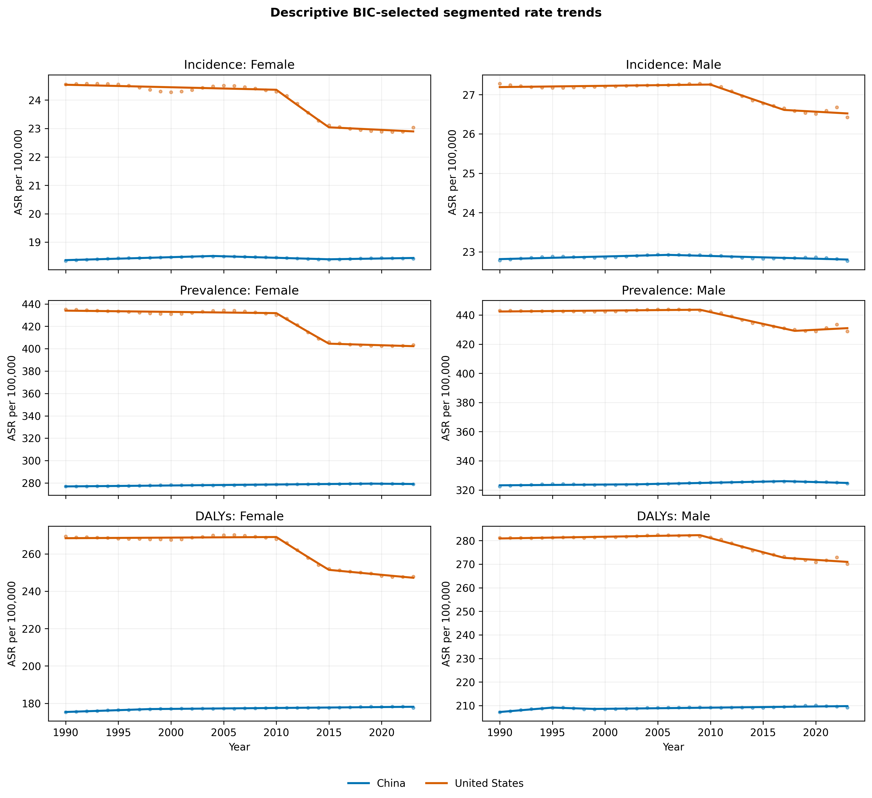
Figure 2. Observed and fitted descriptive segmented age-standardized rate trajectories. Curves were selected by BIC in the open Python workflow and are not NCI Joinpoint output.

Age-specific patterns
The positive-valued age profiles differed by outcome and sex, and male point estimates were generally higher. Incidence peaked in early adulthood, whereas prevalence and DALY rates remained substantial across middle adulthood. Although fine-age categories extended through 95+, exact source-export zeros for incidence at ages 80+ prevent interpreting those plotted cells as observed absence of disease.
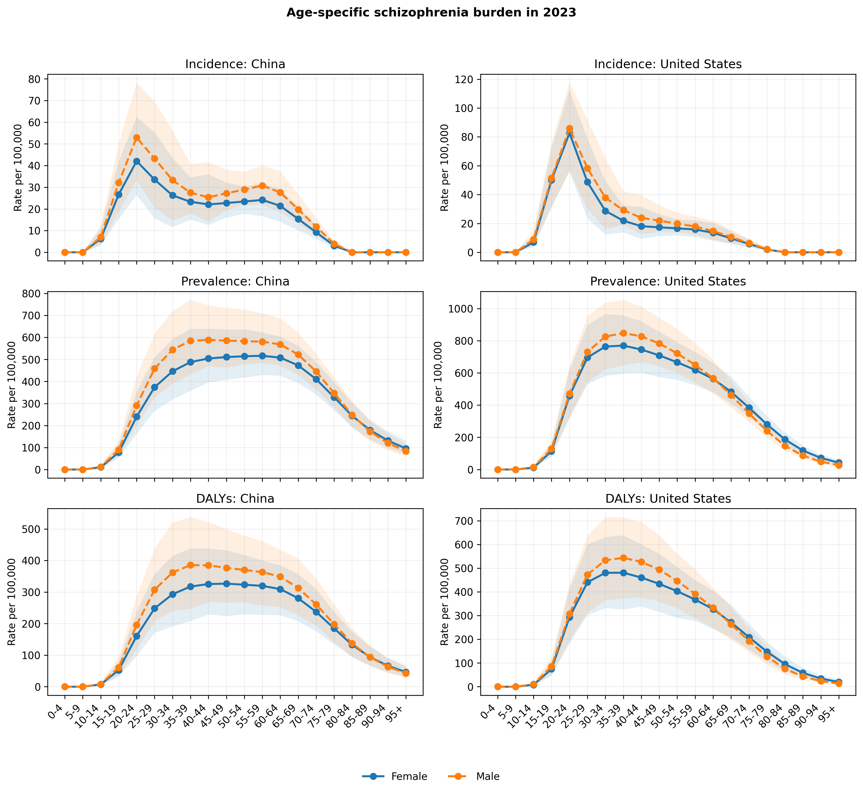
Figure 3. Age-specific incidence, prevalence, and DALY rates in 2023 by country and sex. Shading shows native 95% GBD uncertainty intervals.

Drivers of changing all-age quantities
Table 3. Shapley decomposition of all-age changes, 1990-2023
Location | Sex | Outcome | Population size | Age structure | Age-specific rate | Total change
China | Female | Incidence | 24,854 | -8,744 | 712 | 16,823
China | Female | Prevalence | 394,946 | 511,754 | 18,068 | 924,768
China | Female | DALYs | 249,766 | 297,673 | 19,248 | 566,687
China | Male | Incidence | 30,554 | -8,856 | -95 | 21,603
China | Male | Prevalence | 446,098 | 537,692 | 15,376 | 999,165
China | Male | DALYs | 286,716 | 317,336 | 14,425 | 618,476
United States | Female | Incidence | 8,969 | -2,903 | -1,870 | 4,195
United States | Female | Prevalence | 183,048 | 8,052 | -49,294 | 141,806
United States | Female | DALYs | 112,027 | 1,113 | -33,954 | 79,186
United States | Male | Incidence | 11,463 | -3,817 | -1,117 | 6,529
United States | Male | Prevalence | 204,543 | 9,379 | -21,553 | 192,369
United States | Male | DALYs | 128,713 | 1,060 | -16,847 | 112,927

Population-size change was positive in 12 of 12 panels. Age-structure and age-specific-rate components varied by country, sex, and outcome (Table 3). Negative components represent countervailing allocations; component percentages can exceed 100% and are not compositional shares. Annual- and five-year-chain allocations differed from endpoint allocations by at most 7.9% of total change. Restricting incidence decomposition to positive-valued ages 10-79 preserved every component sign (yes), although magnitudes changed. The age-bin sensitivity flagged material variation in 3 of 12 panels. The fine-age results are the production estimates; collapsed-bin comparisons remain an aggregation sensitivity.
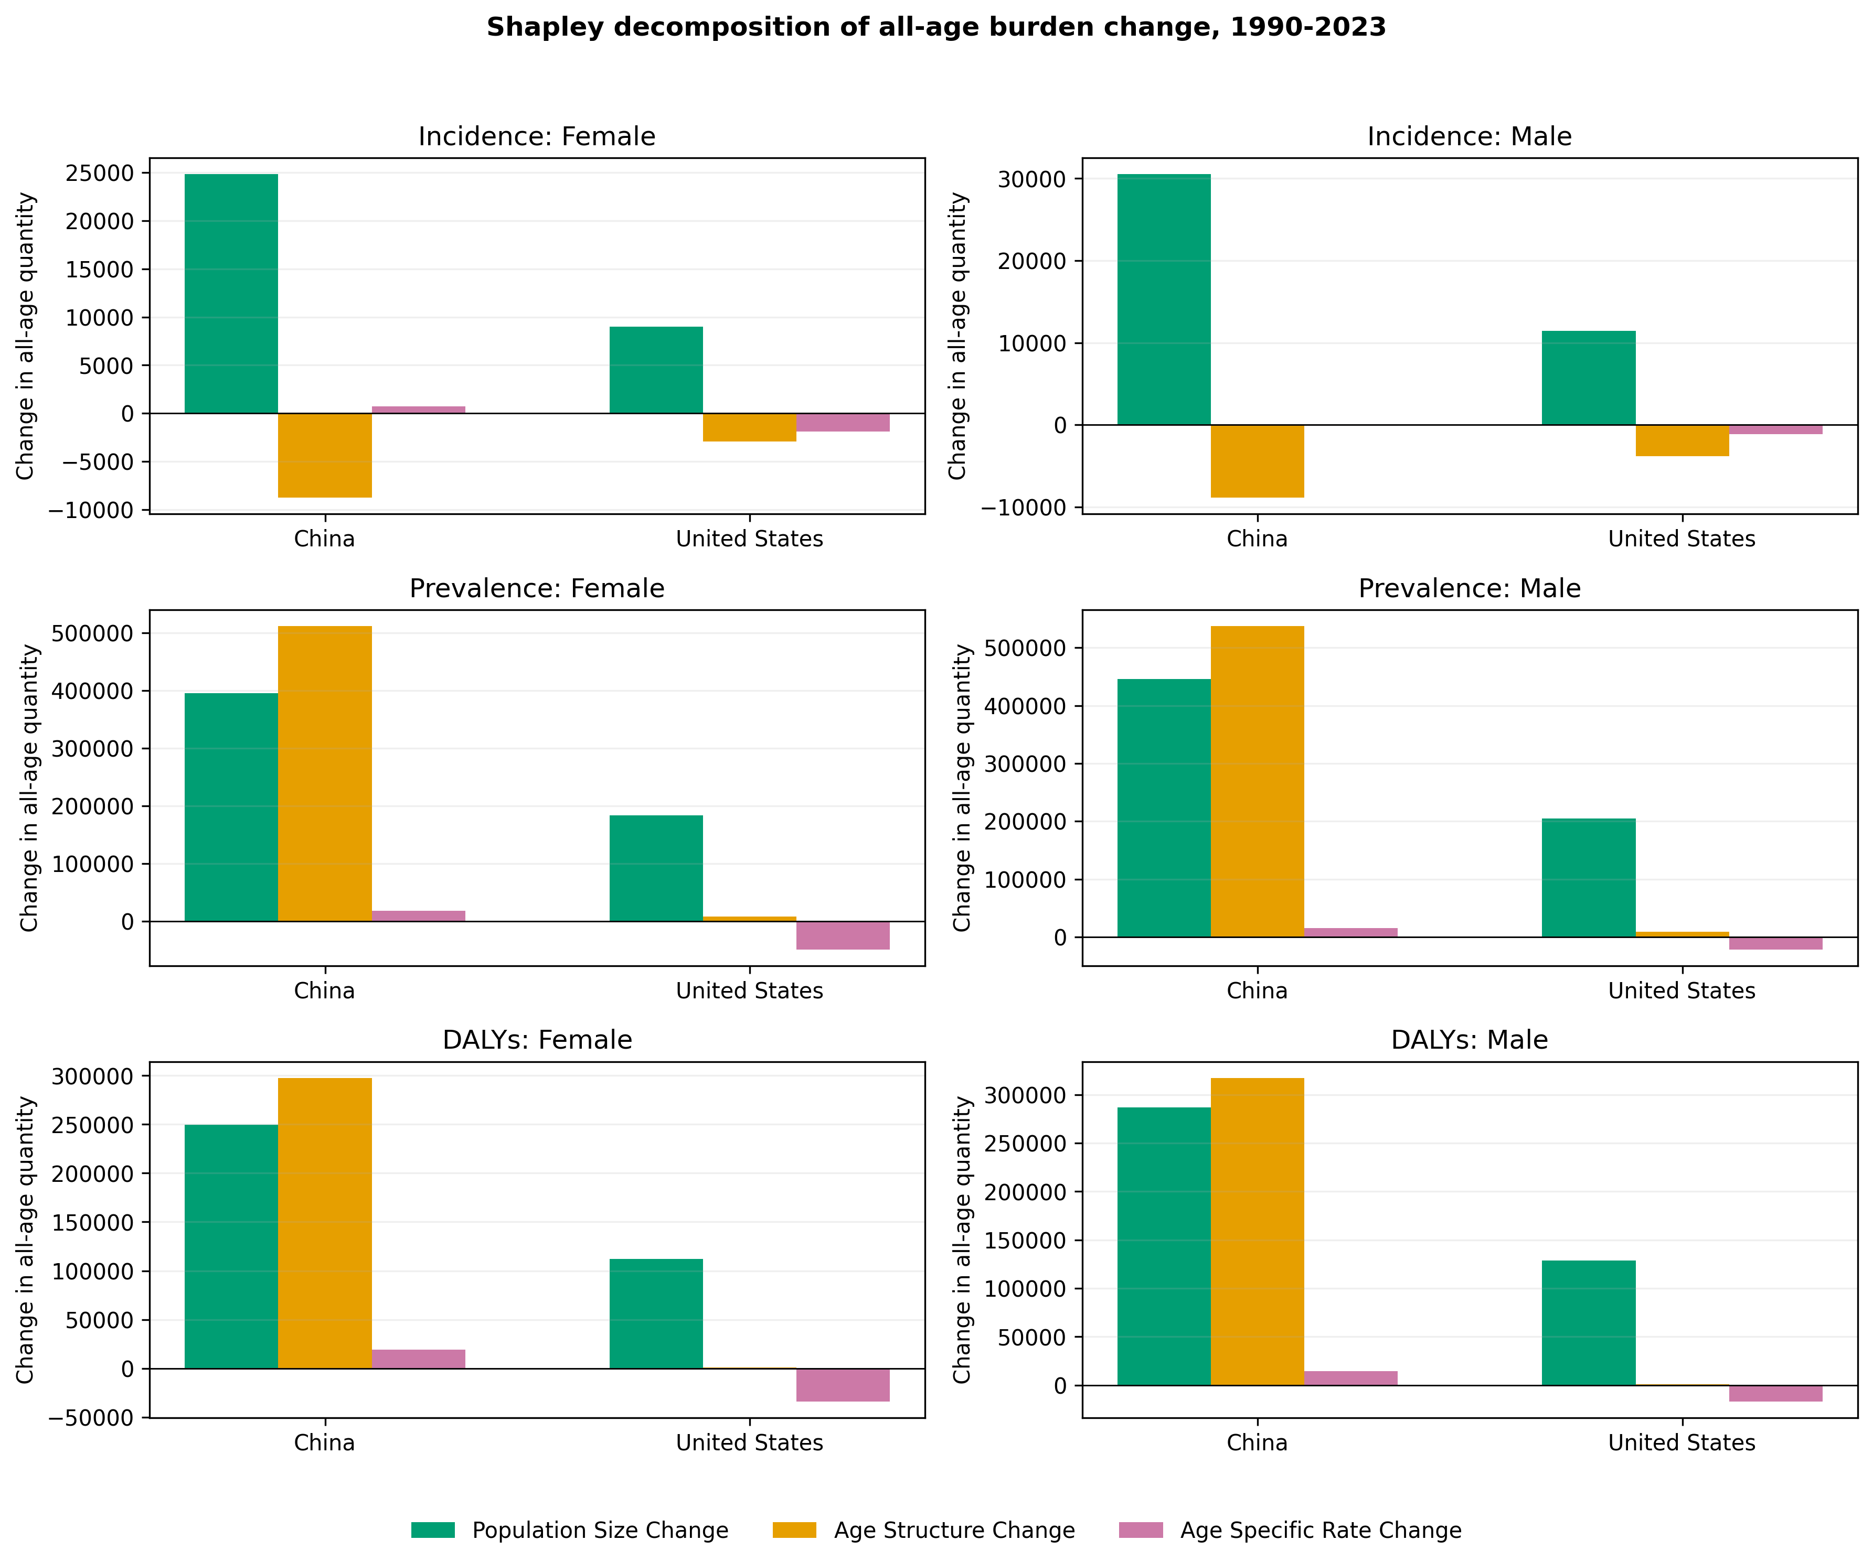
Figure 4. Shapley decomposition of changes in reconstructed all-age schizophrenia quantities, 1990-2023. Components are deterministic attributions based on posterior mean rates.

Secondary age-period-cohort summaries
Across the 12 custom panels, the primary-window global period slope ranged from -0.291%/year for female dalys in the United States to 0.038%/year for male incidence in the United States. Practical-stability classifications agreed between the primary and 1990-2019 windows in 12 of 12 panels. Opposing separately fitted age-specific slopes occurred in 10 panels, showing that aggregate summaries can conceal age heterogeneity.
Period-curvature rate ratios ranged from 0.968 to 1.008, and cohort-curvature rate ratios ranged from 0.925 to 1.018. Equal weighting changed the global period slope by at most 0.002 percentage points/year. These custom contrasts are normalized to one at reference categories, are not claimed equivalent to conventional NCI APC functions, and do not identify causal period or cohort effects.
For the principal incidence comparison, practical labels for the custom global period slope and primary segmented AAPC agreed in 3 of 4 country-sex strata. This comparison is descriptive rather than corroborative: the summaries differ in age coverage, standardization, weighting, calendar aggregation, and model form. Prevalence and DALY panels are exploratory rate-surface summaries and are not incident-event risk models.

Discussion
This comparative study found larger 2023 than 1990 point estimates of incident cases, people living with schizophrenia, and DALYs, alongside different standardized-rate trajectories. Chinese AAPCs were practically stable under the stated descriptive band, whereas U.S. AAPCs were negative, particularly among females. The combination of increasing absolute quantities and flat or negative ASR slopes is not contradictory: population size, age composition, and age-specific rates contribute separately. Without posterior draws, neither change nor between-group contrast was evaluated statistically.
The custom APC summaries add an age-specific view rather than an independent replication of the ASR analysis. Opposing age-specific slopes show that aggregate trajectories can conceal age groups moving in different directions. China-male incidence was practically stable by both segmented AAPC and custom global period slope; U.S.-male incidence had a negative segmented AAPC while its custom selected-age global slope fell within the practical-stability band. Differences are compatible with calendar window, selected-age population weighting, age standardization, piecewise versus global form, and APC identification constraints. Period- and cohort-curvature curves are descriptive population patterns, not causal effects.
The count-rate divergence is consistent with earlier releases but should not be treated as independent validation. GBD 2019 estimates summarized by Solmi and colleagues increased globally from 14.2 to 23.6 million prevalent cases, 0.941 to 1.3 million incident cases, and 9.1 to 15.1 million DALYs between 1990 and 2019, while age-standardized estimates were comparatively stable [3]. In GBD 2023, Song and colleagues reported the same Chinese sex-specific endpoints used here: incidence increased by 14.1% among males and 14.5% among females, prevalence by 51.9% and 59.9%, and DALYs by 49.5% and 57.5%, respectively [4]. Their exact agreement with our Chinese endpoints is expected because both studies query the same release. By contrast, a GBD 2021 China analysis reported a both-sex ASPR change from 374.60 to 388.99 per 100,000 through 2021 [5]; that aggregate from an earlier release is not numerically interchangeable with the present sex-specific GBD 2023 series. Release revision, sex aggregation, and calendar window are therefore plausible reasons for differences across papers.
The present decomposition extends that descriptive context by applying the same population-size, age-structure, and age-specific-rate accounting to both countries and sexes. Component signs and magnitudes are reported directly rather than treated as causal explanations. These deterministic decompositions allocate endpoint differences under the specified identity; they do not identify causes of the demographic or rate changes.
The distinction between measures has practical relevance. Incident and prevalent case counts can help approximate potential service-volume need, whereas DALYs quantify healthy life lost and are not a count of people. None of these quantities measures realized service use or demand, which also depends on detection, access, coverage, severity, and treatment pathways. ASRs facilitate temporal and cross-country rate comparisons after standardizing age composition. Planning based on ASRs alone may miss growth in potential service volume, while interpreting count growth as worsening individual risk would also be misleading.
Sex-specific estimates showed a persistent male excess for several outcomes and an incidence peak in younger age groups, patterns broadly consistent with earlier GBD schizophrenia analyses [2,3]. However, modeled estimates cannot determine whether country or sex contrasts reflect underlying incidence, diagnostic recognition, data availability, care access, remission, excess mortality, or model assumptions. Health-system and policy differences remain contextual hypotheses rather than tested mechanisms.

Strengths and limitations
Strengths include a focused comparative question, consistent GBD 2023 outcome definitions, explicit separation of native UIs from derived point summaries, deterministic trend selection, exact Shapley closure, source-level verification of zero cells, AR(1) and decomposition sensitivities, and a dedicated custom APC module with synthetic recovery and weighting tests. The pipeline now separates data/computational readiness from editorial scientific readiness.
Several limitations are important. First, GBD values are modeled estimates rather than direct observations and may share smoothing assumptions across years, sexes, outcomes, and countries; source availability, diagnostic recognition, and smoothing may differ between China and the United States. Annual posterior means cannot be treated as independent observations, and synchronized U.S. curve changes may partly reflect shared GBD inputs or model structure. Second, posterior draws and cross-estimate covariance were unavailable, so uncertainty could not be propagated to changes, ratios, breakpoints, slopes, decomposition components, rankings, or custom APC summaries. Native endpoint UIs do not solve that problem. Third, even the production five-year groups aggregate heterogeneity within age intervals, and the explicit collapse sensitivity shows how age grouping can alter decomposition components. Exact zero-valued age cells originated in the source export, but their model-support meaning was unavailable. Custom APC summaries cover ages 10-14 to 65-69, use constrained descriptive functions, and are not asserted equivalent to conventional NCI estimable functions. Exploratory prevalence and DALY panels are rate-surface summaries rather than event-risk models. Ecological country contrasts cannot support causal attribution to policy or health systems.

Conclusions
Between 1990 and 2023, point estimates of incident and prevalent case counts and DALYs increased in China and the United States, while Chinese ASR slopes were practically stable and U.S. slopes were negative under the specified descriptive rule. Demographic allocations differed by outcome and setting, but their rankings lack propagated posterior uncertainty. These modeled patterns support considering potential service volume, health loss, standardized rates, age structure, and sex jointly; they do not establish causal policy or health-system effects.

List of abbreviations
AAPC: average annual percentage change; APC: age-period-cohort; ASR: age-standardized rate; BIC: Bayesian information criterion; DALY: disability-adjusted life-year; GBD: Global Burden of Disease; IHME: Institute for Health Metrics and Evaluation; NCI: National Cancer Institute; UI: uncertainty interval; YLD: year lived with disability.

References
1. GBD 2019 Mental Disorders Collaborators. Global, regional, and national burden of 12 mental disorders in 204 countries and territories, 1990-2019: a systematic analysis for the Global Burden of Disease Study 2019. Lancet Psychiatry. 2022;9(2):137-150. doi:10.1016/S2215-0366(21)00395-3.
2. Charlson FJ, Ferrari AJ, Santomauro DF, et al. Global epidemiology and burden of schizophrenia: findings from the Global Burden of Disease Study 2016. Schizophr Bull. 2018;44(6):1195-1203. doi:10.1093/schbul/sby058.
3. Solmi M, Seitidis G, Mavridis D, et al. Incidence, prevalence, and global burden of schizophrenia - data, with critical appraisal, from the Global Burden of Disease (GBD) 2019. Mol Psychiatry. 2023;28(12):5319-5327. doi:10.1038/s41380-023-02138-4.
4. Song H, Fang L, Li H. Long-term trends in the burden of schizophrenia in China, 1990-2052: an analysis of the Global Burden of Disease Study 2023. Psychol Res Behav Manag. 2026;19:574531. doi:10.2147/PRBM.S574531.
5. Huo J, Li R, Ren X, et al. Trends in incidence, prevalence, and disability-adjusted life years of schizophrenia in China from 1990 to 2021, with projections for 2022-2050. Front Psychiatry. 2025;16:1651350. doi:10.3389/fpsyt.2025.1651350.
6. Luo W, Gao J, Guo Z, et al. Trends and cross-country inequalities in schizophrenia from 1990 to 2021, with prediction to 2035: a systematic analysis of the Global Burden of Disease Study 2021. BMC Psychiatry. 2025;25:928. doi:10.1186/s12888-025-07273-6.
7. Zhou W, He J, Wu L, et al. Global, regional, and national burden of schizophrenia: epidemiological trends, decomposition, joinpoint analysis, and projections to 2036 based on GBD 2021. Front Psychiatry. 2026;17:1702808. doi:10.3389/fpsyt.2026.1702808.
8. Global Burden of Disease Collaborative Network. Global Burden of Disease Study 2023 (GBD 2023) Results. Seattle, United States: Institute for Health Metrics and Evaluation; 2024. https://vizhub.healthdata.org/gbd-results/. Accessed 1 September 2026.
9. Kim HJ, Fay MP, Feuer EJ, Midthune DN. Permutation tests for joinpoint regression with applications to cancer rates. Stat Med. 2000;19(3):335-351; correction 2001;20(4):655.
10. National Cancer Institute. Joinpoint Regression Program, version 6.1.0. Surveillance Research Program. https://surveillance.cancer.gov/joinpoint/. Accessed 1 September 2026.
11. Das Gupta P. Standardization and decomposition of rates: a user's manual. Current Population Reports, Series P23-186. Washington, DC: US Bureau of the Census; 1993.
12. Holford TR. The estimation of age, period and cohort effects for vital rates. Biometrics. 1983;39(2):311-324.
13. Clayton D, Schifflers E. Models for temporal variation in cancer rates. II: age-period-cohort models. Stat Med. 1987;6(4):469-481.
14. Luo L. Assessing validity and application scope of the intrinsic estimator approach to the age-period-cohort problem. Demography. 2013;50(6):1945-1967.
15. Rutherford MJ, Lambert PC, Thompson JR. Age-period-cohort modeling. Stata J. 2010;10(4):606-627.

