**Simple Query Bagian 2**

1. SELECT * FROM detail_supplier WHERE alamat LIKE '%rawang%';

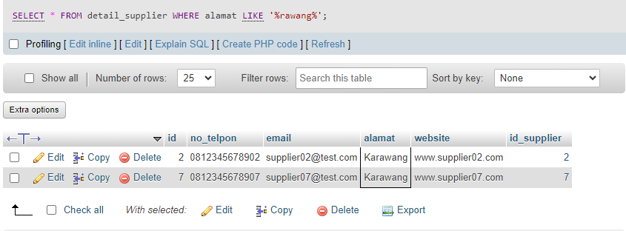

1. SELECT * FROM obat LIMIT 5;

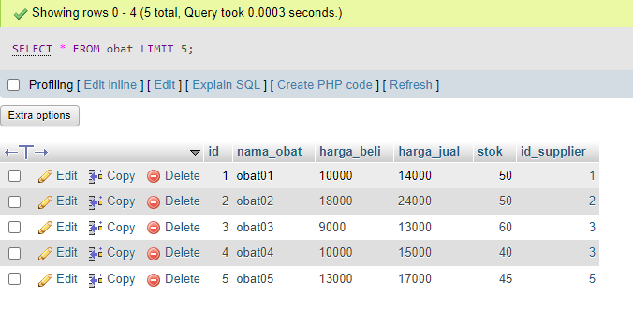

1. SELECT nama_obat, stok FROM obat WHERE stok <= 50;

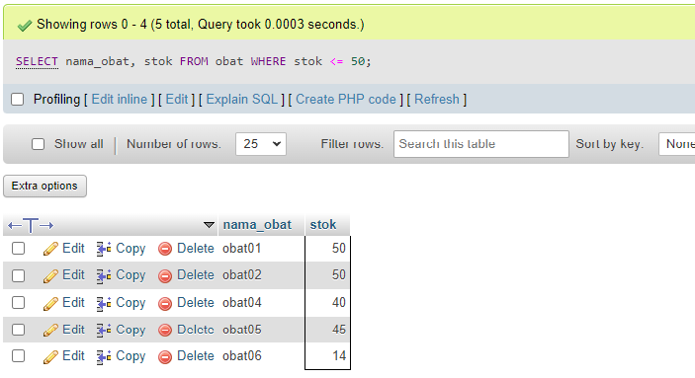

1. SELECT nama_supplier AS pemasok FROM supplier;

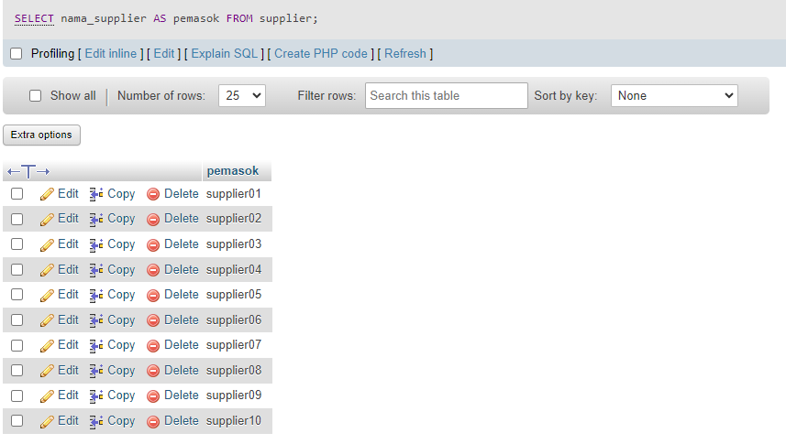

1. SELECT id AS kode_pemasok, nama_supplier AS pemasok FROM supplier ORDER BY kode_pemasok DESC;

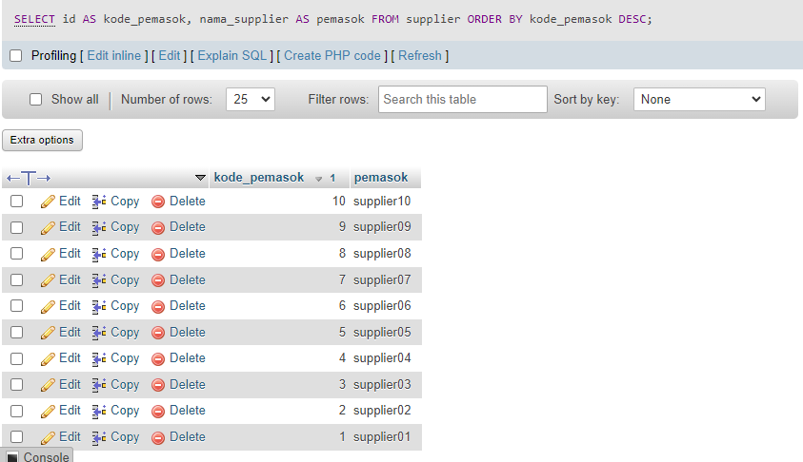

1. SELECT id, SUM(jumlah) AS total FROM detail_transaksi_penjualan WHERE id_obat = 1;

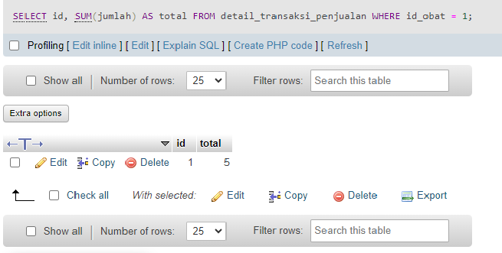

1. SELECT * FROM transaksi_pembelian limit 5,3;

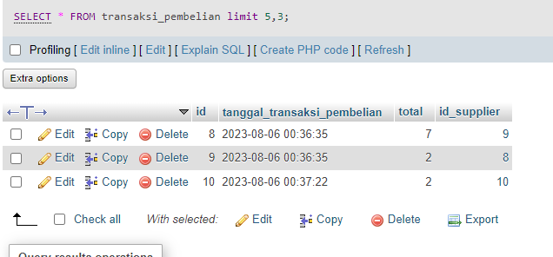

1. SELECT * FROM obat WHERE stok BETWEEN 1 AND 50;

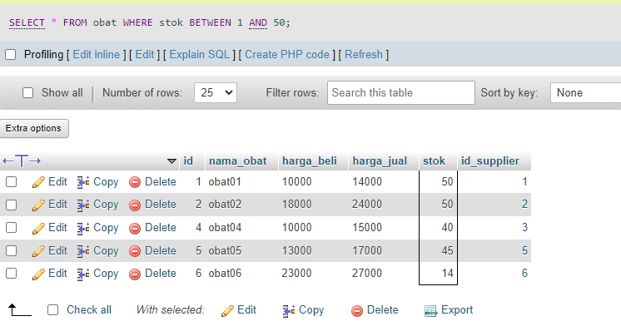

1. SELECT nama_obat, harga_beli, stok FROM obat WHERE harga_beli >= 15000 ORDER BY id ASC;

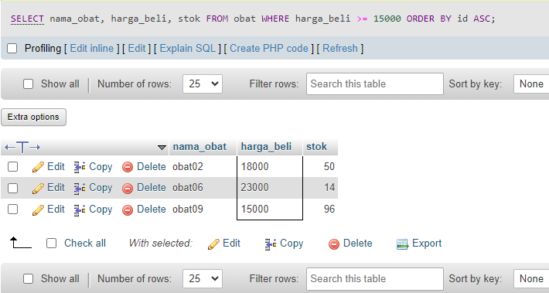

1. SELECT * FROM transaksi_pembelian GROUP BY id_supplier;

