1. [SELECT](http://localhost/phpmyadmin/url.php?url=https://dev.mysql.com/doc/refman/8.0/en/select.html" \t "mysql_doc) detail\_transaksi.id\_obat, tanggal\_pembelian, nama\_obat FROM `detail\_transaksi` JOIN obat ON detail\_transaksi.id\_obat = obat.id ORDER BY nama\_obat ASC

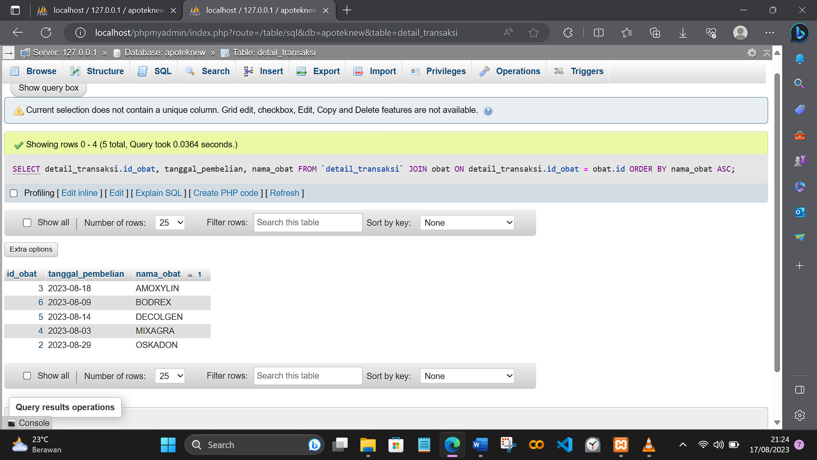

1. [SELECT](http://localhost/phpmyadmin/url.php?url=https://dev.mysql.com/doc/refman/8.0/en/select.html) tanggal\_pembelian, detail\_transaksi.id\_obat, nama\_obat, kegunaan FROM `detail\_transaksi` JOIN obat ON detail\_transaksi.id\_obat = obat.id ORDER BY nama\_obat ASC

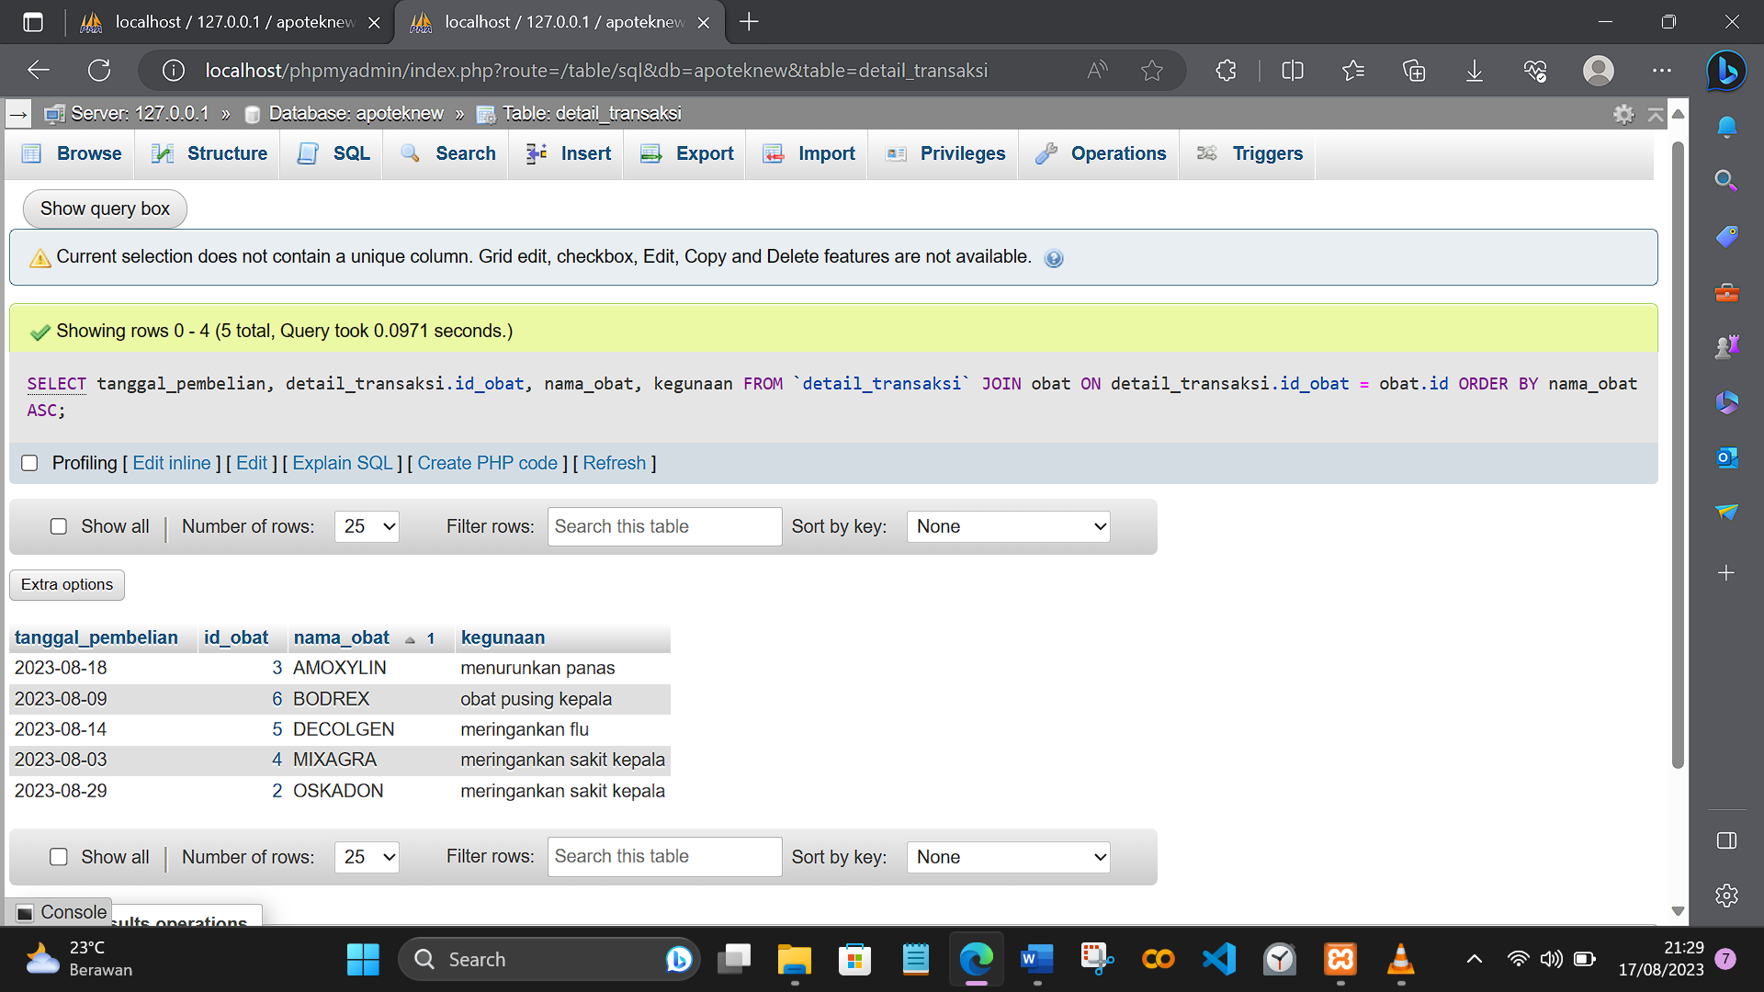

1. [SELECT](http://localhost/phpmyadmin/url.php?url=https://dev.mysql.com/doc/refman/8.0/en/select.html) tanggal\_pembelian, detail\_transaksi.id\_obat, nama\_obat, kegunaan, Harga FROM `detail\_transaksi` [RIGHT](http://localhost/phpmyadmin/url.php?url=https://dev.mysql.com/doc/refman/8.0/en/string-functions.html%23function_right) JOIN obat ON detail\_transaksi.id\_obat = obat.id ORDER BY nama\_obat ASC

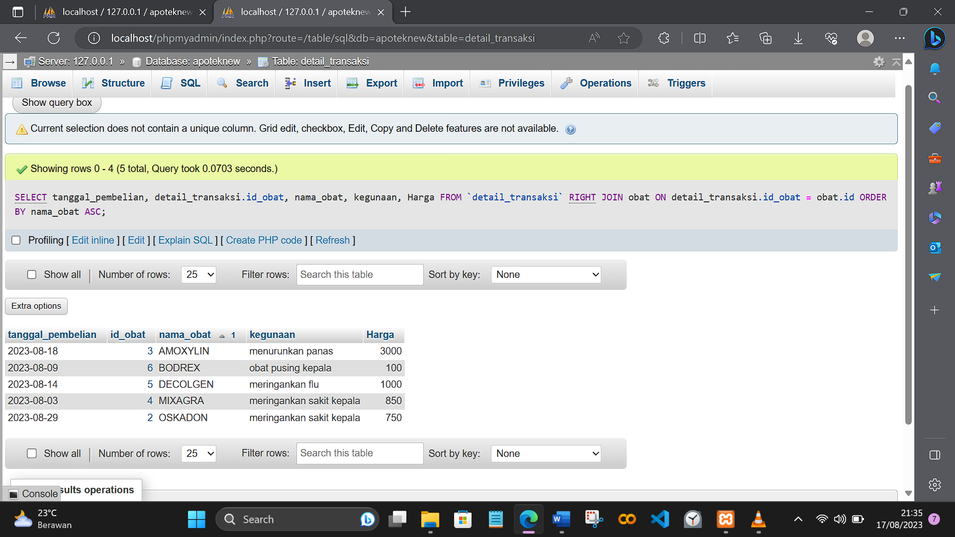

1. [SELECT](http://localhost/phpmyadmin/url.php?url=https://dev.mysql.com/doc/refman/8.0/en/select.html) tanggal\_pembelian, detail\_transaksi.id\_obat, nama\_obat, id\_pembeli FROM `detail\_transaksi` [LEFT](http://localhost/phpmyadmin/url.php?url=https://dev.mysql.com/doc/refman/8.0/en/string-functions.html%23function_left) JOIN obat ON detail\_transaksi.id\_obat = obat.id ORDER BY nama\_obat ASC

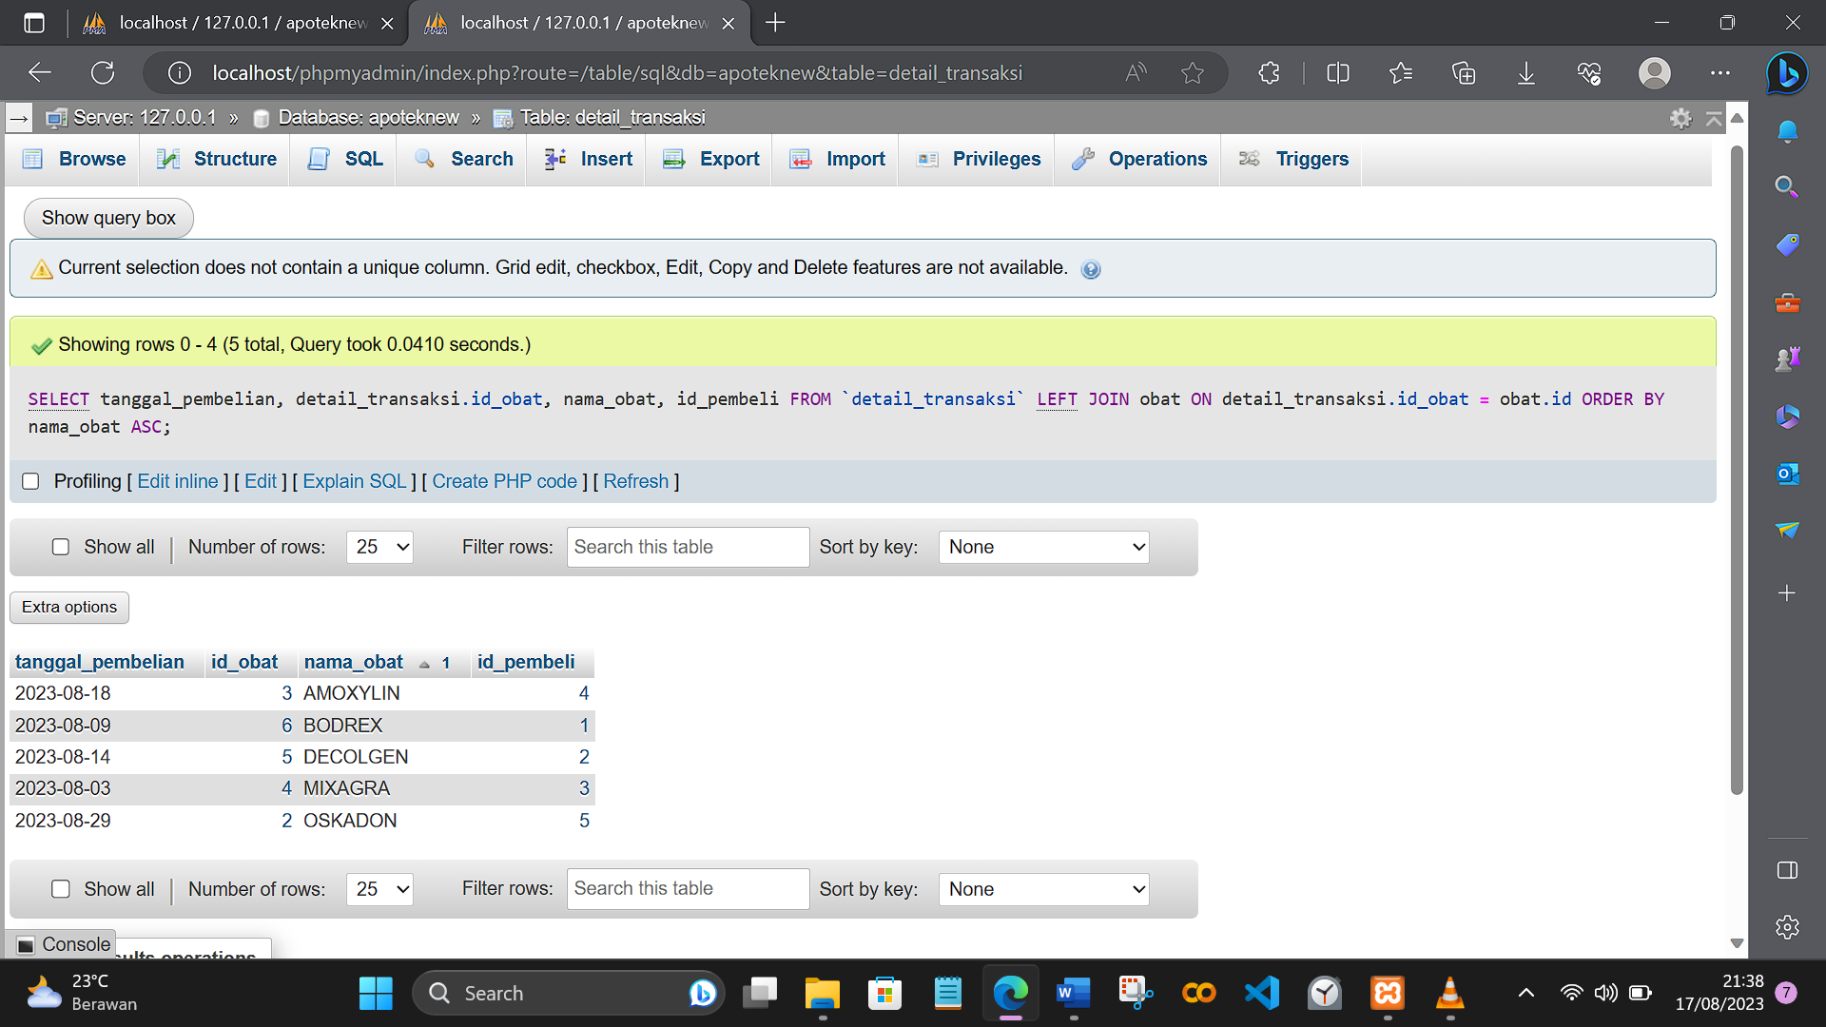

1. [SELECT](http://localhost/phpmyadmin/url.php?url=https://dev.mysql.com/doc/refman/8.0/en/select.html) tanggal\_pembelian, detail\_transaksi.id\_obat, nama\_obat, Harga, jenis FROM `detail\_transaksi` JOIN obat ON detail\_transaksi.id\_obat = obat.id WHERE jenis [LIKE](http://localhost/phpmyadmin/url.php?url=https://dev.mysql.com/doc/refman/8.0/en/string-comparison-functions.html%23operator_like) '%pil%' [AND](http://localhost/phpmyadmin/url.php?url=https://dev.mysql.com/doc/refman/8.0/en/logical-operators.html%23operator_and) Harga < 1000 ORDER BY nama\_obat ASC

