1. [SELECT](http://localhost/phpmyadmin/url.php?url=https://dev.mysql.com/doc/refman/8.0/en/select.html" \t "mysql_doc) \* FROM transaksi ORDER BY tanggal DESC

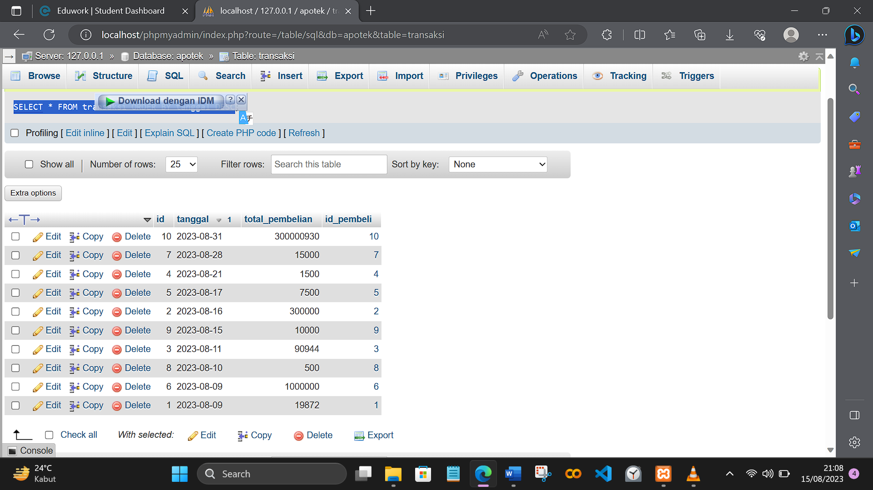

1. [SELECT](http://localhost/phpmyadmin/url.php?url=https://dev.mysql.com/doc/refman/8.0/en/select.html) id\_pembeli, [SUM](http://localhost/phpmyadmin/url.php?url=https://dev.mysql.com/doc/refman/8.0/en/aggregate-functions.html%23function_sum)(total\_pembelian) as total FROM transaksi GROUP BY id\_pembeli

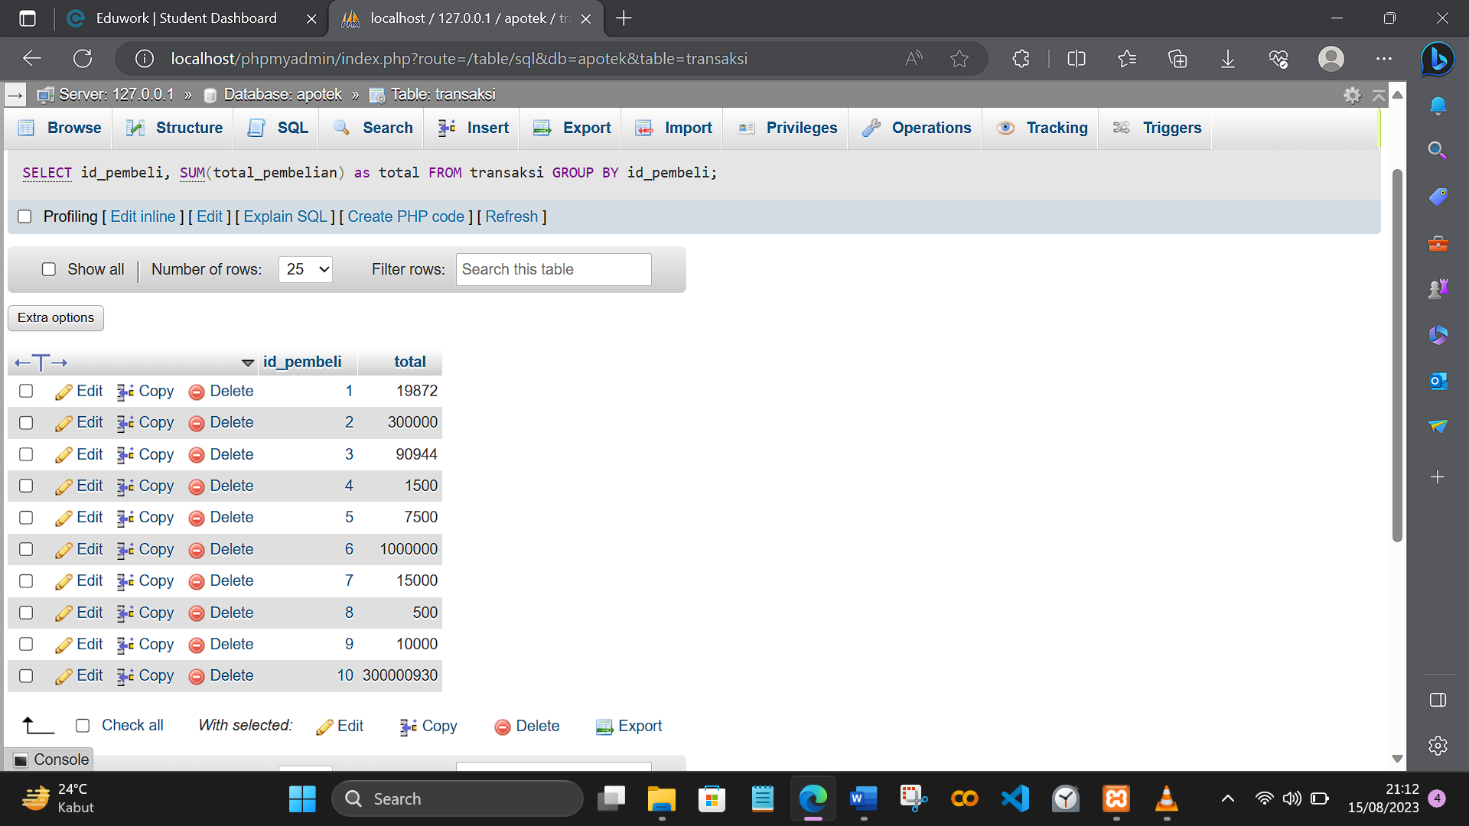

1. [SELECT](http://localhost/phpmyadmin/url.php?url=https://dev.mysql.com/doc/refman/8.0/en/select.html) \* FROM `obat` WHERE nama\_obat [LIKE](http://localhost/phpmyadmin/url.php?url=https://dev.mysql.com/doc/refman/8.0/en/string-comparison-functions.html%23operator_like) '%A%'

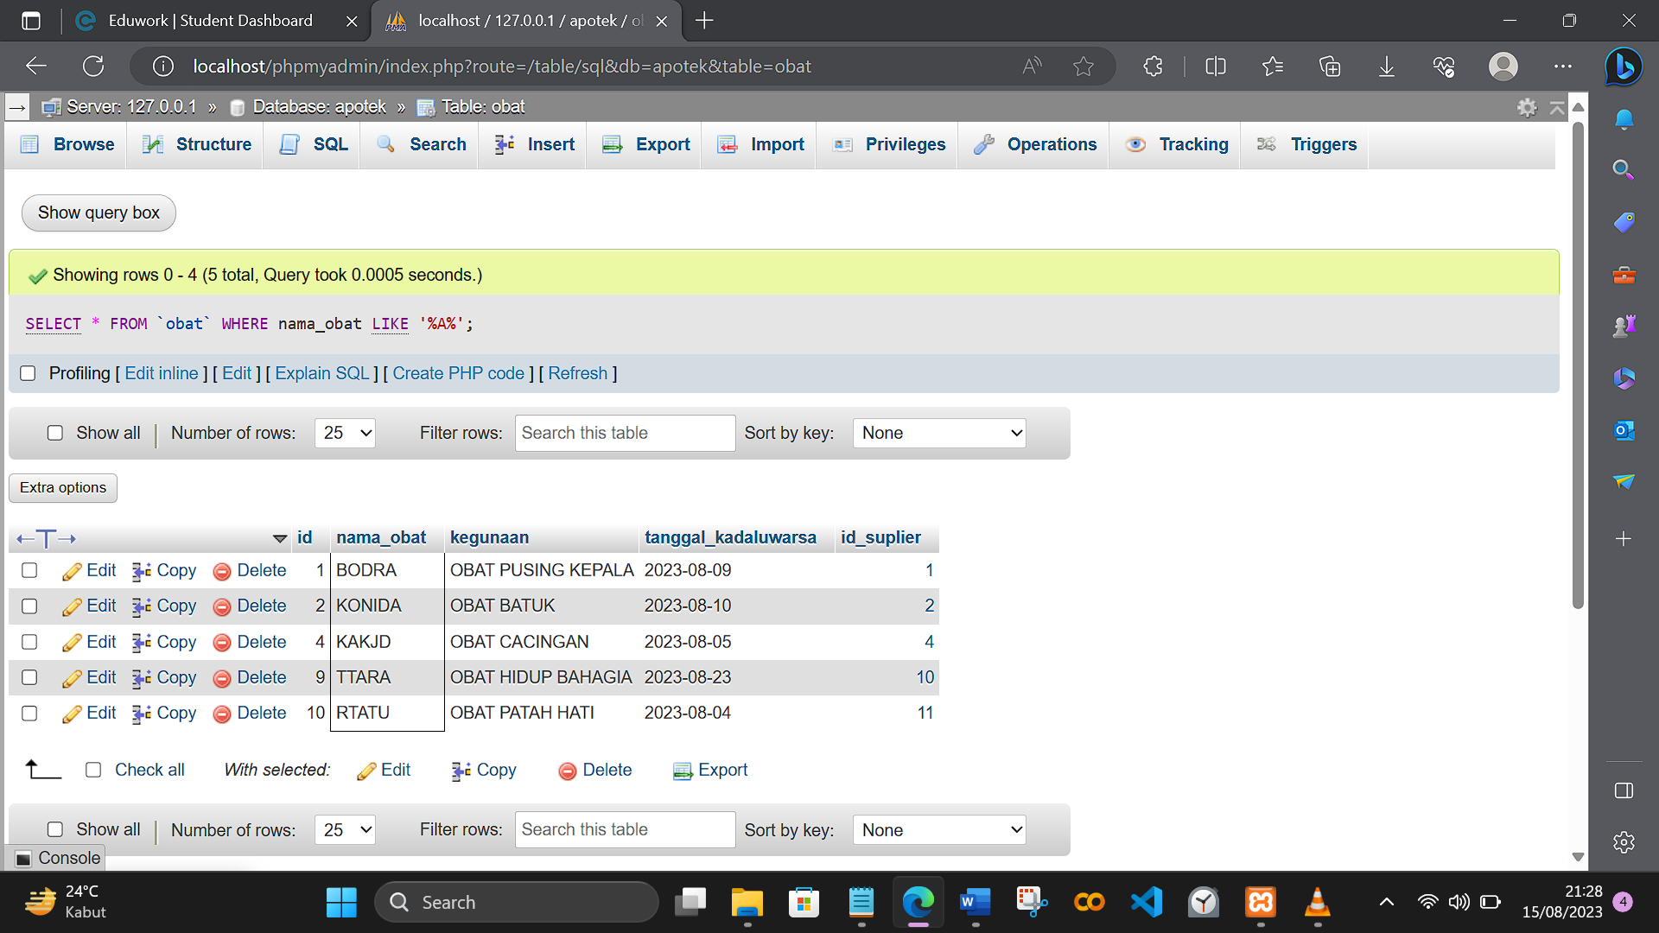

1. [SELECT](http://localhost/phpmyadmin/url.php?url=https://dev.mysql.com/doc/refman/8.0/en/select.html) id\_obat, [SUM](http://localhost/phpmyadmin/url.php?url=https://dev.mysql.com/doc/refman/8.0/en/aggregate-functions.html%23function_sum)(harga\_obat) as jumlah FROM detail\_transaksi GROUP BY id\_obat

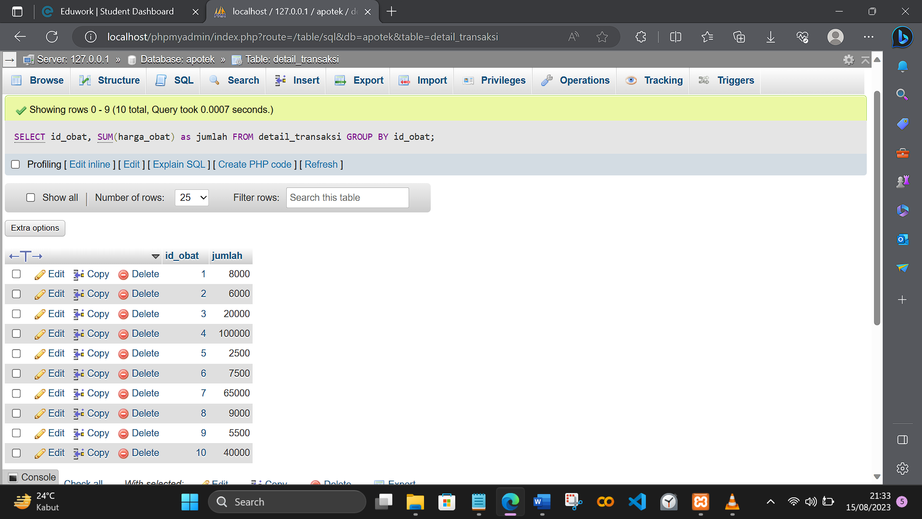

1. [SELECT](http://localhost/phpmyadmin/url.php?url=https://dev.mysql.com/doc/refman/8.0/en/select.html) id\_obat, [SUM](http://localhost/phpmyadmin/url.php?url=https://dev.mysql.com/doc/refman/8.0/en/aggregate-functions.html%23function_sum)(harga\_obat) as jumlah FROM detail\_transaksi WHERE id\_transaksi >= 5 GROUP BY id\_obat

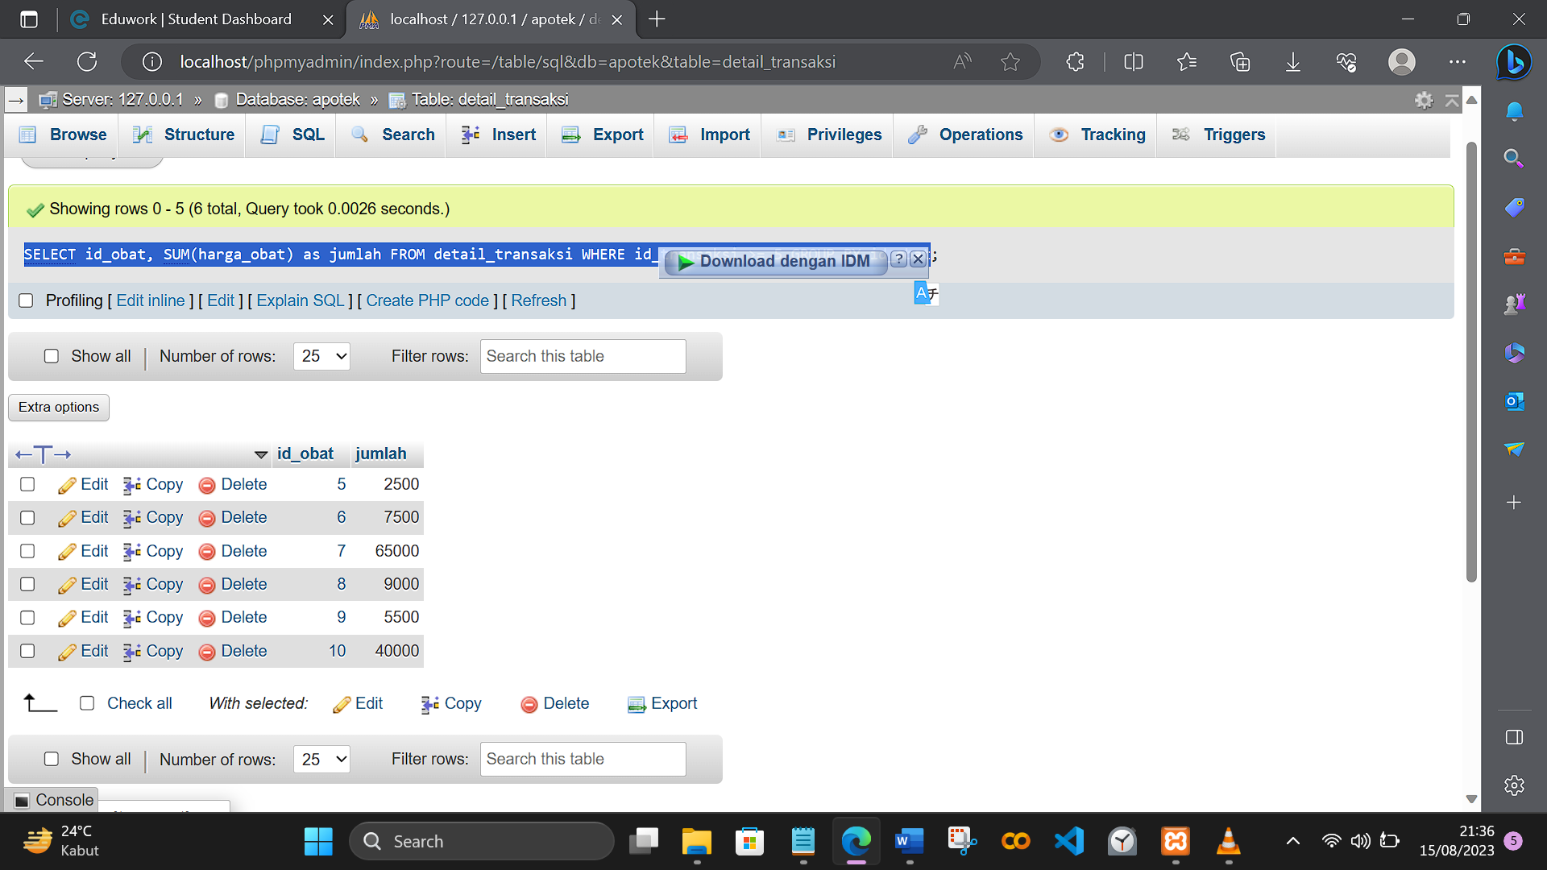

1. [SELECT](http://localhost/phpmyadmin/url.php?url=https://dev.mysql.com/doc/refman/8.0/en/select.html) total\_pembelian FROM `transaksi` WHERE total\_pembelian >= 10000

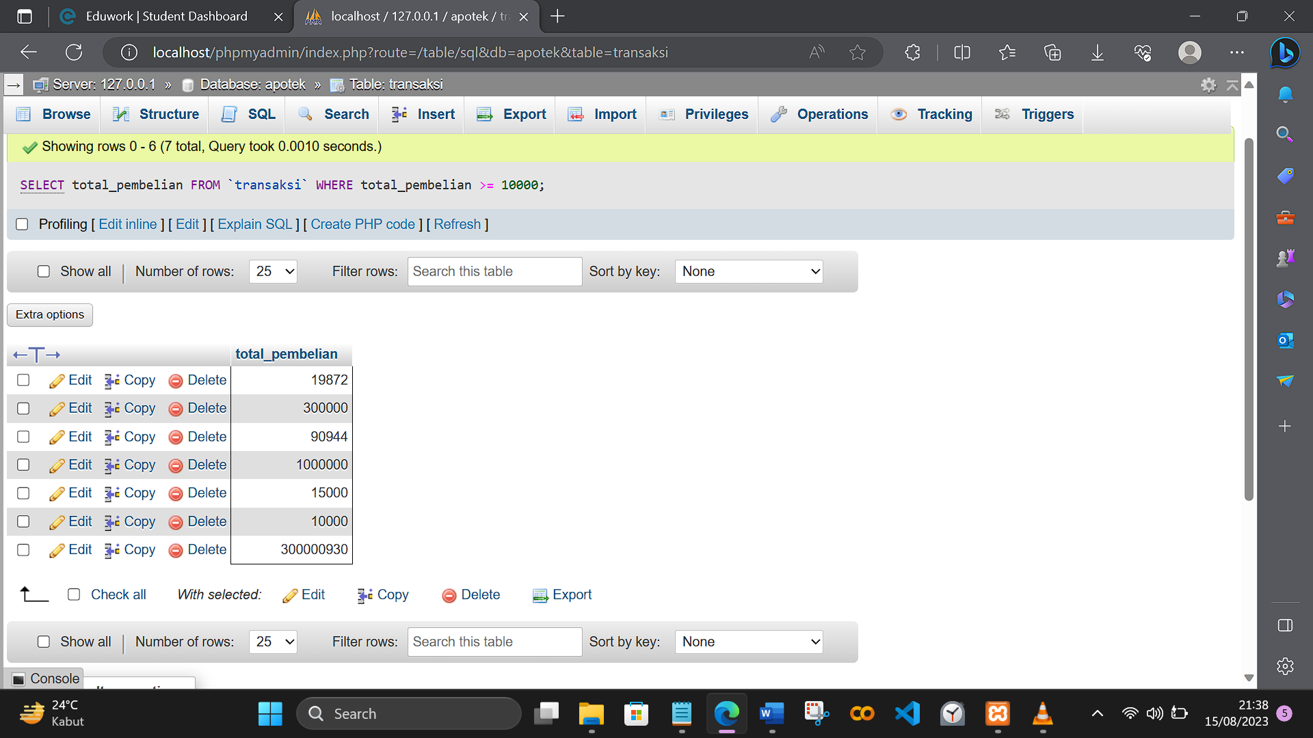

1. [SELECT](http://localhost/phpmyadmin/url.php?url=https://dev.mysql.com/doc/refman/8.0/en/select.html) id, nama\_suplier, alamat FROM `suplier` WHERE id > 6

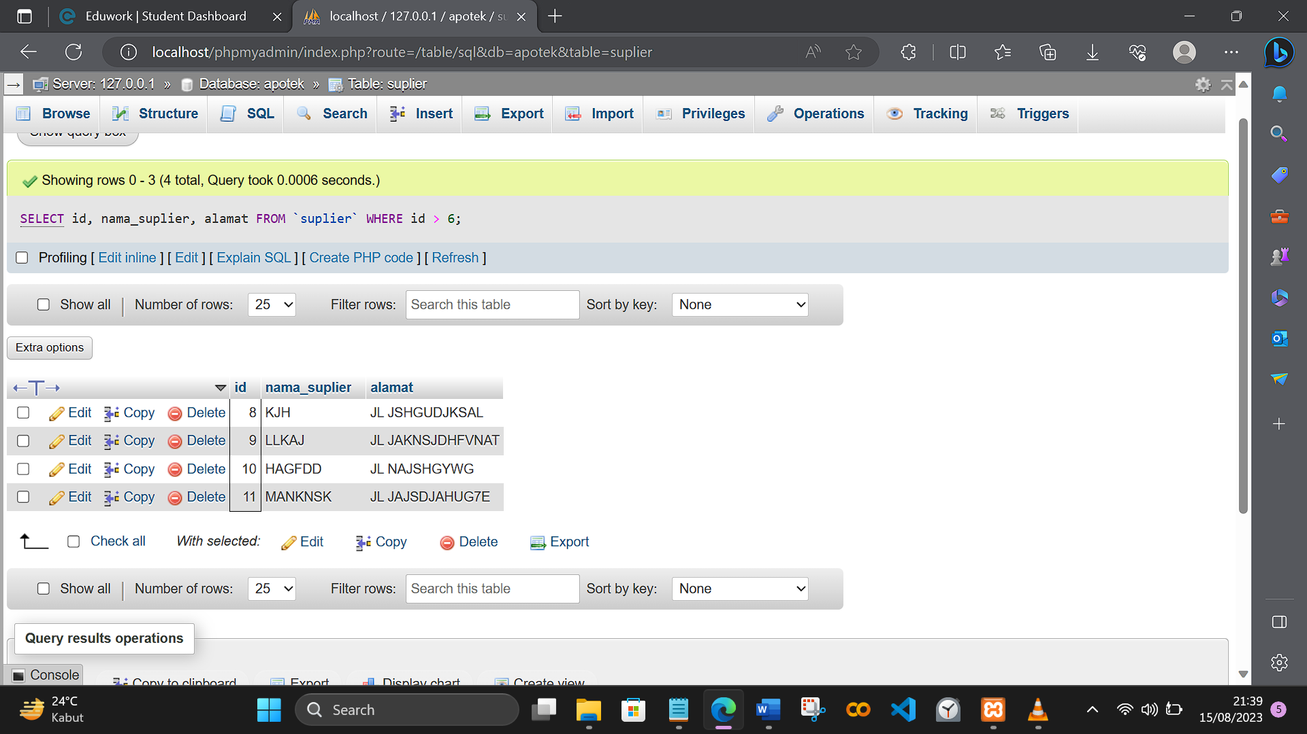

1. [SELECT](http://localhost/phpmyadmin/url.php?url=https://dev.mysql.com/doc/refman/8.0/en/select.html) nama\_obat, tanggal\_kadaluwarsa FROM `obat`

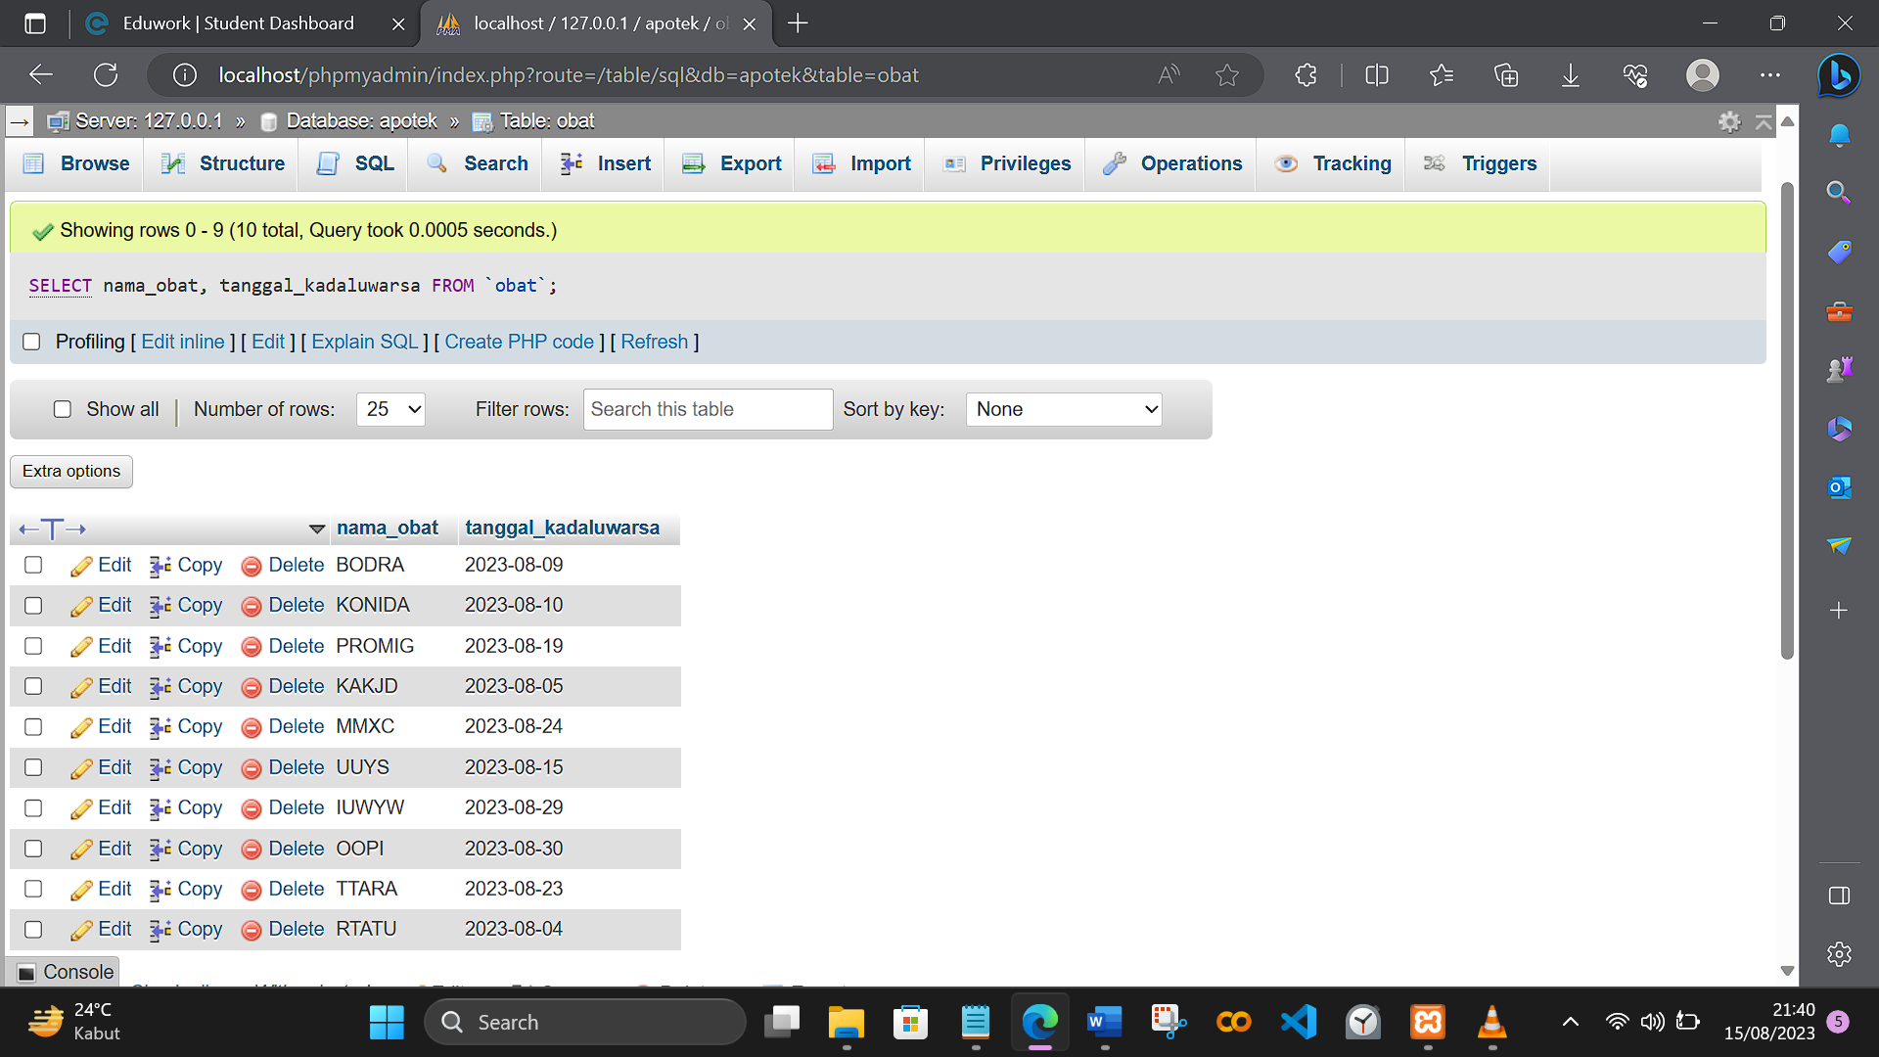

1. [SELECT](http://localhost/phpmyadmin/url.php?url=https://dev.mysql.com/doc/refman/8.0/en/select.html) id\_obat, harga\_obat FROM `detail\_transaksi` WHERE harga\_obat < 10000

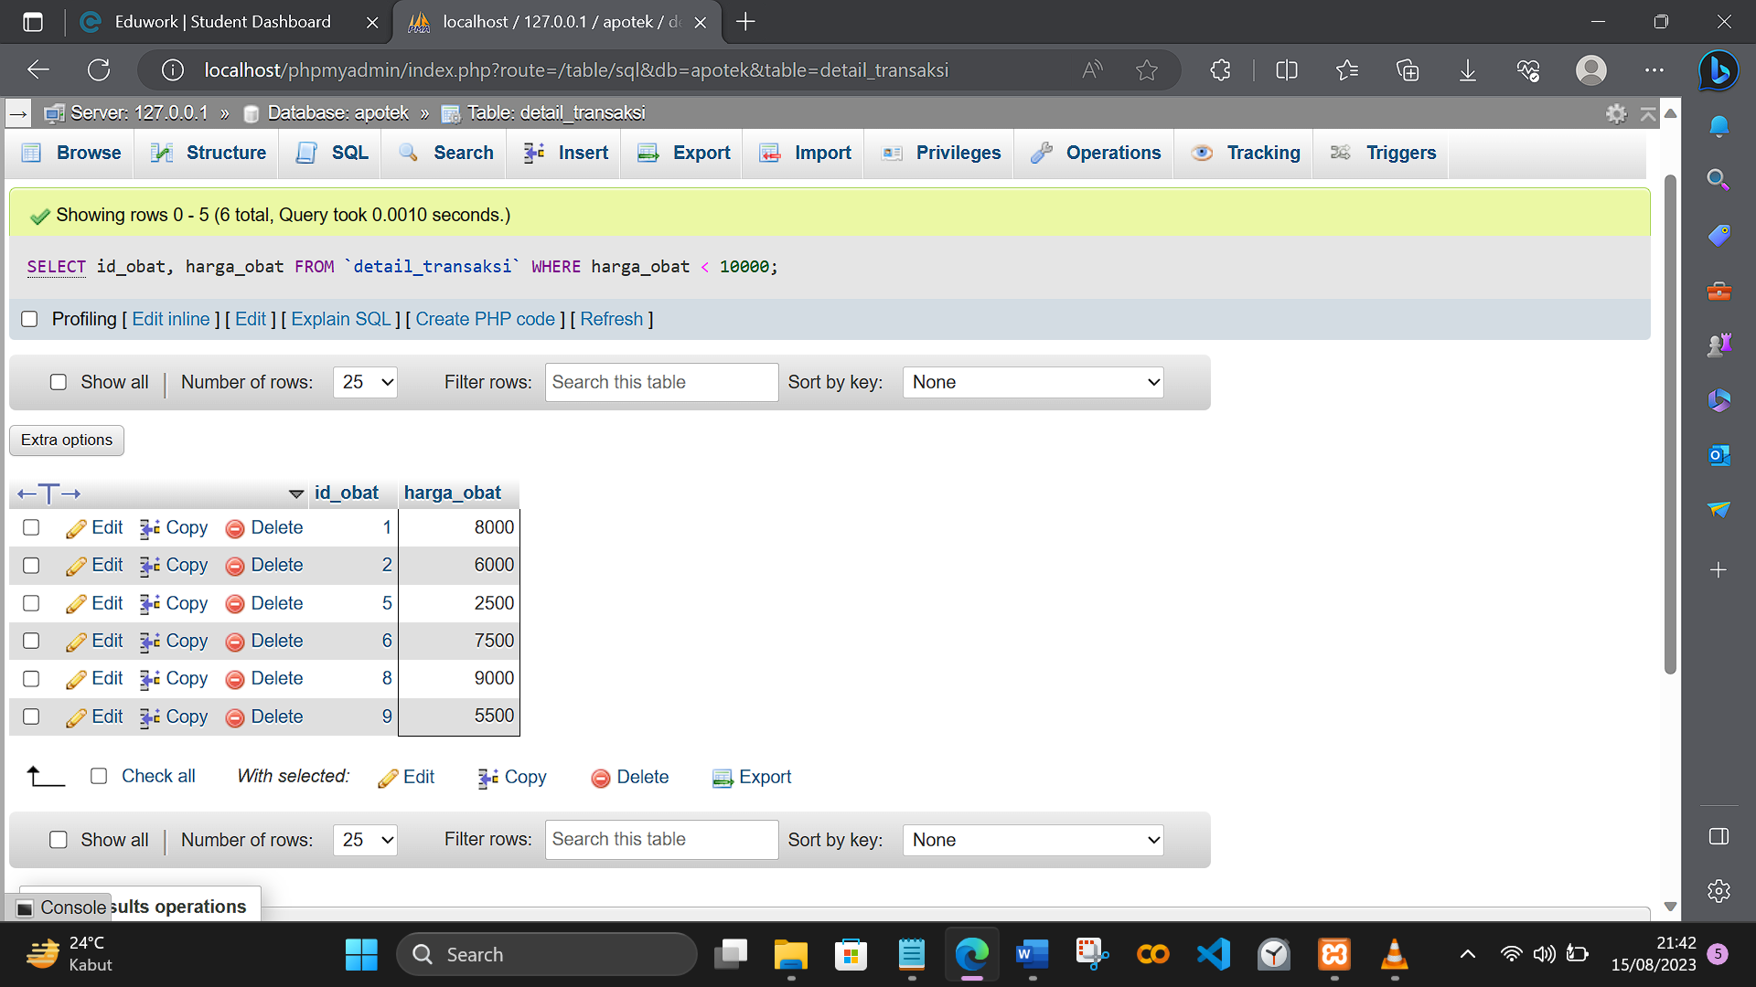

1. [SELECT](http://localhost/phpmyadmin/url.php?url=https://dev.mysql.com/doc/refman/8.0/en/select.html) nama\_PT, alamat FROM `detail\_suplier` WHERE id\_suplier >= 5

