1. [SELECT](http://localhost/phpmyadmin/url.php?url=https://dev.mysql.com/doc/refman/8.0/en/select.html) nama, apoteker, stock, kadaluwarsa FROM `obat` JOIN transaksi ON obat.id = transaksi.obat_id ORDER BY obat_id ASC;

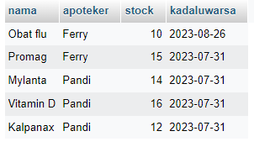

1. [SELECT](http://localhost/phpmyadmin/url.php?url=https://dev.mysql.com/doc/refman/8.0/en/select.html) nama, apoteker, stock, kadaluwarsa FROM `obat` JOIN transaksi ON obat.id = transaksi.obat_id WHERE apoteker = 'Ferry';

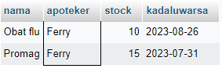

1. [SELECT](http://localhost/phpmyadmin/url.php?url=https://dev.mysql.com/doc/refman/8.0/en/select.html) nama, apoteker, stock, kadaluwarsa FROM `obat` [RIGHT](http://localhost/phpmyadmin/url.php?url=https://dev.mysql.com/doc/refman/8.0/en/string-functions.html%23function_right) JOIN transaksi ON obat.id = transaksi.obat_id ORDER BY obat_id ASC;

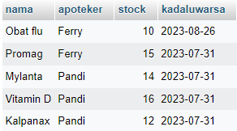

1. [SELECT](http://localhost/phpmyadmin/url.php?url=https://dev.mysql.com/doc/refman/8.0/en/select.html) nama, apoteker, stock, kadaluwarsa FROM `obat` [LEFT](http://localhost/phpmyadmin/url.php?url=https://dev.mysql.com/doc/refman/8.0/en/string-functions.html%23function_left) JOIN transaksi ON obat.id = transaksi.obat_id ORDER BY obat_id DESC;

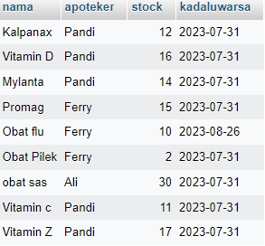

1. [SELECT](http://localhost/phpmyadmin/url.php?url=https://dev.mysql.com/doc/refman/8.0/en/select.html) nama, tanggal_lahir FROM `pasien` JOIN transaksi ON pasien.id = transaksi.pasien_id ORDER BY pasien_id DESC;

