SELECT nama_obat, harga_jual FROM obat

JOIN penjualan_detail ON obat.id_obat=penjualan_detail.id_obat

ORDER BY penjualan_detail.id_obat ASC

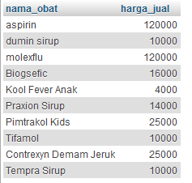

SELECT nama_obat, harga_jual FROM obat

JOIN penjualan_detail ON obat.id_obat=penjualan_detail.id_obat

WHERE harga_jual>=10000

ORDER BY penjualan_detail.id_obat ASC

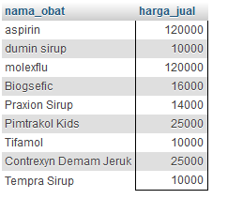

SELECT nama_obat, harga_jual, stok FROM obat

JOIN penjualan_detail ON obat.id_obat=penjualan_detail.id_obat

WHERE harga_jual>=10000 AND stok<100

ORDER BY penjualan_detail.id_obat ASC

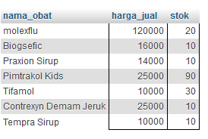

SELECT obat.nama_obat, penjualan_detail.subtotal FROM obat RIGHT JOIN penjualan_detail ON obat.id_obat = penjualan_detail.qty

ORDER BY obat.id_obat ASC

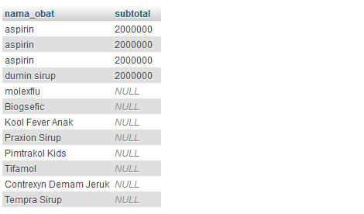

SELECT obat.nama_obat, penjualan_detail.subtotal FROM obat RIGHT JOIN penjualan_detail ON obat.id_obat = penjualan_detail.qty

ORDER BY obat.id_obat ASC

