The 9 Domains of Task Management, Explained

Projects rarely fail from inadequate high-level planning. They stall because someone doesn't know their priorities, can't find the right information, or doesn't know what was decided about a critical issue. They fail when those problems compound as work mounts and deadlines loom. The inevitable crunch tests quality, patience, and endurance.

These aren't worker problems or planning problems, they're coordination problems. The work itself might be straightforward, but the boundaries between people, disciplines, and organizations create friction which results in complexity. When coordination fails, workers stop making progress and start asking questions:
- "What should I work on first?"
- "Where's the current version of this document?"
- "What did we decide about this approach?"
- “Where are my references?”
- “When should I consider alternatives?”
- “What was the intention for this scope?”

Task management exists to prevent these coordination failures. But how do you maintain visibility on coordination needs across a complex, multi-discipline project without micromanaging or creating bureaucracy?

The 9 Domains of Task Management provides a systematic scanning framework. It identifies the key coordination concerns that require attention and shows how task management interfaces with workers, project controls, and project leadership. By scanning these nine domains, coordinators can identify where HOLDs will occur and intervene before they stop project progress.

Mise en place
"Mise en place" is a French culinary phrase meaning "everything in its place." In professional kitchens, it refers to the careful preparation, organization, and arrangement of all necessary ingredients, utensils, appliances, and instructions before cooking begins. Each item is measured, chopped, prepared, and placed conveniently within reach. This ensures that when dishes must be executed with precise timing and impeccable quality, the cook can act with minimal cognitive load and efficient movements because everything around them is in the "right place" for that to occur. If the cook must cross over themselves and search for things, or needs to enter another cook's work area, their ability to execute under pressure breaks down. Chaos and sloppy work ensue.
The 9 Domains
The 9 Domains of Task Management acts as the project’s mise en place, ensuring that all tasks—like ingredients in a kitchen—are clearly defined, thoroughly prepared, and systematically organized, enabling smooth project execution and avoiding common failures.
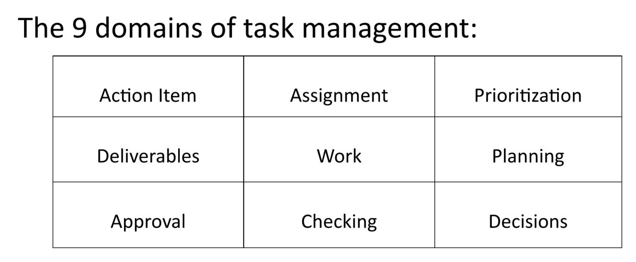
Knowledge work doesn’t progress in straight lines. The work itself can be described in a logical sequence (see “Knowledge Work”), but the path along that sequence looks more like a bee’s flight path rather than a straight line. Sure, the start and end are clear, but work progresses through iterations and loops more often than straight lines. That’s why I present task management as a matrix. This acts like a mnemonic device to recall the domains where our attention is required but not locking into a mental model of a particular sequence of events or actions.
Action Item | Identifies specific tasks or steps that need to be completed. Focuses on what needs to be done to move the work forward.
Assignment | Ensures tasks are delegated to the right person or team with clear ownership and accountability. Answers the question: "Who is responsible for this?"
Prioritization | Determines the order or urgency of tasks based on project goals, deadlines, and dependencies. Answers the question: "What should be done first?"
Deliverables | Defines the tangible outputs or results that need to be produced. Ensures work is aligned with measurable outcomes tied to the project scope.
Work | Focuses on the actual execution of tasks. Ensures workers have what they need (information, resources, tools) to complete their assigned tasks effectively.
Planning | Involves scheduling and sequencing tasks to meet project timelines. Ensures work is organized logically and efficiently.
Approval | Covers the process of obtaining necessary sign-offs or consensus on deliverables, decisions, or changes. Ensures work meets quality and stakeholder requirements before moving forward.
Checking | Involves verifying the quality, accuracy, or completeness of work. Ensures deliverables meet standards before they are approved or issued.
Decisions | Focuses on making and documenting critical choices that impact scope, schedule, or budget. Ensures decisions are tracked and aligned with project goals.
Together, these nine domains form a complete scanning framework. It is a simple 3x3 matrix that acts as a diagnostic scanning tool. Its purpose is to help a project coordinator systematically check for potential HOLDs by ensuring that every critical aspect of a task—from its assignment to its approval—has been addressed. It is a tool for thinking, not a rigid workflow, designed to surface risks and ensure that all project-level coordination is handled proactively.

Understanding Tasks in this Framework
A task is a project-level coordination action that crosses organizational boundaries, moves vertically between teams and leadership, resolves or prevents HOLDs, or affects project baselines. It excludes horizontal discipline coordination, individual planning, quality workflows, and routine progress tracking..
- For a more complete picture of how to work within these domains and how they relate to the broader picture of a project read “9 Rules for Task Management of Deliverables”
The color-coded matrix at the end of this document reveals where task management sits in the project ecosystem. Workers (gold) execute deliverables at the center. Task Management (green) forms a coordination membrane around the work. Project Controls (blue) provide tracking mechanisms. Project Management (purple) sets strategic direction.
What becomes a logged task? The green domains (Action Item, Assignment, Deliverables, Approval) primarily generate tasks because these are coordination actions that interface between workers and project systems. When work needs input from outside the organization (client, vendors, regulators) or requires leadership intervention, that's a task for the Action Items Log.
What doesn't become a task? The gold domain (Work) represents execution itself. When discipline teams need things from each other, they coordinate directly—worker to worker, horizontally. Task coordinators don't manage the work itself; they manage the boundaries that enable work to flow smoothly.
The 9 Domains as a scanning tool: When reviewing project status, coordinators scan all nine domains asking: "Are there HOLDs here that require project-level coordination?" The matrix shows the complete landscape, but tasks are logged only when coordination must cross organizational or hierarchical boundaries.

Integration with Project Controls
The 3 x 3 matrix of task management can be extended out conceptually to identify the most closely related (conceptually) project controls. The outputs from tasks will generate the information necessary for project controls to be utilized.
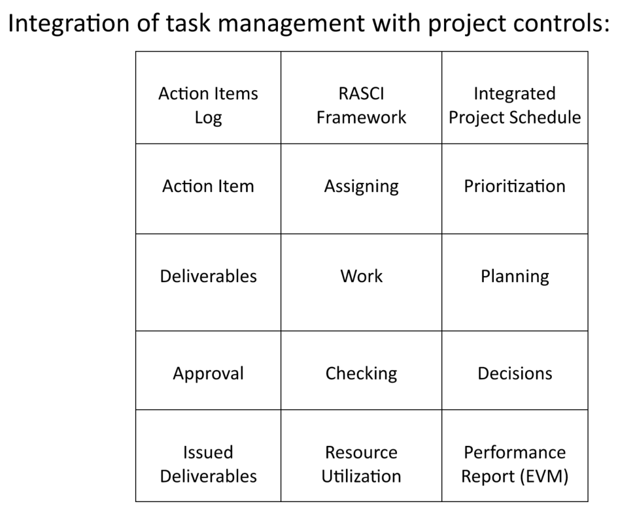

Project Governance
The framework can be expanded again to identify the most closely related (conceptually) aspects of project governance. This is the minimal set of domains for a task coordinator to attend to. A project in and of itself is extraordinarily complex. These domains are how that complexity is reduced without oversimplification.
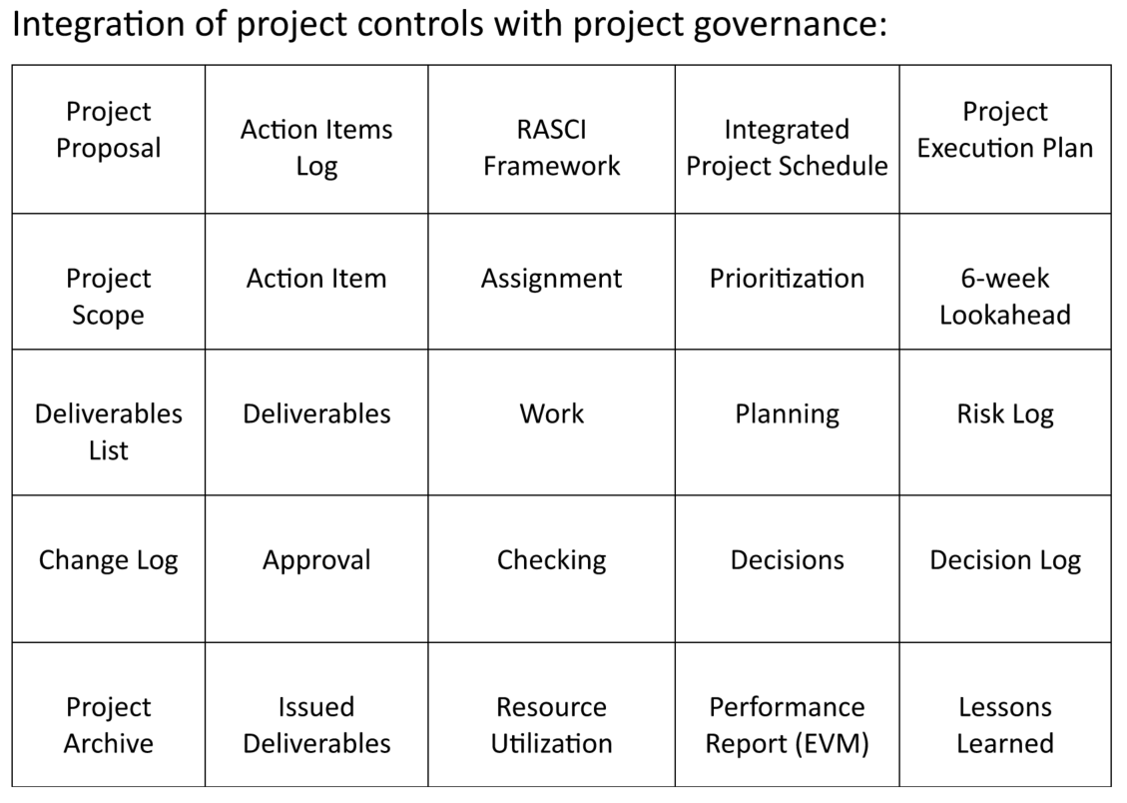

Who does What
Finally if we look at the assignment of responsibilities for each of these domains the color-coded matrix reveals the architecture of project coordination. To ensure clear accountability across the project, primary responsibilities within the governance framework are assigned to four key roles. The following matrix visually assigns the lead role for each component, though collaboration between all roles is expected.
Workers (gold) execute deliverables at the center. Task Management (green) forms a coordination membrane around the work, interfacing between workers and the project systems. Project Controls (blue) provide formal tracking mechanisms. Project Management (purple) sets strategic direction.
Notice that "Work" sits at the center—task coordinators don't manage work execution itself, they manage the coordination boundaries that enable work to flow smoothly. When scanning the 9 Domains, coordinators ask: "Are there HOLDs in any domain that require project-level coordination?" Issues within the gold domain (worker execution) are identified through scanning, but coordination actions are logged in the green domains.

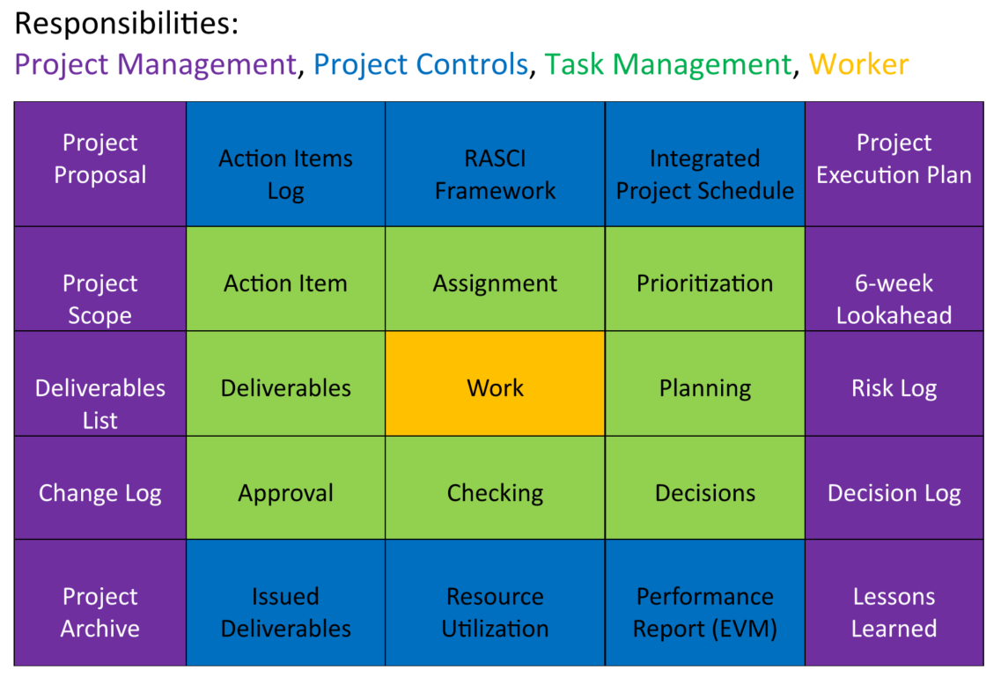

Conclusion
The 9 Domains framework enables systematic scanning that identifies HOLDs before they stop progress, clarifies accountability at every boundary, and documents decisions once so they don't need to be re-litigated.
When we have well-defined coordination between project management, project controls, and workers, we have effective task management. Set your mise en place for the project.
This shifts attention from reactive firefighting to proactive coordination. So instead of project leadership constantly asking:
- "Where is the HOLD and why didn't we see it coming?"
- "Who was supposed to be handling this?"
- "Why are we having this conversation again?"
project management can focus on quality decisions and risk management, project controls receives accurate and timely information, and workers stay focused on execution rather than seeking direction.

