Computer Graphics Class Assignment 2

2016025478 서경욱

▷Implemented Requirements

-Manipulate the camera in the same way as in ClassAsignment1 using your ClassAssignment1 code

-Load an obj file and render it(

1. Open an obj file by drag-and drop to your obj viewer window

2. Read the obj file and display the mesh only using vertex positions, vertex normal, faces information

3. Toggle wireframe / solid mode by pressing Z key(similar to pressing Z key in Blender

4. When open an obj file, print out the following information of the obj file to stdout(console)

-Lighting

1. Use multiple light sources ( not a single light) to better visualize the mesh

2. Choose the number of light sources, light source types, light colors, material colors as you want

-Extra credits

1. Toggle [shading using normal data in obj file] / [forced smooth shading] by pressing S key

2. Load & render a mesh that does not have the same number of vertices of all polygons using glDrawArrays() or glDrawElements()

▷Light configuration

-How many light sources : 4

-Where do you put the light sources? : (1,0,0) / (0,1,0) / (0,0,1) / (-1,-1,-1)

-What is the type of each light source(point or directional light)? : 모두 directional light

▷구현 환경

▷스크린샷

(2)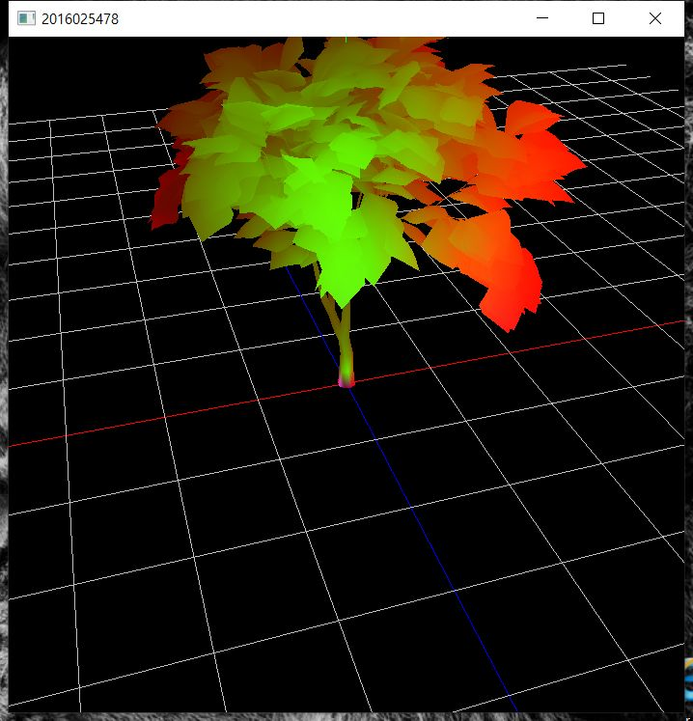(3) ( 1,2,3 순서대로 기본/ press Z key/ press S key)



* 터미널 출력 결과