Lexical Emotion Analyzer

Custom Project Final Report

Spring 2017

Steve Guardado

Table of Contents

**Introduction** **3**

**Hardware** **4**

Parts List 4

Pinout 4

**Software** **5**

**Complexities** **6**

Completed Complexities: 6

**Youtube Link** **6**

**Known Bugs and Shortcomings** **6**

**Future work** **6**

**References** **6**

**Appendix** **7**

# Introduction

Figuring out someone’s emotion over text can sometimes be pretty difficult. With the Lexical Emotion Analyzer, one can send a string of text over Bluetooth to the microcontroller to have the text analyzed to determine the sender’s mood from the text. The aim is to send a string of text from an Android device and have the microcontroller receive the string of text over Bluetooth (USART), then have an algorithm perform analysis on the string of text using a Hash table and then display their determined mood with an image of happy/sad/mad/surprised/neutral face on a LED matrix (SPI).

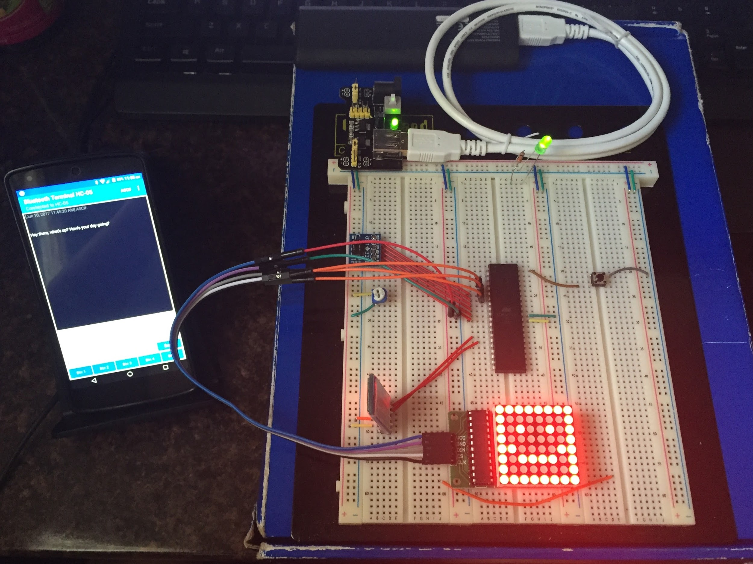

# Hardware

## Parts List

The hardware that was used in this project is listed below. The equipment that was not taught in this course has been bolded.

* ATMega1284 microcontroller
* **8 x 8 MAX7219 LED Matrix**
* **HC-05 Bluetooth 3.0 Module**
* Nexus 5 Android Smartphone w/ Bluetooth Terminal HC-05 application

## Pinout

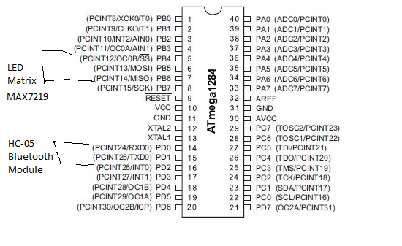

# Software

The software designed for this project was implemented using the PES standard. The overall design as a task diagram is included below.

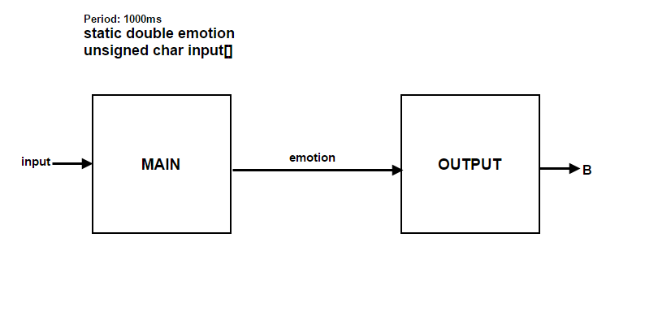

The MAIN task is essentially the main function of the C program. I decided to enclose most of the functionality in the main function as I must wait for user input and thus it makes more sense to do it in there than having a function that doesn’t run to completion inside a synchSM. The purpose of this task is to display a greeting on the screen of the Nexus 5 and wait for user to send a reply and then begin analyzing the received text. Once the input is received, the “emotion” value of the string of text is calculated by comparing each individual word against words stored in a HASH lookup table.

Once the “emotion” of the string of text is determined, the variable is shared with the OUTPUT task to determine the correct emotion to display on the LED matrix, which outputs to PORTB.

# 

# Complexities

## Completed Complexities:

* Use the Nexus 5 to send strings of text over bluetooth to microcontroller.
* Use HC-05 Bluetooth module (USART) to transmit text to Nexus 5 and receive text as well.
* Using the EEPROM to save dictionary of words to be used with analyzing algorithm.
* Lexical analysis algorithm using a HASH lookup table to determine emotion of text.
* Use MAX7219 LED matrix (SPI) to display analyzed emotion from received text.

# Youtube Link

<https://youtu.be/zAIkPyxF3R4>

# Known Bugs and Shortcomings

* The correct emotion of the string of text is not always calculated. This is due to the accuracy of the algorithm in determining the correct emotion. The more words, especially keywords, that are detected in the string, the more accurate the calculated emotion is.
* Due to the relatively small size of the EEPROM on the microcontroller, I wasn’t able to store a large amount of words to be used with the HASH lookup table. I believe that with more words to compare against in the lookup table, the more accurate the algorithm would be at determining the emotion of the string of text.

# Future work

To improve upon my project, I would tweak the analyzing algorithm to determine the sender’s emotion more accurately, perhaps tweaking the word lists and their corresponding scores. With this, I would also display more emotions on the LED matrix as it is currently limited to one determined emotion at a time. Thus, I would also integrate a larger display for the emotions. I would also like to create a GUI to interface with the bluetooth module using a computer. Another possible application would be to have a artificial conversation with the microcontroller as a AI application.

# References

* MAX7219 LED Matrix Driver Library: <https://davidegironi.blogspot.com/2013/07/avr-atmega-max7219-7-segment-led-matrix.html>
* USART Library: <https://github.com/mikebrevard/CS120B_FinalProject/blob/master/bop_it_user_input/usart_ATmega1284.h>
* Bluetooth Terminal HC-05: <https://play.google.com/store/apps/details?id=project.bluetoothterminal>

# Appendix

Include images of all of the SM’s that you have designed and any other work that you think is relevant to this project.

