Prompt Iteration: Refining Weak Prompts\

- Explain regression
  - Revised Prompt: You are acting as an instructor for data analytics students with little to no technical knowledge. Explain regression in beginner-friendly terms in the context of data analysis. Provide a simple real-world example that guides the student how this technique can be used to interpret data.
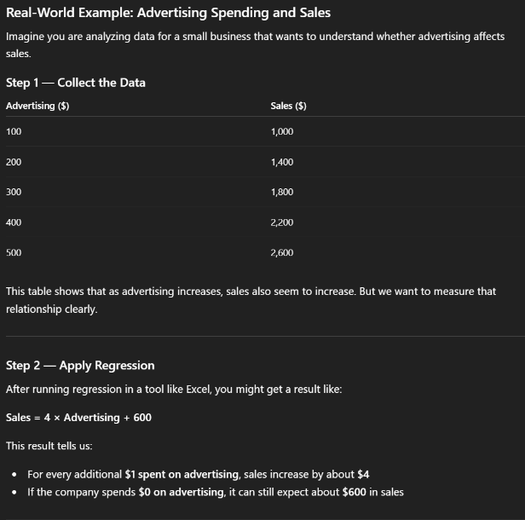
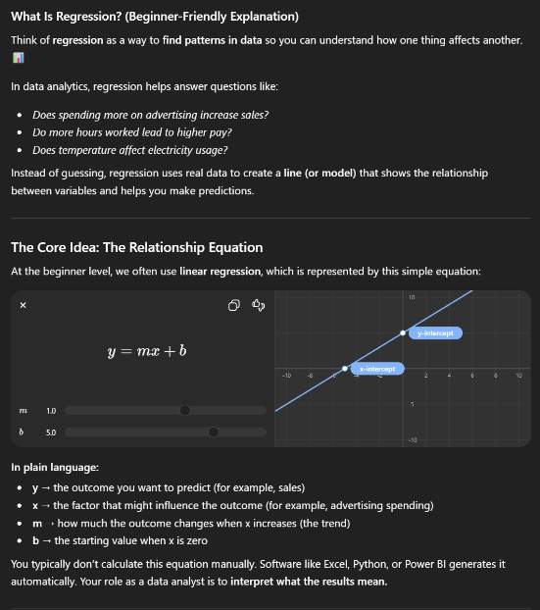

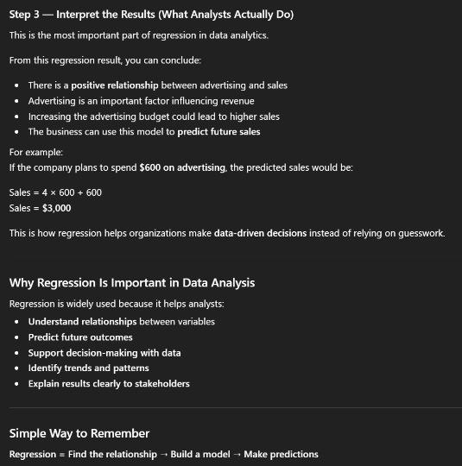

  - The revised prompt is stronger because it gives the AI a persona and gives context to the audience so the AI can adjust its language to beginner-level. It also prompts the AI to generate a real-world explanation to give context and deepen students’ understanding. These new constraints guide the AI to create a response that is teachable for students instead of simply outputting a textbook definition.
- Help me understand SQL
  - Revised Prompt: Create a cheat sheet that covers the most essential and basic commands of SQL. Provide beginner-friendly definitions of SQL and its purpose in data analysis. Provide a simple example for using SQL commands.

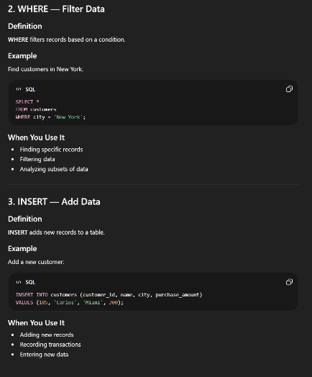
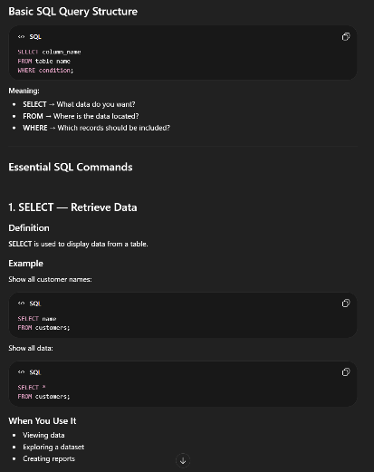
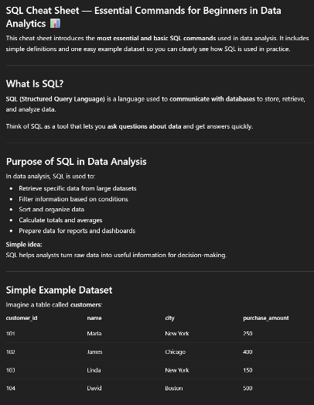

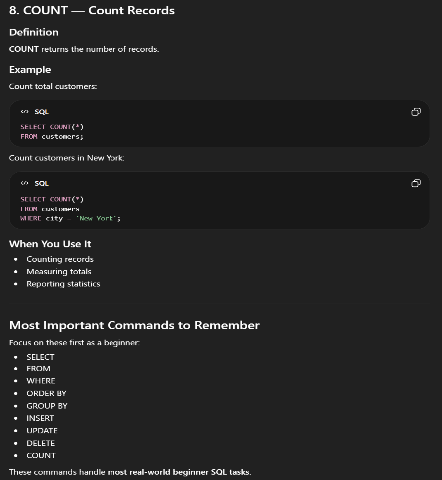
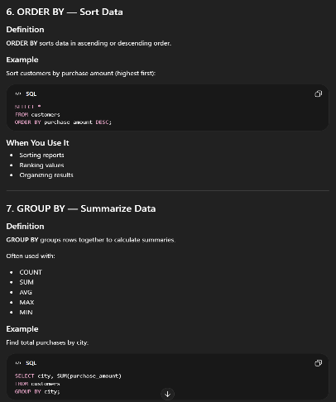
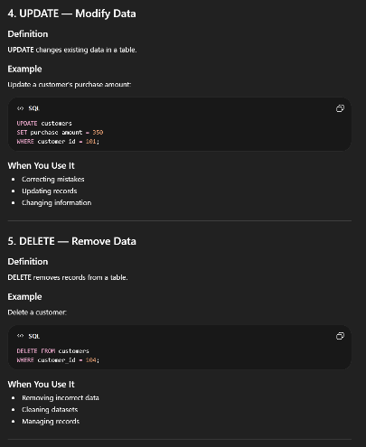

  - The revised prompt is stronger because it specifies the format, scope, audience, and structure for the response. The phrase “cheat-sheet” implies brevity, ensuring the guide is as concise and as easy for beginners to digest as possible. It further guides the AI by asking it to provide a simple example for SQL commands, which produces a consistent usable reference.

- Create a dataset
  - Revised Prompt: Create a clear, dataset in table format showing the titles for all the Spider-Man movies, the year each movie was created, and the total box office revenue for each film. There should be three columns titled, “Release Year,” “Movie Title,” and “Gross Sales.” Exclude the animated Spiderman films from the dataset. Order the data set by release year, past to current.

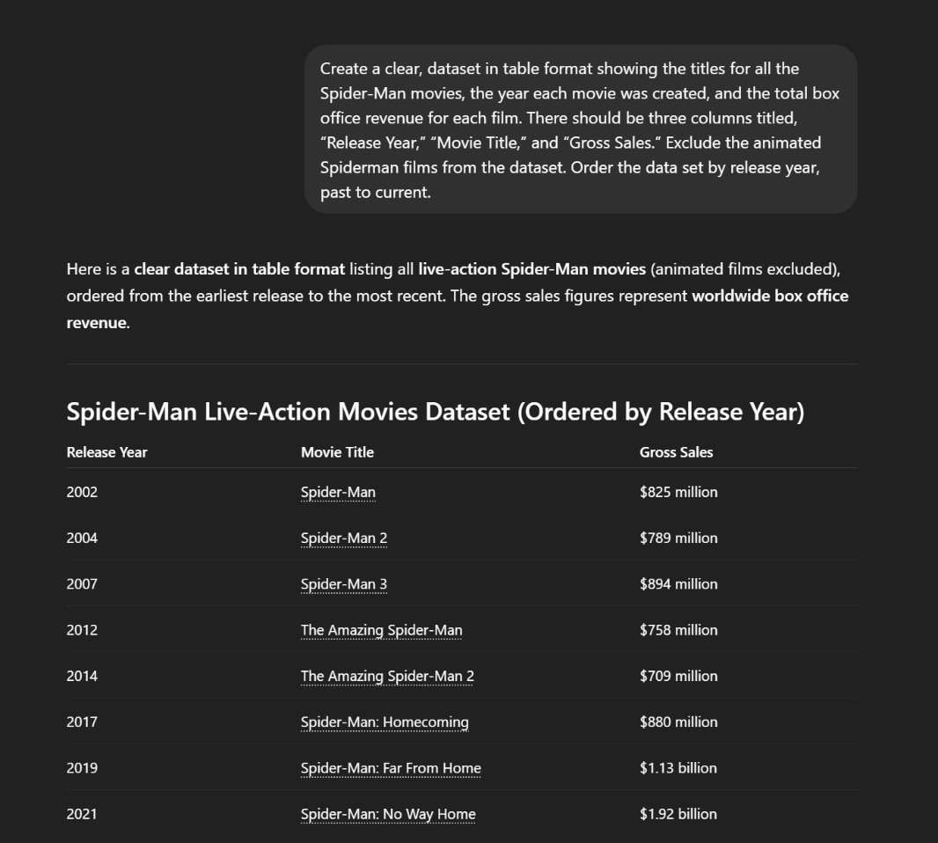

  - The revised prompt is stronger because it provides context with a clear subject matter (Spider-man movies), format (table format and exact column structure), a sorting order (past to current release year), and a content rule (exclude animated films). Compared to the original prompt with zero specifications, these highly specific guidelines provide everything the AI tool needed to create a clean dataset.

