**Sample SQL Queries**

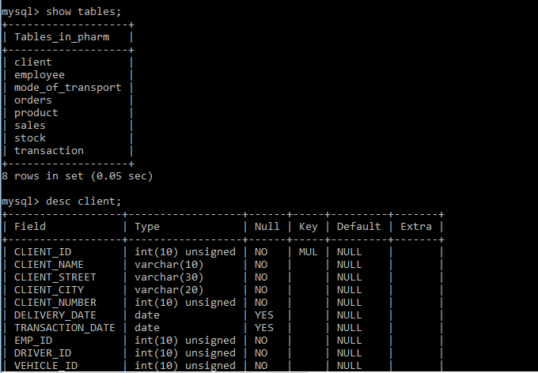

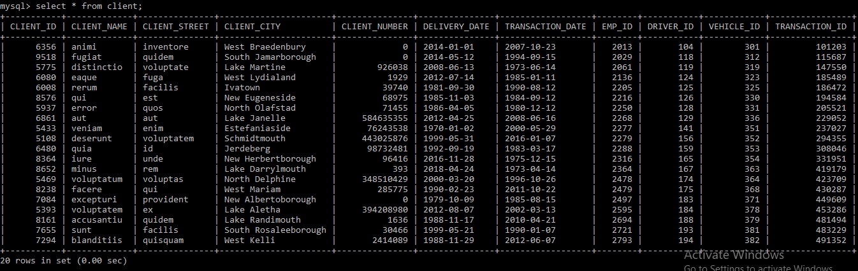

1)Find all the sales_id and their profit whose profit is greater than 10000.

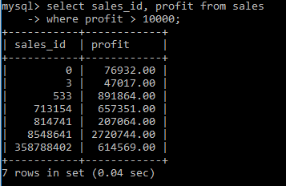

2)Find the client_id, client_name and transaction_id starting transaction_dates from ‘2000-01-01’

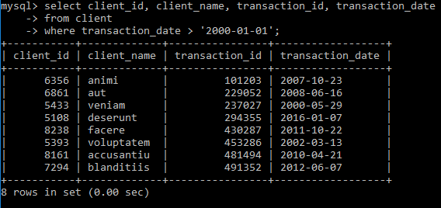

3)Find the no of installments made by clients.

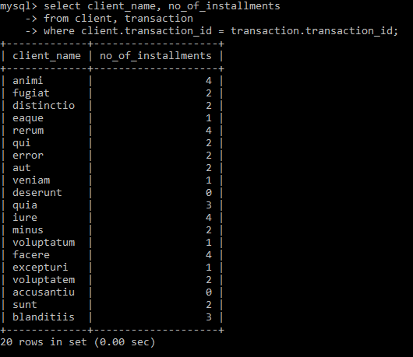

4)Find the product_id of all the products that has been ordered by clients.

