## Priorities List

#### Functional Features:

1. **Essential: (necessary for system to be useful)**
2. **Adding Details:** Initially hotel Management should store the room type, no of rooms, price, discount types, customer classification details into the database.
3. **Online Booking:**

Customer should be able to find the room/rooms based on room type, no of guests, check-in and check-out dates

First time customers should register online through the website, which makes next booking easier.

At the time of registration, customer should choose a unique login ID, password and contact details. Successful registration will send confirmation email along with login information.

Customer must login to the website to book room/rooms and customer details should be validated with the registered customer details before booking

Customer should be able book room/rooms based on the room availability on provided dates. Upon successful booking, customer will receive an email with booking id, room type, check-in, check-out dates and payment details.

Customer should receive invoice with payment details via email.

Provide a secure payment gateway for payments during online booking.

1. **Update Details:** Hotel Management should be able to update room type, availability, and price anytime.
2. **Important: (can be added later)**
3. Customer can view reviews and can write one
4. **Extras: (nice to have)**
5. Able to generate revenue reports on monthly
6. Send greeting to customer on special occasions

#### Non-Functional Features:

* User friendly, customer should get necessary information easily while booking rooms.
* Use Oracle for database design
* Use python for Linux support

ER Diagram

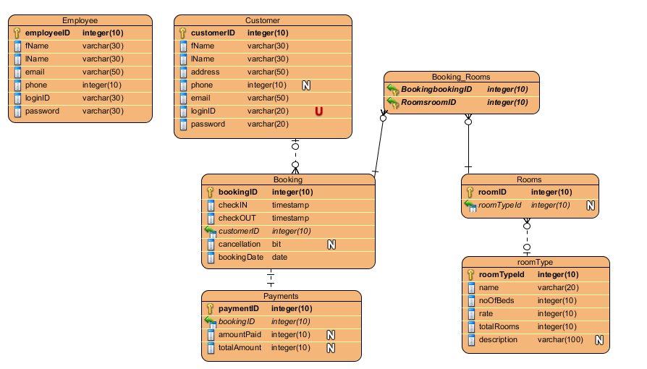

Site Diagram:

