Technical Web Design Program - Grade Tracking and Display Website

## Priorities List

#### Functional Features:

1. **Essential: (necessary for system to be useful)**
   1. Logins that take students, instructors, and administrators to their own area of website.
   2. **Administrators** will be able to:
      1. create an intake and add instructors and students to the intake. Each intake has five predetermined modules. Each module has a credit value for the whole program.
      2. Create and add courses to modules.
      3. Each course can have multiple deliverables (e.g. assignments, labs, tests, projects) that are graded on a percentage basis. Each deliverable may have zero or more parameters (e.g. multiple parameters of one project) graded on a percentage basis.
      4. View grade reports for all students for each course
      5. Course info (all students, marks by deliverable, comments, late penalty) to be exported in xls sheet.
   3. **Instructor** will be able to:
      1. Enter grades only for the courses they teach. At most each course can have two instructors. Course info and deliverables are preset by the Administrator. Instructor cannot change anything about the course, they can only enter grades.
      2. View grades reports for all students in each course they teach
   4. **Students** will be able to:
      1. View their own grades for each parameter, assignment and course.
2. **Important: (can be added later)**
   1. View Final Grades Summary with grade and weight for each course, and grade for whole certificate program.
3. **Extras: (nice to have)**
   1. Once all grades are entered for a module for the whole intake, an automatic email is sent to inform students of new grades and to login.
   2. Import student data into database from excel sheet.
   3. Students be able to view module summary report with totoal grade for module and for each course.

#### Non-Functional Features:

* Cannot store/use BCIT studentID as login ID
* Needs to be built with PHP for use on Linux servers.
* Usability: website must be simple and professional without lots of graphics or distracting content

## USE Case Diagram

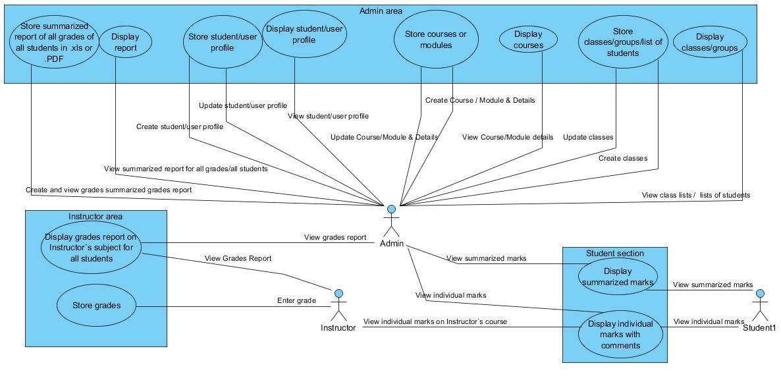

## CRUD Analysis --

|  |  |  |  |
| --- | --- | --- | --- |
| **Use Case** | **Entity** | **CRUD** | **Actors** |
| Store Student/User profile | Users | Create | Administrator |
| Display student/user profile | Users | Read | Administrator |
| Update Student/User profile | Users | Update | Administrator |
| Store class | Classes | Create | Administrator |
| Display class details | Classes | Read | Administrator |
| Edit class | Classes | Update | Administrator |
| Store class list of students (add students to class) | Users | Update | Administrator |
| Create modules | Modules | Create | Administrator |
| Update module | Modules | Update | Administrator |
| Store course and its details (add a course) | Courses | Create | Administrator |
| Display courses | Courses | Read | Administrator |
| Edit courses | Courses | Update | Administrator |
| Add deliverables to course | Deliverables | Create | Administrator |
| Add parameters to course | Parameters | Create | Administrator |
| Store report of all grades in xls sheet | Parameters\_students | Create | Administrator |
| Display report of all grades | Parameters\_students | Read | Administrator |
| Store grades | Parameters\_students | Create | Instructor |
| Display grades for all students in instructor’s course | Parameters\_students | Read | Instructor  Aministrator |
| Display individual marks with comments for course, deliverables, and parameters | Parameters\_students  Parameters  Deliverables  Users\_deliverables  Courses  Courses\_student | Read | Student  Instructor  Administrator |
| Display Summary of Grades (module, course, program) | Parameters\_students  Parameters  Deliverables  Users\_deliverables  Courses  Courses\_student  Modules | Read | Student  Administrator |

## C:\Users\SBS Jones\Documents\BCIT\SSD\SystemsAnalysisDesign\Group Project 1\Daniel,Gurinder,Nick,Brice,Sam_SAD-GroupProject\Site-Map.jpgSite Map

## ERD Diagram

