**As a Team Leader**

Git Hub Version Control , and SET user account details on Git Hub terminal

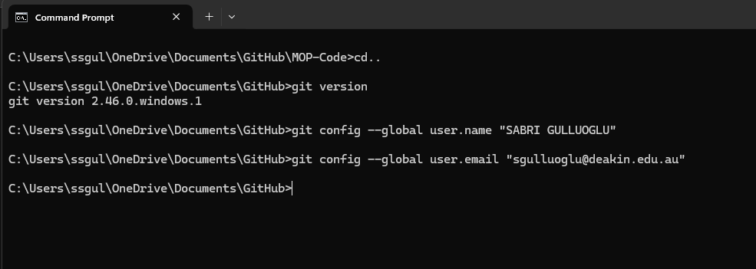

Copy the main repository https://github.com/azadehghn/Deakin-Unit-Page by fork option

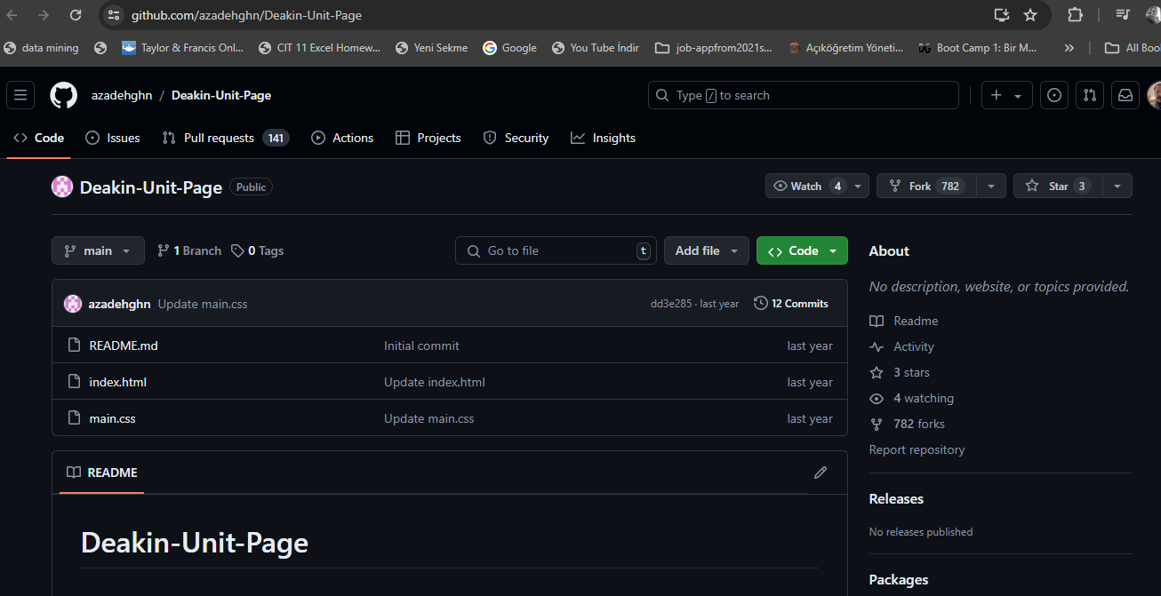

Copied repository as seen below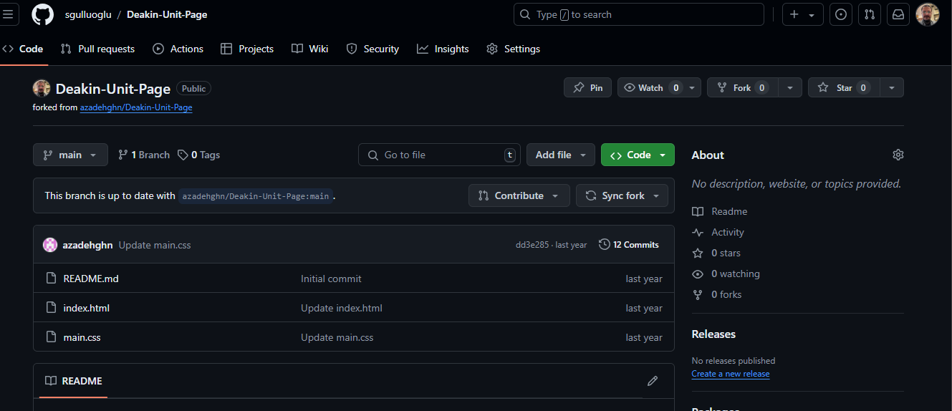

Under settings option, clicked on the Collaborators option to add the other team members

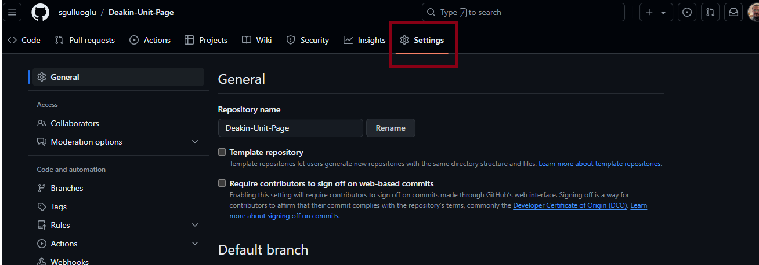

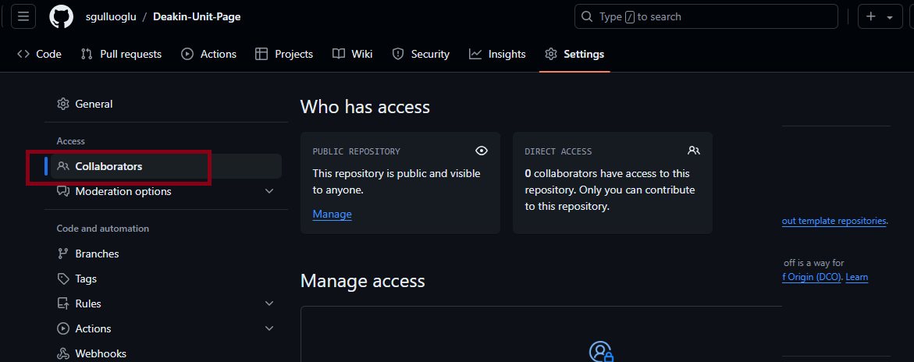

Add the other team members(**UI Designer (UI)** and **Front-end Developer (FD)** )

Invitation was sent to the team members.

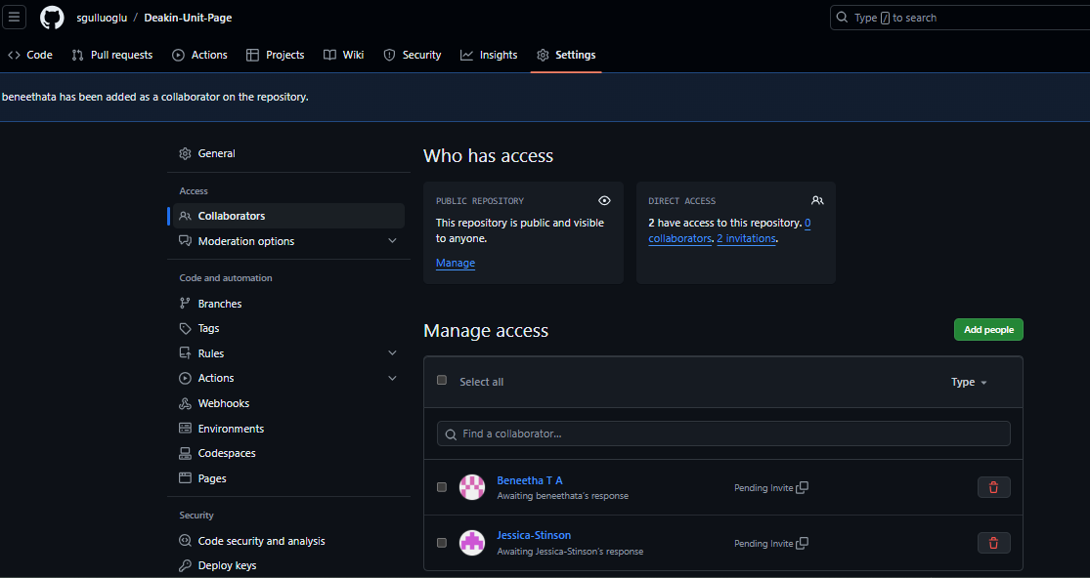

In Git Hub website, Under the copied repository, Under the Code section, clone the repository docs to your local directory, there are 2 options,

First option: Under HTTPS, copy the link, open Git Bash on your computer, paste the folder destination into the terminal, clone the directory URL with git clone.

Second option:Under Code section, Click the Open with GitHub Desktop section and clone the directory URL into your local directory.

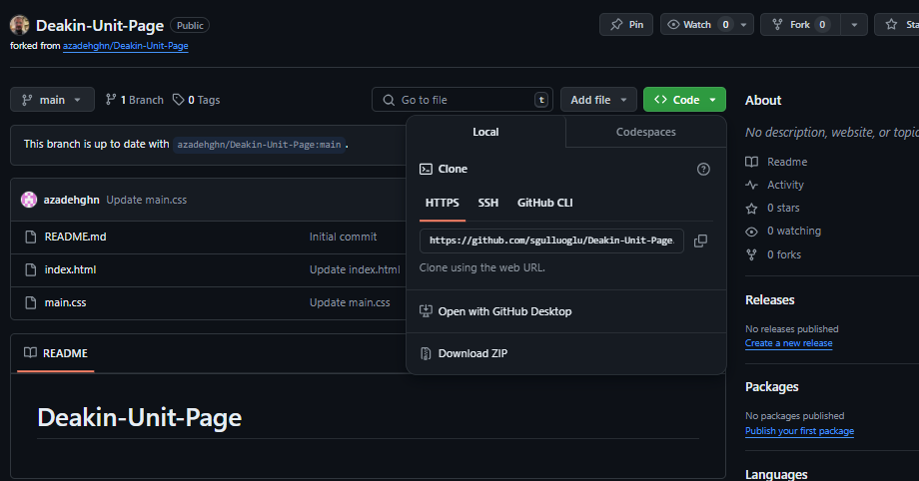

First Option: Clone with Git Bash Terminal

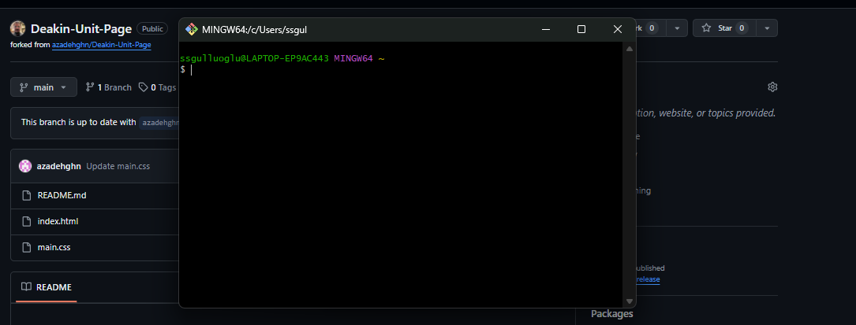

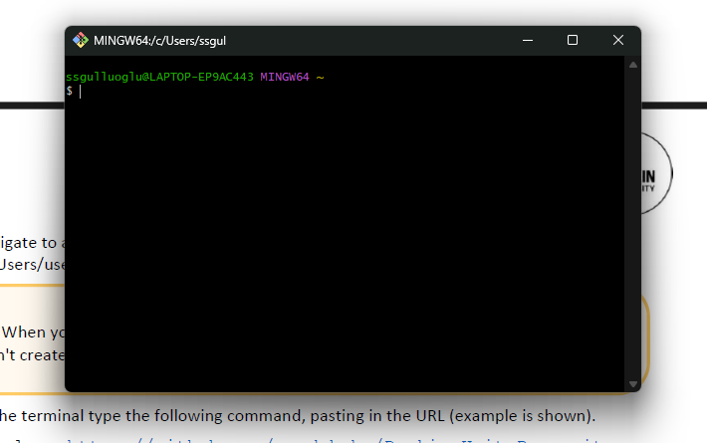

Paste the directory(which you copied from your local directory folder on windows) which you want to add your folder, you can see, URL is not working under the terminal, then change the direction of the dash from ‘\’ to ‘/’ . Then try again, as you can see the expected directory folder.

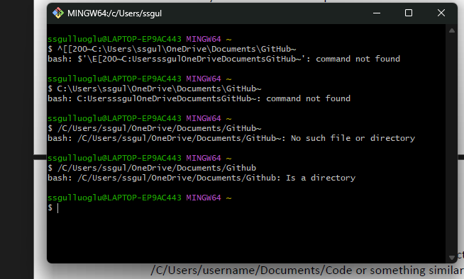

Write git clone and add ‘copied directory folder from github web’

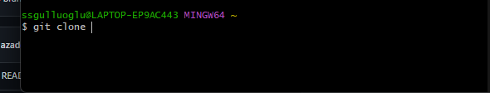

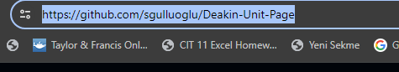

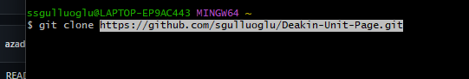

As you can see it is successfully cloned.

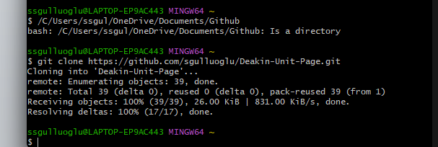

Second Option, Again under code section, click on the Open with GitHub Desktop

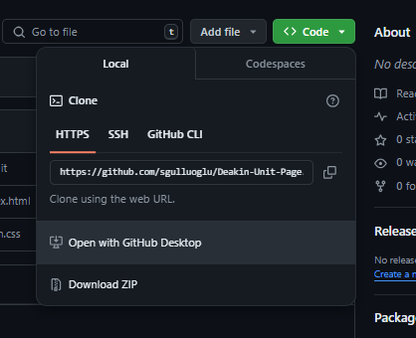

After you click on the Open with Git Hub Desktop, the Github desktop app starts to working. Under clone a repository window, on the first URL, you can see the related directory, and in the second URL, you can prefer the directory folder which you want to clone. Then click Clone.

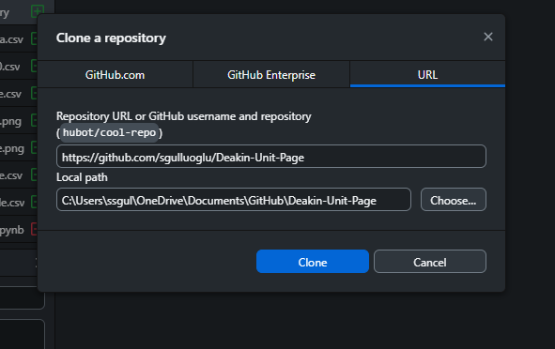

As it can be seen below screenshots, Under github desktop and Under the related folder C:\Users\ssgul\OneDrive\Documents\GitHub , the folder and the related files can be seen under the main folder.

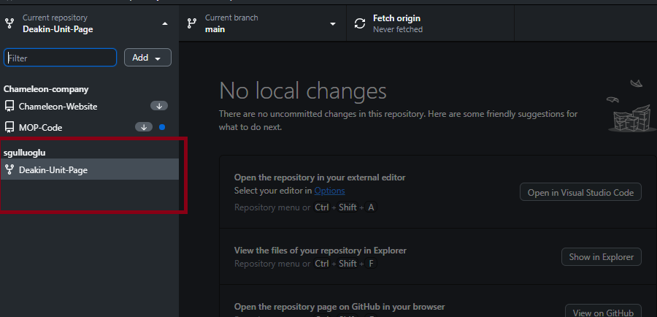

The main folder under the related directory can be seen.

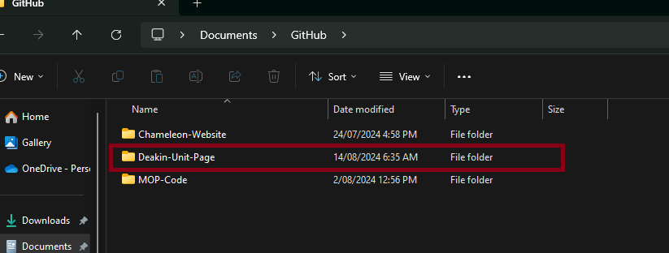

The files under the folder on your local directory.

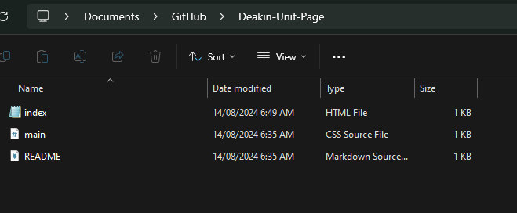

To test if the related html file is working, index.html, write open index.html on the terminal but as you can see if you use windows it is not working, so write start index.html. then you can see the file is opened with a txt file(as you can see the html code) (The file is opened in txt format, that is because I made the configuration that the files are starting as an txt file- it can be configured as a web browser during installing the github)

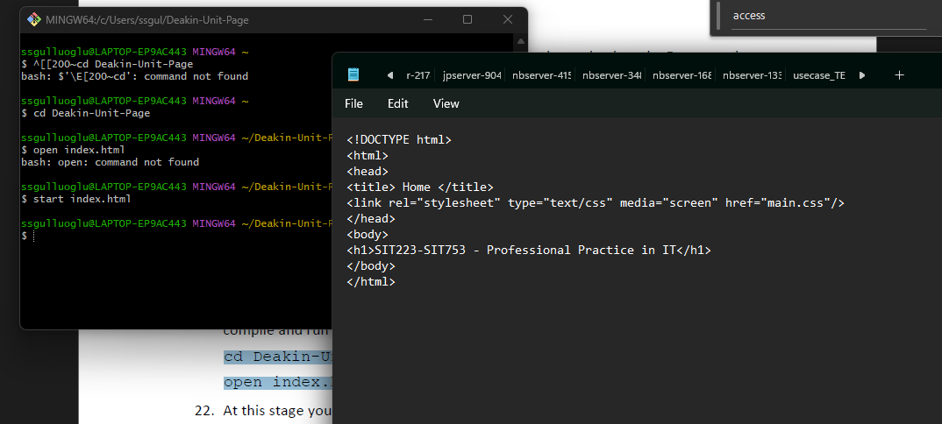

I prefer the work with Microsoft Visual Code, so I opened the html file under the Visual Code.

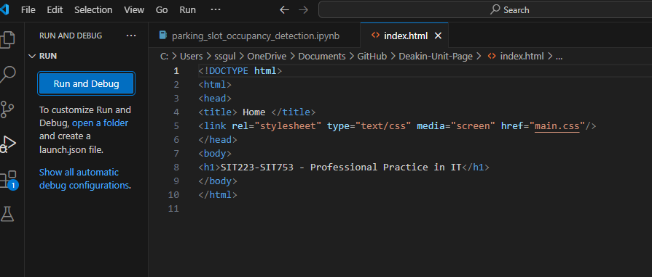

When I run the html under Microsoft visual code , I see It is working successfully.

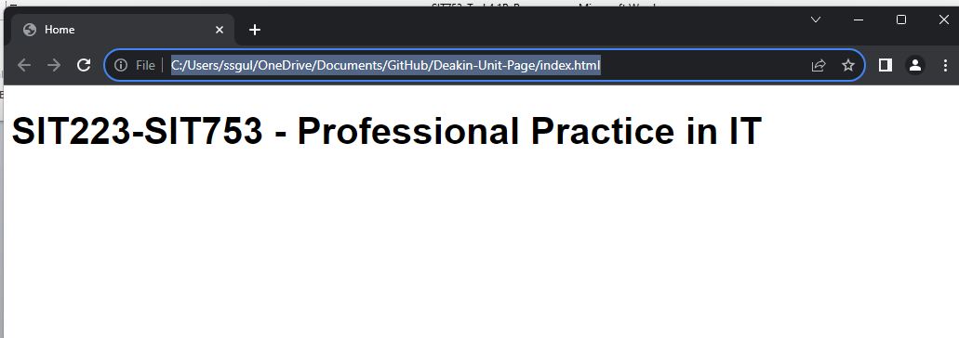

I made a change to see if the code in updating under the local folder, also under the github web.

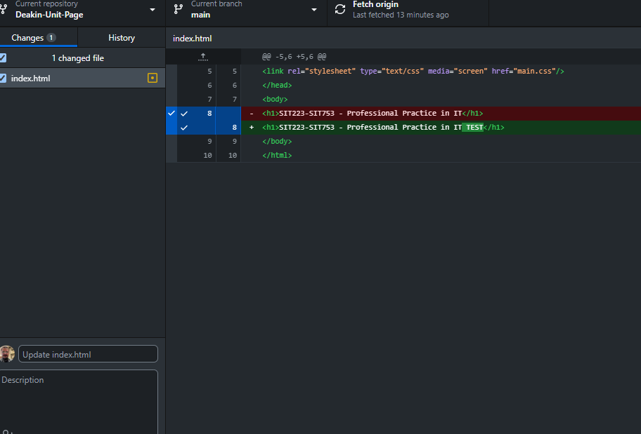

I changed the ‘Professional Practice in IT’ as ‘Professional Practice in IT TEST’. Then click commit to main as it can be seen below.

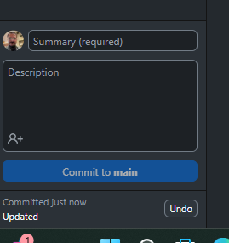

Then click Fetch Origin to update the local directory files and github web.

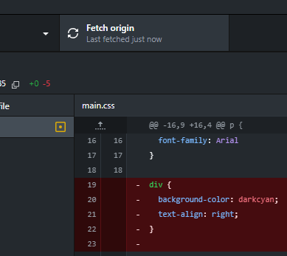

When I physically check the local directory and the html file, I can see it is updated as ‘Professional Practice in IT TEST’.

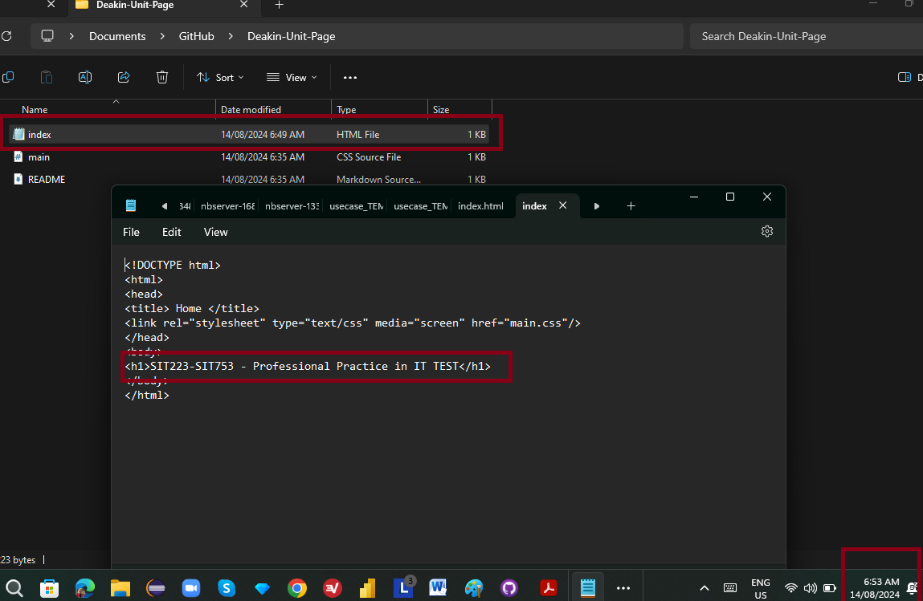

When I go to the Git Hub web, <https://github.com/sgulluoglu/Deakin-Unit-Page>, I can see, the index.html file is updated successfully.

