Even with the rapid scanning procedure that we employed, the three dimensional (3D) reconstruction of the dendritic arbors from moving animals posed challenges. For instance, during the time points with the most rapid movement, the dendritic field of the neuron was moving in the X, Y and Z axes during acquisition of Z-stacks. This caused each Z-section to be an individual snapshot of a portion of the moving arbor and this movement resulted in mis-registration of slices in Z (visualized as a blurred image of the arbor when the stacks were displayed as a maximum intensity projection). Thus, the models of dendritic architecture shown in Figure 1 relied upon computational approaches. Mis-registration was minimized using an algorithm that realigned the slices in the Z axis based on the image intensity using the free-form deformation (FFD) technique [REF1]. These realigned dendrites were then analyzed using the semi-automatic Computer Vision framework for 3D neurite tracing (in each image stack) and tracking (across time) using the neuron plane model. Briefly, the extracted dendritic traces from non-moving stationary time points allowed us to generate a “ground truth” (prototype) model of the dendritic morphology for a particular neuron of interest. Due to the high degrees of freedom of the dendritic morphology and low resolution in Z-axis (high resolution in XY-axes), tracking individual branches of dendrites in 3D poses difficulty and renders the fully automated tracking method like [REF2] unreliable. On the other hand, the neuron plane model is the 2D lattice that encloses the ground truth dendrites and represents the surface that the body segment lays on. The plane model consists of strips along the only possible direction of movement (along the agarose channel) and the plane can be deformed only by changing the angles between adjacent strips (Fig. S3). This helps reduce the degrees of freedom and makes semi-automation possible. The neuron plane model was then warped *in silico* using the algorithm that finds the best-fitted configuration to the recorded confocal data, which in turn deforms the enclosing ground truth dendrites to generate the 3D estimates­­­­­ of the dendritic architecture. The algorithm finds the configuration using the simulated annealing technique [REF3] based on user interaction, image feature, and local shape. Users provide the X-coordinate (direction along the agarose channel) of the farthest tips of dendrites to help handle dendrite detection issues (Fig. S4); while, the local shape acts as the regularization to ensure the smoothness of spatio-temporal transformation and prefer the flat surface (the angles between adjacent strips near 180 degrees, which is the angle on a straight line). With the neuron plane model, the dendrite curvature can be estimated by the bending of the plane model. It is computed by the sum of the angles between adjacent strips.

[REF1] D. Rueckert, L. I. Sonoda, C. Hayes, D. L. G. Hill, M. O. Leach, and D. J. Hawkes, “Nonrigid registration using freeform deformations: Application to breast MR images,” IEEE Trans. Med. Imag., vol. 18, no. 8, pp. 712–721, 1999.

[REF2] S. Gulyanon, L. He, W. D. Tracey Jr., and G. Tsechpenakis, “Neurite tracking in time-lapse calcium images using MRF modeled pictorial structures,” ISBI, pp. 1564-1568, 2018.

[REF3] S. Kirkpatrick, C. D. Gelatt, and M. P. Vecchi, “Optimization by simulated annealing,” Science, vol. 220, no. 4598, pp. 671–680, 1983.

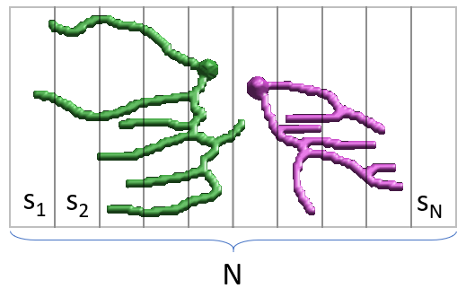

Fig. S3. The neuron plane model enclosing the body segment consists of N strips — s1, s2 …, sN.

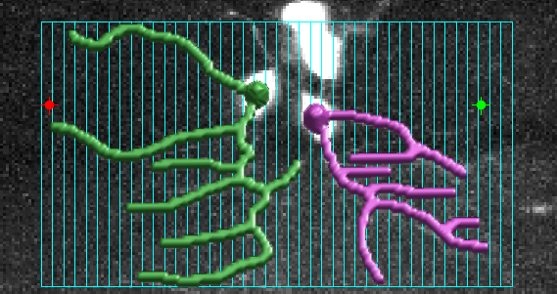 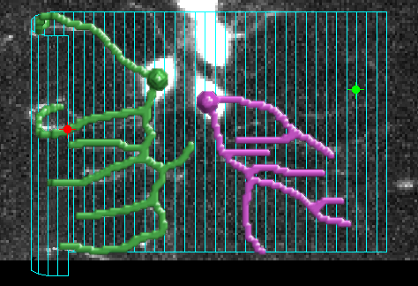

A B

Fig. S4. The algorithm requires the X-coordinates of the farthest dendrite tips as shown by red and green points. The neuron plane model of the body segment is in cyan color. (2A, left) the ground truth dendrites. (2B, right) the deformed ground truth dendrites.