1. Install Jupyter notebook and run the first program and share the screenshot of the output.

**Output**

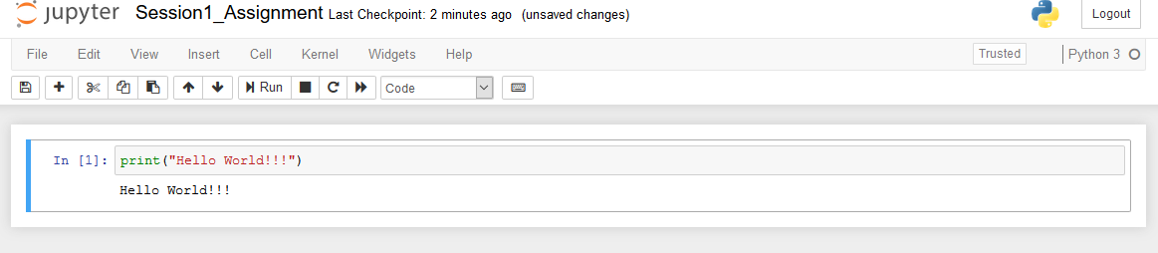

1. Write a program which will find all such numbers which are divisible by 7 but are not a multiple of 5, between 2000 and 3200 (both included). The numbers obtained should be printed in a comma-separated sequence on a single line.

**Output**

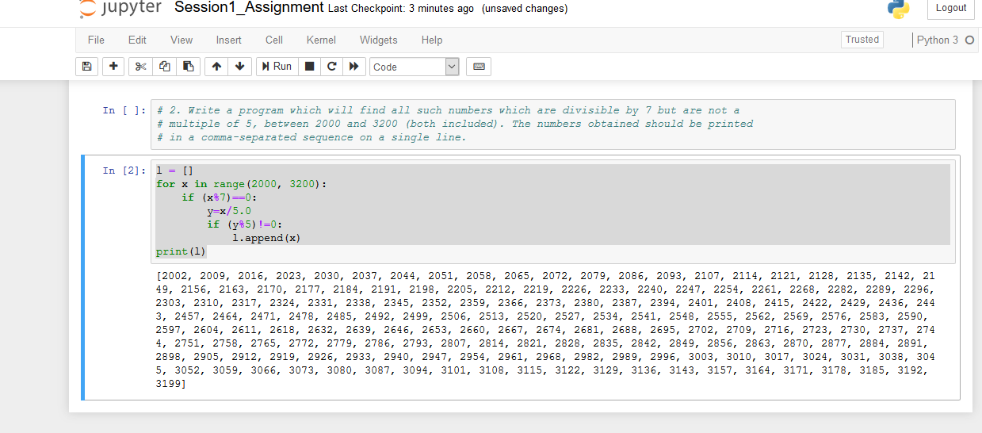

1. Write a Python program to accept the user's first and last name and then getting them printed in the reverse order with a space between first name and last name.

**Output**

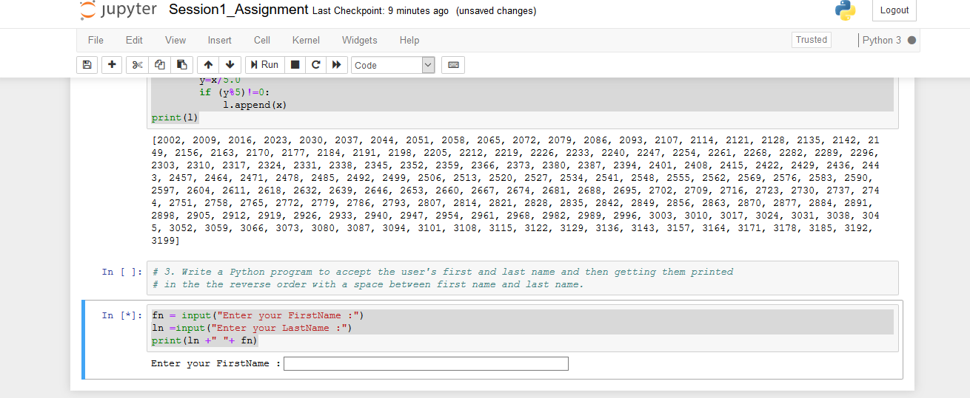

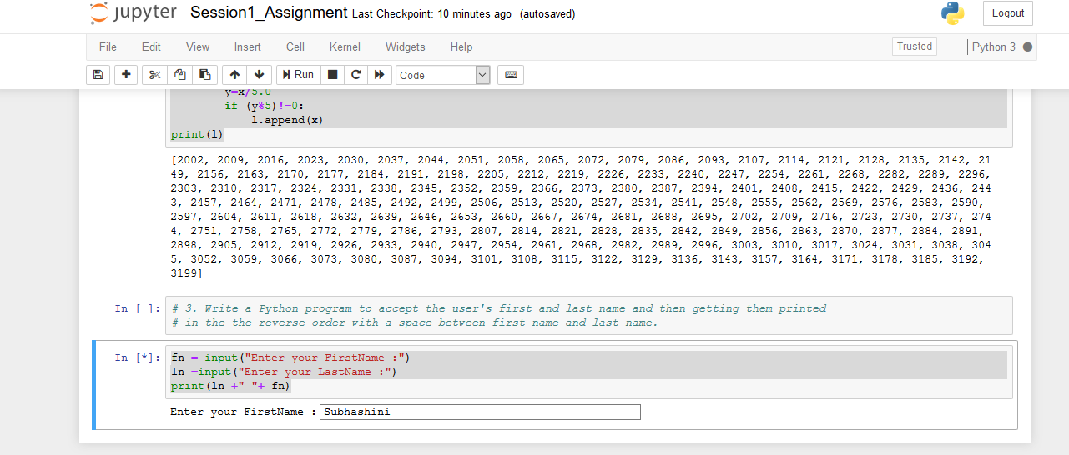

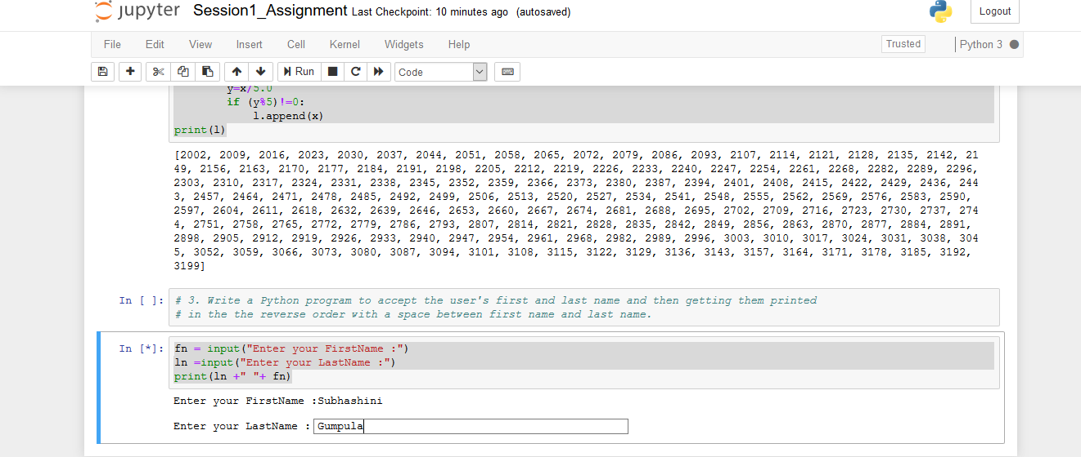

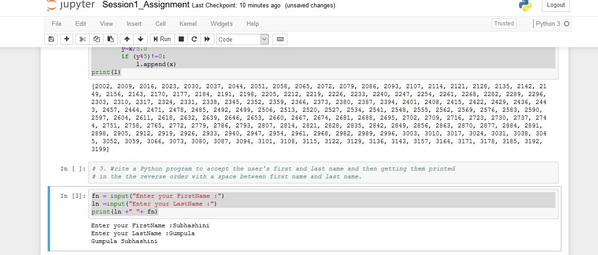

1. Write a Python program to find the volume of a sphere with diameter 12 cm.

Formula: V=4/3 * π * r3

**Output**

