**pymongo:**

pymongo is a MongoDB wrapper or a MongoDB client or a mongodb Driver.

Here Pymongo is a client that interacts with the mongodb server and the server gets the relevant data from the mongodb database and returns it back to the client.

Data will be in the form of JSON/BSON ( Binary form of JSON).

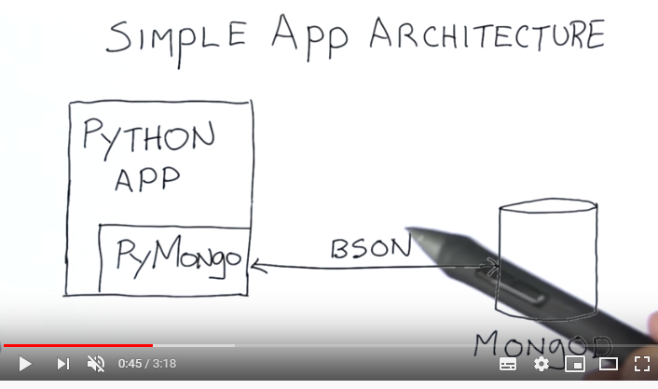

# **Tutorial 4**- MongoDb With Python- Querying JSON Documents|Data Science

* <https://www.youtube.com/watch?v=5c-d5YZ3cc8&t=3s>

# **Tutorial 5**- MongoDb With Python- Updating Records|Data Science

* <https://www.youtube.com/watch?v=XOc3AL64dTs>

**=> Jupyter Notebooks:**

* **Python_mongodb.ipynb**
* [**QueryMongo.ipynb**](http://localhost:8888/notebooks/QueryMongo.ipynb)**.ipynb**
* [**updateMongo.ipynb**](http://localhost:8888/notebooks/updateMongo.ipynb)**.ipynb**