Tableau

1. **=>Intro**

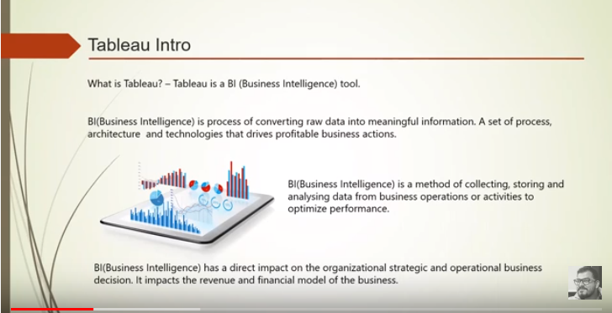

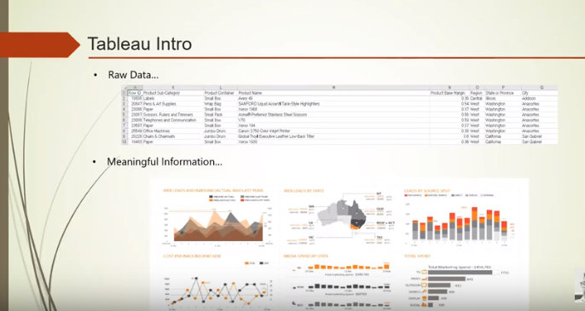

**2)=> Why?**

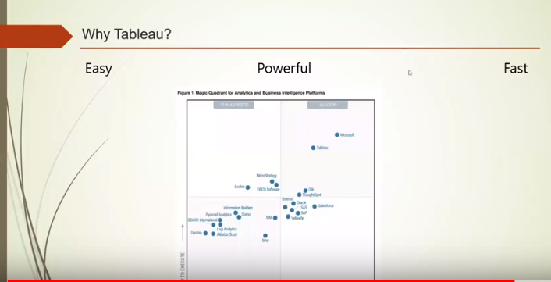

**3)=>Some Important points:**

1. Data fields.
2. Tableau Data Types.

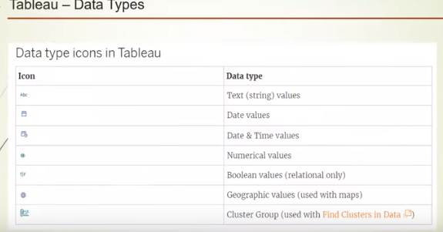

1. Filters.
2. Live vs Extract functionality.
3. Join between tables (left, right, inner, full outer).
4. Dimensions and Measures.

***: Each data or any data always has 2 types (Dimensions and Measures)***

***: Dimensions are those columns on which we cant perform mathematical operations. Always in Blue color.***

***: Measures are those columns on which we can perform mathematical operations. Always in Green color.***

***: We can use Dimension along with Measure as a reference for better visualization.***

1. **Shells:** Pages, Filter, Marks (for formatting - coloring, size and all).
2. **Show me:** show examples of graphs.
3. **Sort** the visualization (ascending and descending order).

**4)=> Data aggregation - local and global aggregation :**

**Aggregation:** the collection of numbers in a single cluster.

Eg: Sum, Mean, Max, etc. See below:

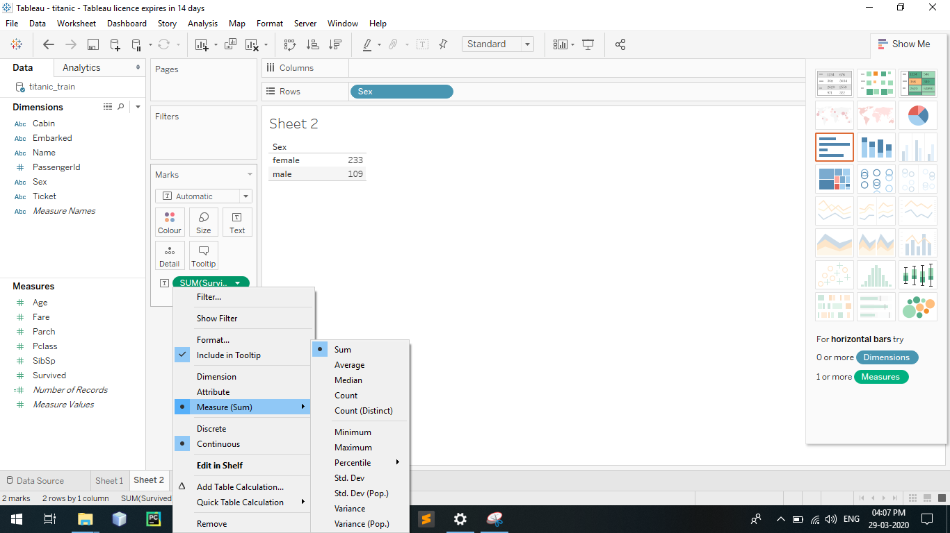

**Global and local aggregation:**

Global is at Measure level and Local at Visual level.

**=>Basic Formatting: format option** to add currency mark and all in front of values)

=> **Analysis option** in the File menu for grand total and stuff.

=> **.twb vs .twbx** format for saving Tableau notebook.

**5)=> Tableau Architecture:**

